GA03 Deliverable

M.U.P

massively underdeveloped project

Rasmus Tilljander - rati10@student.bth.se  
Nils Forsman - nifo08@student.bth.se  
Calle Ketola - cake10@student.bth.se  
Kim Hansson - kiha10@student.bth.se

## Updates to GA02

Motivations:   
* Some motivations given, but no alternatives to design decisions are discussed  
  
Revisit assignment 1:  
* 3 issues have solutions, but no concrete strategies to implement them  
Added strategies to most issues that lacked such.

Strategy mapping to module view:   
* You motivate the decisions well, but you should specify also the concrete  
strategy, not only the issue, which leads to the decision.

The coresponding strategies are now mentioned as well.

Module view:   
* No traceability between conceptual and module view, i.e. not clear which and  
where conceptual components are reflected in the module view.

Added a short mention to each layer description which component that it reflects.

* Why are there 4 "Data transfer" modules? If they all have the same  
functionality, they shouldn't be replicated four times. If they are different,  
e.g. clients in the broker pattern, they should have different names

Each of the modules now have a individual name to show that they are different modules.  
  
Strategy mapping to execution view:   
* The design decisions are not connected to any strategy and/or issue (except  
broker strategy).

New issue-cards and strategies will be added so that we can map them to the execution view.  
  
Execution view:   
* Diagrams are not clear since notation is not followed. We need to see at  
least one diagram showing the execution architecture view and one with  
communication paths.

Communication paths have been added to the entities now and will be described in the text.

* There is no visible mapping between module view and execution view.  
The mapping between the modules in the module view and the modules in the excution view and now mentioned.

Self-evaluation of architecture:   
* Shallow description of alternative evaluation methods, choice weakly  
motivated.

Updated description of alternatives.

* Chosen method (BTH evaluation method) not described and process not explained.

Made a longer description of the chosen method.

* BTH method not followed (i.e. most relevant quality attributes identified,  
but not motivated why they are the most important ones; no normal/worst case  
scenarios defined)

Motivation has been added.

* Scenarios are shallowly analyzed  
* If you look at the description and advantages/disadvantages of the broker  
pattern (e.g. here:  
http://www.openloop.com/softwareEngineering/patterns/architecturePattern/  
arch_Broker.htm), do you still consider it as a good solution?

Yes. After reading the text we find that the pros of reusability and extensibility far outweighs the cons of lost fault tolerance and efficency.  
  
Architecture transformation:   
* Even the weak scenarios identified one issue, leading to create a new  
issue-card ("Multiple crash issue"). How did this affect the architecture and  
which changes did you implement?

We had already taken this issue into concideration, it was just never documented properly. This will be mentioned in the evaluation now.

## Introduction

The assignment consists of creating and documenting an architecture for a predefined system and in doing so learn how to transform quality goals into a practical solution.

The system is an automated test bench for use on various kinds of software. It will feed predefined input into the tested system and verifies the output, reporting any deviations. The system need to be easy to maintain and adding new features such as input types, emulation mechanics and testing techniques with minimal effort and cost.

It also needs to log all the testing data and generate this as a report containing test statistics, how to recreate the errors and the type of errors encountered.

The idea is that the system will be used in maintenance departments of software organizations with a demand for advanced and automated testing.

## Assumptions

We have assumed that:

* All standard computers have an operative system that is either Windows, Linux or MacOS.
* A standard computer has at least a Giga bit network card, DDR2 memory, 2 Ghz single core.
* We do not emulate any software within the system, instead we channel the information through the system between the tested system and the exterior software.
* The MIB will be maintained for 20-30 years.
* The MIB will be developed by a competent team with the required skills to implement it.
* The Development does not have a tight schedule nor any specific budget constraints.
* An avarage software system will use 3-5GB of RAM.

## System analysis

### Factors

|  |  |  |
| --- | --- | --- |
| **TechnologicalFactor** | **Flexibility and Changeability** | **Impact** |
| **T1: General-purpose hardware** | | |
| ***T1.1 Memorytype*** | | |
| The system should use at least DDR2 type memory | The requirements of the tested system can exceed the requirements of the MIB | Higher system costs |
| ***T1.2 Networkbandwidth*** | | |
| The system should use at least a network card which supports at least 1Gbps | The requirements of the tested system can exceed the requirements of the MIB | Higher system costs |
| ***T1.3 Processor requirement*** | | |
| The system should use at least one single core processor with a clock of 2 Ghz | The requirements of the tested system can exceed the requirements of the MIB | Higher system costs |
| ***T3.1 Operating system*** | | |
| The system should be able to run on Windows, Linux or MacOS | The system might not be needed to run on different operating systems | The system will not need to be platform independent |

|  |  |  |
| --- | --- | --- |
| **Product Factor** | **Flexibility and Changeability** | **Impact** |
| **P1: Functional features** | | |
| ***P1.1 Various Input*** | | |
| Simulatingvarious inputs types | None | None |
| ***P1.2 Identify and Validate*** | | |
| Identify output data and compare it to expected output | None | None |
| ***P1.3 Emulate Hardware*** | | |
| Emulate various different hardware applications | Hardware emulation could be removed | Components handling the emulation of hardware would have to be removed. Limitedchangeto the rest of the system |
| ***P1.4 Emulate Software*** | | |
| Emulate various different software applications, platforms and protocols. | Software emulation could be removed | Components handling the emulation of software would have to be removed. Limitedchangeto the rest of the system |
| ***P1.5 Logging the test*** | | |
| The system should log all the test data passing through the MIB | None | None |
| ***P1.6 Generate new input*** | | |
| The MIB should generate new input from the received output | Script rules for generating new input during runtime | More complicated component for handling generating new input |
| ***P1.7 Runparallel tests*** | | |
| It should be possible to run several tests in parallel | Limit the amount of parallel tests that can be done | Less strain on the system in terms of data transfer |
| **P2: User interface** | | |
| ***P2.1 Adapting to new functionality*** | | |
| The user interface should be possible to adapt to added functionality such as new input types etc. | Addition of new functions after the system has been completed | The user interface will have to be updated to reflect changes in functionality |
| ***P2.2 Monitor MIB during runtime*** | | |
| It should be possible to monitor all testdata during runtime | Limit the amount of available data that can be monitored | Less components are affected thus making changes easier |
| ***P2.3 Scriptable input*** | | |
| The user should be able to script new input during runtime | The system could be required to handle several scripting languages | Several scripting components would be needed |
| **P3: Performance** | | |
| ***P3.1 Handling highthroughtput*** | | |
| Handling a throughput of 75Mbps and peek 150Mbps | The required throughput could be made even higher than at this moment | Changes will have to be made in those components that handle data transfering |
| **P4: Dependability** | | |
| ***P4.1 Graceful recovery*** | | |
| Input and output components should gracefully recover if the tested system crashed | None | None |
| ***P4.2 Restarting from checkpoint*** | | |
| Restarting the tested system from a certain point after a system crash | Latency for restarting the test could be increased to allow different kinds of recovery or the need for restarting from a certain point could be removed | Changes to this factor would only affect the component that is responsible for restarting the tested system |
| **P5: Failure detection, reporting, recovery** | | |
| ***P5.1 Robust system*** | | |
| Since the system should be automated it have to be robust | The system might not have to be able to run unsupervised | Crashescould be tolerated |
| **P6: Service** | | |
| ***P6.1 Adding new input types*** | | |
| Adding new input mechanisms | None | None |
| ***P6.2 Adding new hardware emulations*** | | |
| Adding new hardware emulation mechanisms | None | None |
| ***P6.3 Adding new software emulations*** | | |
| Adding new software emulation mechanisms | None | None |
| ***P6.4 Adding test types*** | | |
| Adding new testingtechniques | None | None |

### Issues

|  |
| --- |
| **Name:**  Multiple input issue |
| **Description:**  The system must support several types of input simulations as well as being able to add new types if the costumer requires it.  **Factors:**  P1.1.1 Simulate various input types  P4.1.1 Adding new input mechanisms |
| **Solution:**  Making the interface between the module handling input and the sub modules for different input types work the same no matter what input type it is. |
| **Strategies/Tactics:**  "*Generalize the module*" from "*Software Architecture in Practice Second Edition*" Chapter 5.3 Len Bass, Paul Clements, Rick Kazman 2003.  By ensuring that the input type does not affect the functionality of the methods in the different modules it will be possible to add several different kinds of input. |

|  |
| --- |
| **Name:**  Multiplehardware emulations issue |
| **Description:**  The system must support several types of hardware emulations as well as being able to add new types if the costumer requires it.  **Factors:**  P1.1.3 Emulate various hardware devices  P4.1.2 Adding new hardware emulations |
| **Solution:**  Explore standards for hardware communications currently used or in development to support most hardware emulations without impacting the system. |
| **Strategies/Tactics:**  "*Maintain semantic coherence*" and**"***Anticipate expected changes"* from *"Software Architecture in Practice Second Edition"* Chapter 5.3 Len Bass, Paul Clements, Rick Kazman 2003  By ensuring that each module is strictly separated from the others a change in one hardware emulation will not interfere with the other emulations and it would thus enable the addition of new modules without too much fuss. |

|  |
| --- |
| **Name:**  Multiple software emulations issue |
| **Description:**  The system must support several types of software emulations as well as being able to add new types if the costumer requires it.  **Factors:**  P1.1.4 Emulate various software applications  P4.1.3 Adding new software emulations |
| **Solution:**  Explore standards for software communications currently used or in development to support most hardware emulations without impacting the system. |
| **Strategies/Tactics:**  "*Maintain semantic coherence*" and "*Anticipate expected changes*" from "*Software Architecture in Practice Second Edition*" Chapter 5.3 Len Bass, Paul Clements, Rick Kazman 2003  By ensuring that the software emulations are strictly separated it will be possible to add new emulations without being hindered by already existing emulations. |

|  |
| --- |
| **Name:**  Multiple testing techniques issue |
| **Description:**  The system must support several types of testing techniques as well as being able to add new types if the costumer requires it.  **Factors:**  P4.1.4 Adding new testing techniques |
| **Solution:**  Keeping the semantics of the testing modules coherent so that further testing techniques can be added with minimal changes to the current structure |
| **Strategies/Tactics:**  "*Maintain semantic coherence*" and **"***Anticipate expected changes"*from *"Software Architecture in Practice Second Edition"* Chapter 5.3 Len Bass, Paul Clements, Rick Kazman 2003  By making sure that each testing technique is separated from the others the addition of new techniques would not disturb the already existing techniques. |

|  |
| --- |
| **Name:**  Not crashing with tested system issue |
| **Description:**  The MIB must not crash just because the tested system crashes. This means that the input must be stalled until the tested system is running again.  **Factors:**  P4.2.1 Reliable input and output components |
| **Solution:**  If a crash occurs the wrapper around the tested system will send a message to the data broker stating that further testing must halt until the system is running again. This will stop further data transfers from crashing the rest of the system. |
| **Strategies/Tactics:**  *“Crash detection”* Detect and store the number of crashes. |

|  |
| --- |
| **Name:**  Creating report issue |
| **Description:**  The MIB needs to be able to create a report once the testing is done. This report must contain data from both the output component as well as the log for all the test data.  **Factors:**  P1.1.2 Identify and compare output  P1.1.5 Logging all test data |
| **Solution:**  There must be a connection between the component handling the output verification and the component that logs all the test data so that data can be sent between them to be combined into the final report at the test end. This will be handled by the data broker. |
| **Strategies/Tactics:**  “Broker pattern”  A Broker works as the postal service, sending messages between the different components and the system. This keeps the coupling low. |

|  |
| --- |
| **Name:**  Keeping the system running through a test crash |
| **Description:**  The MIB needs to be able to standby further testing if the tested system crashes until it has been restarted from a earlier point.  **Factors:**  P4.2.2 Restart tested system on crash |
| **Solution:**  A component wrapped around the tested system will record the state of the tested system at regular intervals. If a crash occurs the component will restart the system using the latest checkpoint as reference. |
| **Strategies/Tactics:**  “*Checkpoint/Rollback*”from *"Software Architecture in Practice Second Edition"* Chapter 5.2 Len Bass, Paul Clements, Rick Kazman 2003  A checkpoint records the state of the system and will be loaded on the event of a crash. |

|  |
| --- |
| **Name:**  Running system on all standard computers with required performance |
| **Description:**  The MIB needs to be able to run on all standard computers on the market which have enough performance to run both the MIB itself and the tested system.  **Factors:**  O3.1.1 Development platform |
| **Solution:**  Making the MIB cross-platform compliant |
| **Strategies/Tactics:** |

|  |
| --- |
| **Name:**  Data transfer |
| **Description:**  Data and messages need to be sent between several components that do not have knowledge of each other  **Factors:**  P3.1.1 Large throughput of data  P1.1.5 Logging test data |
| **Solutions:**  We will implement a central data broker that will handle transferring data between components. |
| **Strategies/Tactics:**  “Broker pattern”  A Broker works as the postal service, sending messages between the different components and the system. This keeps the coupling low. |

|  |
| --- |
| **Name:**  Multiple crash issue |
| **Description:**  When the tested system crashes repeatedly so that the test can’t continue the testing needs to be terminated  **Factors:**  P4.2 Restarting from checkpoint  P5.1 Robust system |
| **Solutions:**  The wrapper around the tested system will keep track of which checkpoint was the last to be used to restart the tested system. If the same checkpoint is used more then a predefined amount this will signal that the testing needs to be terminated. The wrapper then send a message to stop the testing up to the message handler in the data broker. |
| **Strategies/Tactics:**  *“Crash detection”* Detect and store the number of crashes. |

|  |
| --- |
| **Name:**  Communication issue |
| **Description:**  How will the system be constructed and what will the different communication-paths be.  **Factors:** |
| **Solutions:**  The MIB itself will be a multithreaded process with each thread commmunicating using intrathread communication. This will enable each component, held by a separate thead, to run simultainously. |
| **Strategies/Tactics:**  “*Multithreaded processing*” We will implement a multithreaded process for the MIB. Thus the MIB will be a process that runs its different funtionality on separate threads. |

|  |
| --- |
| **Name:**  “Quis custodiet?” issue |
| **Description:**  Apart from being run atomatic the system needs to support a monitored modewhere a user can view all the test data and script new input to the MIB.  **Factors:**  P2.2 Monitor MIB during runtime  P2.3 Scriptable input |
| **Solutions:**  A Separate scripting component will feed scripted input into the input component for further transfer down to the tested system. Sending testing data up to be viewed during runtime will be handled by the data broker. This will be implemented as a separate mode so that the MIB can run as both an automatic system and a new monitored system. |
| **Strategies/Tactics:**  *“Finite-state Machine”* enable the system to run two separate settings. |

|  |
| --- |
| **Name:**  Parallel testing issue |
| **Description:**  The MIB must be able to run separate tests of the same instance of the system which means keeping check on which data goes where.  **Factors:**  P1.7 Run parallel tests |
| **Solutions:**  This will require having the testing wrapper keep track of several testing techniques on the same instance. They will need a unique identification so that the checkpoint module and the data broker knows which data goes to which testing technique. |
| **Strategies/Tactics:**  *“Identifier”* Keep an unique identifier tied to each data transfer. |

## Conceptual view description

Here follows short descriptions of all the components of our conceptual view and their link to the strategies we decided on.

### Scripting

The component for handeling scripting new input and output to the MIB. This component was added to adapt the system to the “Scripting” change given by the assignment. It is linked to the issue-card and strategies: “Quis custodiet?”, “Finity-state Machine”.

### I/O

This component handles the different types of predefined input and output using two sub-components, one for input and one for output.

#### Input

This part of the component handles the predefined input. It uses different modules for each input-type that in turn have a common interface such as was decided by the strategy mentioned in the issue-card for *"Multiple input issue"* , strategy: **"***Generalize the module".*

#### Output

This part of the component takes care of validating the output from the tested system against the predefined output. Like the input component it will houses separate modules for each type of output validation and in turn have a common interface. It will also create the final report once the data log has been received, which is mentioned on the issue-card *"Creating report issue".*

### Data Broker

This component is responsible for transferring data between the other modules. It houses two components, the data distributor and the message handler. The data distributor sends data between the components that do not have knowledge of eachother making it a central part of the construction. The message handler takes care of telling the system to halt further testing in case of a crash in the tested system. It will also send a message to resume testing once the tested system has been restarted. The issues mention on the following issue-card are relevant for this component:

*“Data transfer”, “Creating report issue”, “Not crashing with tested system issue”*

### Emulation

This Component holds the two separate components for handling software-interfaces and hardware emulation.

#### Software

Component for the different software-interfaces that will channel different types of software data. The issues mentioned in the issue-card *" Multiple software emulations issue"*will be handled here by maintaining semantic coherence between the interfaces and by exploring standards in software communications.

#### Hardware

This component does the emulation of the different hardware devices, one separate structure for each device. Like the software component mentioned above it will solve the issues of the issue-card *" Multiple hardware emulations issue"* by maintaining semantic coherence between components and by exploring standards for hardware communication.

### Datalog component

This component receives all the data from the testing and categorizes it, then stores it so that it can later be made into the final report by the output-component which is mentioned by the issue-card *"Creating report issue".*

### Test wrapper

This componentfunctions as a wrapper for the tested system as well as storing a checkpoint with the status of the tested system. With this the tested system can be restarted with minimal latency if it crashes. It will also send a message to the data broker to halt the testing until the tested system has restarted. This solves the issue mentioned in the issue-card *"Keeping the system running through a test crash"* by using the strategy mentioned in the same card,

Strategy: *“Checkpoint/Rollback”*.

The semantics in the wrapper will also be kept coherent so that new testing techniques can be added, thus solving the issue mention in the issue-card *“Multiple testing techniques issue” with its strategies:*

"*Maintain semantic coherence*" and **"***Anticipate expected changes"*

## Conceptual View

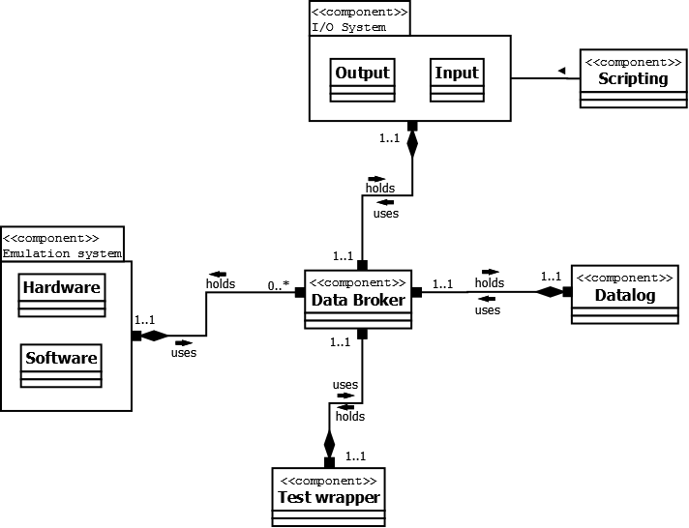

## Module view description

### Emulations

Based on component: Emulation system

This layer gathers the modules that emulate hardware and channel the data from software. We took the decision that these will benefit from ease of communication as well as similar data transfer to the rest of the system since an emulated software might be required to send data to software and vice versa. Data to the rest of the system is sent through the data transfer module. This layer and its modules are a product of the following issue-cards and strategies:

* *“Multiple software emulations issue, with strategy: Maintain semantic coherence and Anticipate expected changes”*
* *“Multiple hardware emulations issue, with strategy: Maintain semantic coherence and Anticipate expected changes”*

### Testing

Based on component: Test wrapper

This layer holds the modules tightly connected with the actual system to be tested. When the tested system crashes the wrapper will need quick access to the checkpoint module so that the system can be restarted with minimal latency. Data to the rest of the system is sent through the data transfer module. This layer and its modules are a product of the following issue-cards and strategies:

* *“Keeping the system running through a test crash with strategy: Checkpoint/Rollback”*
* *“Not crashing with tested system issue, with strategy: Crash detection”*
* *“Multiple testing techniques issue, with strategy: Maintain semantic coherence and Anticipate expected changes”*

### Data Log

Based on component: Datalog

Here all the data from the testing is categorized and stored into a storage-module until it can be sent up to the report module at the end of the test. Data to the rest of the system is sent through the data transfer module. This layer and its modules are a product of the following issue-cards and strategies:

* *“Creating report issue, with strategy: Broker pattern”*

### Data Channeling

Based on component: Data Broker

Holds the data broker subsystem that handles transferring data between different parts of the system that do not have knowledge of eachother as well as the message handler that takes care of informing the rest of the system in case of a crash in the tested system. This layer and its modules are a product of the following issue-cards and strategies:

* *“Data transfer, with strategy: Broker pattern”*
* *“Not crashing with tested system issue, with strategy: Crash detection”*
* *“Creating report issue, with strategy: Broker pattern”*

### Input/Output

Based on component: I/O system

This layer hold the module for the Input managing as well as the subsystem for validating the output and writing the report. We put the report module and the validation module in the same subsystem since the output will not have to be validated until the end of the test for the report. This layer and its modules are a product of the following issue-cards and strategies:

* *“Multiple input issue, with strategy: Generalize the module”*
* *“Creating report issue, with strategy: Broker pattern”*

### Scripting

Based on component: Scripting

This layer holds the module for scripting new input and output that will then be transferred to the I/O system. We made a layer around just one module to simplify adding more modules later if made necessary by changing factors. This layer and its module are a product of the following issue-cards and strategies:

* “Quis custodiet?, with strategy: Finite-state Machine strategy”

## Module view

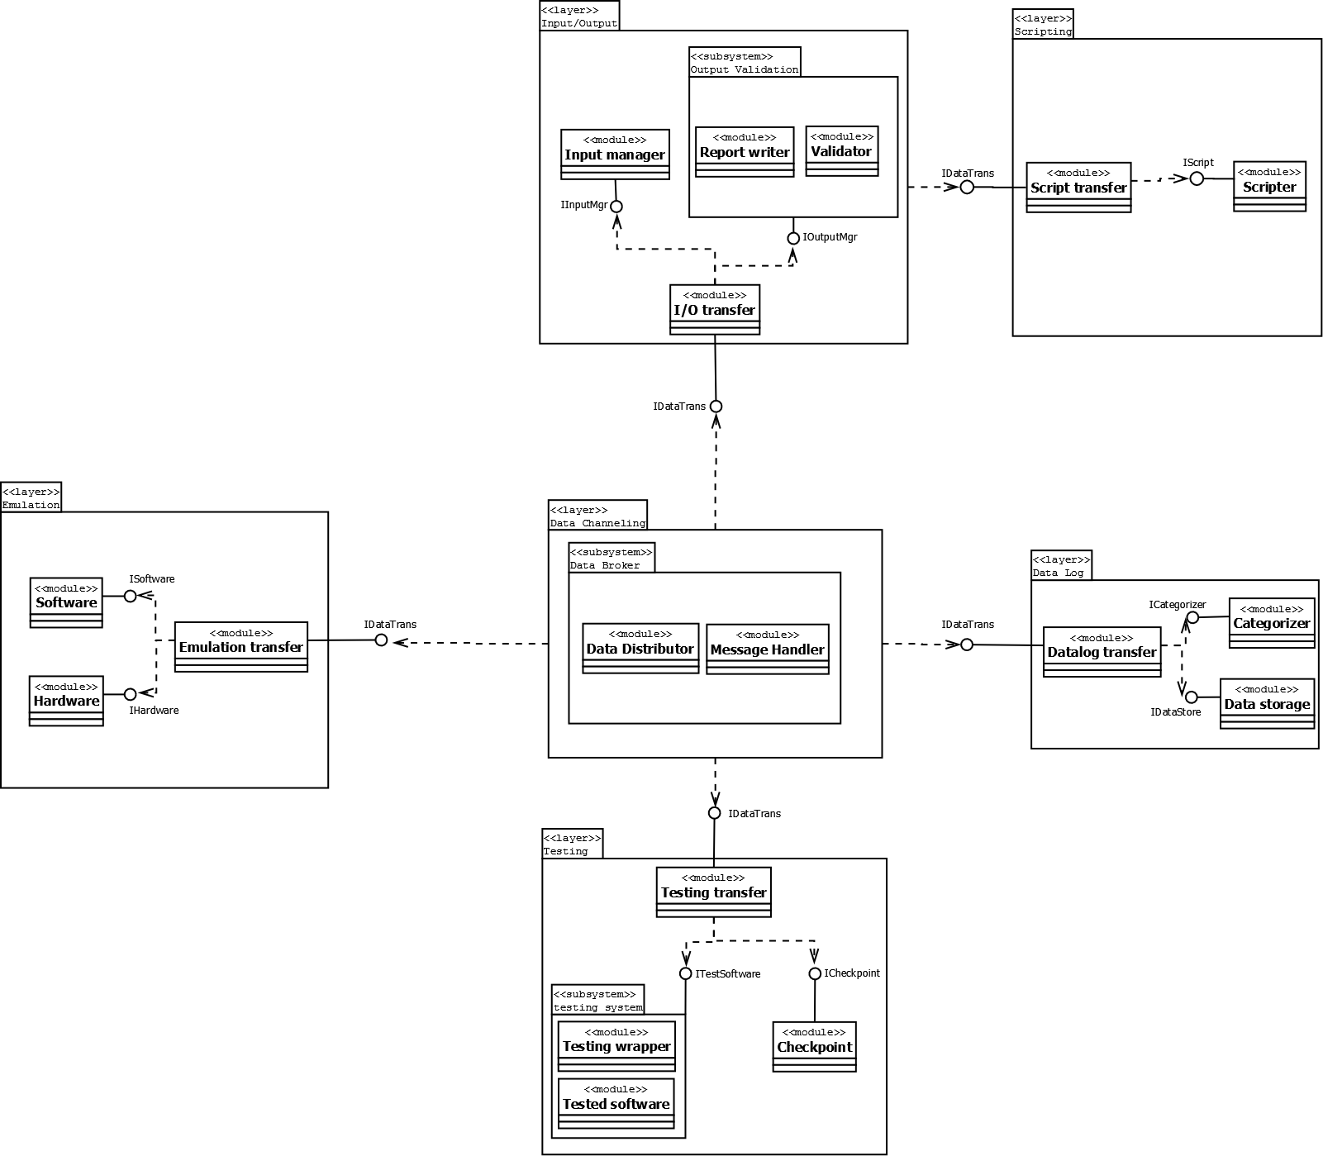

## Execution view description

The software platform will house two processes. One for the MIB itself and one for the tested system. These will communicate via intraprocess communication, IPC. The MIB will be a multithreaded process that has one thread for each major component in the system so that they can work independently. These threads will communicate via intrathread communication,ITC. The reason for this design is tied to the choice of using a multithreaded process strategy. We also mapped which resources each entity needs. The processes consumes Memory and Address-space where as the threads consume CPU-time.

In the diagram we have first described this relationship as well as the relationship with the platform resources. After this we have divided each thread-entity into single diagrams containing those modules that are coupled to that entity thus giving a better view that is not to cluttered.

The division on the thread are based on the division already made in the conceptual and the module view. Components and modules that will work closely together are grouped on the same thread. There has been no new modules added, thus all modules in the execution view can be mapped directly to the same modules in the module view.

We also have two separate entities for specific requirements on the MIB. One file-entity for the input manager since this module will require file handling. One Queue for the Data distributor so that it can handle the vast amounts of data that will be sent simultaneously over the MIB, which comes from the data broker strategy.

## Execution view

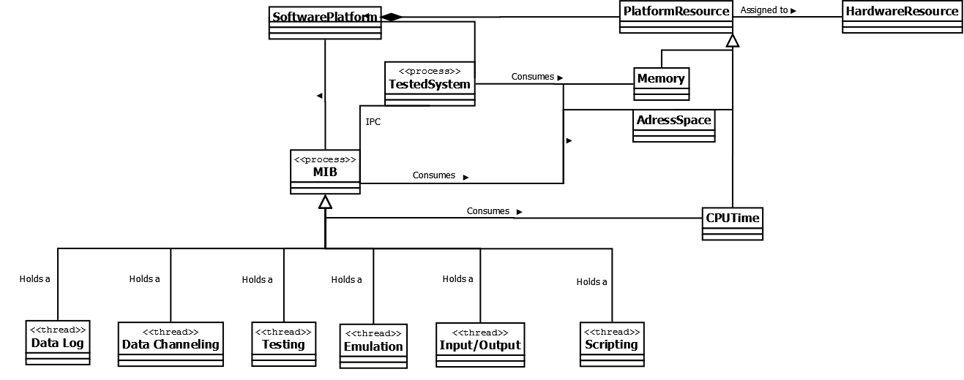

#### Execution view entities

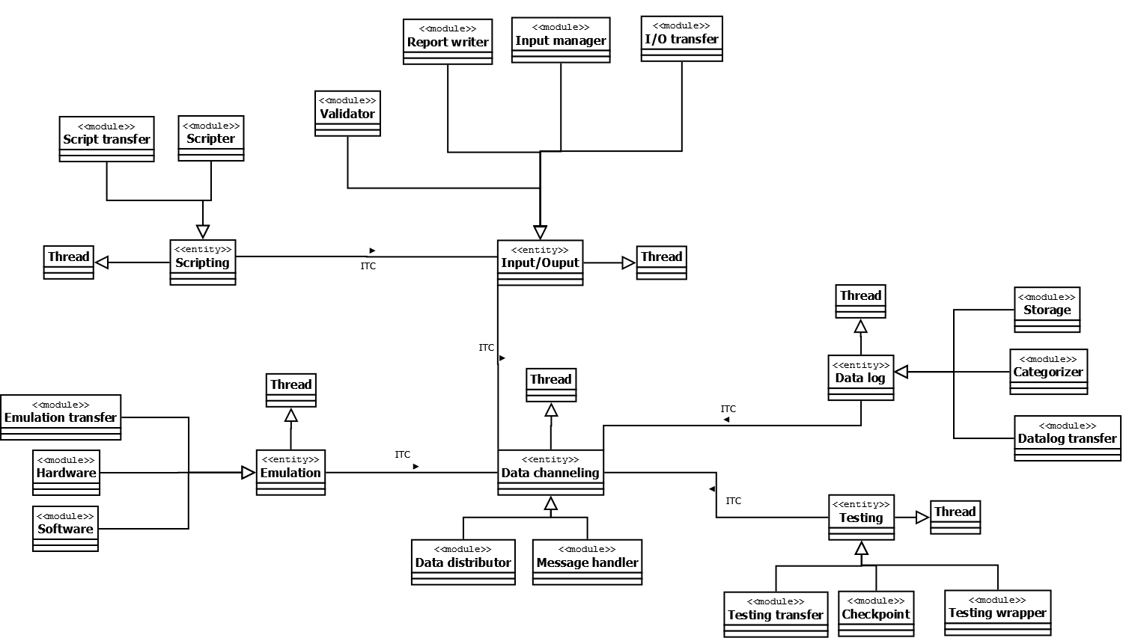

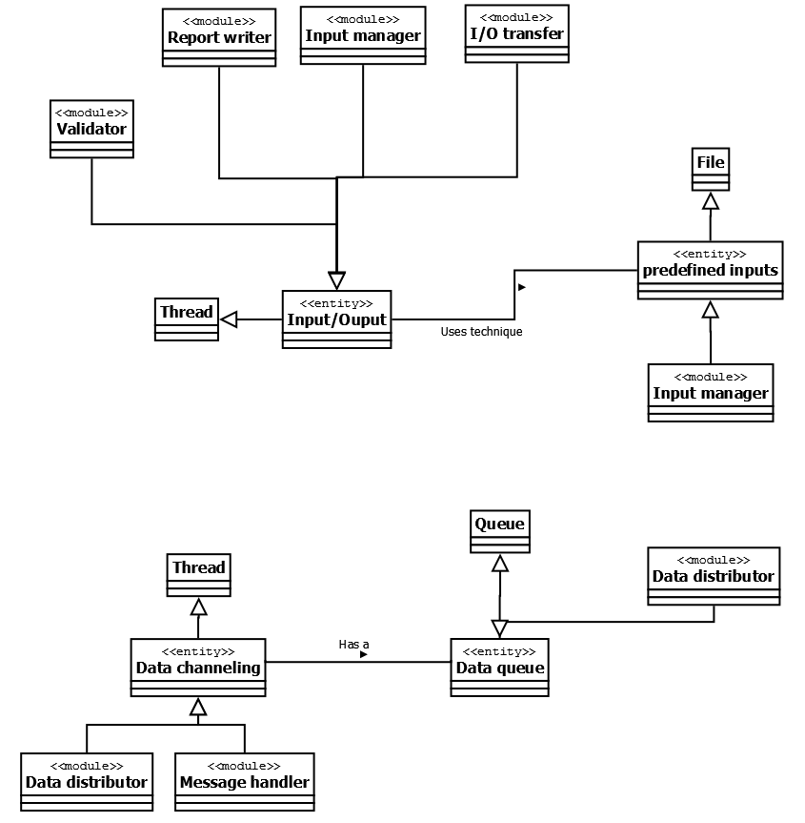

## Evaluation

### Method of Evaluation

#### What method did we choose?

We chose a variant of the BTH 4-hour Architecture Evaluation method, BTH method.

#### Why did why choose this method?

We chose the BTH method because it was the only evaluation method we were familiar with and it was the only one that we found that did not require weeks of evaluation or huge teams of evaluaters.

#### What is the BTH 4-hour Architecture method?

The BTH 4-hour Architecture method is a method developed at Blekinge Institute of Technology. The BTH method is very much like the Architecture Tradeoff Architecture Method and the Software Architecture Analysis Method with the main difference that the BTH method is much shorter. It revolves around creating different scenarios that the architecture should be able to handle, or explainedwhy it does not in fact need to handle the certain scenario. The main purpose of the scenarios is to define the limits and requirements of the evaluated system, and in some cases to develop starategies to counter eventual problems or drawbacks in the system.

When using the BTH method one should have an exterior part to ask the questions and help formulate scenarios. However since we were unable to procure another group for our evaluation we had to improvise and evaluate ourselves. Unfortunatly since one is sometimes blind to one’s own work we risked to miss several possible scenarios that would have aided us greatly, and we did not gainthe insights one may receive when collaborating with another group.

#### Other methods we considered

We considered both the Architecture Tradeoff Analysis Method, ATAM, and Cost Benefit Analysis Method, CBAM, methods, and the reason as to why we considered these alternatives, and only these, was because they were the only other evaluation methods described in the main course literature. There were other methods described during the lectures but we felt we did not know enough about them to take them into consideratoion.

#### Reasons as to why we did not choose the other methods

The reason why we did not choose the ATAM evaluation method was because it required resources we did not have, namely time and a larger team. With ATAM you practically start with an hiatus of two to three weeks after a day of evaluation, and after the hiatus it requires up to a week of continued work, and this was, and is, time that we do not have. And this alone made ATAM impossible for us to use, but beyond the time ruirement ATAM also requires a large evaluation team and prefferably stakeholders, persons we do not have available for obvious reasons.

The main reason as to why we did not choose to use CBAM was because it mainly concerns itself with budget and profits, the economical aspect of the whole project. And since we have been told not to concern ourselves with the organizational aspects of the project, and the fact that we do not have a budget nor a customer we felt that this method was highly irrelevant.

### Quality Attributes Tested GA02

The three quality attributes that we found most important to evaluate were *System dependability*, *Input types* and *Maintainability*.

We felt that the system dependability was the most important attribute to be tested at this point, probably will continue to be, as our system’s purpose is to ensure the integrety and stability of other systems.

We chose evaluate input types since it is one of the major issues in the system description:

“*The system shall be able to simulate various inputs, such as, but not limited to, file input,*

*command line input, socket communication, and graphical input. It must be easy to incorporatenew input mechanisms in the system.”*

With this in the description we felt that it was well worth more of our attention.

The maintainability attribute was chosen because we envision that the MIB will be used by ther companies for many yeasrs to come and thus it is important to consider the maintainabilityaspects of our system.

### Scenarios GA02

#### System dependability

##### The tested system uses as much as 10 gigabyte if primary memory

According to our research this is not a feasable quantity of required primary memory for any program running on a standard computer both presently and in the percievable future. This scenario did however make us add an assumption about the memory requirements of the tested system.

##### The tested system crashes during testing

The testing wrapper will acquire the last saved state of the tested system from the checkpoint module and then restore the tested system from there and continue the testing.

##### The tested system crashes during testing and keeps on crashing at the same moment every time

As we discussed this scenario it became clear that we needed a new issue card, that we named “Multiple Crash Issue”. The wrapper around the tested system will count the amount of crashes and map them to the chackpoints. If the tested system crashes a predetermined amount of times between two checkpoints the MIB will terminate the current test and note this in the test log.

#### Input types

##### Input stream from a blu-ray disc

Our input system is able to handle the streaming from a blu-ray disc as the maximum transfer rate of a blu-ray disc, 54 MB/s, is well below the capacity of any standard computer.

#### Maintainability

##### The customer returns after buying the system and requsts two new testing techniques

By maintaining good semantic coherence thorughout the wrapping module as well as annticipating any expected changes in testing techniques. Thus changes will be kept to a minimum and localized to the testing wrapper.

##### The costumer returns after buying the system requests two new input types

By generalizing the input modules we make it simple to implement new input ttypes and changes the impact on the rest on the systemm will be minimal.

##### The test is finished and the output needs to be validated

When the testing is completed the data from the test will be transferred from the data log to the output validation system. Within the output validation system the output will be controlled and validated against predefined output in the validation module. The report module will then compile all the data together with the validated output into a final readable report.

### Evaluation Conclusion GA02

We have found that, with our current knowledge of architecture structures and with the results of our self evaluation, our current structure upholds the quality requirements as set by the system description. As such we have found no doing an architecture transformation.

The new issue-card "Multiple crash issue" had already been considered in the first assignment but not properly documented, as such the views have not required any polishing because of this “new” issue card.

### Quality Attributes Tested GA03

The evaluation will focus on the new changes made to the MIB, not the old requirements already established at the beginning of the course. the new requirements from the changes are divided into the functionality that they describe.

### Scenarios GA03

### Evaluation Conclusion GA03