PRODUCT REQUIREMENTS DOCUMENT

BitTorrent Desktop Client
Goals · scope · workflows · measurable acceptance criteria · roadmap
Field | Value
Status | Product scope captured; detailed engineering contracts live in ARCHITECTURE.md
First platform | Windows
Development sequence | Browser-first local development; Electron packaging after core workflows stabilize
Stack | React · Node.js · C++ · libtorrent · SQLite
Project intent | Functional portfolio project emphasizing backend, networking, systems programming, and reliability

1. Product summary
Build a functional BitTorrent client with a React interface, Node.js application backend, and a separate C++ process using libtorrent as the BitTorrent engine. The project demonstrates engineering around the engine—IPC, process supervision, persistence, bounded scheduling, security, and recovery—rather than reimplementing the protocol from scratch.

2. Goals
- Import a .torrent file, download and verify its content, pause/resume, preserve state across restart, and seed.
- Provide a torrent library with progress, queued/paused/running states, errors, and controls.
- Support magnet links, DHT, and PEX in the second implementation stage.
- Keep resource use bounded and treat torrent metadata, IPC messages, and paths as untrusted.
- Package a usable Windows desktop app with Electron after the core workflows work reliably.
- Produce a demonstrable portfolio project with reproducible tests, documentation, and measured results.

3. Out of scope for the first release
- Implementing the BitTorrent protocol and piece verification from scratch.
- Advanced peer analytics, sophisticated adaptive scheduling, or an elaborate simulation framework.
- Linux/macOS packaged releases in the first release.
- Deleting downloaded content as part of ordinary torrent removal.
- Guaranteeing recovery from all hardware or power-loss scenarios.

4. Feature scope

Stage 1 — Core download workflow
- Import .torrent; inspect metadata and validate the proposed file layout before starting.
- Download and verify data; show progress and runtime state.
- Pause/resume, remove from active list, seed after completion, and restore after restart.
- SQLite application records plus libtorrent resume data and conditional rechecking.
- Shared active-torrent limit, basic download-priority queue, global bandwidth and peer limits.
- Safe path validation, malformed-input handling, and recovery from engine/IPC failures.

Stage 2 — Discovery and operational polish
- Magnet links and bounded metadata acquisition.
- DHT and peer exchange (PEX), as supported/configured through libtorrent.
- Explicit delete-history and delete-downloaded-files workflows with recoverable operation tracking.
- Additional resource, security, and failure-injection tests.

Later evolution — Advanced client capabilities
- Advanced queue controls, richer peer statistics, file-level priorities, and refined partial-download UX.
- More extensive performance experiments, randomized testing, and optional adaptive scheduling.

5. Architecture at a glance
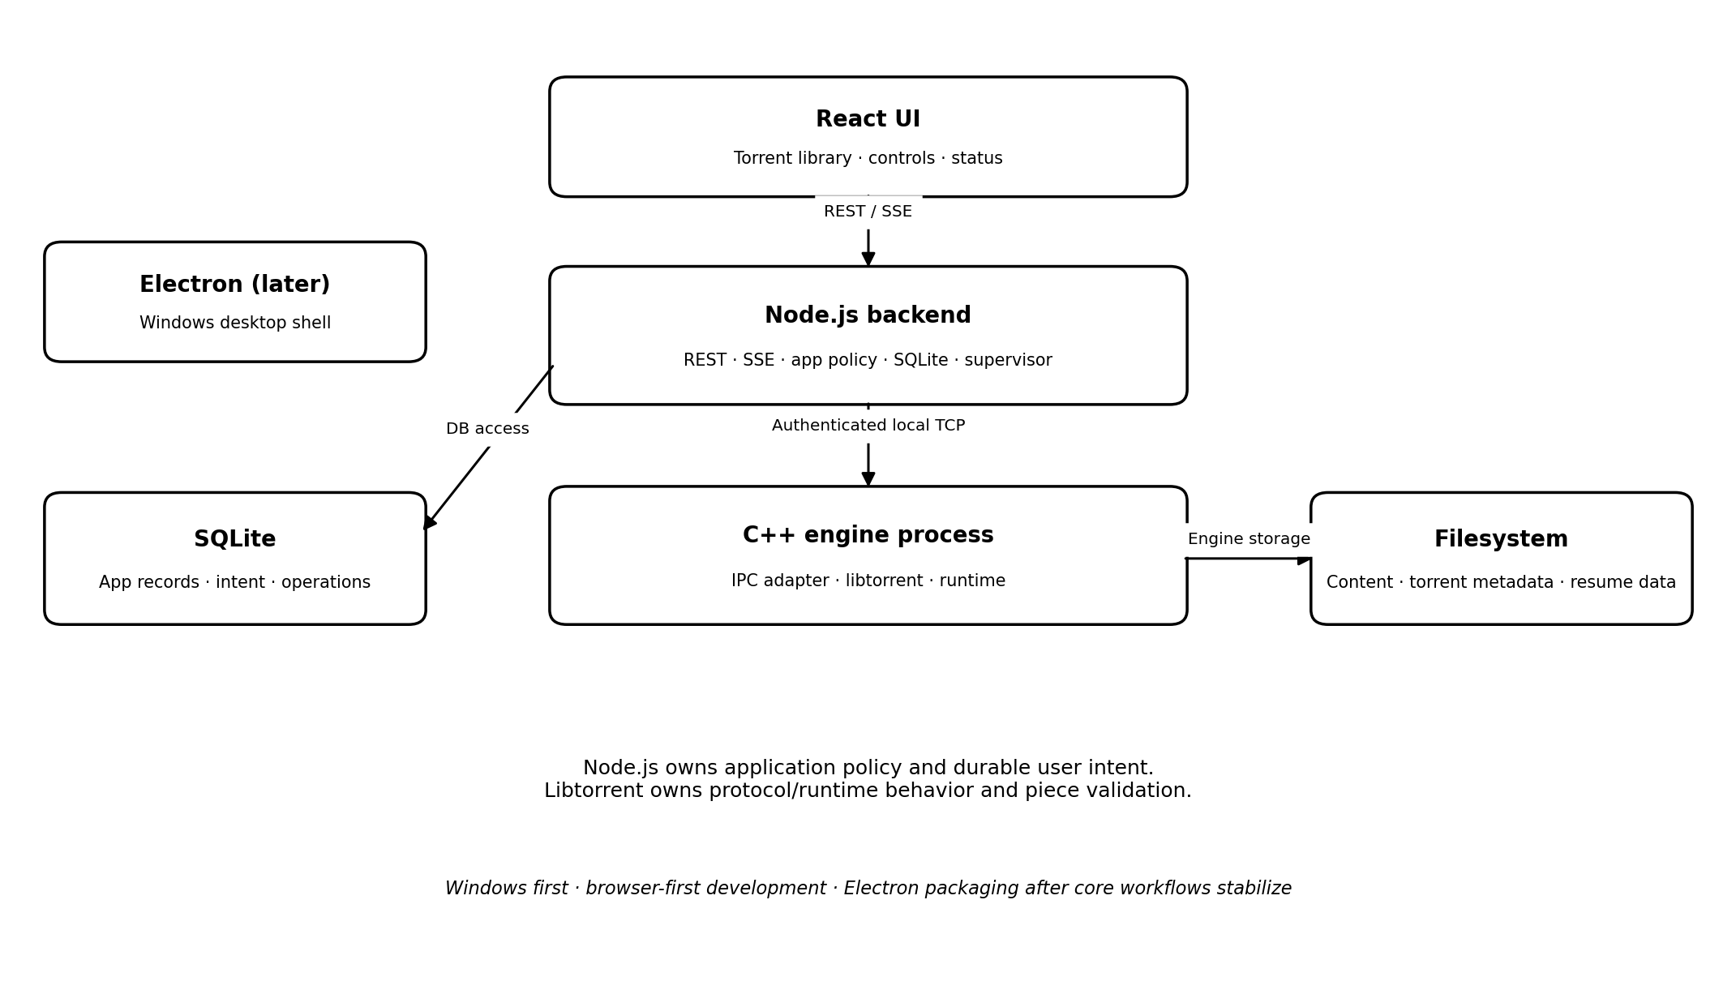
React talks to Node.js over REST for commands and SSE for updates. Node.js owns application policy and SQLite. A separately supervised C++ process integrates libtorrent over authenticated loopback TCP. Libtorrent owns protocol behavior, runtime state, and piece validation. Resume data and downloaded content live on the filesystem.

6. Primary user workflows

6.1 Add and start a torrent
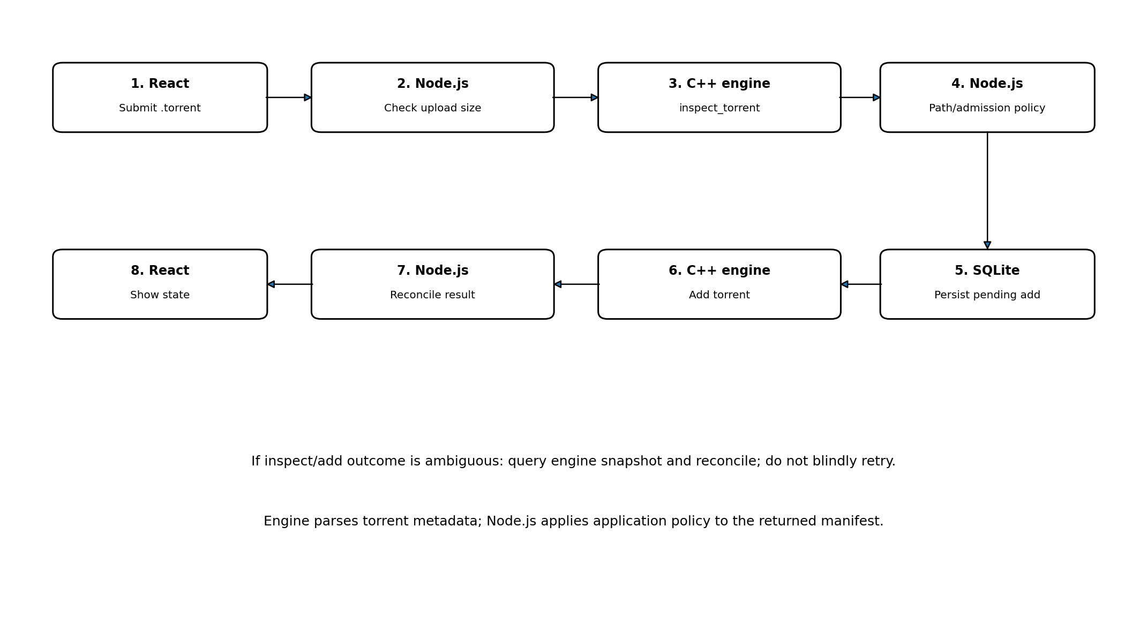
- React submits a .torrent file and destination to Node.js.
- Node.js checks request shape and upload-size limits. It asks the C++ engine to inspect the torrent without starting it.
- The engine parses the metadata and returns a bounded manifest (file paths, sizes, and required identifiers). Node.js applies application-level path, collision, and admission policy to that result.
- If accepted, Node.js persists a pending-add record in SQLite, then sends the authenticated add command.
- Node.js reconciles the response and observed engine state; ambiguous timeouts trigger a fresh snapshot rather than a blind retry.
- React receives current state and aggregated progress updates.

6.2 Pause/resume
- Persist desired user intent through a recoverable operation flow.
- Send idempotent set-paused/set-running commands, not toggles.
- Update runtime state only from engine observations; reconcile after timeouts.

6.3 Restart/recovery
- Start Node.js and C++ engine, authenticate, and complete a readiness handshake.
- Load SQLite records and available resume data; restore usable engine state or reconstruct from retained metadata where possible.
- Conditionally recheck when files are missing, changed, or inconsistent.
- Reconcile observed engine state with durable user intent and scheduler limits; publish a fresh snapshot.

6.4 Removal
- Remove-from-active-list is non-destructive and does not delete content.
- Delete-history and delete-downloaded-files are separate explicit actions, planned for Stage 2.
- File deletion must stop engine use first, validate targets, track partial failures, and avoid ambiguous/shared content.

7. Measurable acceptance criteria
Initial targets below are proposed engineering targets for a local Windows development machine, not measured results. Validate and adjust them after a baseline run.
Area | Proposed target | Measurement method
UI state propagation | 95% of normal engine state changes visible in UI within 1.0 s; progress updates aggregated to at most 4 UI updates/s per torrent. | Timestamp engine event receipt and UI/API publication in integration test.
IPC responsiveness | 95% of ordinary local control commands acknowledged within 500 ms when engine is healthy; long-running work uses accepted/completed semantics. | Instrument request/response timestamps; exclude commands explicitly waiting on disk/network.
Restart recovery | Restore a test library of 20 torrents to a reconciled visible state within 10 s on the reference dev machine, excluding mandatory full rechecks. | Automated restart benchmark; report machine specs and dataset.
Resource bounds | Active download+seed count never exceeds configured cap; IPC frames and pending work never exceed configured limits. | Stress tests with many queued torrents and malformed/slow clients.
Data integrity | Completed test-torrent files match expected hashes; altered/missing content is detected when the engine's validation path is invoked. | Known legal test torrent, hash verification, mutate/remove file and restart.
Failure recovery | Engine crash and lost IPC response do not silently lose SQLite torrent records; ambiguous add/pause outcomes reconcile without duplicate adds. | Controlled process termination and fault injection.
Packaged build | Clean install/launch/shutdown on Windows as a standard user, with child process cleanup and no development-path dependency. | Test packaged artifact outside repository/development environment.

Throughput and memory targets will be established after a reproducible baseline exists; avoid claiming performance wins until measured.

8. Release acceptance gate
- Core .torrent download, piece verification, pause/resume, seeding, and restart flow passes.
- Critical unit, integration, end-to-end, and targeted failure-injection tests pass.
- IPC authentication/framing, bounded work, and engine restart behavior pass tests.
- Unsafe paths and oversized/malformed inputs are rejected or selectively excluded only when safely supported.
- UI clearly distinguishes queued, paused, checking, downloading, seeding, completed, and error states.
- Packaged Windows build starts and shuts down reliably as a standard user.
- README includes architecture, setup, supported scope, test instructions, and known limitations.

9. Roadmap
- Milestone 0 — Pin libtorrent version and toolchain; define IPC/API contracts, state names, SQLite schema, and test harness before engine integration.
- Milestone 1 — C++ adapter: inspect_torrent, authenticated loopback IPC, framing, readiness handshake, snapshot, add/pause/resume.
- Milestone 2 — Node.js API, SQLite persistence, pending-operation handling, scheduler, and process supervision.
- Milestone 3 — React library, REST commands, SSE updates, progress/errors, queued and paused states.
- Milestone 4 — Resume data, conditional checking, graceful shutdown, restart and crash recovery.
- Milestone 5 — Path-safety checks, resource limits, metadata limits, and Stage 2 deletion workflows.
- Milestone 6 — Magnet metadata, DHT/PEX, basic seeding controls and coverage.
- Milestone 7 — Failure injection, acceptance testing, Electron packaging and Windows release validation.
- Milestone 8 — Measure performance against acceptance targets, document results, and prepare portfolio demo.

10. Glossary
Term | Meaning
Stage 1 / core release | Minimal reliable client for .torrent import, verified download, pause/resume, state persistence, recovery, and basic seeding.
Stage 2 | Magnet links, DHT/PEX, and deletion/operational polish.
Advanced evolution | Later queueing, peer analytics, file-level priorities, and richer controls.
Desired state | Durable user intent such as running or paused.
Runtime state | Latest state observed from the engine, such as checking, downloading, or seeding.
Resume data | Libtorrent-generated engine recovery data; not the source of truth for user intent.

