Introduction
Computer hardware refers to the physical components that make up a computer system. There are many different kinds of hardware that can be installed inside, and connected to the outside, of a computer.

List of Computer Hardware
Here are some common individual computer hardware components that you will often find inside a modern computer. These parts are almost always found inside the computer case, so you won't see them unless you open the computer:
- Motherboard
- Central Processing Unit (CPU)
- Random Access Memory (RAM)
- Power Supply Unit (PSU)
- Video card
- Hard Disk Drive (HDD)
- Solid-State Drive (SSD)
- Optical disk drive (e.g., BD/DVD/CD drive)
- Card reader (SD/SDHC, CF, etc.)
Common hardware that you might find connected to the outside of a computer, although many tablets, laptops, and netbooks integrate some of these items into their housings:
- Monitor
- Keyboard
- Mouse
- Uninterruptible Power Supply (UPS)
- Flash drive
- Printer
- Speakers
- External hard drive
- Pen tablet
Less common individual computer hardware devices, either because these pieces are now usually integrated into other devices or because they have been replaced with newer technology:
- Sound card
- Network Interface Card (NIC)
- Expansion card (FireWire, USB, etc.)
- Hard drive controller card
- Analog modem
- Scanner
- Projector
- Floppy disk drive
- Joystick
- Webcam
- Microphone
- Tape drive
- Zip drive
The following hardware is referred to as network hardware, and various pieces are often part of a home or business network:
- Digital modem (e.g., cable modem, DSL modem, etc.)
- Router
- Network switch
- Access point
- Repeater
- Bridge
- Print server
- Firewall
Network hardware isn’t as clearly defined as some other types of computer hardware. For example, many home routers will often act as a combination router, switch, and firewall.
In addition to all the items listed above, there are more computer hardware called auxiliary hardware, of which a computer might have none, or several, of some kinds:
- Fan (CPU, GPU, Case, etc.)
- Heat sink
- Data cable
- Power cable
- CMOS battery
- Daughterboard
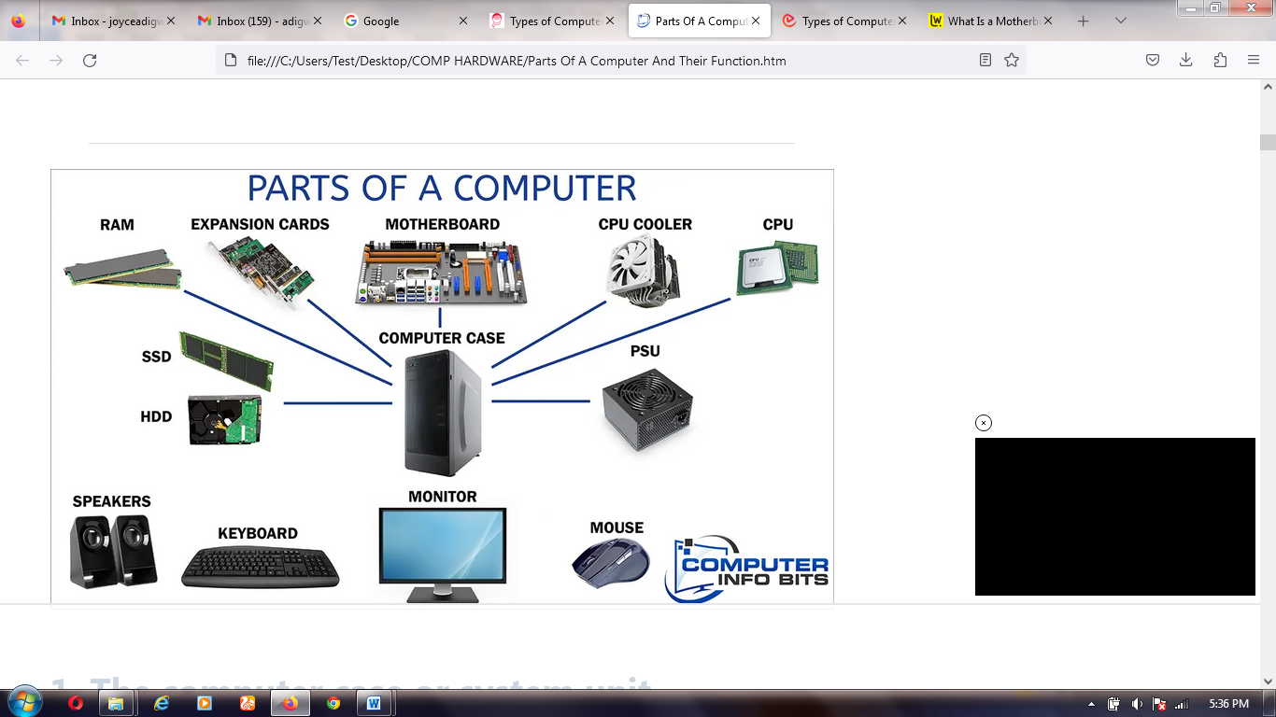
Some of the devices listed above are called peripheral devices. A peripheral device is a piece of hardware (whether internal or external) that isn’t actually involved in the computer’s main function. Examples include a monitor, video card, disc drive, and mouse.

Health and Safety Procedures
A company’s health and safety procedures should be set out in a handbook, possibly as part of an employee’s induction handbook. Health and safety procedures should:
  - Identify what to do in the event of a fire or other emergency.
  - Identify responsible persons (for example, for overall health and safety, nominated first aiders, fire marshals, and so on).
  - Identify hazardous areas in the workspace and precautions to take when entering them.
  - Describe best practice for use and care of the workspace and equipment within it.
  - Establish an incident reporting procedure for detecting and eliminating workplace hazards and accidents.

General Emergency Procedures
Here is a general procedure for emergency situations:
- Raise the alarm and contact the emergency services, giving them a description of the emergency and your location.
- If possible, make the scene safe. For example, if you are faced with a fire, establish that you have an escape route, or if faced with electrical shock, disconnect the power (if it is safe for you to do so).
- If you have training and it is safe to do so, do what you can to tackle the emergency (for example, give first aid or use firefighting equipment).
Of course, circumstances might dictate that you do something differently. It is vital thatyou keep calm and do not act rashly.
Electrical Hazards
The most prevalent physical hazards that computer technicians face are electrical hazards. Electricity is necessary to run a computer, but it can also damage sensitive computer equipment, and in some cases, pose a danger to humans. Following established best practices for promoting electrical safety will protect not only the computer equipment that you work on, but also your personal safety and the safety of others.
Electrical equipment can give an electric shock if it is broken, faulty, or installed incorrectly. An electric shock can cause muscle spasms, severe burns, or even kill (electrocution).
Electrical currents can pass through metal and most liquids, so neither should be allowed to come into contact with any electrical device installations. Damaged components or cables are also a risk and should be replaced or isolated immediately.
It is important to test electrical devices regularly. The frequency will depend on the environment in which the device is used. In some countries, portable appliance testing (PAT) carried out by a qualified electrician or technician ensures that a device is safe to use.
The human body is an electrical conductor and a resistor, so a current will pass through it and make it heat up, manifesting as a burn if the current is strong enough. A current can interfere with the body’s nervous system, which also uses electrical signals. This might manifest as spasm or paralysis or in a severe case cause a heart attack.
Collateral injuries occur when involuntary muscle contractions caused by the shock cause the body to fall or come in contact with sharp edges or electrically live parts.
Electricity can hurt you even if you are careful and avoid becoming part of an electrical ground circuit. The heat generated by an electric arc or electrical equipment can burn your skin or set your clothes on fire.

High Voltage Device Safety
Most of the internal circuitry in a computer is low voltage (12 V or less) and low current, so there is not much of a threat to your personal safety. However, there are exceptions to this, and these exceptions can be very dangerous. Power supplies, CRT monitors, the inverter card in an LCD display’s fluorescent backlight, and laser printers can carry dangerously high levels of voltage. Charges held in capacitors can persist for hours after the power supply is turned off. You should not open these units unless you have been specifically trained to do so. Adhere to all printed warnings, and never remove or break open any safety devices that carry such a warning.
Electrical Fire Safety
Faulty electrical equipment can pose a fire risk. If the equipment allows more current to flow through a cable than the cable is rated for, the cable will heat up. This could ignite flammable material close to the cable. If an electrical wire does start a fire, it is important to use the correct type of extinguisher to put it out. Many extinguishers use water or foam, which can be dangerous if used near live electrical equipment. The best type to use is a Carbon Dioxide (CO2) gas extinguisher. CO2 extinguishers have a black label. Dry powder extinguishers can also be used, though these can damage electronic equipment.
You should also ensure that the electricity supply is turned off. This should happen automatically (the fuses for the circuit should trip), but make sure you know the location of the power master switches for a building.

Guidelines for Working Safely with Electrical Systems
Consider these guidelines as you prepare to work with electrical equipment.
Electrical Safety
Follow these guidelines to work safely with electrical systems:
  - Do not work on electrical systems unless you have a good understanding of the risks and appropriate safety procedures.
  - Do not attempt repair work when you are tired; you may make careless mistakes, and your primary diagnostic tool, deductive reasoning, will not be operating at full capacity.
  - Do not assume anything without checking it out for yourself. A ground wire might have been disconnected or never properly installed, for example.
  - Disconnect the power to a circuit if you must handle it.
  - Hold down the power button on the device to ensure the circuits are drained of residual power.
  - Test live parts with a multimeter to ensure that no voltage is present.
  - Always use properly insulated tools and never grip a tool by its metal parts.
Note: It is especially important not to touch the live parts of multimeter probes, as these may be connected to an energized circuit. Handle the probes by the insulated sheaths only.
  - Take care not to touch any part of a circuit with both hands to reduce the risk of a serious shock. This is called the "hand in pocket" rule. It reduces the chance that the current will pass through your chest and cause a heart attack.
  - Make sure your hands and the surrounding area are dry. Sweat can make your hands more conductive.
  - Do not leave any spill hazards in the vicinity and ensure you are not standing on a wet floor.
  - Do not wear jewelry, a wrist watch, or other items such as name badges that may dangle from your neck or wrist, as they can cause a short circuit or become trapped by moving parts.

Electrostatic discharge (ESD)
Static electricity is a high voltage (potential difference) stored in an insulated body. Electrostatic discharge (ESD) occurs when a path is created that allows electrons to rush from a statically charged body to another with an unequal charge. The electricity is released with a spark. The charge follows the path of least resistance, so it can occur between an electrical ground, such as a doorknob or a computer chassis, and a charged body, such as a human hand.
Although the voltage is high, the amount of ESD current sustained is very low, so static electricity is not that harmful. It can, however, be slightly painful. You might have felt a small shock when reaching for a metal door handle for instance. You can feel a discharge of over about 2500V. A discharge of 20,000V or more could produce a visible spark. Walking over an untreated carpet in dry conditions could create a charge of around 35,000V.
The human body is mostly water and so does not generate or store static electricity very well. Unfortunately, our clothes are often made of synthetic materials, such as nylon and polyester, which act as good generators of static electricity and provide insulating layers that allow charges to accumulate. Humidity and climate also affect the likelihood of ESD. The risk increases during dry, cool conditions when humidity is low.
In humid conditions, such as before or during a storm, the residual charge can bleed into the environment before it can increase sufficiently to be harmful to electrical components.
An electronic component, such as a memory or logic chip, is composed of fine, conductive metal oxides deposited on a small piece of silicon. Its dimensions are measured in fractions of a micron (one millionth of a meter). Any static electricity discharged into this structure will flash-over (spark) between the conductive tracks, damaging or even vaporizing them. A transistor designed to work with 1-3V can be damaged by a charge of under 100V, though most have ESD protection circuits that improve this tolerance.
A static discharge may make a chip completely unusable. If not, it is likely to fail at some later time. Damage occurring in this way can be hidden for many months and might only manifest itself in occasional failures.
Component Handling
By eliminating unnecessary activities that create static charges and by removing unnecessary materials that are known charge generators, you can protect against ESD related damage and injuries. There are several other prevention techniques that you can use to protect yourself and equipment when you are working with computer components.
  - Self-grounding, or manual dissipation of static buildup by touching a grounded object prior to touching any electronic equipment. You can accomplish this by touching an unpainted part of a metal computer chassis or other component.
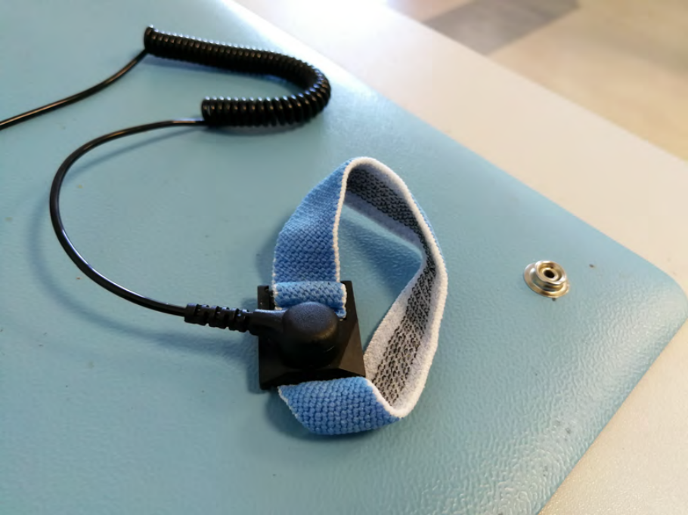
  - Using an anti-ESD wrist strap or leg strap can dissipate static charges more effectively than self-grounding. The band should fit snugly around your wrist or ankle to maximize contact with the skin. Do not wear it over clothing. The strap ground is made either using a grounding plug that plugs into a wall socket or a crocodile clip that attaches to a grounded point or an unpainted part of the computer's metal chassis.

Electrostatic Discharge ESD wrist strap on ESD mat

  - An anti-ESD service mat is also useful. Sensitive components can be placed on the mat safely. The mats contain a snap that you connect to the wrist or leg strap. If the technician’s clothing has the potential to produce static charges, an ESD smock, which covers from the waist up, can be helpful.

Guidelines for Protecting Components from ESD Damage
Here are some guidelines to help you protect your electronic components from ESD damage.
ESD Protection
Follow these guidelines to protect electronic components from damage due to ESD:
- Use proper component handling and storage procedures whenever you are performing PC maintenance work.
- To protect components and equipment from ESD damage:
- Make sure that your body and clothing are drained of static electricity before starting work.
- If possible, work in an uncarpeted area.
- The simplest (but least effective) means of self-grounding is to touch an unpainted metal part of the PC, such as the power supply unit, before you handle a sensitive component. This is only a temporary solution and a static charge could build up again.
Caution: Do not leave the PC plugged in if you open the case for servicing. Your safety is more important than the risk of damaging some PC components.
- Where possible, handle vulnerable components by holding the edges of the plastic mounting card, and avoid touching the surfaces of the chips themselves.
- Use ESD wrist or ankle straps and dissipative floor mats.
Note: Ensure that the strap has a working current-limiting resistor for safety (straps should be tested daily). Do not use a grounding plug if there is any suspicion of a fault in the socket or in the building's electrical wiring, or if the wiring is not regularly inspected and tested.

Motherboard and Its Installation
The motherboard is the main circuit board inside a computer. The important system components like the central processing unit (CPU) and random access memory (RAM) modules are connected directly to the motherboard via slots or sockets designed specifically for those components. The motherboard will also provide a number of expansion slots designed to accommodate add-on cards such as video graphics adapter (VGA) cards and network interface cards (NICs).

The motherboard connects the components of a computer and provides power to the systems that need low power. The motherboard contains a socket in which one or more processors are attached. In addition it has slots that allow connecting peripheral cards such as video cards, sound cards, and networking cards. The internal structure of a motherboard is shown below:
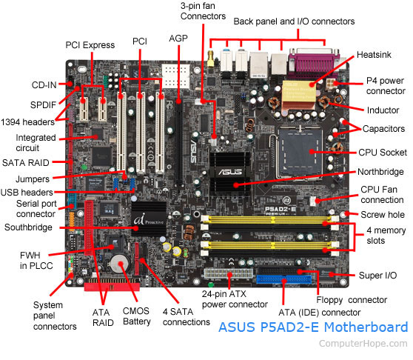

Motherboard Components
- Expansion slots (PCI Express, PCI, and AGP)
- 3-pin case fan connectors
- Back pane connectors
- Heat sink
- 4-pin (P4) power connector
- Inductor
- Capacitor
- CPU socket
- Northbridge
- Screw hole
- Memory slot
- Super I/O
- ATA / IDE disk drive primary connection
- 24-pin ATX power supply connector
- Serial ATA connections
- Coin cell battery (CMOS backup battery)
- RAID
- System panel connectors
- FWH
- Southbridge
- Serial port connector
- USB headers
- Jumpers
- Integrated circuit
- 1394 headers
- SPDIF
- CD-IN

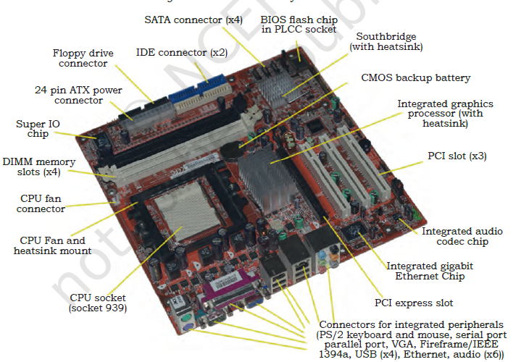

Types of Motherboard
Motherboards are classified as either integrated or non-integrated.
Integrated Motherboard
This has several components integrated into the board itself. These may include the video card, sound card, and various controller cards. The maintenance is of a specific nature as the repairing of the whole board is a complex task.
Non-integrated motherboard
This motherboard uses installable components and expansion cards. In non-integrated motherboard, if any component fails, it is possible to replace that component instead of changing the entire motherboard. For example, you can remove the old video card and install a new one. Non-integrated motherboards typically have several PCI Expansion slots as well.

Basic Components of Motherboard
The modern motherboard has the following components —
- Sockets (or slots) to install one or more microprocessors.
- Slots to install main memory RAM.
- A chipset which forms an interface between the CPU’s front-side bus, main memory, and peripheral buses.
- Non-volatile memory chips usually flash ROM in modern motherboards, containing the system’s firmware or BIOS.
- A clock generator which produces the system clock signal to synchronise the various components.
- Slots for expansion cards. These interface to the system via the buses supported by the chipset.
- Power connectors, which receive electrical power from the computer power supply and distribute it to the CPU, chipset, main memory, and expansion cards.
Motherboard Form Factors
Form Factor | Description
ATX Advanced Technology eXtended | This form factor is commonly used in tower and desktop systems. It supports a maximum of seven expansion slots.
MicroATX | This form factor is a smaller version of ATX. It supports a maximum of four expansion slots.
FlexATX | This form factor is the smallest version of ATX. It supports a maximum of three expansion slots.
LPX Low Profile eXtension | The number of expansion slots was limited in LPX, the system was difficult to upgrade or repair due to its proprietary format and the low availability of compatible parts and poor airflow inside the chassis could lead to cooling problems.
NLX New Low-Profile eXtended | This form factor can be found in smaller desktop and mini towers. The number of expansion slots supported, varies.
BTX Balanced Technology eXtended | This form factor is commonly found in newer tower and desktop systems. It supports a maximum of seven expansion slots.
PicoBTX | This form factor is the smallest version of BTX. It is commonly used in smaller low-end systems and supports a maximum of one expansion slot.
MicroBTX | This form factor is slightly smaller than the regular BTX. It is commonly found in newer mid range systems and supports a maximum of four expansion slots.

Installation of Motherboard
Step 1: Open the case
First step in assembling the computer is to open the computer case. There are different methods for opening cases. The computer comes with various types of cabinets. The methods of opening the case are different based on the manufacturer. To open the case, first remove the screws of the left side cover and slide the side cover. Pull the latch to release the side panel. Then lift the side cover out from the chassis.

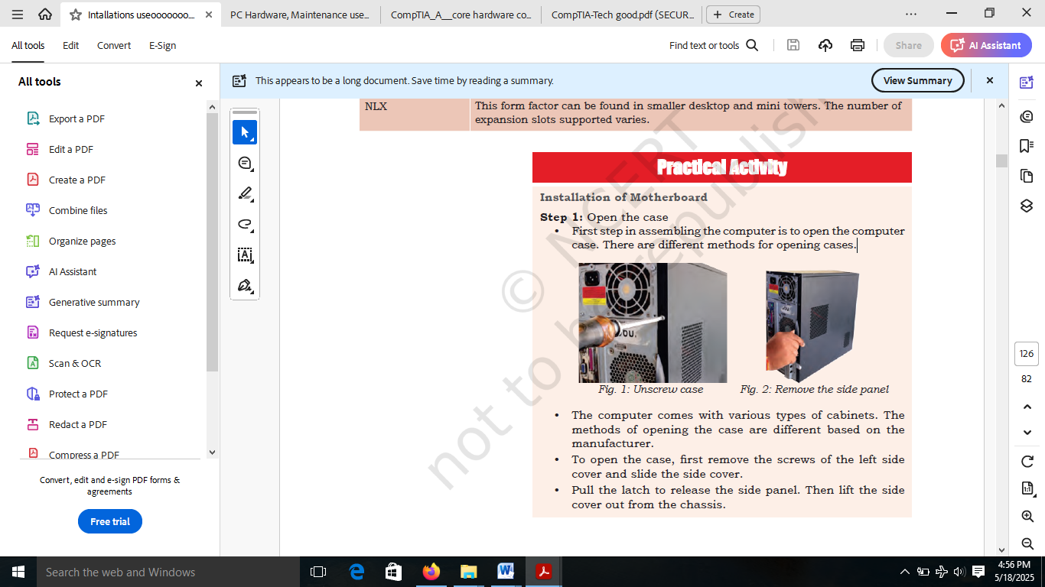

Unscrew case
Remove the side panel

Install Motherboard
After preparing the motherboard, you can install the computer case, as shown below in. Plastic and metal standoffs are used to mount the motherboard and to prevent it from touching the metal portions of the case. To install the motherboard, follow these steps:
- Lay the motherboard over the standoffs to mount it on the holes.
- Align the screw holes of the motherboard with the standoffs.
- Then screw the board using a standard screwdriver.
- Tighten all the motherboard screws.
- Connect the 4pin ATX power connector from the power supply to the motherboard.

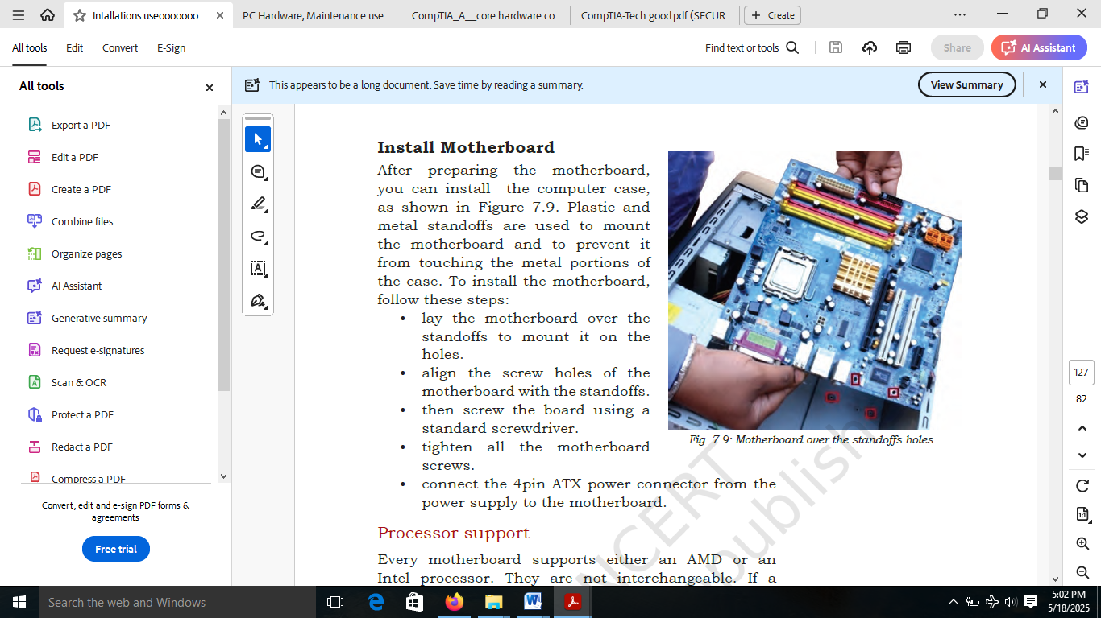
Motherboard over the standoffs holes

CPU and heat Sink Installation
The processor is commonly known as central processing unit or CPU. It is an electronic circuit which executes computer programs containing a processing unit and a control. A central processing unit (CPU) processes the instructions by performing the basic arithmetical, logical, and input/output operations of the system. Although the form and design of CPUs is changing with generation but its main working principle remains the same.

The CPU and motherboard are sensitive to electrostatic discharge. So place them on a grounded anti-static mat and wear an anti-static wrist strap while handling the CPU. When handling a CPU, do not touch the CPU contacts at any time. The CPU is secured to the socket on the motherboard with a locking assembly.
Thermal compound which is used to conduct heat away from the CPU is applied on top of the CPU. In case of an old CPU, first clean the top of the CPU and then apply the thermal compound. Clean the top of the CPU and the base of the heat sink with isopropyl alcohol and a lint free cloth. This removes the old thermal compound. Then apply a new layer of thermal compound.

Applying thermal compound on CPU
Installing Processor on the motherboard
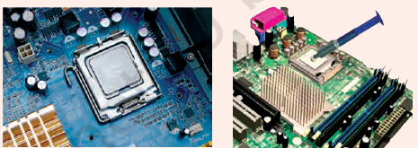

Thermal Paste
Thermal Paste - A silvery-gray substance that you apply to a processor before installing a cooling solution. It allows for an efficient transfer of heat from the IHS of the processor to the base plate or water block of the CPU cooler that is designed to dissipate that heat
Functions of the Thermal Compound/Paste
The functions are follows:
Filling Gaps: The CPU and cooler’s surfaces may appear smooth, but they still have microscopic imperfections. Air pockets form between these surfaces, acting as insulators and hindering heat transfer. It fills the microscopic gaps and irregularities on the surfaces
Improving Contact: Thermal paste bridges these gaps, creating a more uniform and complete contact surface between the CPU and cooler, allowing for better heat dissipation.
Enhancing Heat Transfer: By facilitating efficient heat transfer from the CPU to the cooler, the paste helps to keep the CPU at a safe and stable operating temperature.
Preventing Overheating: Overheating can lead to CPU throttling (slowing down to prevent damage), system crashes, and even permanent damage. Thermal paste is crucial for preventing these issues.
Extending Component Life: By maintaining optimal operating temperatures, thermal paste helps to extend the lifespan of the CPU and other components

CPU Heat Sink
This is an important component in the modern computer. It is an attachment for a chip that prevents the chip from overheating. The components that generate the most heat in your computer are the CPU (central processing unit) and the power supply. These components need to be kept within a specified temperature range to prevent overheating, instability, malfunction, and damage leading to a shortened component lifespan. They always have some cooling usually in the form of a fan.
A heat sink is a device that incorporates either a fan or some other means, to keep a hot component such as a processor, cool. It is made from metal, which serves as the thermal conductor that carries heat away from the CPU. It uses either copper, aluminum, or a combination of the two in order to move heat from the base of the cooler through heat pipes to the heat sink. A fan then blows air through the heat sink to move the heat into the air, and then out of the system, effectively keeping the CPU within safe operating temperatures.
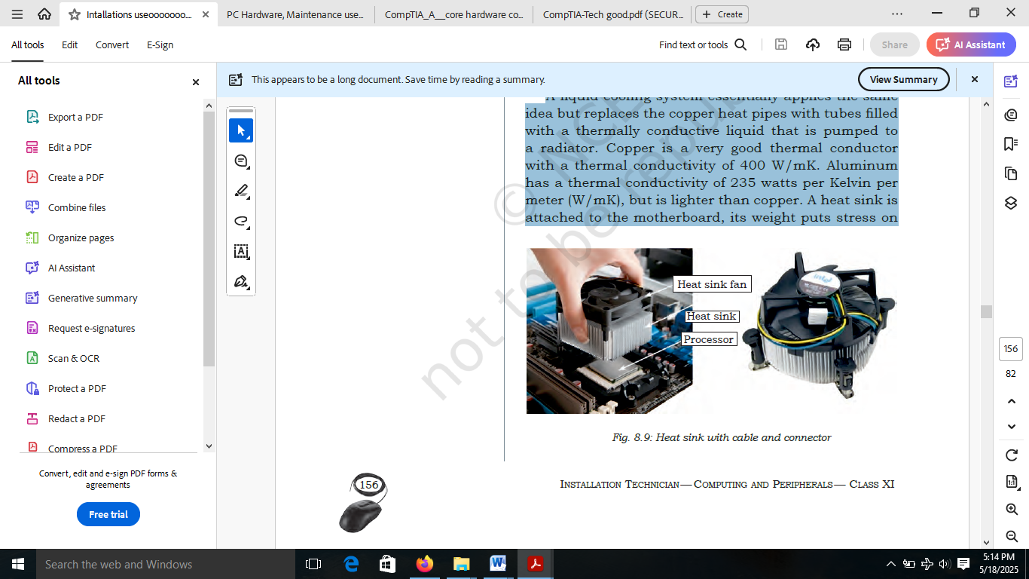

The heat conducted from the processor goes out through the heat sink. A fan inside the computer moves air across the heat sink and out the computer. Most computers also have an additional fan installed directly above the heat sink to help properly cool the processor. Heat sinks with these additional fans are called active heat sinks, while those with the single fan are called passive heat sinks. The most common fan is the case fan, which draws cool air from outside the computer and blows it through the computer, expelling the hot air out of the rear.
Installation of heat sink
To install a heat sink, you will need to prepare the surface, apply thermal compound, and then mount the heat sink securely. Here is a step-by-step guide:
1. Prepare the Surface:
Power off and unplug: Ensure the device is completely powered off and unplugged before starting any work.
Clean the surface: If there's existing thermal paste, carefully clean the surface with an alcohol pad.
Apply new thermal paste: If necessary, apply a thin, even layer of thermal paste to the processor’s heat-spreading area.
Align the heat sink: Carefully align the heat sink with the processor and the retention bracket or mounting hardware.
Mount the heat sink: Press the heat sink into place, ensuring it's securely mounted. This may involve using screws, clips, or other retention mechanisms.
Tighten screws (if applicable): If using screws, tighten them in a cross pattern to ensure even pressure and avoid damage.
Check for proper fit: After tightening, verify that the heat sink makes good contact with the processor and that it's securely mounted.
Reassemble: If you removed any components during the installation, carefully reassemble them.
Power on and test: Turn on the device and monitor its temperature to ensure the heat sink is functioning correctly.

CPU Fan Installation
Installing a CPU fan correctly is important for keeping your computer cool and quiet
- Begin CPU fan installation by making sure that all four push pins are facing the correct direction. The grooves on the push pins should be facing the center of the CPU fan

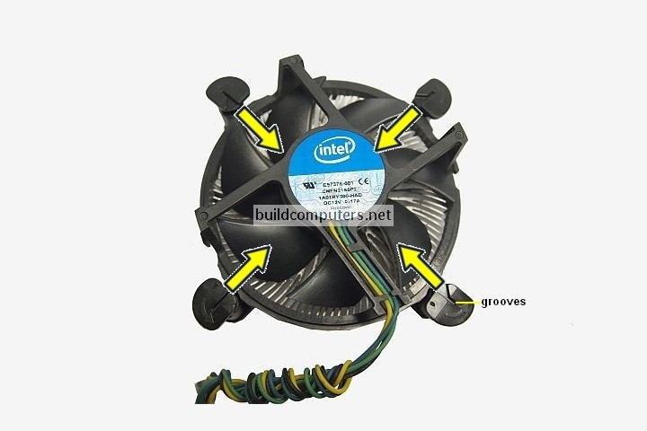

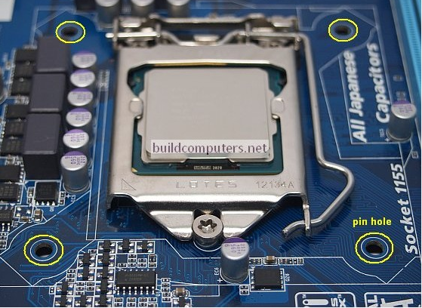
- To install a CPU fan and heat sink, you will need to align the four push pins of the heat sink (circled in yellow above) with the four pin holes on the motherboard as shown below

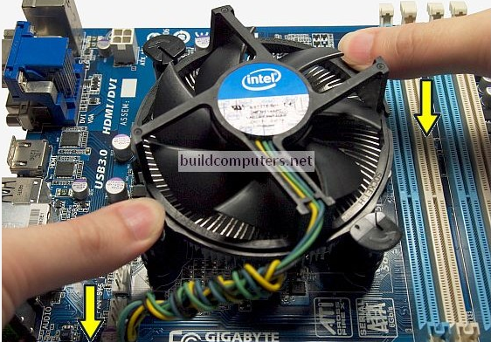
- Once everything is aligned, place your thumbs on the two diagonally opposite push pins and press down on both pins at the same time until you hear a “click” sound. See image below:

- Once you have pushed down all four pins, take a look at the bottom of the motherboard. If you have installed the CPU cooler correctly, the pins should protrude fully.
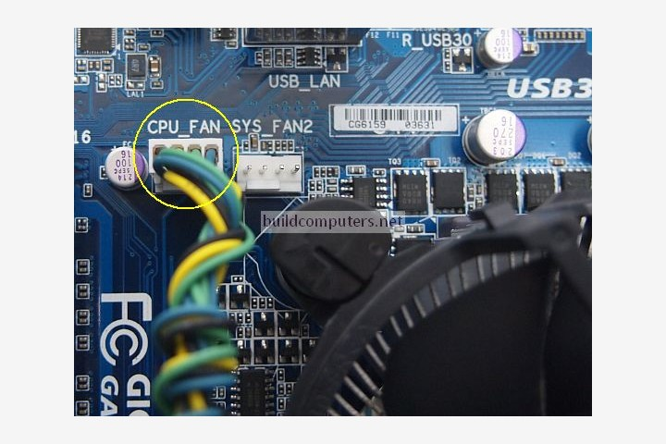
- The final step of installing a CPU fan is to plug the CPU fan power connector into the 4-pin CPU fan header on the motherboard. On most motherboards, this header will be located near the CPU socket:

Installing a CPU
Installing a new CPU in your computer can boost its performance and allow you to run more demanding applications. However, it is not a simple task and requires some preparation and caution.

1) Check compatibility: Before you buy a new CPU, you need to make sure that it is compatible with your motherboard and power supply. The CPU socket type and chipset on your motherboard determine which CPUs you can use. You can check this information on your motherboard manual or online. You also need to check the power requirements of your new CPU and see if your power supply can handle it. If not, you may need to upgrade your power supply as well.

2) Gather tools and materials: To install a new CPU, you will need some tools and materials, such as a screwdriver, an anti-static wrist strap, a thermal paste, and a microfiber cloth. You will also need a new CPU cooler if your new CPU does not come with one or if your old one is not compatible. Make sure you have everything ready before you start the installation process.

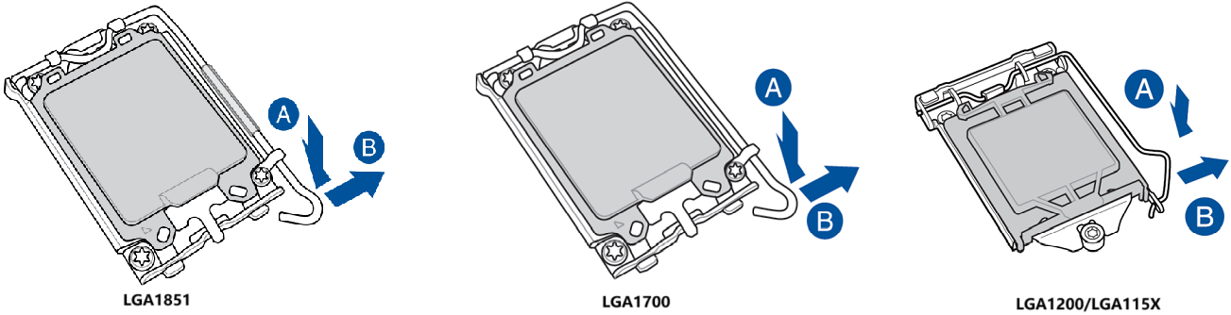
3) Remove the old CPU and cooler: The first step to install a new CPU is to remove the old one and its cooler. To do this, you need to shut down your computer and unplug it from the power source. Then, open the case and locate the CPU and cooler on the motherboard. You may need to disconnect some cables or fans to access them. Next, unscrew the cooler from the motherboard and gently lift it off the CPU. You may need to twist it slightly to break the seal of the thermal paste. Then, unlock the CPU socket by lifting the lever or pushing the button. Carefully pull out the old CPU and place it in a safe place.

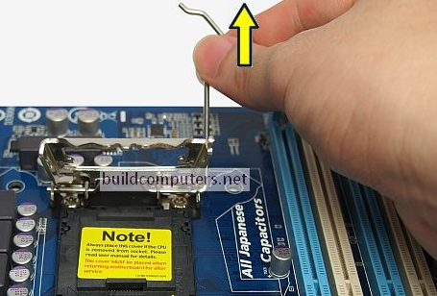
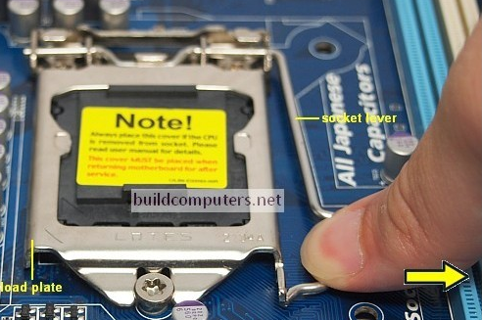

4) Clean the socket and cooler: The next step is to clean the socket and cooler from any dust or residue of the thermal paste. You can use a microfiber cloth and some rubbing alcohol to wipe them gently. Do not use any sharp or metal objects to scrape them, as this may damage them. Make sure they are dry before proceeding to the next step.

5) Install the new CPU and cooler: The final step is to install the new CPU and cooler. To do this, you need to align the new CPU with the socket and gently lower it into place. Do not force it or bend the pins. Then, lock the socket by lowering the lever or pushing the button. Next, apply a small amount of thermal paste on top of the CPU. Remember when installing a new CPU, be sure to hold it by the sides and avoid touching the golden pins at the bottom. Make sure it is secure and evenly distributed. Finally, reconnect any cables or fans that you disconnected earlier.
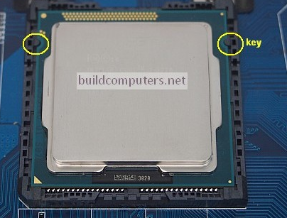
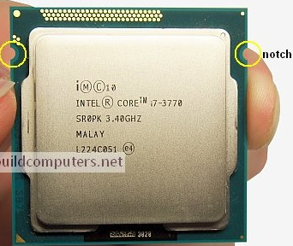

6) Test the new CPU: The last thing you need to do is to test the new CPU and make sure it works properly. To do this, you need to close the case and plug in your computer to the power source. Then, turn on your computer and enter the BIOS or UEFI settings. You can do this by pressing a key such as F2, F10, or Delete during the boot process. Check if the new CPU is detected and if the temperature and voltage are normal. If everything looks fine, you can exit the BIOS or UEFI and boot into your operating system
Installation of RAM Module
The basic purpose of memory is to remember the information for a period of time. Humans have their memory in their brains, which is a part of the human body. Computers also have memory as a part of the computer system. Computer memory is the storage space in the computer, to store data and instructions. The memory is divided into a large number of small parts called cells. Computer has internal as well as external storage. The internal storage is known as primary or main memory while external storage is known as secondary storage. There are different types of memory and each one plays an important role in the running the computer system.

Importance of memory in computers
Memory is one of the most essential components of a computer. The CPU is constantly using memory right from the startup to shut down of the computer.
When you turn on the computer, the computer loads data from read-only memory (ROM) and performs a power-on self-test (POST) to make sure that all the major components are functioning properly. Memory controller checks all the memory addresses with a quick read/write operation to ensure that there are no errors in the memory chips. Read/write means that data is written to a bit and then read from that bit.
The computer loads the Basic Input/Output System (BIOS) from ROM. The BIOS provides the most basic information about storage devices, boot sequence, security, plug and play capability, and a few other items.
The computer loads the operating system (OS) from the hard drive into the system’s RAM. Generally, the critical parts of the operating system are maintained in the RAM as long as the computer is on. This allows the CPU immediate access to the operating system, which enhances the performance and functionality of the overall system.

When you open an application, it is loaded into RAM. After loading an application, any files that are open for use in that application, are loaded into RAM. When you save a file and close the application, the file is written to the specified storage device and then the file and applications are removed from the RAM.

In the above process, RAM is used as a temporary storage so that the CPU can access that information more easily. The CPU requests the data from RAM, processes it, and sends the output back to RAM in a continuous cycle. In computers, this shuffling of data between the CPU and RAM happens millions of times per second. The outputs are saved permanently on the storage device. If the output is not saved to a permanent storage device, the data is lost.
Classification of Memory
Computer memory is classified as either internal or external memory:

Internal memory
It is also called as main or primary memory. It refers to memory that stores small amount of data, that can be accessed quickly while the computer is running.
External memory
It is also called secondary memory. It refers to a storage device that can retain or store data persistently. There are internal or removable storage devices. Examples include hard disk or solid state drives, USB flash drives, and compact discs (CD).
There are basically two kinds of internal memory — ROM and RAM.
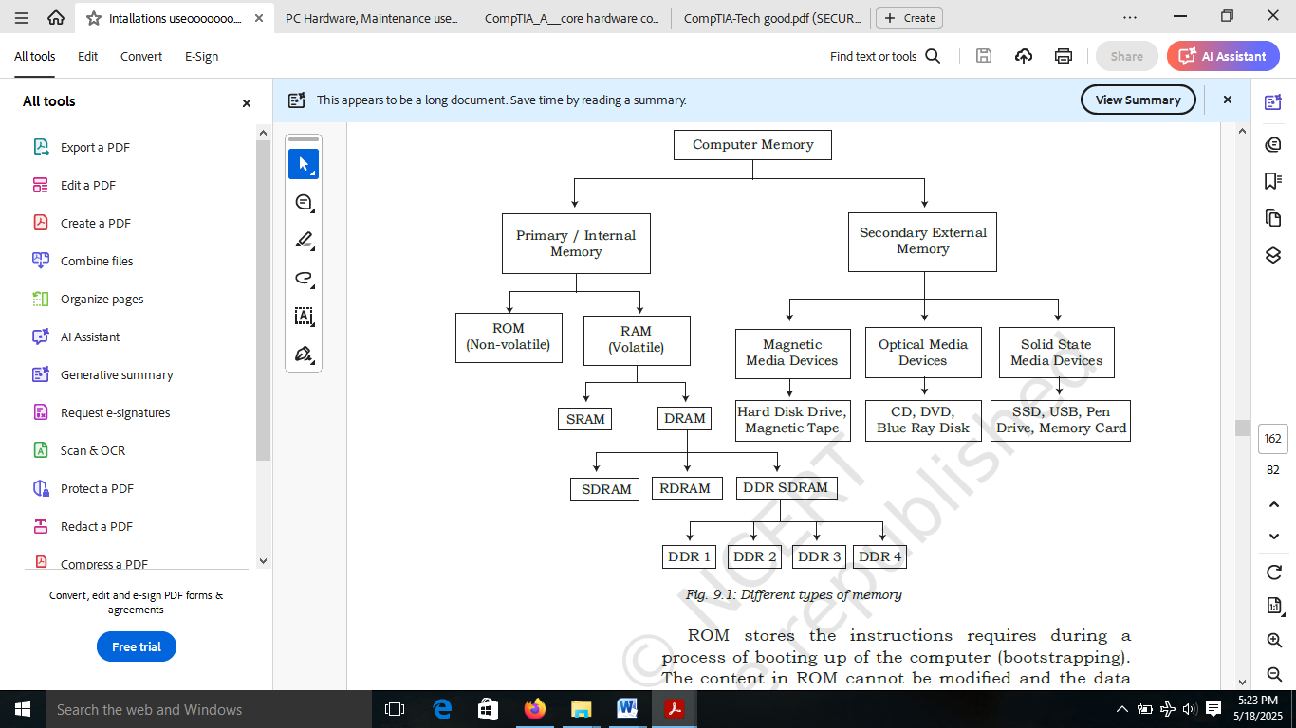
Summary of Different types of Memory

Installation of RAM
First, open the computer cabinet. To open the case, remove the screws of the left side cover and slide the side cover. Pull the latch to release the side panel. Then lift the side cover out from the chassis.
To install the RAM, first ensure its compatibility with the motherboard. If DDR3 is mentioned on the motherboard, then DDR3 RAM may be fixed in the memory slot.
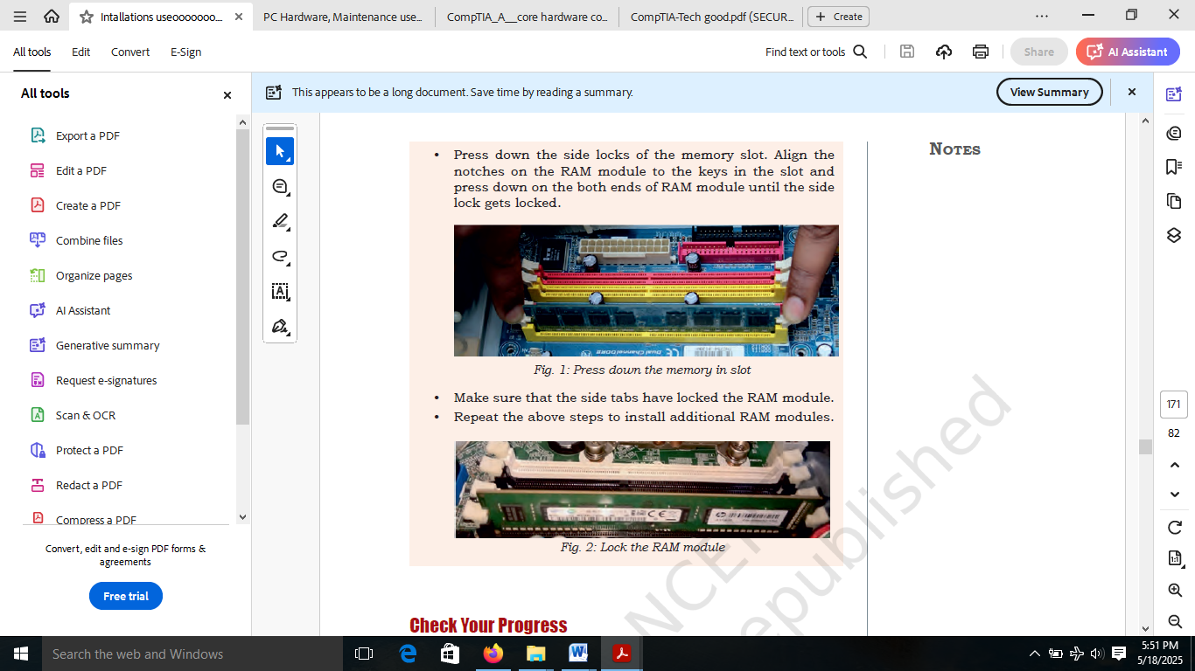
Press down the side locks of the memory slot. Align the notches on the RAM module to the keys in the slot and press down on the both ends of RAM module until the side lock gets locked.

Holding your RAM memory as shown in the image, apply equal downward pressure on both sides and push it into the DIMM slot. Both retaining clips will snap into place once the RAM memory has been fully inserted:
While installing RAM memory requires you to apply moderate pressure, avoid excessive force or you may end damaging it. If both retaining clips don't snap in, check if the RAM memory has been inserted in the correct direction.
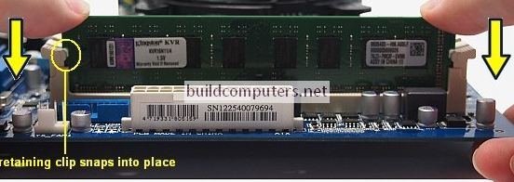

Hard Disk Installation
Hard disk drive (HDD) is the most popular storage medium used in modern computers for storing and accessing data. HDD has a large storage capacity and is cheaper. It can be attached internally inside the cabinet as well as can be connected externally to the computer. It supports rapid access to random data locations, meaning that data can be written or retrieved quickly for a large number of simultaneous users or applications.
Overview of Hard Disk Drive (HDD)
It is the primary long-term storage device used in personal computers. A hard disk drive fits inside a computer case and is firmly attached with the use of braces and screws to prevent it from being jarred as it spins. Typically it spins at 5,400 to 15,000 RPM. The disk moves at an accelerated rate, allowing data to be accessed immediately. Most hard drives operate on high speed interfaces using serial attached technology (SATA). When the platters rotate, an arm with a read/write head extends across the platters. The arm writes new data to the platters and reads data from them. Most hard drives use Enhanced Integrated Drive Electronics (EIDE) including cables and connectors to the motherboard. All data is stored magnetically, allowing information to be saved when power is shut off.
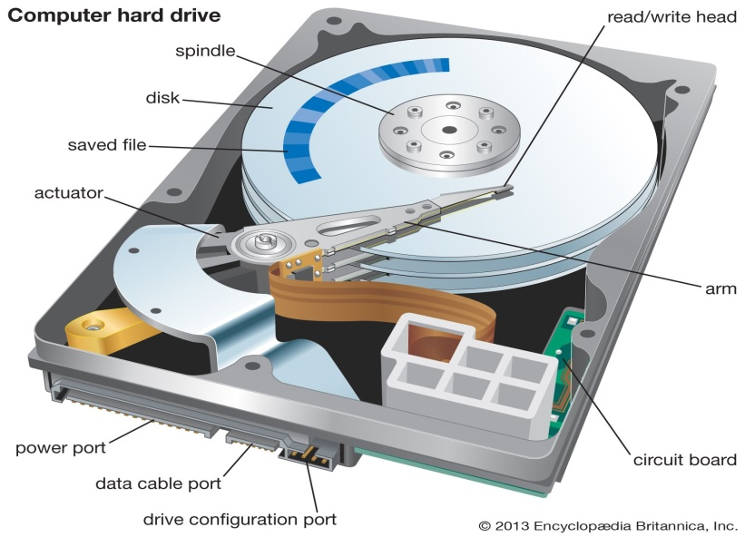
A hard drive is divided into one or more partitions, which can be further divided into logical drives or volumes. Usually a Master Boot Record (MBR) found at the beginning of the hard drive, which contains a table of partition information. Each logical drive contains a boot record, a File Allocation Table (FAT) and a root directory for FAT file system or any other file system. The HDD can be internal (fixed) or external.

Internal or Fixed HDD
Almost every computer has a fixed HDD. A fixed HDD is built into the case of a computer. It is the main backing storage device of computers since it provides instant and random access to data with high access speed.
External or Portable HDD
A portable HDD can be attached to the computer externally through USB. It is used to store very large amount of data and easy to use in computer just by plugging it in the USB port of computer.
Physical Components of HDD
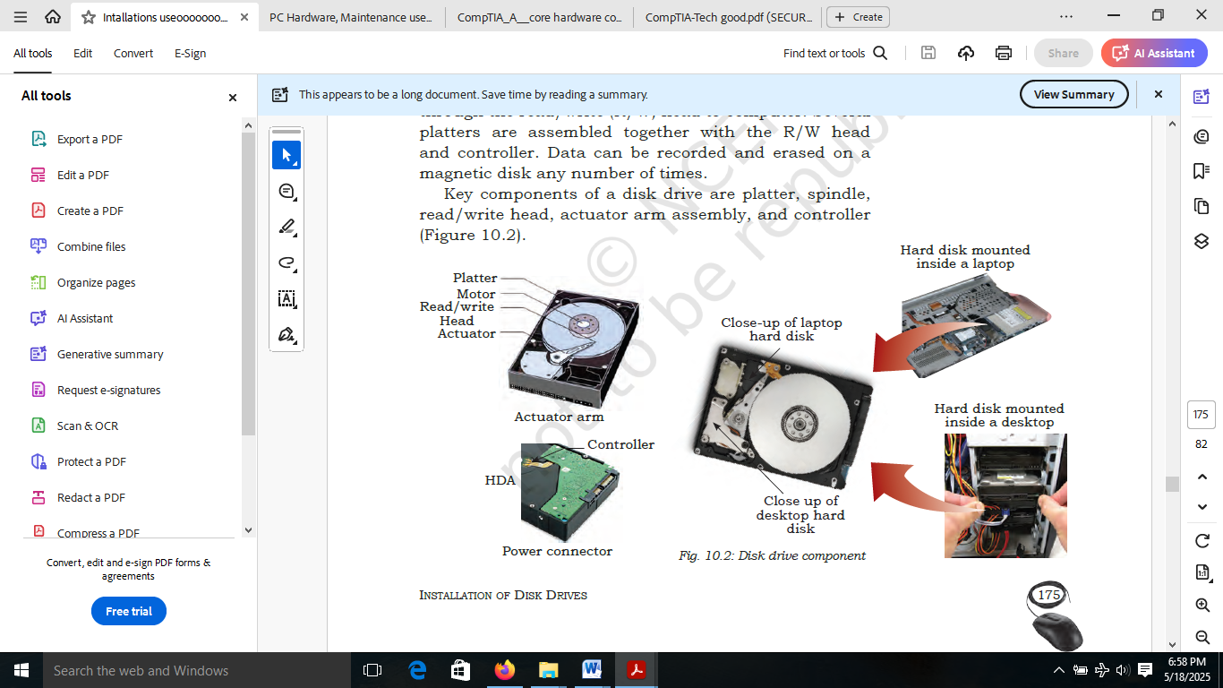
A hard disk drive uses a rapidly moving arm to read and write data across a flat platter coated with magnetic particles. Data is transferred from the magnetic platter through the read/write (R/W) head to computer. Several platters are assembled together with the R/W head and controller. Data can be recorded and erased on a magnetic disk any number of times. Key components of a disk drive are platter, spindle, read/write head, actuator arm assembly, and controller

Types of HDD
The various types HDD such as, IDE or PATA drives, SATA, SCSI drives are explained below.
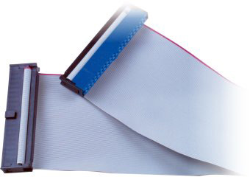
IDE drives: The IDE drives or PATA drives is an old technology. It used 40 or 80 pin wide ribbon cables to transfer multiple bits of data. It’s data transfer rate was 133 MB/sec. PATA cables were used to connect these drives.

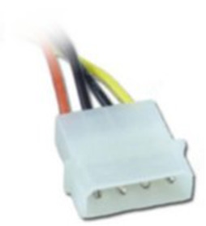
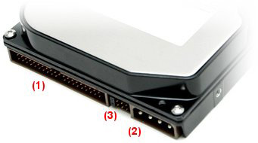
IDE drives are powered using a 4-pin Molex connector. The design of this connector makes it non-reversible. If you apply force and attach it backwards, you can easily destroy the device.

In the above
- IDE data port. Please pay attention to the small notch in the top center. It is used as an index for correct cable connection. Incorrect cable connection can damage the connector and the drive.
- Power supply port. It also has a keyed shape for correct connection of the power cable. Incorrect cable connection can damage the connector and the drive.
- A jumper block between the IDE data port and supply port is used for identification of the order of the drives in a paired IDE cable (master/slave) as well as for additional IDE settings.
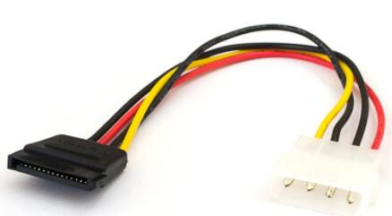
SATA drives: SATA (serial advance technology attachment) are new and currently used drives. These drives have generally seven pins made available with 1 meter data cable. our of seven, four pins are used for sending and receiving data and other three are grounded. It starts with the data transfer rate from 1.5 Gbits/sec. Currently, the fastest drive offers 16 Gbits/sec. SATA cables are used to connect SATA drives. Only one drive can be connected with single data cable. These drives operate with 250 mV. Three generations of SATA are currently in use. The table below outlines the different versions and their speeds.
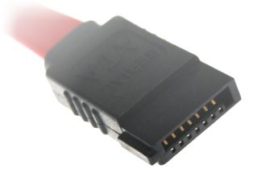

Advantage of SATA
- SATA Cables are flexible and thinner
- The transfer rate of SATA is very high than HHD.
- It is very easy to manage cables length.
- SATA manages RAID in an efficient way.
- It provides an internal-external interface.
- It is equipped with NCQ (Native Command Queuing)
- SATA does not have jumper cables and due to this no fussing with Master/slave/cable select setting

Disadvantages of SATA
- Sate drives can be used only in an IDE.
- The computer can only use a cheap SATA to IDE reversible interface.
- if the cable length is too long, serial devices driven at high speed can be subject to interference

IDE vs SATA Interface
SATA hard disk has a new design structure, fast data transmission, save space, and many other advantages over IDE hard disk:
1) SATA hard disk has a higher transmission speed than IDE hard disk. SATA can provide a peak transfer rate of 150MB/s. It will reach 300 MB/s and 600 MB/s with the development. At that time, we will get a transfer rate nearly 10 times faster than IDE hard drives.
2) Compared with the PATA40-pin data cable of IDE hard disks, the SATA cable is small and thin. And the transmission distance is long, which can be extended to 1 meter, making it easier to install equipment and wiring in the machine. Because the size of the connector is small, this kind of cable effectively improves the air flow inside the computer and also speedsthe heat dissipation in the case.
3) The power consumption has been reduced. SATA hard drives can work with 500 mA of current.
4) SATA can be backward compatible with PATA devices by using multi-purpose chipsets or serial-parallel converters. Since SATA and PATA can use the same drive, there is no need to upgrade or change the operating system.
5) SATA does not need to set the master and slave disk jumpers. The BIOS will number it in the order of 1, 2, 3. Whilethe IDE hard disk needs to set the master and slave disks through jumpers.
6) SATA also supports hot plugging and can be used like a U disk. IDE hard disks do not support hot swap.

Installation of Internal HDD
The process of installing an internal hard drive involves mounting it and connecting a couple of cables.
DRIVE CAGES, BAYS, and Mounting Options
Internal 3.5-inch hard disk drives are mounted in a drive cage or drive bay. Placement and orientation of the cages or bays will vary from case to case. Drive cages/bays will most often be mounted perpendicular to the bottom of the chassis, while drives mounted in the cages usually sit parallel to the bottom of the case. The drive connectors are on the rear side of the hard disk drive.
Step 1: Fit hard disk into a bay.
To fit a hard disk, identify a spare 3.5 inch drive bay. Four screws are required to secure the drive to a cage on the sides or bottom of the drive. Some drives have screw less fittings. Such hard drive come with tool-less brackets that make mounting hard drives easy. Slide the hard disk into a spare drive bay until the screw holes in the side of the drive line up with the holes in the drive bay. Then secure the disk with four screws, two on either side. Use magnet-tipped screw drivers. The screws are provided with the hard disk or case. Screw them tightly to prevent the drive from dangling.
Step 2: Connect the hard drives with SATA.
Once the drive is mounted, connect it to system. The SATA interface hard drive uses SATA cables. One end of SATA cable is connected to the hard drive and other end to motherboard connector.
Step 3: Plug in SATA power.
Locate the correct connector from power supply unit (PSU) and plug it into the back of the hard disk. Be careful when plugging it in, as downward pressure can break the clip surrounding the power connector.
Step 4: Plug in SATA data cable.
Unlike IDE, SATA uses a simple and thin connector to carry data. The motherboard has several SATA cables. Take one of these and plug it gently into the rear of the hard disk. Be careful to plug it in, as downward pressure can break the connector and prevent the SATA cable plugging in.
Step 5. Plug SATA data cable into motherboard.
Next, find a spare SATA port on motherboard. These are usually located at the bottom-right of the board and are numbered. The lowest number has the higher boot order in case of multiple disk. So plug the SATA cable into the lowest-numbered port.

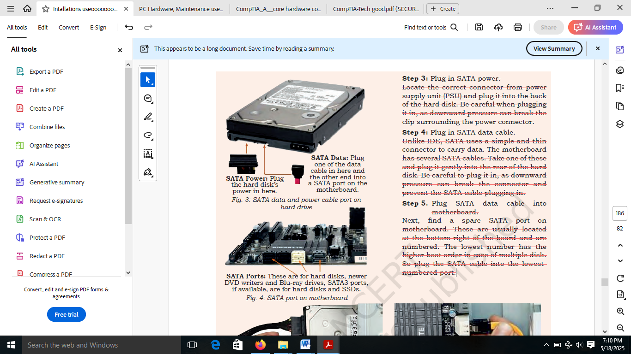
SATA data and power cable port on hard drive
SATA port on the motherboard

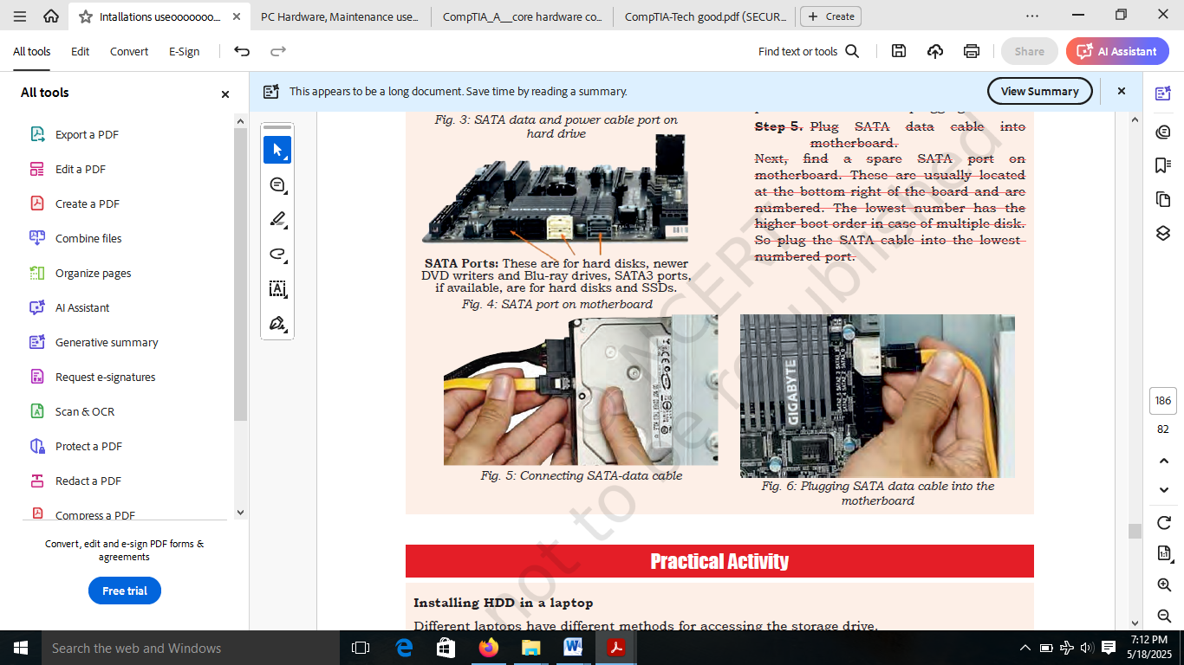
Connecting SATA data cable
Plugging SATA data cable into the motherboard

Installing HDD in a laptop
Different laptops have different methods for accessing the storage drive.
Material required
Laptop, mini screwdriver, anti-static wrist strap, magnifying glass.

Procedure
There are several types of small screws that are used throughout the laptop. Place these in small envelopes and write the component name on the envelope. Be organized and keep track of all the screws.
Step 1: Start the disassembly process by removing the battery. Turn the notebook upside down and remove all screws securing the bottom case. There are two screws (green circles) hidden under bottom.
Step 2: Remove three screws fixing the hard drive bracket to the case. Disconnect the hard drive cable from the motherboard.
Step 3: Remove the old hard drive from the notebook and replace with new hard disk.

Solid State Drives
These do not have any moving components. They use only electronics to store and retrieve data. You can think of a SSD as a huge bank of random access memory (RAM). Most SSDs are non-volatile, meaning that they will not lose data when power is removed. The most common type of memory used with SSDs is flash-based RAM, the same type of non-volatile RAM used in USB flash drives. SSD drives are lightning-fast when compared with mechanical hard drives. Additionally, they don’t require motors to spin the platters and move the actuator, so they are lighter and draw less power. Mobile devices such as tablets, commonly use SSDs, and many hobbyists replace laptop hard drives with SSDs. With the price of memory continuing to fall, SSD drives have become very affordable. For example, you can purchase a 128 GB SSD drive for about the same price as a 2 TB mechanical drive. Some people use a SSD drive for the operating system and applications, and use a mechanical drive for data. Most SSD drives use SATA and will install just like any other SATA drive. In addition to SSD drives and USB flash drives, several types of flash memory are used in digital cameras and recorders, including the following:

Optical Discs and Drives
The modern PC comes with a DVD writer drive. The common types of discs which can be used in these drives include Blu-ray discs, different types of DVDs, and compact discs. An optical disc drive uses either electromagnetic waves or laser beams very close to the visible spectrum of light to write or read the data on optical discs. Apart from the general and exclusive applications in a computer, the optical disc drives are used as DVD players, CD players, and DVD recorders. They are most extensively used in computers for various purposes like archiving of data, reading software, recording discs, and to distribute the consumer media for exchange purpose.

Functioning of Optical Drive The main components of an optical disc drive consist of an optical path, usually mounted on a pick up head and containing a semiconductor laser, the laser beam guiding lens, and the photodiodes which detect the reflection of light from the surface of the disc.
With the advent of more recent versions of optical discs, the wavelengths of the laser beams used in the process is changed from 780nm to 405nm in the Blu-ray disc.
The main aspects to be noted for the proper functioning of the CD drive are that, between the disc and the lens, a correct distance has to be maintained. Secondly, the beam should be focused on the laser spots of the disc. The data stored in spiral path will be accessed by moving the head all the way through the radius of the disc and keeping laser beam focused.
The mechanism by which the recorded encode the data on a disc is that by heating selectively the different parts of the dye layer by using the laser beam.
The reflectivity of the dye will be changed during this process leading to the creation of marks, represented by lands and pits on discs. The writer laser is more powerful than the reading laser.
With a higher speed in writing, less time will be taken by the laser to heat an area. The normal power is around 200 MW for the writing beam.
In rewritable discs, instead of dye layer, the crystalline metal complex used to cover the disc is melted with the laser beam. The lands and pits on metal alloy layer differ based on the extent to which the beam is exposed and can cause greater reflectivity.
In dual layered media, a polycarbonate layer separates the first semi-reflective layer and the second layer. The writing starts in the inner edge for the first layer and from the outer edge for the second layer.
Installation of optical drive
Material required
Computer system, optical drive, screw driver
Procedure
- To install an optical drive, first check the position of the optical drive so that it aligns with the 5.25 inch drive bay.
- Insert the optical drive into the drive bay so that the optical drive screw holes align with the screw holes in the case
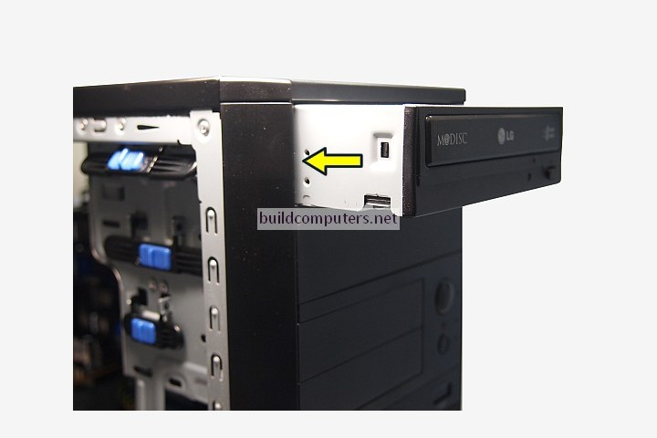
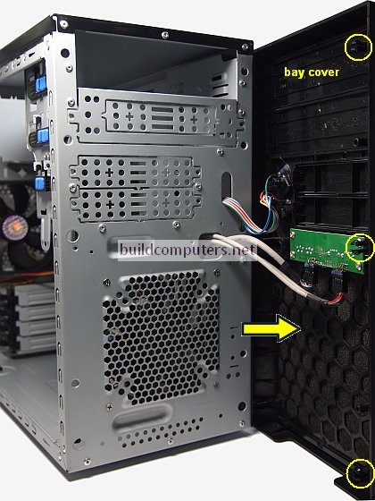

- Secure the optical drive to the case using the proper screws (Figure 2).
- Connect the power cable coming from the SMPS to the power socket of optical drive
- Connect SATA data cable from optical drive socket to the motherboard socket.
- Connect the SATA data cable to the optical drive as shown in Figure 4.
- Connect the other end of the SATA data cable to the motherboard as shown
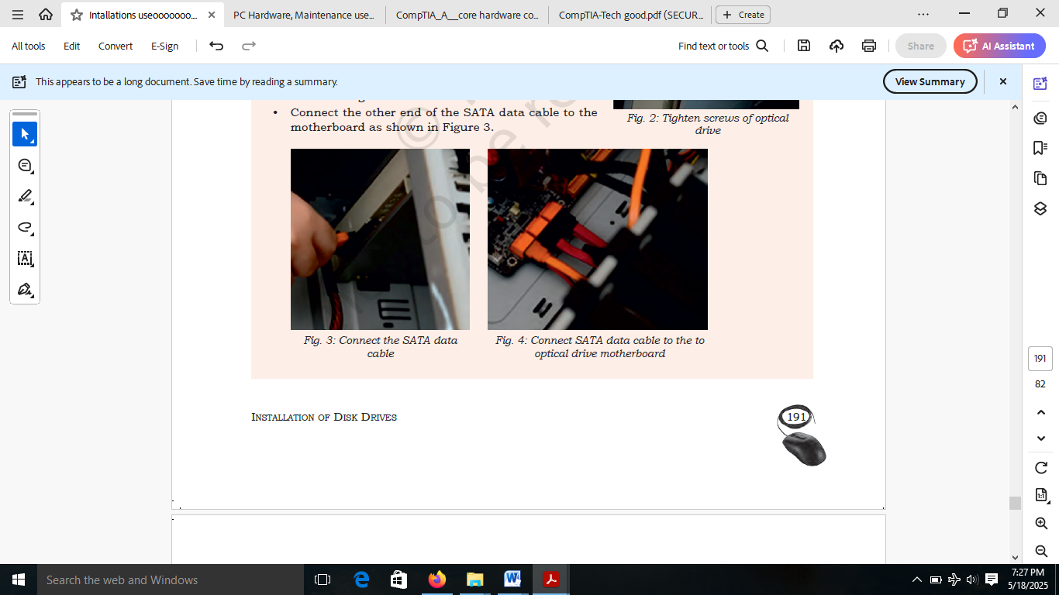

Disk Drive Interfaces
IDE/EIDE/PATA drives
Hard drive interfaces have gone through several changes and improvements over the years. Even though you will not see many of the older versions, if you understand a little about them, it makes it easier to understand current versions. The different disk drives are briefly explained below.
Integrated Drive Electronics (IDE)
These appeared in the 1980s and included drive controller electronics on the drive.
An IDE (Integrated Drive Electronics) cable, also known as a Parallel AT Attachment (PATA) cable, is a flat, ribbon-like cable used to connect hard disk drives (HDDs) and other storage devices to a computer's motherboard. It enables parallel data transfer between the storage device and the motherboard
Key characteristics of IDE cables:
Parallel Data Transfer: IDE cables use parallel communication, meaning multiple bits of data are transmitted simultaneously.
Standard Connector: IDE cables use a 40-pin connector to connect to both the motherboard and the storage device.
Limited Speed: IDE is an older technology and is generally slower than modern interfaces like SATA.
Supports Multiple Devices: A single IDE cable can connect up to two devices on a single IDE channel.
Older Technology: IDE is an older interface, and newer computers typically use SATA or other more advanced technologies.
Cable Select: Some IDE cables use a cable select mechanism, where the master/slave designation is determined by the cable's physical position.
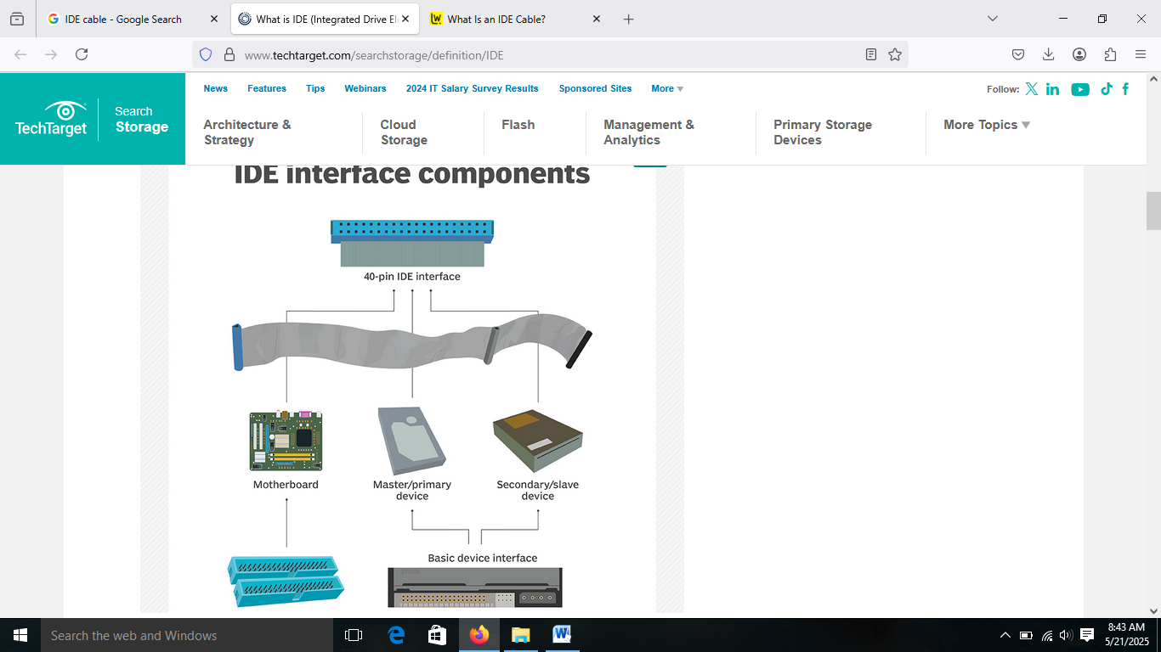
IDE Interface Components

Advanced Technology Attachment (ATA)
IDE was standardised as ATA and later became known as ATA-1. The maximum drive size was 137GB. In earlier drives, the maximum was 2.1GB.
Extended IDE (El DE) and ATA-2
Modifications and enhancements of the original IDE were marketed as EIDE and later standardised as ATA-2.
ATA Packet Interface (ATAPI)
Originally IDE and ATA were designed only for hard drives. ATAPI provided standards so that EIDE and ATA versions could be used for other drives, such as CD-ROM and DVD-ROM drives.
Parallel ATA (PATA)
ATA was upgraded regularly to ATA-7, which also introduced Serial ATA (SATA). EIDE versions were renamed to PATA to differentiate it from SATA. PATA drives use direct memory access (DMA) transfers. DMA allows a device to directly access without the central processing unit (CPU), freeing up the CPU for other tasks. Ultra DMA (UDMA) appeared in ATA version 4 (ATA-4) and supported data transfers as high as 44 megabytes per second (MBps). ATA and UDMA were updated several times, and table below identifies the speeds and names for the different versions.

PATA
It is drives use ribbon cables similar to the one shown below. Each ribbon cable includes three connectors, one for the motherboard IDE connection and two for the drives. In the Figure, the two IDE connectors (IDE 1 and IDE 2) are on the left, and the cable is lying on top of the motherboard. A typical PATA-based system would have two ribbon cables connecting a maximum of four drives. Early versions of PATA cables used 40 wires, but this was switched over to 80 wire cables with ATA-4. These extra wires provided signal grounds within the cable and supported the higher UDMA speeds. Even though the number of wires in the cables doubled, the connectors still have 40 pins. The maximum length of an IDE cable is 18 inches.
PATA Connectors and Cables
All PATA connectors are 40-pin rectangular connectors, and they are the same on both the hard drive and the motherboard. Motherboards that support PATA typically have two connectors named IDE1 and IDE 2.
Master and Slave Configuration
Each IDE connection supports two drives and these are commonly identified as master and slave drives. The system will try to boot to the master drive, but it does not automatically know which drive to select. Instead, you have to manipulate jumpers on the drive to let the system know which drive is the master and which is the slave.

The PATA hard disk has a 40-pin connector for the ribbon cable and a Molex connector for power. It also has a set of jumpers used to identify whether the drive is the master or the slave.
If one is replacing or adding a drive, it is important to understand these jumpers. You will find a chart on the back of the drive, similar to the chart as shown in the Figure that identifies exactly how the jumper should be configured for each drive.
Cable Select
Cable select allows the system to identify the drive based on which connector is used. You can see that the end connector of the ribbon cable is labelled ‘Master’ and the middle connector is labelled ‘Slave’. If you configure the jumpers for both drives to use ‘Cable Select’, they are identified based on which connector is used. If the drives are jumpered for ‘Master’ and ‘Slave’, the connector does not identify the drive.
Serial advanced technology attachment (SATA)
Early data transmissions sent data between components one bit at a time, or serially. Engineers later improved this by sending multiple bits at a time to improve the speed. Therefore, data could be sent using multiple wires so that bits were next to each other or in parallel. The trade-off was that the cable needed more wires to send all the data at the same time. For example, a 40 pin EIDE ribbon cable includes 16 bits for data. If you send 16 bits at a time, you can send as much as 16 times more data than if you send just one bit at a time at the same speed. The idea that parallel is faster than serial held for many years, until a breakthrough with low voltage differential (LVD) signaling occurred. LVD signaling is a standard that transmits data as the difference in voltages between two wires in a pair. These differences can be rather small and engineers discovered they could send data serially along an WO cable quicker than they could with parallel. Many technologies use LVD signaling, including SATA drives, hyper transport used by AMD processors, and FireWire.
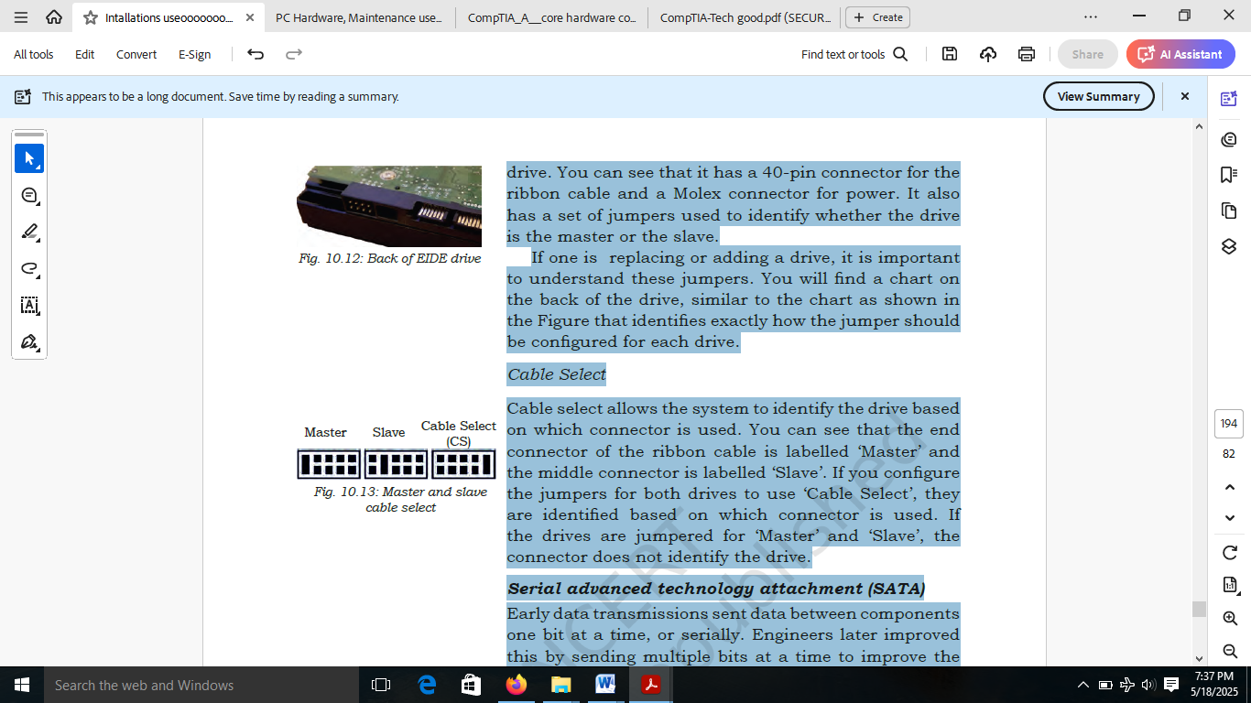
Master and Slave cable select
SATA generations
Three generations of SATA are currently in use. It is important to know the capabilities of each and also to recognise the different names that have been used. Table 4 below outlines the different versions and their speeds.

Different versions of SATA and their speeds
Generation | Bit Speed | Byte Speed | Names
SATA 1 | 1.5 Gbits/s | 150 MBps | SATA 1.5G, SATA 1.5Gb/s, SATA 1.5Gbit/s, SATA 150
SATA 3 | 3.0 Gbits/s | 300 MBps | SATA 3G, SATA 3Gb/s, SATA 3Gbit/s, SATA 300
SATA 3 | 6.0 Gbits/s | 600 MBps | SATA 6G, SATA 6Gb/s, SATA 6Gbit/s, SATA 600

SATA hard drive cables are thin, flexible data cables used to connect hard drives and solid-state drives (SSDs) to a computer’s motherboard. They use a serial interface for data transfer, offering faster speeds and more streamlined connections compared to older PATA (Parallel ATA) cables.
Characteristics of SATA:
Thin and flexible: SATA cables are significantly thinner and more flexible than the ribbon cables used for PATA, making them easier to manage inside a computer case.
Serial data transfer: SATA uses a serial connection, transmitting data one bit at a time, which enables faster transfer rates compared to PATA’s parallel transmission.
Standardized connectors: SATA data connectors have 7 horizontal pins, with four pins arranged in two pairs for data and three ground pins.
Power connector: A separate power connector is used, distinct from the data connector, to supply power to the hard drive or SSD.
Short lengths: SATA cables are typically designed for short lengths, as they are used internally inside a computer case. The maximum length is around one meter.
Differential signaling: SATA uses differential signaling, which helps to reduce electromagnetic interference (EMI) and crosstalk.
Backward compatibility: SATA cables are backward compatible, meaning that a SATA III cable will work with earlier SATA standards, though at a reduced speed.

SATA cables can connect a range of devices, including:
- Hard drives
- Optical drives
- Solid-state memory drives
How to Differentiate Between SATA and PATA Hard Disk

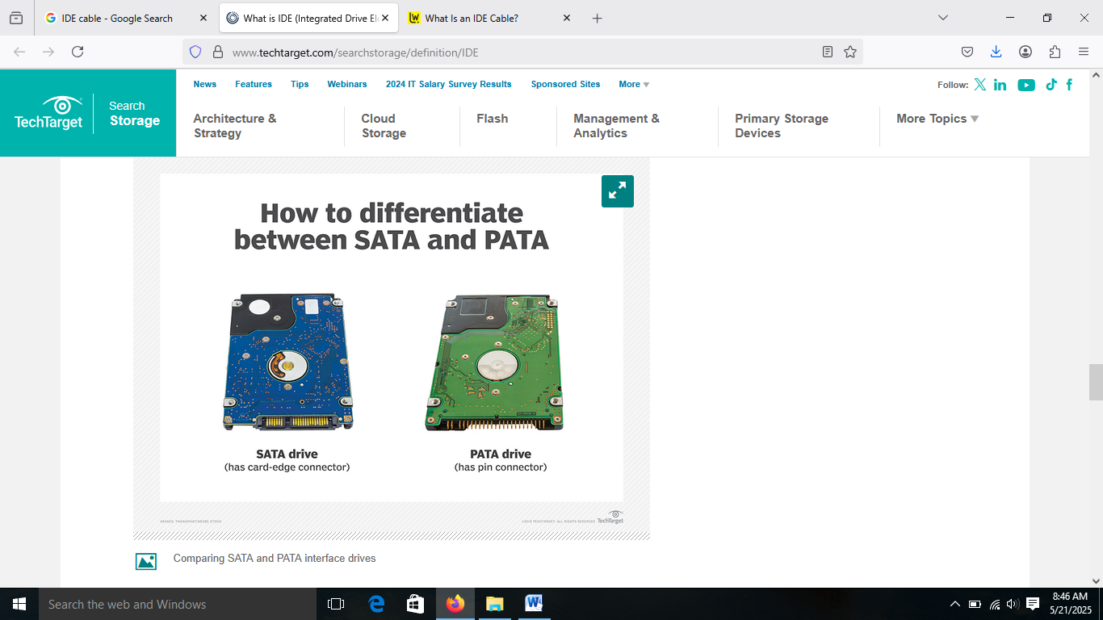
SATA drive (has card-edge connector)
PATA drive (has pin connector)

Installing SATA Cables
Installing SATA cables should not be a complicated task, but it is still important to complete the installation safely and correctly. The exact method of installation will vary depending on the intended purpose of the SATA cable.
If you simply need to replace an HDD, it’s worth noting that it is possible to avoid the need to disconnect the SATA cable from the motherboard. This way, only the SATA cable connector attached to the HDD itself will need to be removed and replaced once the new HDD has been successfully installed.
On the other hand, , you do not need to address the existing hard drive. Instead, you will if you are using a SATA cable to add additional storage to a configuration need to follow these steps:
- Insert the new hard drive into an empty bay in the PC case, ideally with space between the new and existing drives to enable better airflow
- Ensure that the SATA cable connection ports are easily accessible then secure the drive in position
- Connect the SATA cable to the port on the hard drive, then connect the other end of the cable to the motherboard, taking care not to disturb or impede the connection to the existing HDD
- The primary drive should be connected to the motherboard’s lowest SATA port – usually SATA 0 or SATA 1
- Complete the process by ensuring all connections are secure, closing the PC casing, then powering the system up once it is safe to do so
- It may be necessary to format the new drive or potentially reinstall the operating system, depending on the specifics of your application

SATA Cable Applications

SATA Power Cables: When it comes to SATA power cables, 15-pole, power and data all have the same pitch of connector pins, but each has a different number of ways. It is also worth noting that adaptors are generally available for PC power supplies that feature alternative types of power connectors.

SATA Cables for HDDs: In a PC setup, SATA cables can be used to connect the hard disk to the motherboard. Hard disks typically feature multiple inlet ports, at least one of which will be SATA compatible. The SATA cable is also responsible for supplying power to the hard disk so additional hard drive power cables may not be required. SATA cables are beneficial as their shape has been specifically designed to help maximise airflow inside a CPU, saving space and boosting performance.
It is also worth noting that SATA cables can be used to connect external hard drives to a PC via the e-SATA input. Likewise, it may be possible to connect an external hard drive to a computer using a SATA to USB adapter if the particular hard drive supports USB input.

SATA Cables for Laptops: If you are using a laptop rather than a standard PC, the chances are that the laptop’s storage devices (HDDs, SSDs etc) are attached directly to the motherboard. As a result, a SATA cable should not be necessary. The motherboard and the breakout boards connected to the storage devices are joined with a thin, flat SATA cable specially designed for use in laptop assemblies.

SATA Cables by Length
SATA cable length is generally quite short as these cables are used internally inside PC cases. The maximum length tends to be around one metre. Larger SATA cables are available but these are rarely used because the extra cable length is just not necessary in standard assemblies.
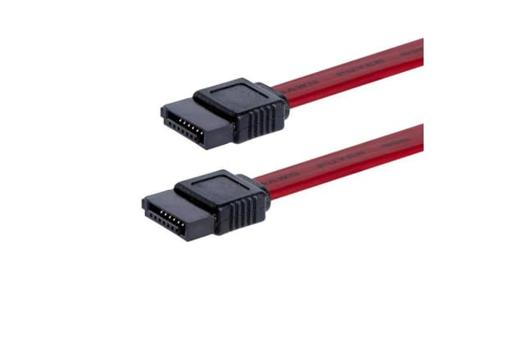
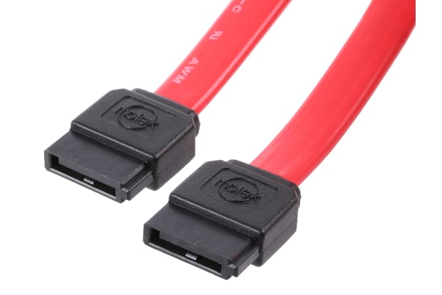
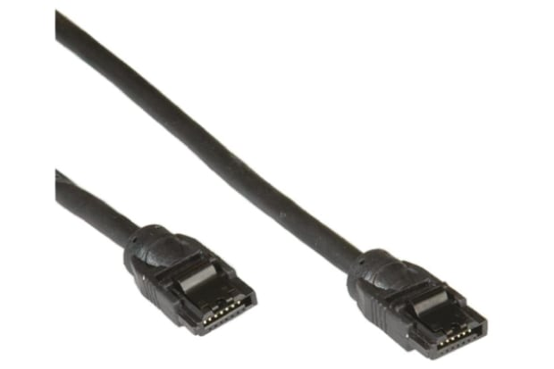

300mm SATA Cables

500mm SATA Cables

1m SATA Cables

Installing IDE Cable on Hard Drive

Before you start
- Do not drop or bump the drive.
- Keep the drive in the protective anti-static container until ready to install.
- Protect the drive from static discharge by wearing a grounded wrist strap. Attach the wrist strap to the metal chassis of your computer.
- Handle the drive by the edges of the frame.
- Do not apply pressure or attach labels to the circuit board or the top cover of the drive.
- Turn off the power to the host system before installation.

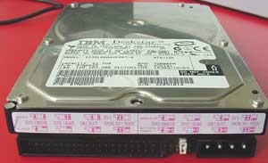
- Unpack everything. Drives come defaulted to be ready to be installed in a single drive environment.

First of all configure for Master or Slave. The master can also be referred to as the "primary" drive with the slave being the "secondary". A lot of people like to use what is called Cable Select. If you want to do that you will just have to make sure that it is plugged into the right part of the cable.
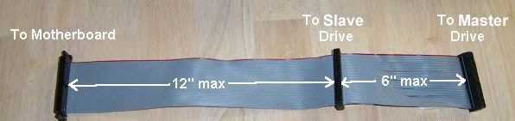

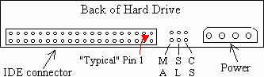

If you want to make it the master or the slave, you will have to look around the drive to find where the instructions are.

2) Setting the Jumpers
- Master or Single Drive - Use this setting if the drive is the only drive on the ATA interface cable.
- Drive is Slave - Use this setting if the drive is an additional drive on the cable and the original drive is set as Master.
- Master with non-ATA compatible drive - Use this if the drive is Master to a CD-ROM, tape drive or other non-ATA drive. And here one thing to note is that it is preferred to have the CD-ROM and other non-hard drive products on the secondary ATA channel.
- Cable-Select Option (Default) - Use with Ultra ATA cables. This allows the cable to select if the drive is master or slave based on the position on the cable. The Master drive goes on the black connector at the end of the cable, the slave drive connects to the gray connector in the middle and the host adapter connects to the blue connector at the other end of the cable.
- Limit Capacity Option - This option may be required if the system the drive is being installing into does not support the full capacity of the drive. If the limit capacity jumper is installed you will need to use a drive overlay program such as the one installed by Disc Wizard Starter Edition.
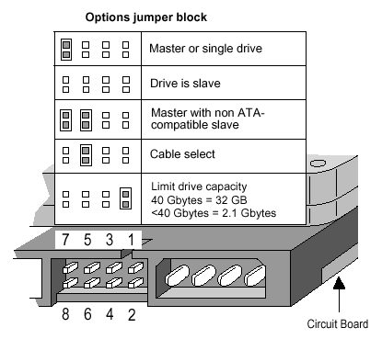
The figure below depicts the jumper settings for the U-Series and Barracuda ATA drive families (most Seagate ATA drives above 20 GBytes). If you have an older drive please visit our Technical Library and find your model number for details on jumper configuration.

3) Install hard drive
Before you install the new drive make sure you unplug the power connector from the computer. Anytime you mess with anything inside your computer it is a good idea to unplug it. It's also a good idea to touch the power supply before you go sticking your hands in there! Static discharge can jump and do some bad things. Open up your computer case.
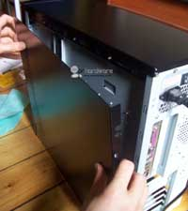

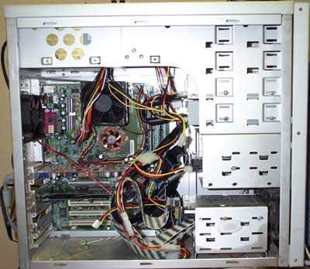
Now you should be able to find an open 3.5" slot somewhere.

Slide the drive into an available slot and find 2 or 4 case screws. Two if you are lazy and only screw things in on the side. Four if you never touch anything in your system. For that you will have to pull off both side panels to your case. The case screws are bigger than the ones used to screw in your CD drives.
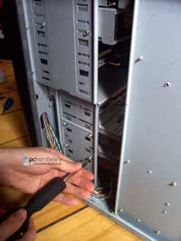
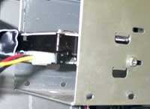

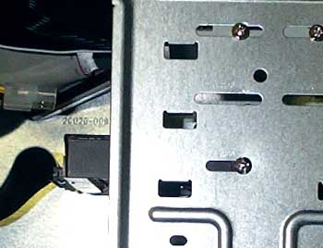
After the drive is secured then go ahead and connect the power and IDE cables. On the edge of one of the cables you will see a line. Normally it is red on the grey cables and white on black cables etc there will be some kind of colored line to indicate pin 1. This pin always goes on the same side as the power connector.

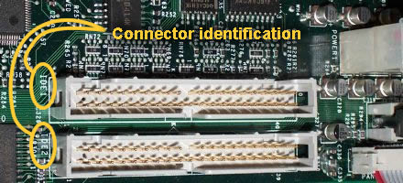
To connect the IDE cable to the motherboard you will have to find something that looks like this:

Each connector represents 1 IDE channel. Most boards have 2 channels while 4 is becoming more and more common at least on the higher end boards.
Power Supply Unit
Despite the name, Power Supply Units (PSU) do not supply systems with power - instead they convert it. It can be seen as an electrical device that offers electric power to an electrical load such as laptop computer, server, or other electronic devices. The main function of a power supply is to convert electric current from a source to the correct voltage, current, and frequency to power the load.

Specifically, a power supply converts the alternating high voltage current (AC) into direct current (DC), and they also regulate the DC output voltage to the fine tolerances required for modern computing components.

The power supply as the name implies is the device that supplies power to all the components in the computer. Its case holds a transformer, voltage control, and (usually) a cooling fan. The power supply unit can be define as the unit that converts about 100-120-240 volts of alternating current (AC) power to low-voltage direct current (DC) power for the internal components to use. The most common computer power supplies are built to conform with the ATX form factor. This enables different power supplies to be interchangeable with different components inside the computer. ATX power supplies also are designed to turn on and off using a signal from the motherboard, and provide support for modern functions such as standby mode.

Below shows ATX power supply and the wiring configuration diagram of an ATX system board power connector. Notice that it is keyed so that it cannot be installed incorrectly.
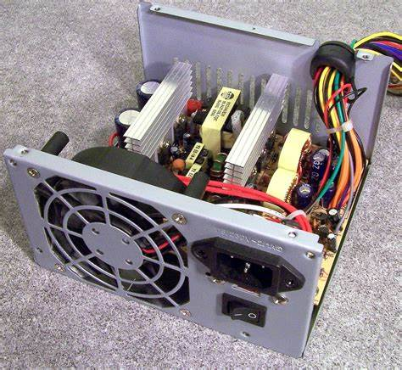
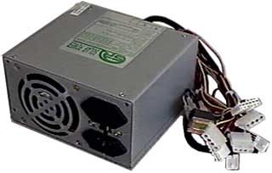
Power Supply Unit

Functions of a Power Supply Unit (PSU)
The primary function of a Power Supply Unit (PSU) in a computer is to convert the high-voltage AC power from a wall outlet into the low-voltage DC power required by the computer’s components. This conversion ensures that all parts of the computer, from the motherboard and CPU to the graphics card and storage devices, receive the correct voltage and current to operate properly.
AC to DC Conversion: The PSU receives alternating current (AC) from the wall outlet, which is typically 110-220 volts depending on the region. It then converts this AC power into direct current (DC) at lower voltages, such as 5, 12, and 3.3 volts, which are the standard voltages used by computer components.
Voltage Regulation: The PSU regulates the DC voltage to ensure that the correct voltage is supplied to each component, preventing damage from voltage fluctuations or spikes.
Power Distribution: The PSU distributes the converted DC power to the various components of the computer, providing the necessary power for the motherboard, CPU, graphics card, hard drives, and other peripherals.
Efficiency: A good PSU not only converts power effectively but also minimizes energy loss, contributing to a more efficient and environmentally friendly computer system.
Protection: PSUs also provide protection against voltage surges and other external threats that could damage the computer’s components.

Basic Components of Power Supply Unit
A computer power supply unit consists of a number of important components. It is necessary to know some of these units as someone that will be performing upgrade some day
Rectifier – The rectifier of the computer power supply is a device that is used in changing the ac power into the pulsating dc. Diode is the basic rectifier. It is usually a unidirectional device which operates as a rectifier particularly in the forward direction.
Transformer – The transformer of a power supply is a static device which transfers the electrical energy to the secondary winding from the primary winding without necessary having any effect in the frequency. The transformer is used to step-down or step-up the ac voltage level as well as to cut off the rest of the electronic system completely from the ac power. The main functions of a transformer in a computer supply unit is to step the voltage down, step the voltage up, and to provide isolation between the secondary and primary circuits.
Filter – This is another important component of a computer power supply unit. Its main function is to ensure that the ripple component doesn’t appear in the output. It converts the pulsating DC from the rectifier circuits into an appropriate smooth DC level. The two basic types of power supply filters are the capacitance filter (C-filter) and Resistor-Capacitor filter (RC-filter). The C-filter is the simplest and most economical filter available. On the other hand, RC-filter is used to reduce the amount of ripple voltage across a capacitor filter. Its primary function is to pass most of the DC component while attenuating the AC component of the signal. The RC filter is composed of resistors and capacitors. RC filters are used to filter a signal by simply blocking certain frequencies and passing others. Common RC filters are High-Pass filters and Low-Pass filters.

Ripple is the unwanted AC component of the signal after rectification. It is unwanted because it can destroy or damage the load. This is the main reason why filters are installed in power supply - to prevent high ripples. The job of the filter is to smoothen the signal and suppress the AC component or variations. Ripple factor is the ratio of the root mean square of the ripple voltage to the value of DC component at the output voltage. It is sometimes expressed in percentage or in peak-to-peak value. The ripple factor determines the effectiveness of a filter being used in the circuit.

Power Supply Connectors
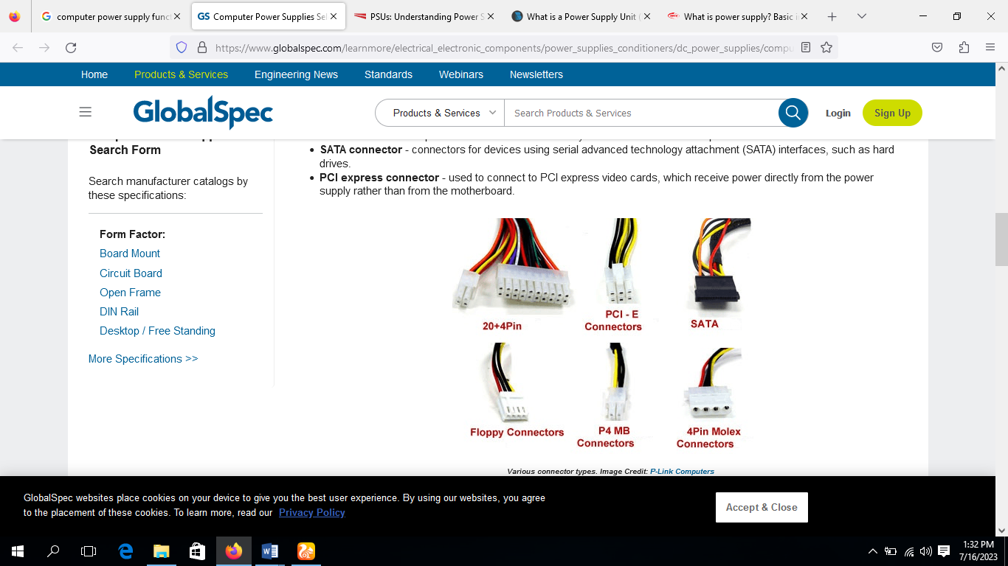
Power supplies use four major types of connectors to power the various devices within the computer: there are AT system connectors, ATX power connectors, standard peripheral connectors and floppy drive power connectors. Each has a different appearance and way of connecting to the device. Additionally, each type is used for a specific purpose. Each of them is discussed below for clarity.

AT System Connectors
This is one of the types of power connector and it is called the AT system connector. There are two 6-wire connectors, labeled P8 and P9 as shown below. They connect to an AT-only motherboard and deliver the power that feeds the electronic components on it. These connectors have small tabs on them that interlock with tabs on the power connector on the motherboard. If there are two connectors, you must install them in the correct fashion. To do this place the connectors side by side with their black wire together, and then push the connectors onto the receptacle on the motherboard.
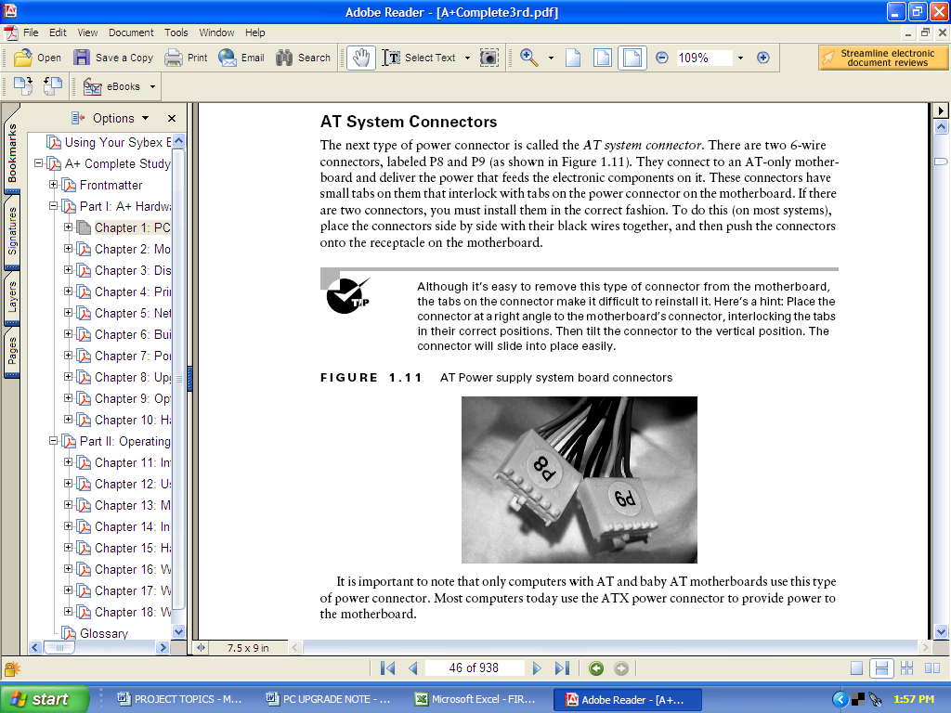
It is important to note that only computers with AT and baby AT motherboards use this type of power connector. Most computers today use the ATX power connector to provide power to the motherboard.
P8
P9
- (Orange) Power Good
- (Red) +5V
- (Yellow) +12V
- (Blue) -12V
- (Black) Gnd
- (Black) Gnd
- (Black) Gnd
- (Black) Gnd
- (White) -5V
- (Red) +5V
- (Red) +5V
- (Red) +5V

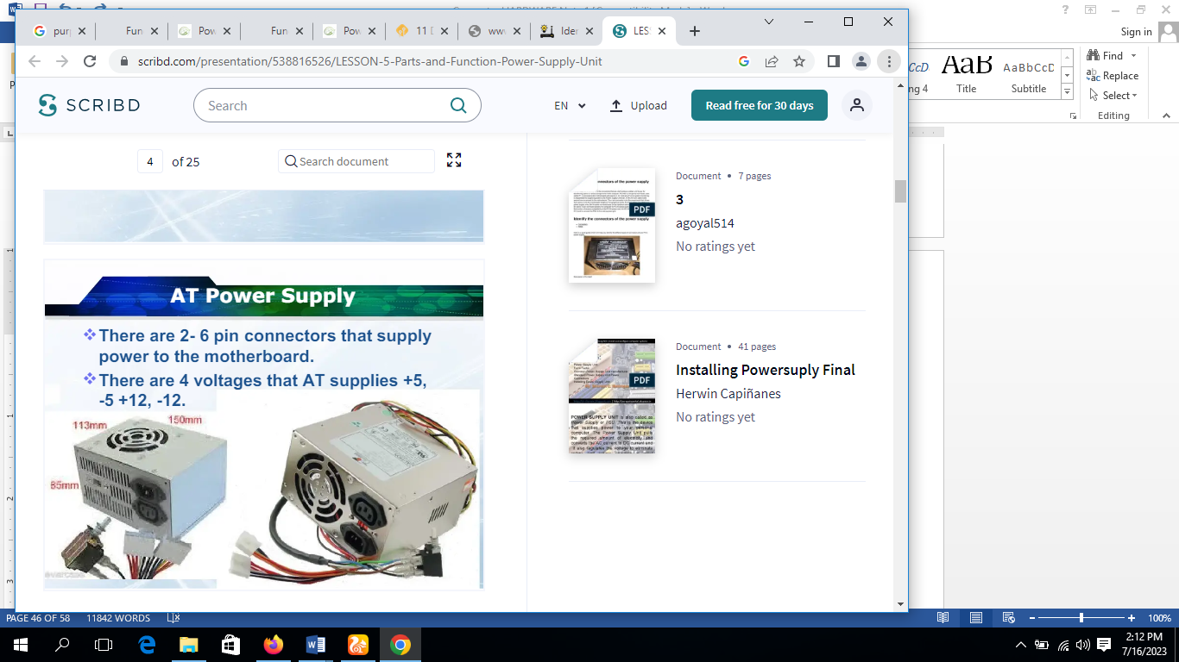

ATX power Connector
ATX connector is a primary power connector which plays the important role of providing power to the motherboard, CPU, RAM, and other integrated components, it is consist of 24 pins that include 20 pin block and a additional 4 pin connector attached. the wire in ATX connector are colure coded for indication of their function.

Originally the motherboard was powered by one 20-pin connector. Current version of ATX12V 2.x power supply provides two connectors for the motherboard: a 4-pin auxiliary connector providing additional power to the CPU, and a main 24-pin ATX 2 power supply connector, an extension of the original 20-pin version.
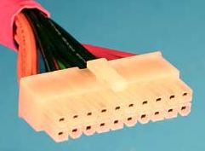
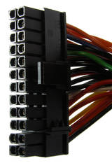
20 – Pin ATX connector
24 – Pin ATX connector

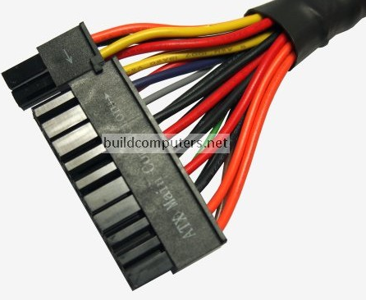
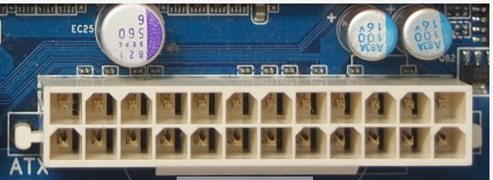

Connects to: ATX 12V power connectors on motherboards

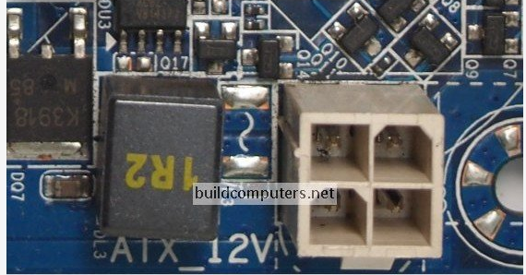

SATA Power Connector
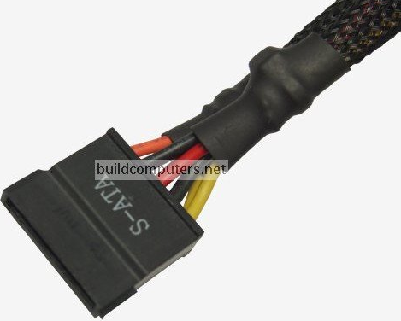
SATA Power Connector is a flat, L-shaped connector and are designed to supply power to SATA (Serial ATA) devices within a computer system, some example of SATA (Serial ATA) devices are hard disk drives (HDDs), solid-state drives (SSDs) and other storage devices. It ensure stable and consistent performance of connected storage devices by providing a reliable and efficient power supply.

The ATX P4
This connector, called P4-ATX (ATX 12V or as), was introduced by Intel for Pentium 4 (hence the name): it plugs into the motherboard and exclusively powers the processor. Today, most motherboards possess 4 to 8 pins dedicated to powering up the CPU. The latest standards for power supply make use of an 8-pin connector (sometimes called EPS 12V), made up of 2 x 4-pin blocks, again to ensure compatibility with old motherboards and the classic ATX P4. The diagram below shows the ATX P4 connector.

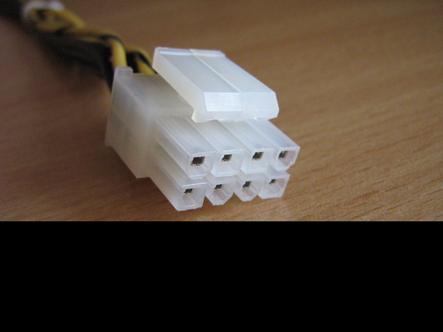
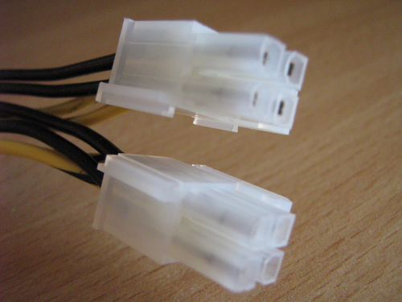

Standard Peripheral Power Connector
The standard peripheral power connector is generally used to power different types of internal disk drives. This type of connector is also called a Molex connector. Below shows an example of standard peripheral power connector for both PATA and SATA devices. This power connector, though larger than the floppy drive power connector, uses the same wiring color code scheme as the floppy drive connector.

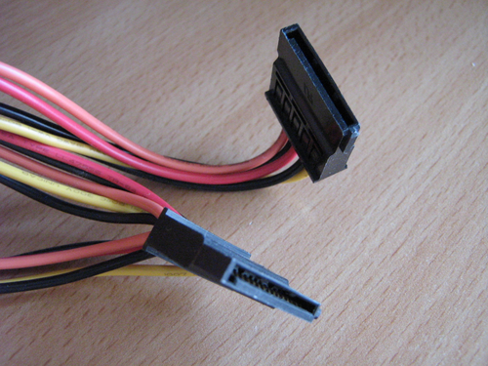
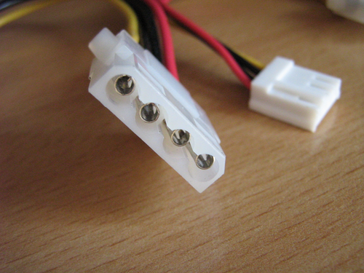

Floppy Drive Power Connectors

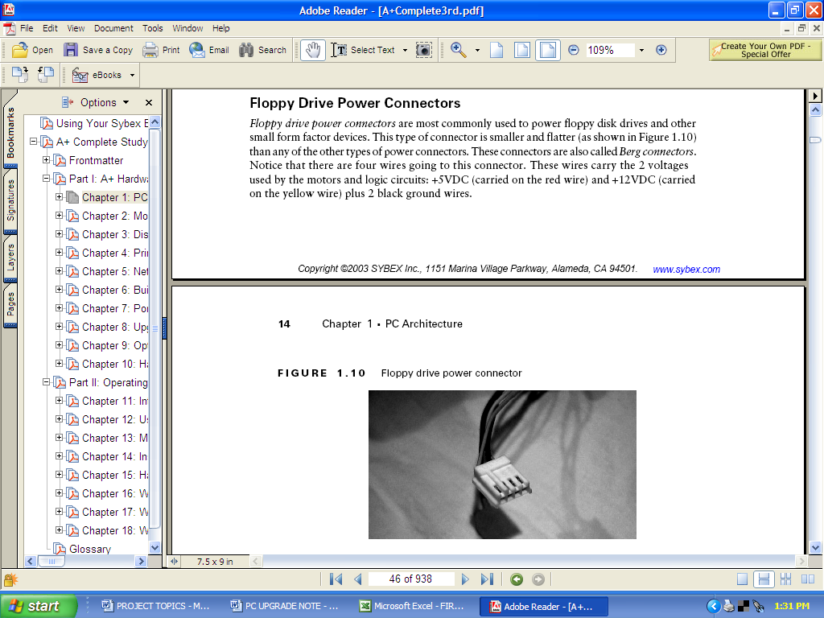
Floppy drive power connectors are most commonly used to power disk drives and other small form factor devices. This type of connector is smaller and flatter as shown below than any of the other types of power connectors. These connectors are also called Berg connectors. Notice that there are four wires going to this connector. These wires carry the 2 voltages used by the motors and logic circuits: +5VDC (carried on the red wire) and +12VDC (carried on the yellow wire) plus ground wires. The Berg connector is shown below:

The PCI Express Connector
Modern graphics cards need more power. They need to power themselves directly from the power block. This is the role of this connector. Originally it was a 6-pin configuration but now available in 8-pin. If you plan to buy a powerful graphics card, be careful on this point: your power supply should contain at least two PCI Express slots including one convertible at least 6 / 8 pin, the PCI Express connector is shown below.
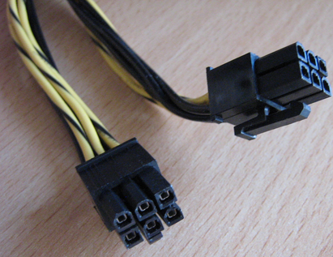

Whether a graphics card requires this power supply connector will depend on its power consumption. Low end graphics cards may not need it at all, while high end graphics card (such as the one pictured below) may require up to two such connectors to run. There are also 8 pin (6 + 2) PCI Express connectors that deliver more power than the regular 6 pin connectors.

EPS Connector
EPS stands for Extended Power Supply, as the name suggest EPS Connector extend the power to CPU by supplying additional power. EPS connector are of either 4 pin or 8 pin, mostly in high-performance systems in which CPU require more power in order to function properly so in this scenario a 8-pin EPS connector is utilized for ensuring stable and efficient power supply to the CPU.

Why use ATX Form Factor
The ATX form factor can be seen as a replacement for the older AT and baby AT form factors. This was invented by Intel in 1995, this no doubt brought about the first major change in the layout of PC motherboards that is being used even till recent times. The ATX motherboard rotates the orientation of the board 90 degrees. This allows for a more efficient design, with disk drive cable connectors closer to the drive bays and the CPU closer to the power supply and cooling fan. All Intel motherboards currently produced are ATX motherboards. Generally speaking, an ATX motherboard is required to use the newest Intel processors. Because of this and the general improvements that ATX brings, the ATX form factor is the form factor of choice for both commercial mass-production systems and for home PC builders.

The ATX form factor involves changes that does not affect only the motherboard design and layout, but also to the case and power supply as well. The improvements and changes brought by ATX form factor are outlined below:
- This design brought about Integrated I/O port connectors
- It brought in also Integrated PS/2 mouse connector
- The design reduced drive bay interference
- It also reduced expansion card interference
- It brought better power supply connector
- The Soft Power support was as a result of this design
- The design came with 3.3V power support
- Better air flow inside the system unit were made possible through this design
- It brought greater Improved upgradability

Factors to Consider when Choosing a Power Supply Unit (PSU)
1. Wattage: If the PSU is providing insufficient amount of Wattage can lead to system instability or even system failure which result in unnecessary costs so the PSU should provide sufficient Wattage to fulfill the requirement of entire system, taking into account the need of CPU, GPU and other components. we can ensure optimal performance and longevity by Determining the power requirements of all components .
2. Efficiency Rating: The more efficient PSU not only make the system cooler and quieter but also reduce the electricity costs and generate less heat. see the PSU's with high efficiency Rating which are indicated by certifications (80 plus) to minimize energy waste to reduce heat output, the efficiency rating provide overview how effectively the PSU convert electric power to specific voltage.
3. Modularity: modular PSU's eliminates unused cables which enhances the cleanliness and organization of the internal system, opting for the modular PSU's allows users to connect only the required cables which improve cable management and helps to build a proper airflow which help in maintenance of system internal temperature .
4. Connectors: Compatibility is key for selecting the PSU's if it does not have the required connecter you may never be able to use it so its important to ensure that the PSU has all the required connecters for your component including SATA , PCIe and CPU power connectors.
5. Reliability and Brand Reputation: PSU is an important component so its Reliability really matters, the Established manufacturers with a positive image in market are more likely to produce a PSU that adhere to quality standards and minimizing the risk of hardware failures.so choosing PSU from Established manufacturers will ensure reliability and performance.

Power Supply Unit Functions
- Without the power supply, the computer will not work. Therefore, the user will not be able to use the computer.
- PSU or the power supply provides the other parts of the computer electrical current.
- It helps in converting the Alternating current (AC) coming from the output or the switchboard to Direct Current (DC) which goes to the other parts of the computer.
- The fan attached in the PSU is used to blow out the heat which is generated by the computer.
- It helps in regulating and limiting the amount of power drawn by appliances to safe levels
- UPS or the Uninterruptible Power Supply helps in the power supply of the user’s computer from “surges” and “voltage drops”.

Power Supply Unit (PSU) Installation Process
Find a power supply for your computer. The power supply that you buy depends on the computer’s motherboard and housing size, meaning that you will need to research your motherboard model to see which power supplies will fit.
- Make sure that you buy a power supply that is optimized for your region. Power supplies for European markets use different voltage settings than the ones used in North American markets.
- Assemble your tools. You'll need at least one screwdriver (typically a Phillips head) to open the CPU housing, which is usually the right-hand side of the CPU box when looking at the back of the box. You may need a different screwdriver for your power supply as well—look at the screws that came with the power supply to determine whether or not this is the case.
- Ground yourself. This will help prevent you from accidentally damaging the internal components of your computer with static electricity.
- You can buy a grounding strap to help keep you grounded while working.
- Open the computer case. You should be looking at the computer's internals at this point. Lay the computer case on its side, with the exposed side facing up.
- Set the power supply's voltage switch. If there is a voltage switch on the power supply, switch it to the 110v or 115v setting. This will ensure that your power supply provides ample power without damaging the components to which it's connected. Not all power supplies have voltage switches, and those that do normally have the switch set to the standard of the region for which they were purchased.
- Find the power supply’s intended location. Power supply units (PSUs) typically sit at the top of the case; this is why the computer’s power cable usually plugs into the top-back section of the case. Refer to your computer’s instruction manual for the proper placement of the power supply unit, or look for a rectangular cut-out on the back of the case.
- If you are removing an old power supply, look for a power plug on the back of the case to find the power supply.
- Insert the power supply. The power supply should have a distinct “back” with plugs and a fan, as well as a “bottom” with a fan on it. The “back” should face the back of the case, while the “bottom”" should face the internal part of the case. If you have an old power supply in your computer, remove it first.
- Screw the power supply into place. With the “back” of the power supply unit pressed against the back of the case, insert the included screws to lock the power supply into place. Many CPU housings have shelves on which the power supply will rest.
- Attach the power supply to the motherboard. Find the main power cable on the power supply (usually the one with the largest plug) and attach it to the long, rectangular port on the motherboard, then attach the secondary power cable to the motherboard.
- Depending on your power supply and motherboard, you may not have a secondary power cable.
- The plug used to attach the power supply to the motherboard is usually a 20- or 24-pin connector.
- Connect the power supply to other computer components. Using the smaller cables, connect the power supply to your computer's hard drive, CD drive, and graphics card. If you have other components in your case (e.g., a lighting system), you may need to plug these in as well.
- Close and plug back in your PC. Place the cover back on the PC, then stand it up and plug it back into the wall and your monitor
- Turn on your computer. If everything is connected and powered properly, the fan on the power supply should turn on and your computer will boot like usual. If you hear a beep and nothing happens, then something inside is not connected correctly, or the power supply is not providing enough power to your components.

