Midterm Exam

Student Number: 301234567

Student Name: Sujal Acharya

1. Screenshots of before changesA screenshot of a computer

   Description automatically generated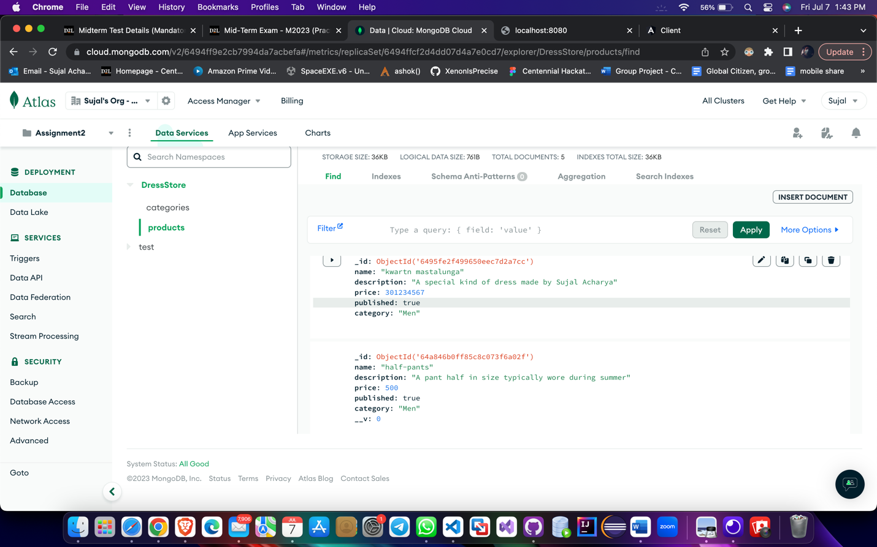
2. Screenshot of adding File

1. Updated DatabaseA screenshot of a computer

   Description automatically generated

