Study on finite element modeling method of oral soft and hard tissues based on CBCT images and digital scanning technology

Ruize Tang1, Qing Cui1,2, Shuo Ren1, Khadbaatar Unurjargal1, Jingxu Li1

(1.Departement of Stomatology,Affiliated Hospital of Yanbian University, Yanbina,Jilin Province 133000 China;2.School of Stomatology,Baicheng Medical College,Baicheng,Jilin Province,137000 China)

Correspondence: Jingxu Li,Email: 0000007562@ybu.edu.cn

**Abstract**

**Objective**: To study an accurate, efficient, and fast method for creating a three-dimensional finite element model using a combination of oral soft and hard tissue images obtained from various field of view CBCT scans and intra-oral 3D scan.**METHODS**: An adult female volunteer was selected, and the mandible was scanned using two different field of view CBCT scans, the resulting images were imported into Mimics, Blue Sky Bio, and 3-Matic software using DICOM format, then it was used to create models of the teeth, periodontal ligament, and mandible bone, respectively. The oral soft tissues and dental arch were scanned using an intra-oral digital scanner. The obtained scans were processed using Geomagic and 3-Matic software to create a gingival model. The created model was meshed, and a three-dimensional finite element model consisting of a tetrahedral mesh was generated.**RESULTS**: A comprehensive finite element model consisting of the mandible, dental arch, periodontal ligament, and gingiva was established. The model comprised a total of 222,873 nodes, with the following distribution: 892,871, 40,358, 405,043 and 234,224 for the mandible bone, periodontal ligament, teeth and gingiva, respectively. **CONCLUSION**: The modeling method based on different field of view CBCT scans and Intra-oral scan can establish a comprehensive finite element model of the mandible bone and gingiva, which is more accurate, faster, and has a wide range of applicability.

**Keywords**: Tooth; Periodontal ligament; Mandible; Gingiva; Finite element method (FEM); CBCT; Intraoral Scanner(IOS)

**Introduction**

The finite element method is an important mechanical research method that combines multidisciplinary techniques such as mathematics, mechanics, and computer science. In 1960, Friedenberg[1]first introduced the finite element method into the field of medicine. In 1973, the finite element method was first applied to the biomechanical research in oral medicine by Thresher et al[2].Since then, it has been widely developed in various fields of oral medicine.

In oral and maxillofacial surgery, the finite element method is widely used in biomechanical research such as the mechanical mechanism of fracture occurrence[3] and stability analysis after fracture fixation[4]. Before finite element analysis, three-dimensional reconstruction of the corresponding anatomical structure is required. Reconstructing a reasonable three-dimensional model is an important foundation for finite element analysis. Currently, three-dimensional reconstruction is mostly based on the following imaging data: CBCT[5]and oral digital scanning model[6]. Cone-beam computer tomography (CBCT) has the characteristics of short scanning time, low radiation dose, low shooting cost, and high resolution. It has become an important clinical diagnostic method in recent years. In terms of modeling oral and maxillofacial hard tissues, CT, spiral CT, Micro-CT, and CBCT imaging data are commonly used. Among them, CBCT balances clinical accessibility and high resolution, making it more suitable for finite element modeling compared to other imaging data [7]. Intraoral Scanner (IOS) refers to obtaining intraoral image information and automatically generating digital models through an intraoral scanner. By emitting laser beams and reflecting them to the receiver, a large amount of two-dimensional images can be obtained and spliced into a three-dimensional model. When teeth are used as recognition markers, the effect of acquiring gingival soft tissue contours is excellent. Based on the above imaging data, a complete model of the maxillary and mandibular soft and hard tissues can be established, including jaws, teeth, periodontal ligaments, and attached gingiva. The current research lacks a systematic method for quickly and completely establishing a maxillofacial soft and hard tissue model. This paper proposes a new modeling technique route that can be applied to finite element modeling in the field of oral and maxillofacial surgery.

**Materials and Methods**

1.1 Materials

An adult female volunteer was selected, who had no malocclusion, dentition defect, periodontal disease, or temporomandibular joint disease. Large field-of-view CBCT (KaVo 3D eXam, Germany), small field-of-view CBCT (CS 8100SC 3D, France), and digital scanner (FUSSEN S6000, China) were used to obtain DICOM raw imaging data and gingival .stl models. This study has been approved by the ethics committee of Affiliated Hospital of Yanbian University (YYLL2024161).

1.2 Three-dimensional reconstruction of jaw bones and dentition

When importing DICOM format files into Mimics26.0 (Materialise, Belgium) software for three-dimensional reconstruction, a complete mandibular model is obtained through the gray threshold adjustment function. At this point, the dentition, jaw bones, and periodontal ligament form a boundaryless integral model. However, due to their different physical properties, it is necessary to separate them and assign different physical properties to them before finite element analysis can be performed. Therefore, the reconstructed model mentioned above can be used for clinical anatomical structure observation or measurement research, but it cannot establish a finite element model.

Small field-of-view CBCT has higher resolution than large field-of-view CBCT, so the separated teeth are clearer. However, the drawback is that it cannot capture images of the mandibular ramus. Therefore, in this study, large field-of-view CBCT was used to separate the jaw bones, while small field-of-view CBCT was used to separate the teeth. Because the hydroxyapatite content of cementum and jaw bones is similar, when using Mimics for separation, the surface structure of the tooth root may be unclear, and there may be redundant structures. Further processing of the tooth root is required, and the adjacent relationship of the teeth also needs to be addressed. However, such processing may damage the original anatomical structure. Therefore, this study will use BlueSkyBio Plan4.1.1 (BlueSkyBio, USA) software to separate the teeth. This software can automatically separate the dentition and obtain a clear and complete dentition model without further processing of the tooth roots and adjacent relationships.

The large field-of-view CBCT was imported into Mimics, and a complete jaw bone model was obtained by setting the gray threshold. Then, the crowns were separated from the jaw bones. The small field-of-view CBCT was imported into BlueSkyBio, and the .stl model of the full dentition was separated using the automatic tooth separation function.

Due to modeling using two different software, the coordinates of the dentition and jaw bones were inconsistent. Therefore, the two sets of models needed to be imported into 3-matic 18.0 (Materialise, Belgium) for registration. Distinct anatomic landmarks such as cusps, cingulum, and contour highs were selected as registration points to align the dentition with the separated crowns, ensuring the correct position of the dentition.

Due to the resolution limitations of the CBCT machine, the periodontal ligament could not be directly reconstructed in three dimensions. Therefore, it was assumed to have a homogeneous thickness of 0.25mm. Models created from different CBCT resolutions vary in precision, so a fitted surface was generated first. Then, using Geomagic Warp 2021 (Raindrop, USA), the dentition model was offset outwards by 0.25mm. Boolean subtraction and intersection operations were performed between the offset dentition and the mandible. The Boolean subtraction yielded the mandible with alveolar sockets, while the Boolean intersection produced a homogeneous periodontal ligament model. Through these steps, a complete mandibular model as shown in Figure 1 was obtained.

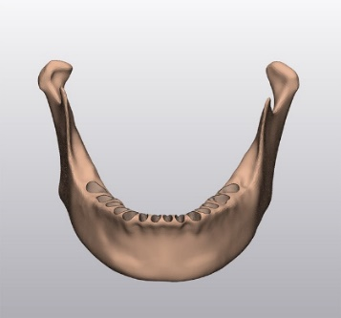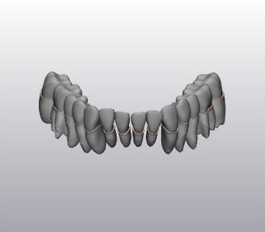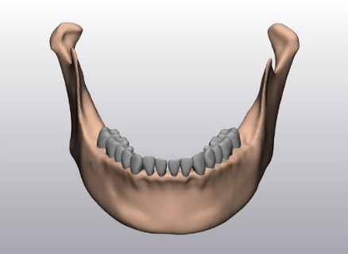

A:Mandible ;B:Periodontal ligament;C:Entire model

Figure 1: Complete three-dimensional model of mandible, dentition, and periodontal ligament

1.3 Three-dimensional reconstruction of gingiva

The three-dimensional model of the full dentition and attached gingiva in .stl format was obtained through digital scanning technology. Due to the inconsistency of the model's coordinates, it needed to be first imported into 3-Matic for registration. Then, the .stl model was imported into Geomagic software to edit the model into a closed shell for subsequent operations. The bottom of the model was divided into multiple small areas, and then the filling command was used to repair each area separately. This avoided problems such as incomplete shell closure caused by large-scale repairs. The crowns on the model were manually segmented, the teeth were deleted, and repairs were performed using the same method as described above. Through the above operations, a complete shell model of the gingiva could be obtained. The model was then imported back into 3-Matic software, and Boolean subtraction operations were performed with the dentition and jaw bones, resulting in the three-dimensional gingiva model shown in Figure 2.

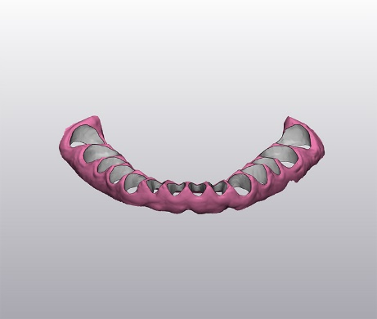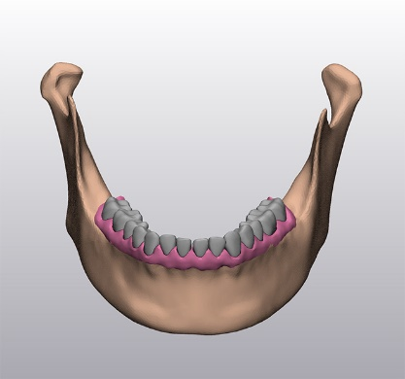

A:Gingival;B: Entire model

Fig 2 Gingival model

**Results**

In this study, a three-dimensional finite element model of the jaw bone, dentition, periodontal ligament, and gingiva was established, as shown in Figure 3. The model was divided into tetrahedral elements, resulting in a total of 222,873 nodes. The jaw bone consisted of 892,871 elements, the periodontal ligament had 40,358 elements, the teeth comprised 405,043 elements, and the gingiva was made up of 234,224 elements.

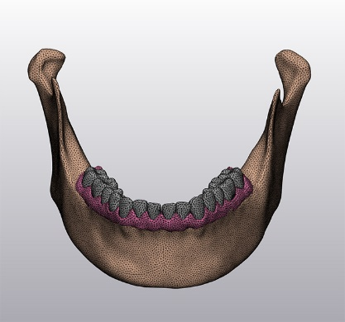

Fig 3 Finite element model for Mandibular ,tooth,periodontal ligament and Gingival with full dentition

**Discussion**

This paper proposes an improved modeling method based on dual CBCT, which effectively reduces modeling time while increasing the accuracy of the model. For gingival modeling, this paper introduces a new gingival modeling method that utilizes oral digital scanning technology to obtain personalized gingival thickness, rather than assuming a homogeneous thickness. This approach is more realistic and has a wide range of applications, including the analysis of stress distribution in the periodontal ligament and tooth displacement involved in orthodontics, the study of fracture stress distribution and numerical analysis of stress in oral and maxillofacial surgery, and discussions in prosthodontics on stress analysis under different implant designs, design optimization, stress analysis of personalized titanium meshes for buccal and lingual bone defects, and stress analysis of edentulous gingival.

The modeling method proposed in this study involves extracting two sets of raw data in DIOCM format and importing them into Mimics and Blue Sky Bio software for modeling, respectively. In previous studies [7, 8], tooth extraction was typically performed in Mimics. However, there are several issues with using Mimics for extraction:Firstly, during the tooth separation process in Mimics, a gray threshold needs to be set for tooth extraction. Different CBCT machine parameters and individual differences among people can lead to variations in threshold settings. Therefore, adjusting the threshold based on experience is required to separate the teeth. This method of extraction requires subsequent processing because it can be difficult to separate the tooth roots, and it increases the workload.Secondly, the teeth extracted using the aforementioned method need further optimization in Geomagic, such as deleting sharp corners and surface features, removing extra triangular facets, and performing repairs. However, this approach has limitations. Deleting and repairing operations in Geomagic can alter the original anatomical structure, especially when performing feature deletion and smoothing operations, which may accidentally delete correct anatomical structures and lose the advantage of personalized modeling.Lastly, for handling the adjacency relationship of the dentition, the aforementioned methods used Geomagic to delete facets [7] or direct segmentation by thresholding [8].In this paper, we propose a method that uses Blue Sky Bio software instead of Mimics for tooth extraction. Its advantages include faster tooth extraction, elimination of manual operations such as threshold adjustment and mask segmentation, thus avoiding individual differences and reducing modeling time.

In previous literature, the gingival soft tissue was obtained by offsetting outward from the jaw bone contour to simulate the gingival tissue attached to the bone surface[7]. The resulting gingiva had a uniform thickness, referred to as homogeneous gingiva. Although simplified homogeneous gingiva can be used for finite element analysis, the model's personalization is limited because gingival thickness varies at different locations. Some studies have used a slice-and-redraw contour method for modeling[8]. This involves acquiring cross-sectional images at 2.5mm intervals using CBCT, drawing contours on each cross-section, and generating a model by extending these contours. However, since the soft tissue contours between cross-sections are computationally generated rather than representing the actual intraoral soft tissue situation, this method has limitations. Digital scanners are widely used in clinical settings and can capture clear STL models of dentition and gingiva, which are often used in digital implantology, orthodontic design, and other areas. Because these models accurately reflect the gingival contours, they can be indirectly aligned through dentition alignment, offering advantages such as simple model acquisition, high contour fidelity, and true gingival thickness. Therefore, they are suitable for establishing finite element models of the gingiva.

**Funding**

No funding

**Data Availability**

The datasets used and/or analyzed during the current study are available from the corresponding author on reasonable request.

**Ethics approval and consent to participate**

This study has been approved by the ethics committee of Affiliated Hospital of Yanbian University (YYLL2024161).

**Competing interests**

The authors declare no competing interests.

Volunteers have agreed to participate in the experiment and signed the informed consent.

**References**

1. Friedenberg R: **"Direct analysis" or "finite element analysis" in biology: a new computer approach**. *Curr Mod Biol* 1969, **3**(2):89-94.

2. Thresher RW, Saito GE: **The stress analysis of human teeth**. *J Biomech* 1973, **6**(5):443-449.

3. Sancar B, Çetiner Y, Dayı E: **Evaluation of the pattern of fracture formation from trauma to the human mandible with finite element analysis. Part 2: The corpus and the angle regions**. *Dent Traumatol* 2023, **39**(5):437-447.

4. Li Y, Li H, Lai Q, Xue R, Zhu K, Deng Y: **Finite element analysis of 3D-printed personalized titanium plates for mandibular angle fracture**. *Comput Methods Biomech Biomed Engin* 2023, **26**(1):78-89.

5. Cheng KJ, Liu YF, Wang JH, Wang R, Xia J, Xu X, Jiang XF, Dong XT: **3D-printed porous condylar prosthesis for temporomandibular joint replacement: Design and biomechanical analysis**. *Technol Health Care* 2022, **30**(4):1017-1030.

6. Abad-Coronel C, Atria PJ, Romero Muñoz C, Conejo J, Mena Córdova N, Pendola M, Blatz M: **Analysis of the mesh resolution of an .STL exported from an intraoral scanner file**. *J Esthet Restor Dent* 2022, **34**(5):816-825.

7. WANG Shuang，SUN Jiang, et al. Study on finite element modeling approach of mandible with full dentition based on CBCT images[J], 2019, 35: 55-59.

8. ZENG Shaoyu , LI Shan, et al. Three-dimensional finite element modeling of the jaw and a stress analysis under dynamic loading[J], 2023, 40: 647-652.

9. Wang CX, Rong QG, Zhu N, Ma T, Zhang Y, Lin Y: **Finite element analysis of stress in oral mucosa and titanium mesh interface**. *BMC Oral Health* 2023, **23**(1):25.

10. Wakabayashi N, Suzuki T: **Patient-specific finite element analysis of viscoelastic masticatory mucosa**. *J Dent Biomech* 2013, **4**:1758736013483298.