الجمهورية الجزائرية الديمقراطية الشعبية
وزارة التعليم العالي و البحث العلمي

People's Democratic Republic of Algeria
Ministry of Higher Education and Scientific Research

Ahmed Zabana University of Relizane
Faculty of Science and Technology
Department of Computer Science

THESIS
In pursuit of the Bachelor's degree (LICENCE)
Within the framework of Decision 008: Diploma in Economic Institution
Information Systems (IS)
Titled

Presented by :
Mr :Bettahar abdelmadjid
Mr :Amari Younes
Mr :Kredim ahmed
Ms :Mostefa tounsi hadil

In the presence of the jury members:
President : Mlle Maître de conférences (B) (U. Relizane)
Supervisor : Mr sofian ammara Maître de conférences (B) (U. Relizane)
Examiner : Mme Maître de conférences (B) (U. Relizane)
Représentant de l’incubateur : Mr Maître de conférences (B) (U. Relizane)
Representative of the economic partner : Mr (Etablissement / adresse)

Academic Year: 2024/2025

Summary
Vertex is a professional networking platform designed to help individuals connect, collaborate, and grow their careers. The website allows users to create detailed profiles, showcase their skills and experience, and engage with a community of professionals. Built using advanced web technologies, Vertex aims to bridge the gap between talent and opportunity by offering features like messaging, job listings, and a personalized activity feed ,all within a clean, user-friendly interface.

ACKNOWLEDGEMENTS:
I would like to express my gratitude to all those who have supported me throughout this journey.
Firstly, I dedicate this work to my family for their continuous encouragement and support. Their presence has been a constant source of motivation.
I also extend my thanks to my teachers and academic supervisors for their guidance and valuable contributions to my academic development.
Special thanks to my friends for their support, encouragement, and the enriching experiences we shared during this process.
Lastly, I dedicate this work to the memory of my late father, whose influence and values continue to inspire me every day.

ACKNOWLEDGEMENTS:

I would like to express my deepest gratitude to my family, whose unconditional support and encouragement have been my source of strength throughout this journey. Their belief in me has pushed me forward even during the toughest moments. I dedicate this achievement to them.

ACKNOWLEDGEMENT:

My sincere thanks go to our professors and academic supervisors who guided us with their knowledge, patience, and dedication. Their valuable insights and continuous support have played a vital role in the success of this work.
ACKNOWLEDGEMENTS:

A heartfelt thank you to our friends and classmates, whose collaboration, discussions, and positive spirit have made this experience not only productive but also enjoyable. Their presence lightened the load and turned this journey into a memory we will cherish forever.

Table of Contents:
Summary 3
ACKNOWLEDGEMENTS 4
ACKNOWLEDGEMENTS: 5
TABLE OF FIGURES: 11
GENERAL INTRODUCTION: 13
Chapter 1 : 14
Presentation and analysis of need 14
1. Introduction 15
2. Presentation of the Platform 16
2.2. Key Features 17
2.3. Comparative Analysis 17
2.4. Organizational Structure 18
2.5. User Interaction Dynamics 18
3. Project Purpose 18
4. Existence Study 19
5. Needs Analysis 20
5.1. Functional Needs 20
5.2. Non-Functional Needs 20
6. User Identification 21
7. Conclusion 22
Chapter 2 : 23
General design 23
1. introduction 24
2. Information Systems 24
3. Software Development Lifecycle (SDLC) 25
3.1. Key Phases of the SDLC 26
3.2. Benefits of SDLC 26
3.3. Maintenance Types 27
3.4. Life Cycle Models 27
3.4.1. The Waterfall Model 27
3.4.2. The V-Model (Verification and Validation Model) 28
Phases of the V-Model 28
3.4.3 the spiral model 29
Phases of the Spiral Model 30
5. Unified Modeling Language (UML) 31
5.1 Class Diagram : 31
5.2 Use Case Diagram : 31
5.3 Activity Diagram : 32
5.4 Sequence Digram : 33
5.4.1 For SignUp & Login : 34
5.4.2 For Posting : 35
5.4.3 For Advertisement Posting & Payment : 35
5.4.4 For Inter with Posts : 36
5.4.5 For Community Management (Creating & Joining) : 36
5.4.6 For Moderation Actions (Delete Post_User) : 37
5.4.7 For Messaging & Chat System : 38
Chapter 3 : 39
Implementatio 39
1. introduction 40
2. Development Environment 40
2.1. Hardware Environment 40
2.2. Software Environment 40
2.2.1. UML Modeling Environment 40
2.2.2. Programming Languages 41
2.2.3. Programming Environment 42
2.2.4. Database Management System Environment 43
3. Application Functionality 44
4. Conclusion 44
General Conclusion 47
Annexe: Guide du projet 48
A.1 Information Card 49
A.2 Project Overview 49
A.2.1 Project Idea (Proposed Solution) 49
A.2.2 Suggested Values 50
A.2.3 Project Team 51
A.2.4 Project Objectives 51
A.2.5 Project Implementation Plan 52
A.3 Innovative Aspects 52
A.3.1 Nature of Innovations 52
A.3.2 Innovation Domains 53
A.4 Strategic Market Analysis 53
A.4.1 Market Segment 53
A.4.2 Competition Intensity Assessment 54
A.4.3 Marketing Strategy 54
A.5 Production and Organization Plan 55
A.5.1 Production Process 55
A.5.2 Supply Chain 56
A.5.3 Workforce 56
A.5.4 Key Partners 57
A.6 Financial Plan 57
A.7 Prototype Description 58
A.8 Business Model Canvas (BMC) 59
A.8.1 Key Partners 59
A.8.2 Key Activities 59
A.8.3 Value Propositions 60
A.8.4 Customer Relationships 60
A.8.5 Customer Segments 60
A.8.6 Channels 61
A.8.7 Key Resources 61
A.8.8 Cost Structure 62
A.8.9 Revenue Streams 62

TABLE OF FIGURES:

CHAPTER 1:
FigureI- 1 Social media team structure 15

CHAPTER 2:
Figure II- 1 The Waterfall Model 25
Figure II- 2 The V-model 26
Figure II- 3 Spiral Model 28
Figure II- 4 Use case diagram 29
Figure II- 5 Activity diagram. 30
Figure II- 6 Sequence diagram for sign up and log in 31
Figure II- 7 Sequence diagram for posting 32
Figure II- 8 Sequence diagram for Advertisement Posting & Payment 32
Figure II- 9 Sequence diagram for Inter with Posts 33
Figure II- 10 Sequence diagram for Community Management (Creating & Joining) 33
Figure II- 11 Sequence diagram for Moderation Actions (Delete Post_User) 34
Figure II- 12 Sequence diagram for Messaging & Chat System 34

CHAPTER 3:
Figure III- 1 StarUML. 42
Figure III- 2 CSS JS TS HTML. 43
Figure III- 3 Vs code logo 44
Figure III- 4 authentication (create account) 45
Figure III- 5 Pricing Page 46
Figure III- 6 home page 46
Figure III- 7 Creating a post 47
Figure III- 8 sharing a comment 47
Figure III- 9 Users Profile posts side 48
Figure III- 10 Users Profile community side 48
Figure III- 11 Profile edit 49
Figure III- 12 community creation 1st part 49
Figure III- 13 community creation 2nd part 50
Figure III- 14 password reset 50
Figure III- 15 sharing post by link 51

GENRAL INTRODUCTION

GENERAL INTRODUCTION:
In the rapidly evolving digital age, technology plays a central role in shaping human interaction, communication, and collaboration. Social media platforms have transformed the way individuals and communities connect, share ideas, and work together across geographical boundaries. While general-purpose platforms such as Facebook, Twitter, and LinkedIn offer various features for social interaction, they often fall short in meeting the specific needs of professional or interest-based communities that require tailored tools for collaboration, learning, and knowledge sharing. This final year project aims to address this gap by designing and implementing a specialized social media platform dedicated to fostering professional development and structured community engagement. By incorporating advanced features such as real time collaboration tools, knowledge-sharing modules, the platform aspires to become a vital space for users to grow, learn, and work together in an efficient digital environment. The following document outlines the research, design methodology, development process, and technical implementation of the proposed platform. It is the result of months of study, experimentation, and commitment, and serves as both an academic contribution and a potential real-world solution to an existing digital communication challenge.

Chapter 1 :

Presentation and analysis of need

1. Introduction
In today's digital era, social media platforms have become essential tools for connecting individuals and fostering community engagement. These platforms enable users to share knowledge, collaborate on projects, and build relationships across various interest groups, transcending geographical boundaries. Social media is no longer just a means of entertainment or casual communication; it has evolved into a powerful instrument for professional networking, skill development, and community building. The integration of these platforms into daily life has transformed how communities form, interact, and evolve, making collaboration more dynamic and accessible. Whether in education, business, technology, or creative industries, the role of social media in bringing together people with shared interests and goals cannot be underestimated [1].
Despite the abundance of general social media platforms, there is a growing need for specialized applications that cater to specific community interests and needs. Generalist platforms such as Facebook, Twitter, and LinkedIn provide broad networking opportunities but often lack the specific tools and features required for niche communities. For instance, designers, developers, marketers, educators, and artists each have unique requirements for collaboration, portfolio showcasing, and skill enhancement. Specialized platforms can offer tailored tools and environments that enhance collaborative efforts, streamline workflows, and promote a cohesive community experience. The rise of niche social networks, such as Dribbble for designers and GitHub for developers, demonstrates the demand for platforms that cater to industry-specific interactions. However, there remains a gap for an all-encompassing space that unites multiple professional communities in a structured and meaningful way .
This project seeks to create a specialized social media platform that addresses the unique needs of various communities, fostering continuous learning and professional development. Unlike general social networks, this platform will provide a structured environment where users can not only connect but also actively engage in meaningful discussions, share resources, and participate in collaborative projects. By leveraging the latest technological advancements, real-time collaboration tools, and integrated learning modules, the platform will offer a seamless experience for knowledge sharing and skill-building. Furthermore, it will encourage mentorship opportunities, allowing experienced professionals to guide newcomers in their respective fields. This initiative aligns with the growing trend of digital ecosystems designed to support both socialization and professional growth, ultimately contributing to the enrichment of multiple fields and industries.
In addition to facilitating professional networking, this platform will serve as a knowledge hub where individuals can access curated content, participate in discussions, and contribute to a continuously expanding repository of information. Unlike traditional social media, which often prioritizes engagement metrics over quality interactions, this platform will focus on meaningful exchanges that add value to users' professional journeys. With the integration of advanced communication features such as live Q&A sessions, expert panels, and skill-based forums, it will create a space where learning is not only passive but highly interactive. As online learning and professional development become increasingly digitized, a well-structured platform dedicated to these purposes can help bridge the gap between education and practical application, making knowledge more accessible to a wider audience.
Ultimately, the goal of this project is to redefine the way communities interact in the digital space. By providing a dedicated social media platform tailored to the needs of different professional and interest-based communities, it will create opportunities for collaboration, mentorship, and skill enhancement. As social media continues to evolve, specialized platforms like this will play an essential role in shaping the future of digital communication, networking, and knowledge-sharing across various industries.

2. Presentation of the Platform
With the rapid digital transformation, communities worldwide are seeking more efficient ways to connect, collaborate, and share knowledge. While traditional social media platforms provide general networking opportunities, they often lack the necessary tools to facilitate structured collaboration and knowledge exchange tailored to specific groups. To address this gap, our platform is designed as a dedicated space for diverse communities, enabling members to interact in a more meaningful and productive way. By integrating advanced communication and collaboration features, this platform fosters an environment where users can build connections, exchange expertise, and work on shared projects seamlessly.
2.1. Platform Overview
The proposed platform is a specialized social media application designed to create dynamic and interactive spaces for various interest-based communities. It allows users from different fields to connect, share their knowledge, and work together efficiently. Unlike conventional platforms, this solution provides a structured environment that enhances both social interactions and professional collaborations.

2.2. Key Features
The platform includes several innovative features to enhance user experience and engagement:
- User Profiles: Each user has a customizable profile to showcase their skills, interests, and contributions, making it easier to connect with like-minded individuals.
- Community Hubs: Dedicated spaces where users can join or create communities based on specific interests, fostering focused discussions and collaborations.
- Content Sharing: Users can post articles, videos, and project updates, promoting knowledge dissemination and interactive learning.
- Collaboration Tools: Integrated project management features, shared workspaces, and real-time communication tools support seamless teamwork.
- Event Management: Users can organize and attend virtual or in-person events, workshops, and networking sessions.
- Resource Library: A centralized repository where users can upload and access educational materials, guides, and tutorials.

2.3. Comparative Analysis
To better understand the platform’s uniqueness, it can be compared with existing solutions:
- Reddit: While Reddit provides topic-based communities, it lacks integrated collaboration tools for structured teamwork.
- Facebook Groups: These allow for group discussions but are not designed for professional collaboration or resource sharing.
- LinkedIn: Primarily a professional networking platform, LinkedIn does not emphasize community-driven engagement and real-time collaboration.
This platform differentiates itself by merging social engagement with powerful collaboration tools, creating a unique space for diverse communities to thrive.

2.4. Organizational Structure
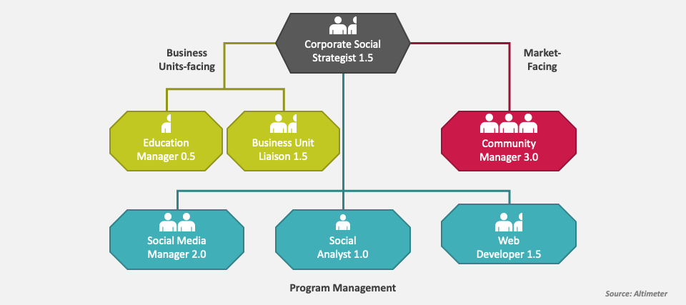
FigureI- 1 Social media team structure

2.5. User Interaction Dynamics
The platform supports various interaction modes to maximize engagement:
- Hierarchical Interactions: Users can engage with administrators and community managers for guidance and support.
- Peer-to-Peer Interactions: Members can directly collaborate, exchange knowledge, and work on shared projects.
- Cross-Community Engagement: Users can participate in multiple communities, fostering interdisciplinary knowledge exchange and collaboration.
By promoting diverse interaction modes, the platform enhances user engagement, making it a valuable tool for both professional and social networking.

3. Project Purpose
The primary objective of our platform is to establish a structured and interactive social media application that bridges the gap between knowledge-sharing communities and professional collaboration. In today’s digital age, traditional social media platforms often focus on casual networking and entertainment, leaving a gap in structured community engagement and knowledge exchange [2]. Our platform aims to address this need by integrating features that foster meaningful interactions, professional networking, and knowledge dissemination.
To achieve this, the platform is designed with several core objectives:
- Enhance Knowledge Sharing: Users can seamlessly interact through discussion forums, multimedia content sharing, and expert-driven contributions, making the learning process more engaging and informative .
- Foster Professional Growth: Users can develop their professional profiles, engage in knowledge-driven communities, and establish valuable industry connections.
- Encourage Collaboration: The platform includes dedicated collaboration tools, such as shared workspaces, real-time messaging, and task management features, ensuring efficient teamwork and project execution .
Provide a Secure and Reliable Environment: Robust security protocols, encrypted communication, and customizable privacy settings will ensure that user data remains protected.
- Ensure a Seamless User Experience: With an intuitive and accessible interface, the platform facilitates user engagement across different backgrounds and skill levels .
By addressing these objectives, the platform will become an essential tool for fostering innovation, collaboration, and professional development within various knowledge-sharing communities.

4. Existence Study
A fundamental step in project development is analyzing the existing landscape to identify gaps and challenges. Traditional social media platforms offer broad connectivity but lack specialized features that promote structured knowledge exchange and collaboration [3]. To justify the necessity of our platform, we conducted extensive research on current systems and identified several limitations:
- Lack of Structured Knowledge Exchange: Most social media platforms prioritize casual interactions over meaningful professional discussions, creating an environment where valuable insights often get lost in the clutter .
- Limited Collaboration Tools: Users frequently rely on third-party applications for teamwork and project management, leading to fragmentation and inefficiency .
- No Direct Market Integration: Many professionals struggle to connect with potential clients or employers within their social media networks, missing out on valuable opportunities .
- Absence of Engagement Incentives: Unlike specialized platforms, general social media lacks gamification features that encourage active participation and contributions .
- Privacy and Security Concerns: Many users face data privacy issues and lack control over their shared content, reducing trust in digital collaboration spaces .
These shortcomings highlight the need for a social media platform that integrates knowledge-sharing, professional networking, and collaboration tools into a single, user-friendly environment. By addressing these gaps, our platform will empower communities to exchange ideas, develop skills, and create opportunities more effectively.

5. Needs Analysis
To ensure the success of the platform, a detailed needs analysis was conducted, classifying requirements into two main categories: functional and non-functional needs.

5.1. Functional Needs
The platform must include essential features to support user engagement and productivity:
- User Account Management: Secure registration, customizable profiles, and role-based access control .
- Community Interaction: Features such as discussion forums, group creation, and content posting to enable active participation .
- Collaboration Tools: Integrated project management, file-sharing capabilities, and task delegation to streamline teamwork .
- Content Management: Tools for uploading, organizing, and accessing knowledge resources, including multimedia formats .
- Event Organization: Scheduling and hosting virtual or in-person events, webinars, and community meetups.

5.2. Non-Functional Needs
Non-functional needs define the technical specifications and quality standards that the system must meet to provide a reliable, high-performance, and user-friendly service. Based on usability studies and platform performance benchmarks, our system must meet the following criteria:
- Security: The platform must ensure strong protection of user data, both personal and professional, against unauthorized access or misuse.

- Performance: The system should guarantee fast and responsive operations, minimizing loading times to enhance user experience.
- Reliability: Even under high traffic or heavy workload conditions, the platform should maintain stable and uninterrupted functionality.
- User-Friendliness: The interface must be designed for intuitive navigation, allowing even beginners to interact effortlessly with the platform.
- Compatibility: The platform should be accessible across various devices, including computers, tablets, and smartphones, and support multiple browsers.
- Scalability: As the user base grows, the system should support new features and increased activity without compromising performance.
- Accessibility: Compliance with accessibility standards is essential to accommodate a diverse audience, including individuals with disabilities.
By integrating both functional and non-functional requirements, our platform aims to deliver a comprehensive, high-quality learning and collaboration environment that aligns with technological advancements and user expectations.

6. User Identification
The social media platform for professional communities is structured around three distinct user roles, each playing a fundamental role in fostering engagement, facilitating knowledge exchange, and enhancing the overall functionality of the platform;
- Community Member:
A general user who joins the platform to engage with like-minded professionals. They can create and share posts, comment on discussions, follow specific topics or individuals, and participate in knowledge-sharing activities.
- Content Creator:
This user actively contributes valuable content such as tutorials, industry insights, and project showcases. Content creators have access to tools for structuring and distributing their content effectively within the platform.
- Community Moderator/Admin:
Moderators oversee platform activities to ensure a healthy and constructive environment. They can manage discussions, enforce community guidelines, remove inappropriate content, and assist users in resolving disputes.
These user roles work together to foster an interactive and knowledge-driven platform, enabling professionals to connect, collaborate, and grow within their respective fields.

7. Conclusion
In this chapter, we explored the fundamental aspects that shape our platform, including its technical requirements and user roles. By defining both functional and non-functional needs, we ensure the system will deliver a seamless and enriching experience for all participants. The clear identification of user roles further emphasizes the collaborative nature of the platform, fostering an environment where students, clients, and instructors benefit from mutual engagement. In the next chapter, we will discuss the methodology adopted for the platform’s development, detailing the steps taken to bring our vision to life.

Chapter 2 :

General design

1. introduction
The design phase is a critical step in software development, providing the structural foundation to meet system requirements efficiently. It ensures seamless interaction between components while prioritizing performance, security, and scalability. For our professional social media platform, this phase establishes the architecture that enables a dynamic and interactive user environment [4].
In this chapter, we highlight the core elements of system design, emphasizing the importance of effective information systems in managing digital interactions. This is especially vital in social platforms where fast data processing and smooth communication are key.
While there are various methodologies used in managing software projects, including models like the Waterfall and Spiral approaches, we focus primarily on the design aspects relevant to our platform without delving into each model in detail.
We also introduce modeling tools such as the Unified Modeling Language (UML), which helps visualize system behavior and define component interactions. UML serves as a standardized way to document and communicate design decisions within the development team [5].
Ultimately, this chapter aims to deliver a clear design strategy that meets both functional and technical requirements, minimizing risks and aligning the application with user expectations.

2. Information Systems
An information system (IS) has become a fundamental pillar in the operational framework of modern organizations. It encompasses a comprehensive set of resources, including personnel, software, processes, data, hardware, and telecommunications infrastructure, all working together to facilitate the collection, storage, organization, management, analysis, transmission, and dissemination of information. This information can take multiple forms, including text, images, audio, and video, making information systems highly versatile tools in today’s digital landscape [6].
A well-structured information system consists of several critical components, such as databases, database management systems (DBMS), enterprise resource planning (ERP) software, and customer relationship management (CRM) tools. These components help organizations streamline data handling, ensuring that information is stored efficiently, accessed securely, and processed accurately. Additionally, IS plays a key role in automating business processes, reducing redundancies, and improving overall productivity [7].
Beyond its technical aspects, an information system integrates human and technical resources into a cohesive structure. It aligns processes, business rules, and technological assets to optimize an organization’s workflow. By enabling seamless interaction between various business functions, IS enhances communication, supports real-time decision-making, and ensures that information is accessible to the right people at the right time [8].
The ability of organizations to leverage information systems effectively translates into strategic advantages, such as enhanced operational efficiency, improved customer service, and informed decision-making. With the rapid advancements in cloud computing, artificial intelligence, and big data analytics, modern IS solutions continue to evolve, offering unprecedented opportunities for businesses to adapt and remain competitive in a fast-paced digital environment [9].

3. Software Development Lifecycle (SDLC)
The Software Development Lifecycle (SDLC) is a structured framework that outlines the entire process of software creation, from initial conception to eventual retirement. It provides a systematic approach to software development, ensuring that the final product meets user requirements while maintaining high quality and efficiency. By establishing clearly defined phases, SDLC facilitates project management, risk mitigation, and quality control, ultimately leading to a more reliable and cost-effective software development process [10].
One of the core principles behind the SDLC is the recognition that addressing defects and inconsistencies early in the development cycle significantly reduces costs and effort compared to resolving them later in the process. Breaking down software development into distinct phases allows teams to detect potential issues early, refine project objectives, and ensure that the final product aligns with stakeholder expectations. Additionally, the SDLC enhances collaboration between developers, project managers, and clients by providing a structured workflow that clarifies responsibilities at each stage.

3.1. Key Phases of the SDLC
The Software Development Lifecycle (SDLC) consists of several structured phases, each playing a crucial role in ensuring software quality and efficiency. These phases provide a clear roadmap from project initiation to software deployment and maintenance, ensuring that the final product aligns with user expectations and technical requirements [11].
- Planning: The project's scope, goals, and timeline are defined, ensuring alignment with the organization's strategic vision and identifying required resources.
- Requirements Analysis: Stakeholder needs are collected and analyzed to establish clear functional and non-functional software requirements.
- System Design: The overall structure and technical specifications of the software are outlined, including system architecture, data flow, and user interfaces.
- Development: The software is built according to the design documents using appropriate technologies and programming languages.
- Testing: Functional and non-functional aspects of the software are thoroughly tested to identify and resolve defects, ensuring it meets quality standards.
- Deployment: The software is released into the production environment, making it available to users in real-world conditions.
- Maintenance: Ongoing updates, bug fixes, and performance enhancements are made to ensure the software remains secure, stable, and aligned with user expectations.

3.2. Benefits of SDLC
The SDLC approach brings several advantages that contribute to efficient software development and project success:
- Provides a structured and organized framework for software development.
- Reduces complexity by dividing the process into manageable and sequential stages.
- Enhances early error detection and resolution, reducing costly modifications later.
- Improves software quality by ensuring adherence to user requirements and industry standards.
- Increases predictability in project timelines, cost estimates, and risk management [12].

3.3. Maintenance Types
Software maintenance is a critical post-deployment phase, ensuring long-term software stability and adaptability. The main types of maintenance include:​
- Corrective Maintenance: Involves identifying and fixing defects or errors discovered after software deployment.​
- Adaptive Maintenance: Focuses on updating the software to accommodate changes in the environment, such as new operating systems or hardware.​
- Perfective Maintenance: Aims to enhance software functionality and performance based on user feedback and evolving requirements.​
- Preventive Maintenance: Entails modifications to prevent potential future issues, improving software reliability and maintainability.​
The specific SDLC activities may vary depending on the chosen development model, such as the Waterfall Model, V-Model, Spiral Model, or iterative approaches like Agile. However, regardless of the model, SDLC provides a well-defined structure to manage software projects effectively, minimize risks, and ensure high-quality deliverables [13].

3.4. Life Cycle Models

3.4.1. The Waterfall Model
The Waterfall Model is one of the earliest and most widely recognized software development methodologies. It was introduced by Winston W. Royce in 1970 and follows a linear, sequential approach to software development, where each phase must be completed before moving to the next. While this model is simple and idealistic, it was once highly popular due to its clear structure and easy-to-follow progression [14].

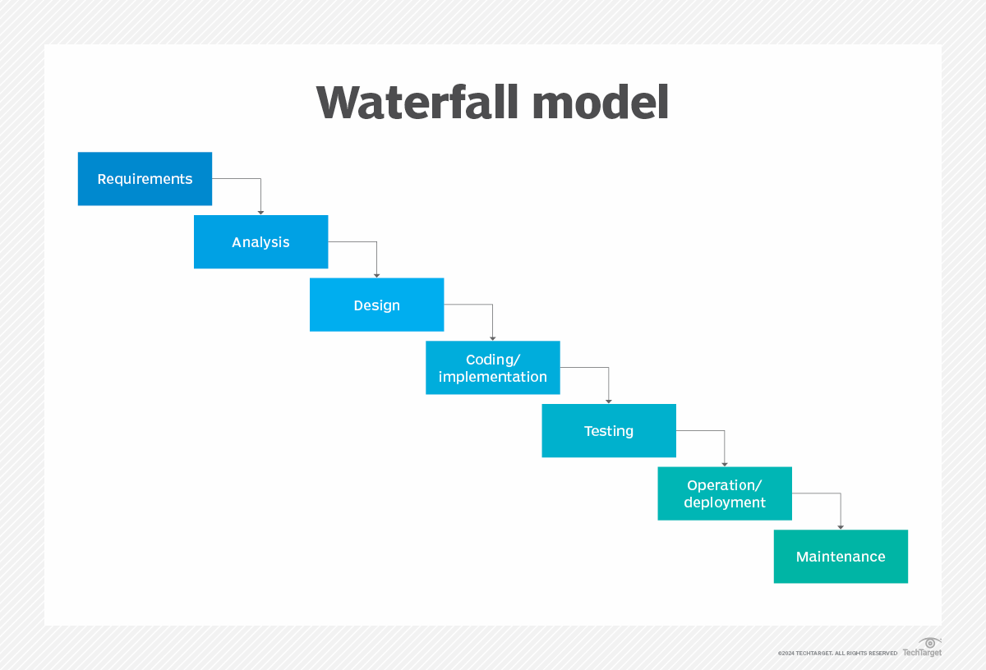
Figure II- 1 The Waterfall Model

3.4.2. The V-Model (Verification and Validation Model)
The spiral model is a software development life cycle model that incorporates the different stages of the V-model. By implementing successive versions, the cycle restarts, offering an increasingly complete and robust product. However, the spiral model places more emphasis on risk management than the V-model. [15].

Phases of the V-Model
The V-Model consists of two main phases:

Development Phases (Left Side of the V):
- Requirements Analysis: Identifies business needs and system requirements.
- System Design: Defines the architecture and major components of the system.
- High-Level Design: Specifies module interactions and data flow.
- Low-Level Design: Focuses on internal module logic, functions, and database structures.
- Implementation (Coding): Translates the design into source code using a programming language.

Testing Phases (Right Side of the V):
- Unit Testing: Tests individual software components against the low-level design.
- Integration Testing: Ensures that different software modules work together as specified in the high-level design.
- System Testing: Verifies that the entire system meets business and functional requirements.
- User Acceptance Testing (UAT): Validates that the software satisfies user needs before deployment.
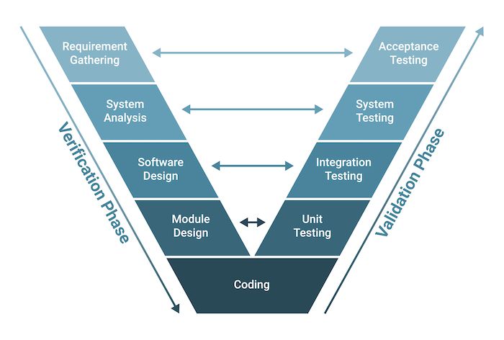
Figure II- 2 The V-model

3.4.3 the spiral model
The Spiral Model, introduced by Barry Boehm in 1986, is a risk-driven software development approach that combines iterative development with systematic risk analysis. Unlike traditional linear models such as the Waterfall Model, the Spiral Model emphasizes continuous refinement through multiple iterations or "spirals" of development. Each cycle of the model represents a new version of the software, improving functionality and addressing risks at every stage.
This model is particularly useful for large, complex projects where requirements are uncertain or likely to change. It allows for early identification of potential risks and encourages customer feedback throughout the development process, making it a flexible and adaptive approach [16].
The Spiral Model consists of four major phases, which are repeated in multiple iterations until the final product is ready for deployment.

Phases of the Spiral Model
The Spiral Model follows an iterative approach to software development, integrating risk management and continuous refinement. It consists of four key phases:
- Planning Phase
In this phase, project objectives, requirements, and constraints are identified. A feasibility study is conducted to assess project viability, and an initial plan is established for the next cycle.
- Risk Analysis Phase
Potential risks are identified, analyzed, and mitigated through research, simulations, or prototyping. This phase ensures that critical issues are addressed before progressing further.
- Engineering Phase
The actual development of the software takes place, including system design, coding, and testing. Prototypes or early versions are created and refined based on risk assessments.
- Evaluation & Review Phase
The developed iteration is reviewed with stakeholders to gather feedback. Adjustments are made as necessary, and decisions are taken regarding further iterations or final product deployment.
This cycle is repeated for each iteration until the software is fully developed and meets all user requirements.
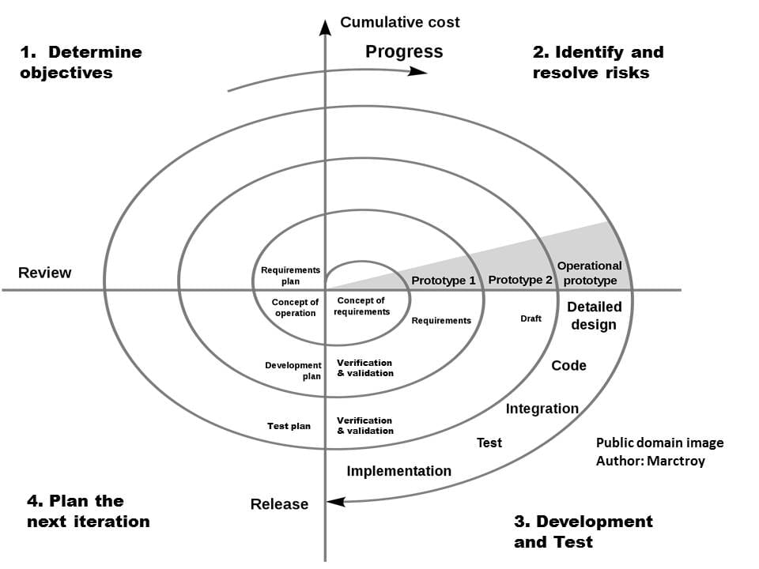
Figure II- 3 Spiral Model

5. Unified Modeling Language (UML)
UML is the English acronym for "Unified Modeling Language." It is translated as "Langage de modélisation unifié" in French. UML notation is a visual language made up of a set of diagrams, each providing a different perspective on the project being developed. UML therefore provides us with diagrams to represent the software to be developed: its functionality, how it operates, the actions the software can perform, and so on [17*].

5.1 Class Diagram :
Represents the static structure of the system, showing classes like User, Post, Community, Message, and their relationships.

5.2 Use Case Diagram :
Illustrates the interactions between users (members, admins, moderators) and system functionalities like SignUp, Post, Interact, Manage Communities, and Chat.

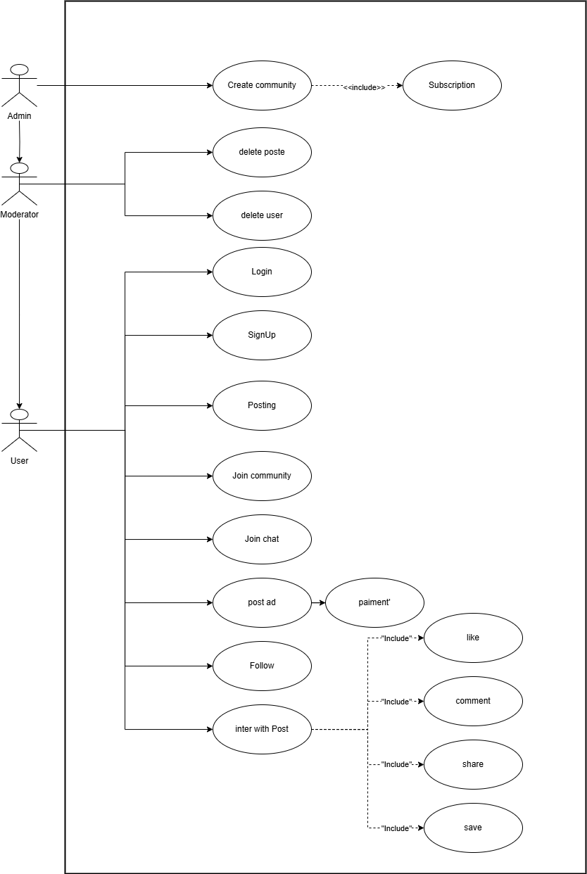
Figure II- 4 Use case diagram

5.3 Activity Diagram :
Shows the flow of activities for key processes like user registration, posting content, and payment for ads.
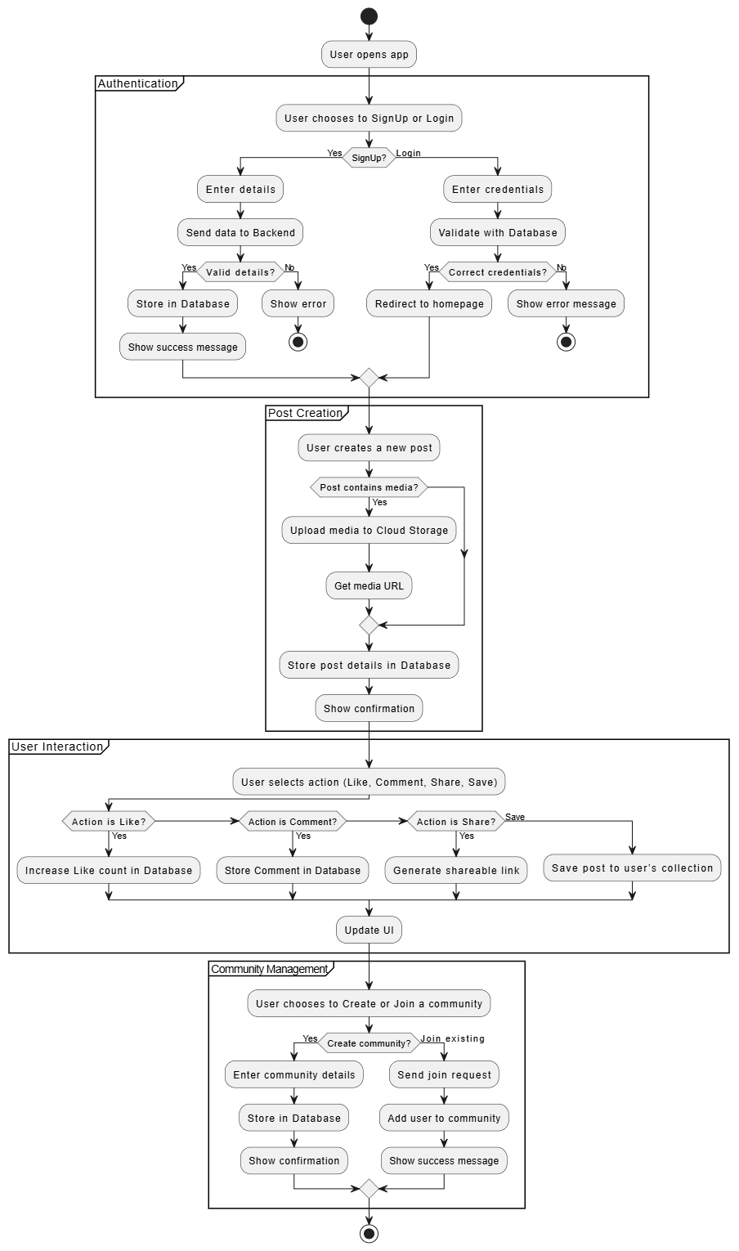
Figure II- 5 Activity diagram.

5.4 Sequence Digram :
Details the step-by-step interaction between system components during tasks like login, creating posts, and sending messages.

5.4.1 For SignUp & Login :
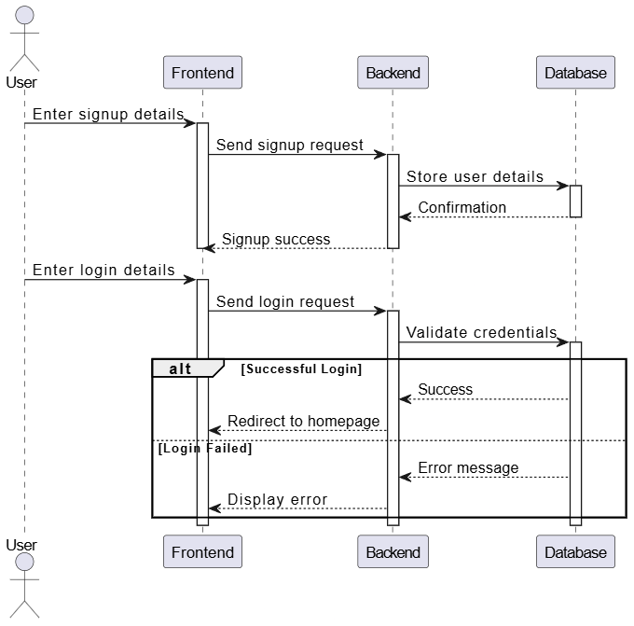
Figure II- 6 Sequence diagram for sign up and log in

5.4.2 For Posting :

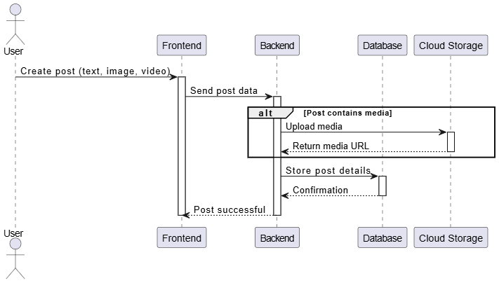
Figure II- 7 Sequence diagram for posting

5.4.3 For Advertisement Posting & Payment :
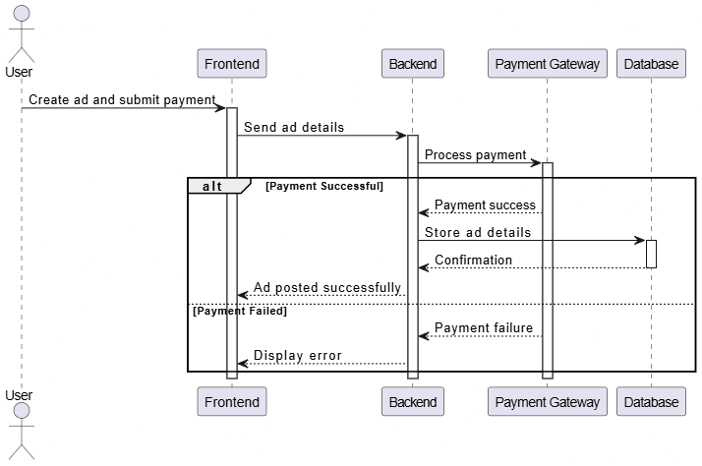
Figure II- 8 Sequence diagram for Advertisement Posting & Payment

5.4.4 For Inter with Posts :
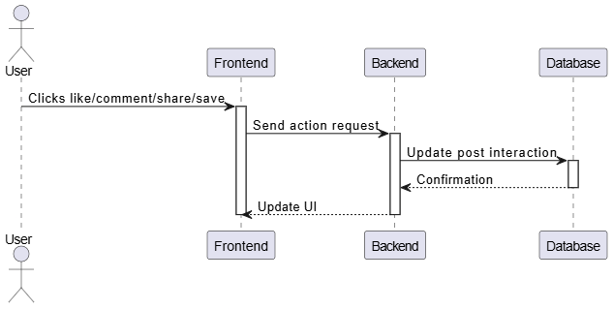
Figure II- 9 Sequence diagram for Inter with Posts

5.4.5 For Community Management (Creating & Joining) :

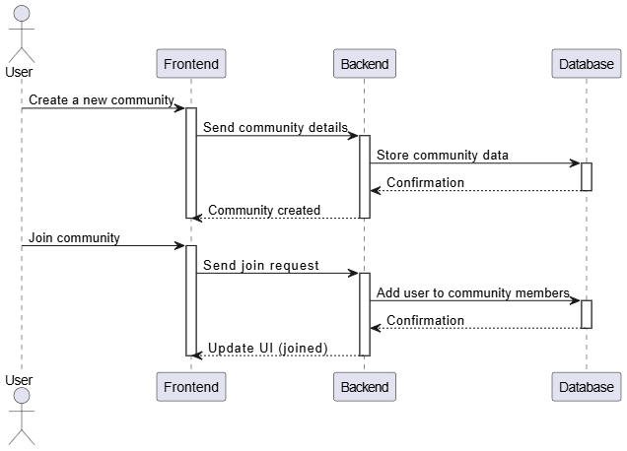
Figure II- 10 Sequence diagram for Community Management (Creating & Joining)

5.4.6 For Moderation Actions (Delete Post_User) :

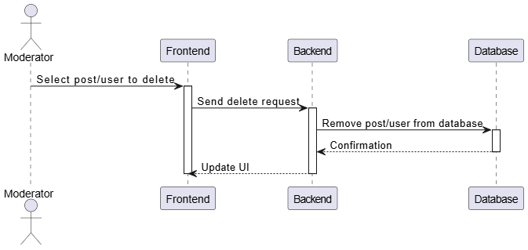
Figure II- 11 Sequence diagram for Moderation Actions (Delete Post_User)

5.4.7 For Messaging & Chat System :
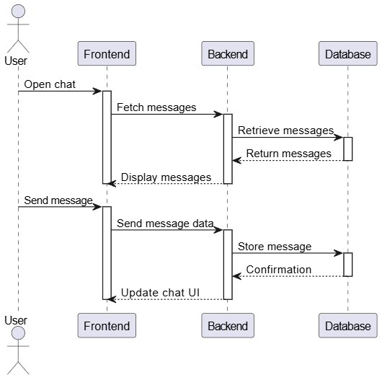
Figure II- 12 Sequence diagram for Messaging & Chat System

Chapter 3 :

Implementatio

1. introduction
In this chapter, we will present the implementation phase of our project. We will begin by describing the development environment as well as the technical tools selected to meet the system’s requirements. Then, we will detail the integration process of the various interfaces, highlighting the main functionalities through screenshots and technical explanations. This section aims to demonstrate the overall operation of our application through practical testing.

2. Development Environment

2.1. Hardware Environment
For the development of our application, we used a set of computers with the following specifications:
- Intel Core i3 10th Generation, 8GB RAM, 256GB SSD
- AMD Ryzen 3 7000 Series, 8GB RAM, 256GB SSD
- Intel Core i7 6th Generation, 16GB RAM, 512GB SSD
For deployment, the server was hosted on a Linux environment (Ubuntu 22.04 LTS), chosen for its reliability, security, and compatibility with production systems. It efficiently supports the Go backend and PostgreSQL database, making it suitable for scalable web hosting.

2.2. Software Environment
We carried out the implementation of our system using Visual Studio Code (VS Code), a lightweight yet powerful code editor developed by Microsoft. VS Code is well-suited for modern web development and supports a wide range of programming languages and extensions [18].

2.2.1. UML Modeling Environment
To design and model our system architecture, we used StarUML, a popular open-source modeling tool that supports Unified Modeling Language (UML) [19]. Licensed under GNU GPL, StarUML is designed to be modular, lightweight, and extensible.
Key features of StarUML include:
- An intuitive interface for creating UML diagrams
- Support for generating class skeletons in Java, C++, C#, and more
- Plugin support to extend its capabilities
- Export options in XMI and JPG formats for documentation and sharing
- Customizable visual styles (backgrounds, fonts, connectors, etc.) [19]
The application is organized into five main zones:
- Model Explorer: hierarchical navigation through diagrams
- Properties Panel: editing selected element properties
- Toolbox: drag-and-drop elements for diagrams
- Workspace: main editing area for creating diagrams
- Style Panel: appearance customization for entities and links
StarUML helped us efficiently visualize our system design and communicate our architectural choices clearly.

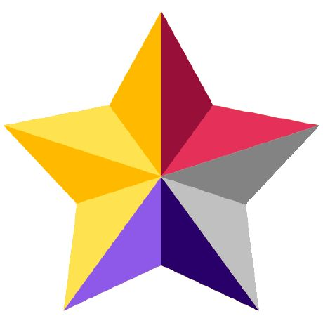
Figure III- 1 StarUML.

2.2.2. Programming Languages
Our application was developed using modern and powerful programming languages that are widely adopted in both academic and industrial settings.
- On the frontend, we used:
  - HTML (HyperText Markup Language) for structuring the content
  - CSS (Cascading Style Sheets) for styling and layout
  - JavaScript for adding interactivity and client-side logic
  - TypeScript, a statically typed superset of JavaScript, to improve code maintainability and catch errors during development [20]
- On the backend, we used Go (or Golang), a statically typed, compiled language developed by Google, known for its simplicity, concurrency support, and high performance. It is particularly well-suited for building scalable APIs and microservices [21].
These languages collectively provided a robust, efficient, and maintainable stack for full-stack web development.

Figure III- 2 CSS JS TS HTML.

2.2.3. Programming Environment
For coding and managing our project, we used Visual Studio Code (VS Code) as our primary development environment. VS Code is a powerful, free source-code editor developed by Microsoft [18]. It supports a wide range of programming languages and is highly extensible through its rich ecosystem of plugins.
Key features of VS Code include:
- Built-in Git integration for version control
- Rich debugging tools and code navigation
- Support for IntelliSense for code completion and hints
- Extensions for Go, JavaScript, TypeScript, HTML, and CSS
- Terminal access directly from the editor
VS Code enabled us to maintain a fast development workflow and ensure code quality across the entire application. Additionally, the modular extension system allowed us to configure the environment precisely to our needs.

Figure III- 3 Vs code logo

2.2.4. Database Management System Environment
In our project, we adopted PostgreSQL as the Database Management System (DBMS). PostgreSQL is an advanced, open-source, object-relational database system that has been actively developed and maintained for over 30 years. It is renowned for its stability, extensibility, and strict compliance with SQL standards [22].
PostgreSQL provides robust support for advanced data types such as JSON, XML, and arrays, as well as modern programming constructs like window functions, common table expressions (CTEs), and full-text search capabilities. This flexibility allows developers to design powerful and efficient database schemas tailored to the specific needs of their applications.
One of the key reasons we selected PostgreSQL is its ACID compliance (Atomicity, Consistency, Isolation, Durability), which ensures reliable transaction processing and data integrity, even in cases of unexpected shutdowns or concurrent user operations. This is particularly important in a multi-user environment, where data accuracy and consistency are crucial.
Additionally, PostgreSQL features strong indexing mechanisms such as B-tree, Hash, GiST, SP-GiST, GIN, and BRIN indexes, which contribute to faster query performance. Combined with its robust permission system and role-based access control, PostgreSQL ensures that sensitive data remains secure.
From a deployment standpoint, PostgreSQL is cross-platform, compatible with Linux, Windows, and macOS, and has wide compatibility with numerous development frameworks and programming languages. This made it a seamless choice for integrating with our backend, which was developed using the Go programming language.
Moreover, PostgreSQL benefits from a strong, active community and rich ecosystem of extensions such as PostGIS (for geospatial data) and pgAudit (for security auditing), which ensures continuous improvements and reliable long-term support [7node].
In summary, PostgreSQL provided us with a high-performance, secure, and feature-rich environment that perfectly matched the complexity and scalability needs of our application.

3. Application Functionality
3.1 authentication page
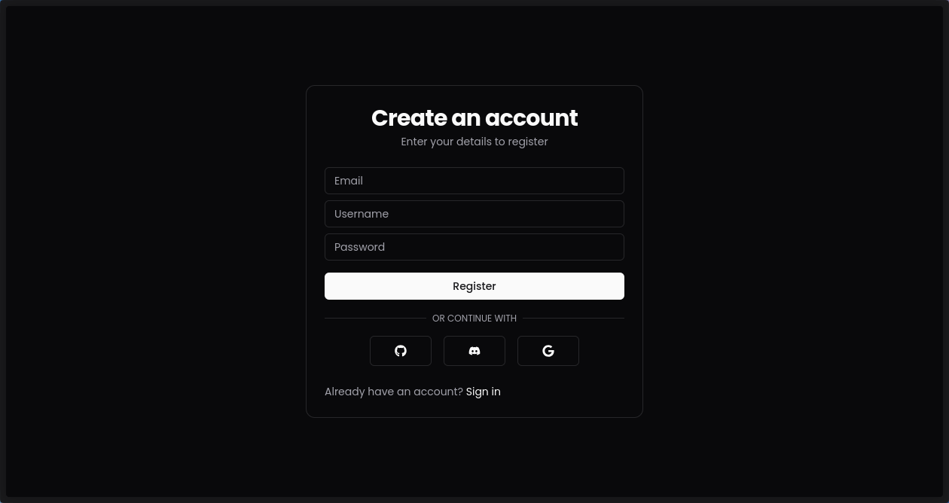
Figure III- 4 authentication (create account)

3.2 Pricing Page
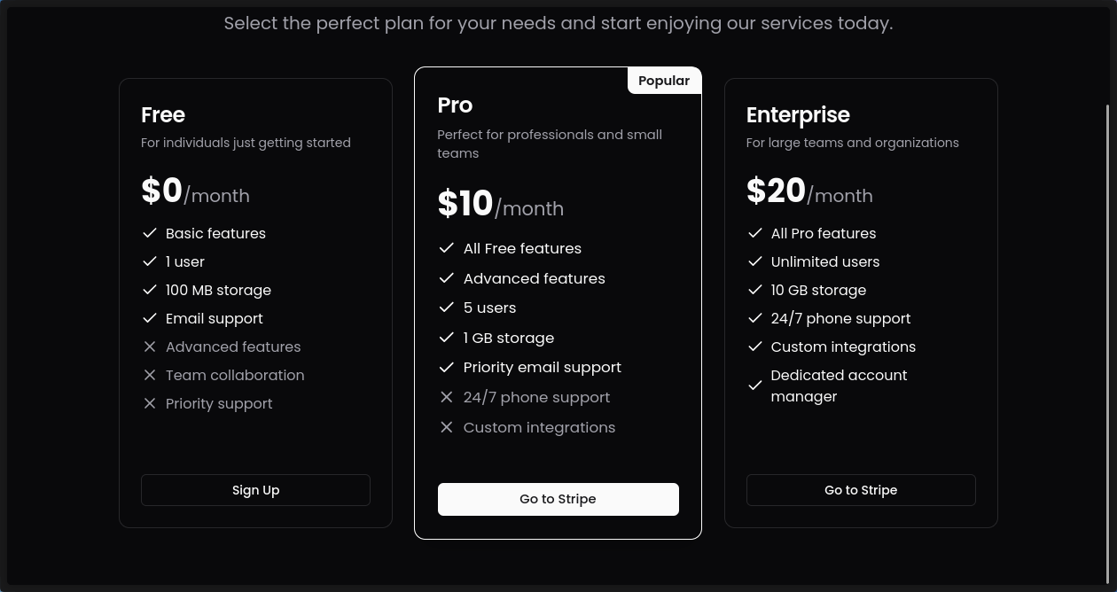
Figure III- 5 Pricing Page
Pricing plans comparison showing Free, Pro ($10/month), and Enterprise ($20/month) tiers with increasing features and support levels
3.3 home page
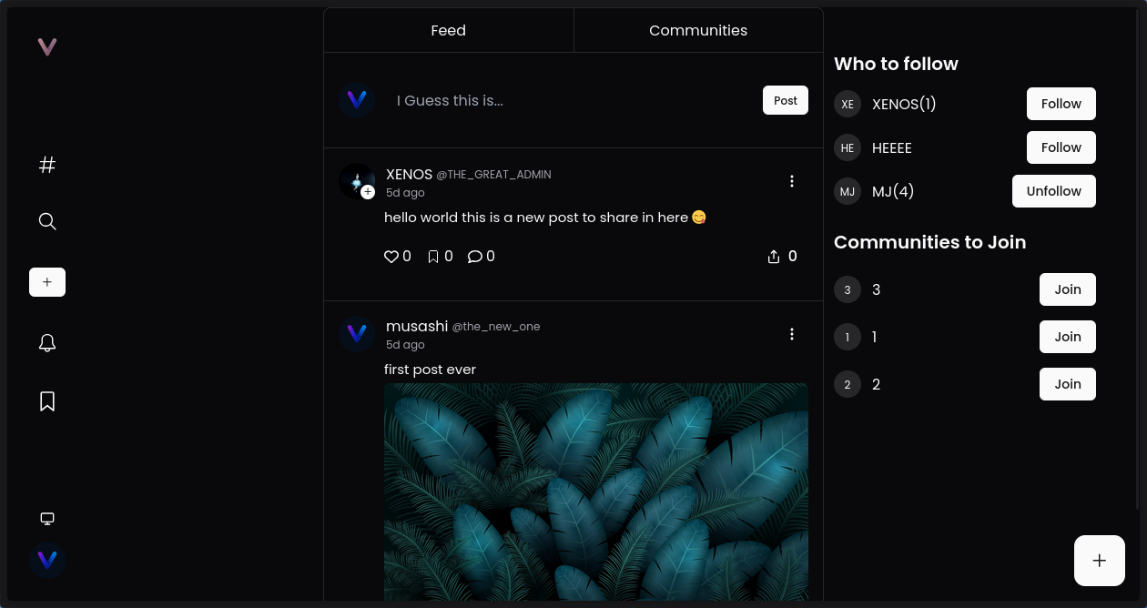
Figure III- 6 home page

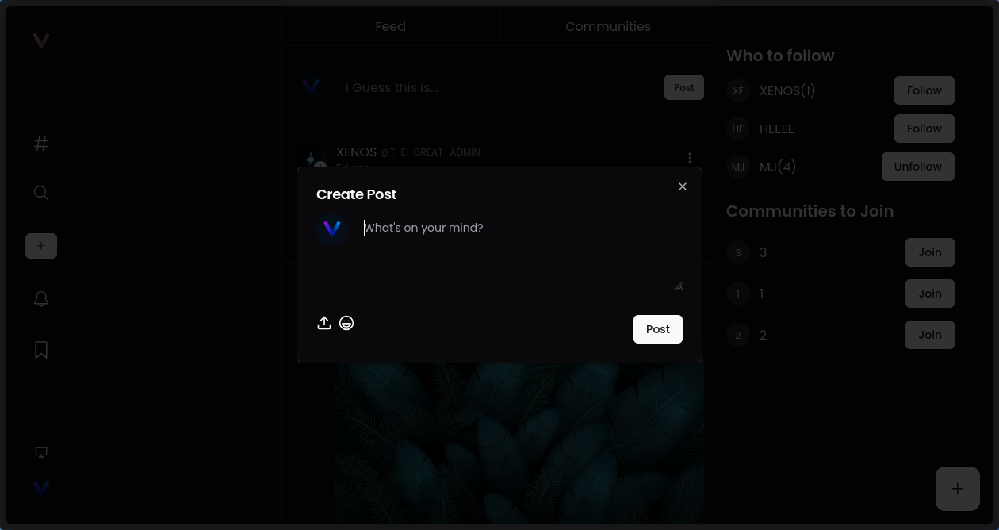
3.4 Creating a post
Figure III- 7 Creating a post
Users can upload images and text in this simple widget, and then publish them.
3.5 comment
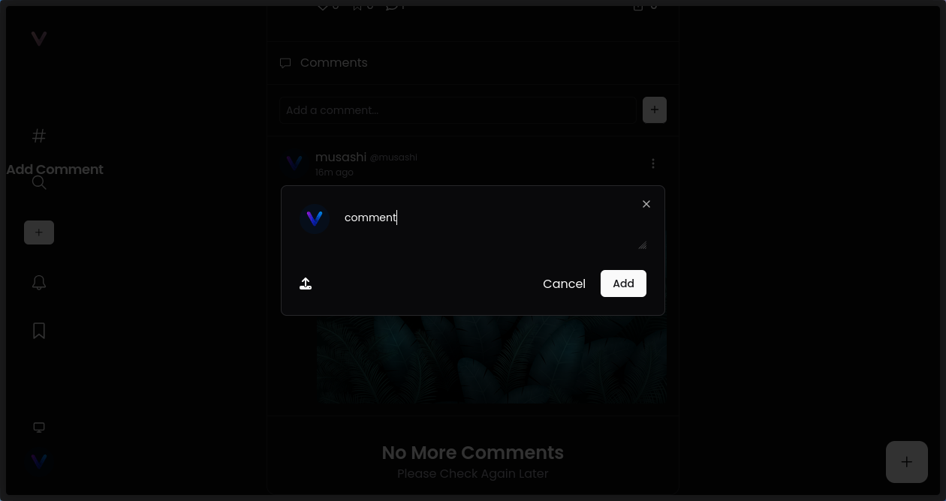
Figure III- 8 sharing a comment

3.6 Profile “posts”
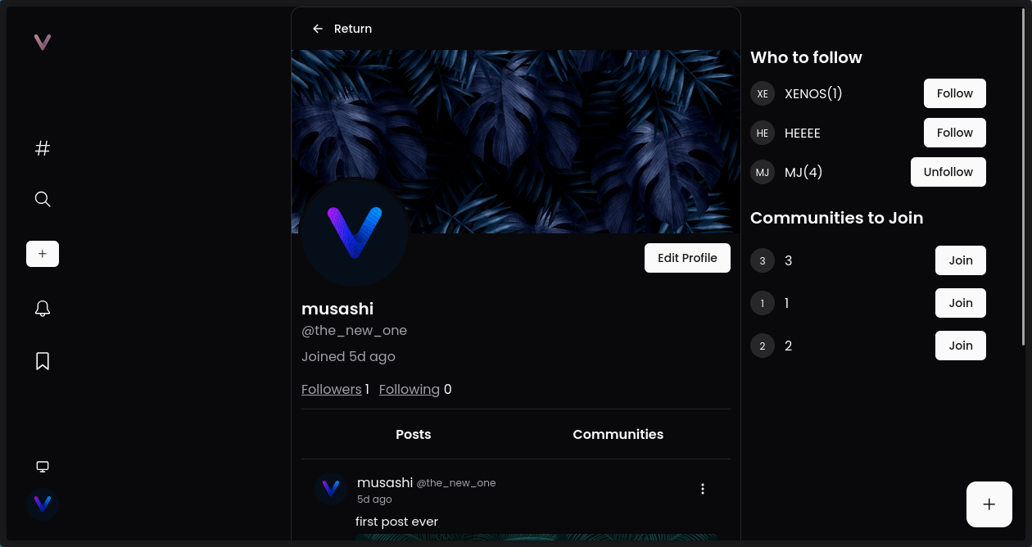
Figure III- 9 Users Profile posts side
3.7 Profile “community”

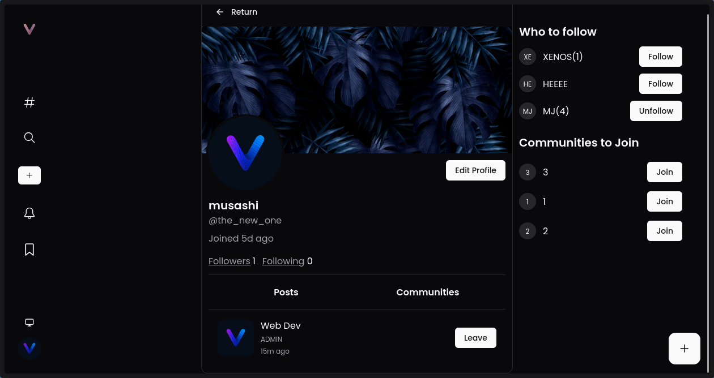
Figure III- 10 Users Profile community side

On this page, you can update your profile details, view and manage your posts, and explore the communities you're part of.

3.8 Profile edit page
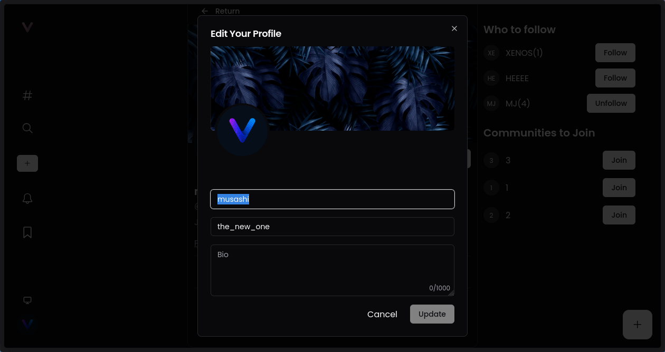
Figure III- 11 Profile edit

In this page the user can edit his own informations,
3.9 communities creation
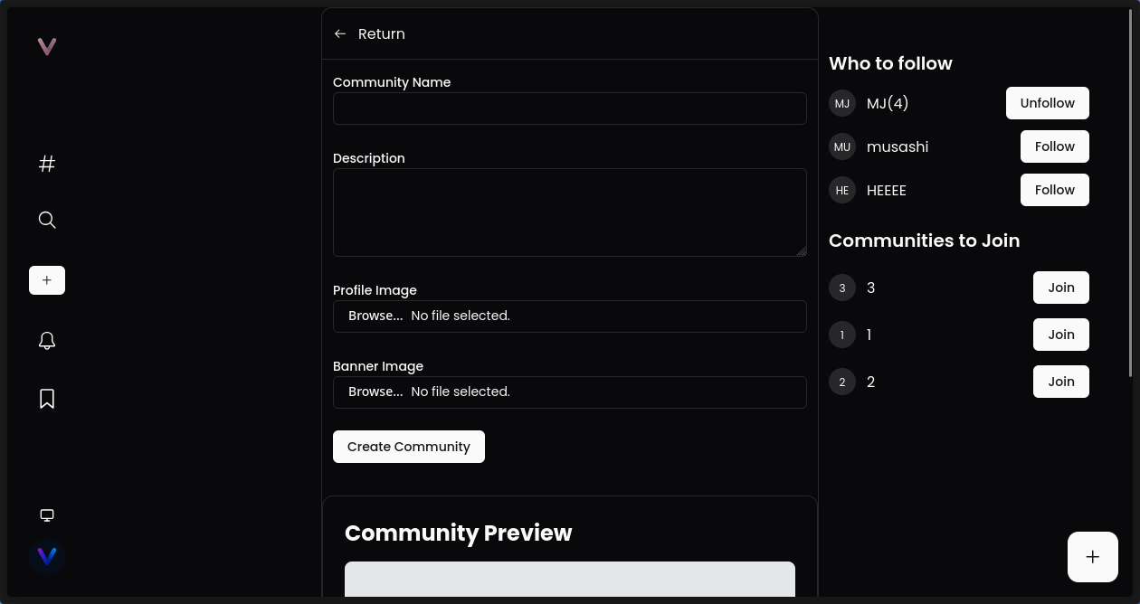
Figure III- 12 community creation 1st part

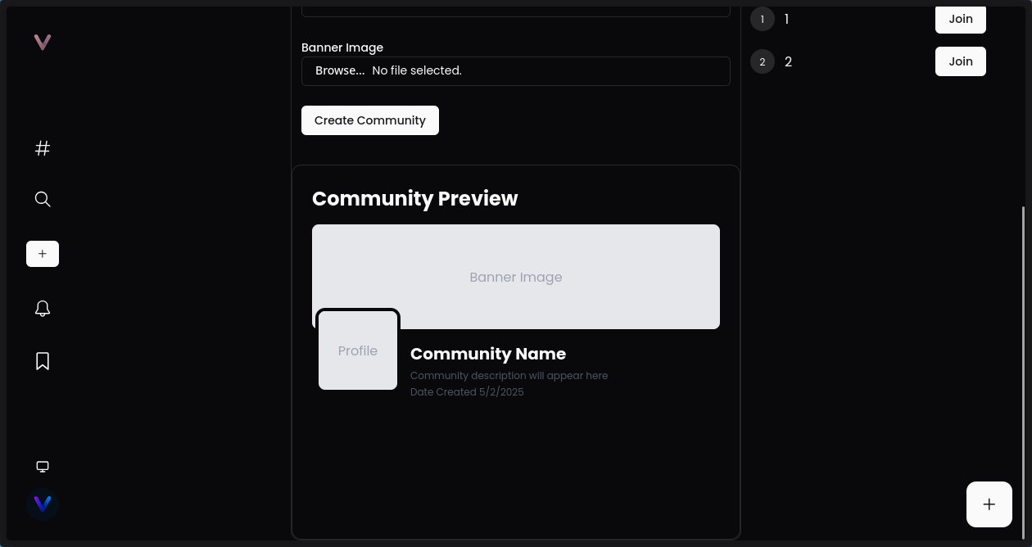
Figure III- 13 community creation 2nd part
On this page, the user can create and fully customize their own community by setting the banner, icon, and all relevant information such as the name, description, and rules.

3.10 reseting password by email

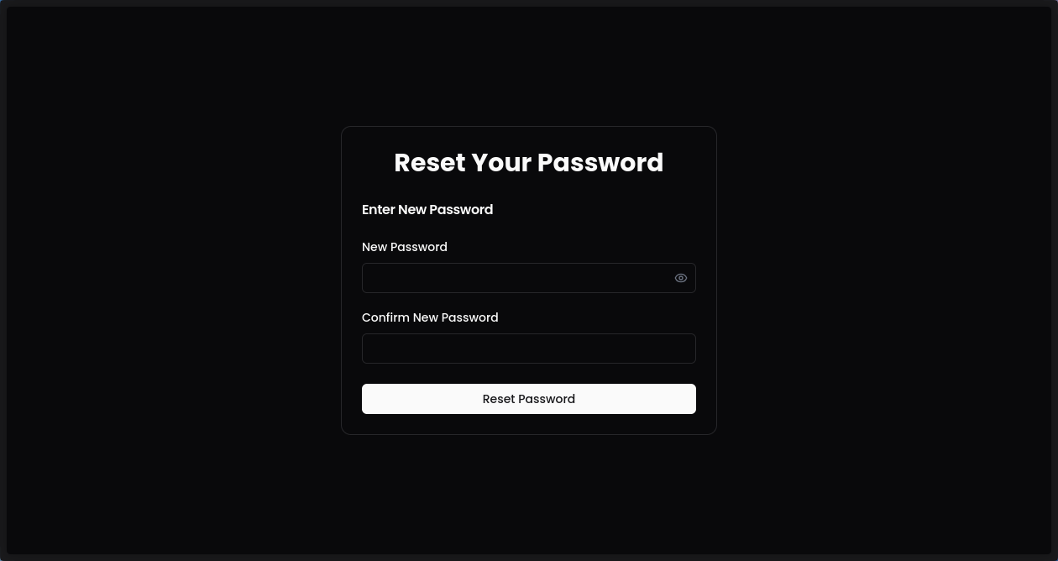
Figure III- 14 password reset

3.11 share a post by link

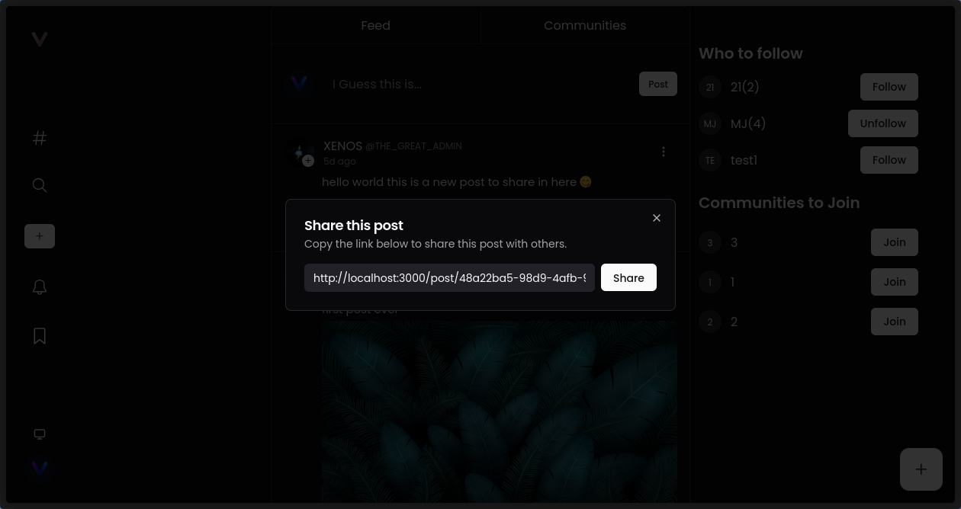
Figure III- 15 sharing post by link

4. Conclusion
The implementation phase marked a significant milestone in the realization of our social media platform, translating theoretical designs into functional components. By leveraging modern tools such as Visual Studio Code, robust programming languages like TypeScript and Go, and a reliable database system like PostgreSQL, we ensured a scalable, maintainable, and high-performing application. This phase involved meticulous attention to detail, adherence to best practices, and continuous testing to validate each feature's functionality. Ultimately, the implementation laid a solid foundation for the system’s deployment and future enhancements, ensuring that the platform delivers a seamless and dynamic user experience.

GENERAL CONCLUSION

General Conclusion
This thesis aimed to design and implement a social media platform tailored for professionals, with a particular focus on fostering collaboration and knowledge sharing within communities such as developers and designers. From the initial concept to the final implementation, our objective was to create a dynamic and user-friendly digital space that supports professional networking and community engagement.
We began by analyzing the specific needs of professionals who seek more than casual interaction those who value structured content sharing, project collaboration, and meaningful connections. This analysis guided the overall design and technical choices made throughout the development process. In the design phase, we applied modeling techniques such as UML to define the system’s architecture and ensure coherent functionality across the platform.
During the implementation phase, we used modern technologies including Visual Studio Code, TypeScript, PostgreSQL, and Go to develop a responsive, secure, and scalable web application. We paid particular attention to user experience, real-time interaction, and community-based features to ensure the platform meets the expectations of its target users.
This project presented a valuable opportunity to apply both theoretical and practical knowledge in software engineering. Although the application is functional, future improvements can include adding advanced recommendation algorithms, optimizing performance for large user bases, and strengthening the platform’s moderation and security mechanisms.
In conclusion, this social media platform serves as a foundation for a professional digital community. With further development, it has the potential to become a powerful tool for individuals seeking growth, inspiration, and meaningful connections in their field

Annexe A

Annexe: Guide du projet

A.1 Information Card
- Supervising Team: Mr. ammara sofian. Specialty: Computer Science.
- Project Team:
Student 1: bettahar abdelmadjid.
Specialty: Computer Science: Bachelor's degree.
Student 2: amari younes.
Specialty: Computer Science: Bachelor's degree.
Student 3: kredim ahmed.
Specialty: Computer Science: Bachelor's degree.
Student 3: Mostefa tounsi hadil.
Specialty: Computer Science: Bachelor's degree.

A.2 Project Overview

A.2.1 Project Idea (Proposed Solution)
Vertex is a professional networking platform designed to connect communities such as developers, designers, and other tech professionals. Unlike traditional social media, Vertex addresses the lack of structure and focus in professional interactions by providing a dedicated, well-organized environment for networking, collaboration, and knowledge sharing.
Through features like personalized profiles, interactive feed posts, and community-driven discussions, Vertex allows users to share expertise, discover opportunities, and engage meaningfully with peers. The platform's goal is to bridge the gap between isolated professional groups and create a space where collaboration and growth happen naturally.

A.2.2 Suggested Values
The suggested values can be integrated into the value propositions for the Vertex professional networking platform:
Modernity: Deliver innovative features and leverage cutting-edge web technologies to meet the evolving needs of creative and technical communities such as developers and designers, ensuring a forward-thinking and efficient networking experience.
Design: A clean, intuitive, and user-friendly interface will enhance user interaction, making it easy to explore communities, connect with others, and engage with relevant content without friction.
Performance: The platform should provide fast, responsive services such as real-time notifications, instant messaging, and smooth browsing of posts and profiles, contributing to an efficient user experience.
Flexibility: Users should have the freedom to personalize their profiles, switch between roles (e.g., freelancer, collaborator, recruiter), and engage in different types of interactions depending on their professional needs.
Task Accomplishment: Vertex will simplify key professional tasks such as posting opportunities, sharing updates, managing collaborations, and networking — helping users stay focused and productive.
Cost Efficiency: By offering a centralized space for discovering talent and opportunities, Vertex helps reduce the need for costly recruitment tools or inefficient outreach methods.
Risk Reduction: Ensuring user data privacy, account security, and clear community guidelines will help reduce the risks of misuse, spam, or unprofessional behavior on the platform.
Accessibility: Vertex should be accessible to users of all technical skill levels, with an inclusive design that supports various devices and meets accessibility standards.
Ease of Use: A straightforward and streamlined user experience will lower the learning curve, enabling professionals to start connecting and collaborating quickly without extensive onboarding.

A.2.3 Project Team
The project team for Vertex is composed of the following members:
Student 1: bettahar abdelmadjid
Specialty: Computer Science – Bachelor's Degree
Student 2: amari younes
Specialty: Computer Science – Bachelor's Degree
Student 3: kredim ahmed
Specialty: Computer Science – Bachelor's Degree
Student 3: mostefa tounsi hadil
Specialty: Computer Science – Bachelor's Degree
Each member contributes to the design, development, and implementation of Vertex, combining technical knowledge with a shared vision of creating a structured, community-focused professional networking platform.

A.2.4 Project Objectives
The business objectives of the Vertex project are as follows:
Short Term (1 year): Our goal is to capture 10% of the target market within our initial launch region by making the platform accessible to key communities such as developers and designers. We aim to reach 10,000 monthly active users and establish early partnerships with tech communities, universities, and professional organizations.
Medium Term (3 years): We aim to solidify our position in the professional networking space by increasing our market share to 25%. This includes expanding to other regions, growing our user base, and forming strategic partnerships with coworking spaces, startups, and recruitment platforms. Our target is to achieve 100,000 monthly active users.
Long Term (5 years): Our long-term vision is to reach 40% market share nationwide by becoming the go-to platform for professional collaboration and networking. We plan to attract a broader range of professionals by offering a diverse set of services and maintaining a strong online presence across communities and industries.

A.2.5 Project Implementation Plan

Table A. 1 Timeline overview.
Phase / Week | Week 1 | Week 2 | Week 3 | Week 4 | Month 2 | Month 4
Ideation & Planning |  |  |  |  | X
Core Feature Development |  |  |  |  |  | X
Testing & Quality Assurance |  |  |  | X
Deployment & Launch Prep |  | X
Monitoring & Maintenance |  |  |  |  |  | X

A.3 Innovative Aspects

A.3.1 Nature of Innovations
The innovations incorporated into the Vertex project are characterized by:
Market Innovations: Vertex introduces a structured and purpose-driven alternative to traditional social media platforms. It streamlines professional networking by offering tools for targeted collaboration, content sharing, and community engagement all designed to improve efficiency and foster meaningful connections across industries.
Community-Driven Innovation: Vertex stands out by placing community interaction at its core. Instead of one-way posting or superficial connections, it promotes interactive discussions, peer-to-peer recognition, and project-based networking helping users engage with real value rather than just visibility.
Technological Uncertainty: The platform must remain adaptable to changes in technologies, frameworks, and data privacy standards. Continuous updates and tech monitoring will be key to maintaining reliability and competitiveness.
Market Uncertainty: As a new entrant in the professional networking space, Vertex must adapt to shifting user expectations, monitor trends in remote work and digital collaboration, and adjust strategies accordingly to stay relevant and grow its user base.

A.3.2 Innovation Domains
In our Vertex project, the innovation domains include:
— New processes: Vertex introduces automated processes to connect professionals (developers, designers, etc.) with relevant opportunities, streamlining professional networking and reducing the time spent searching for meaningful collaborations.
— New features: The platform offers innovative features such as a structured, domain-specific news feed, and collaboration spaces for community-driven projects.
— New clients: We target new segments of professionals, including junior freelancers, final-year students, and underrepresented tech communities, by providing tools tailored to their career growth and visibility.
— New offerings: Vertex introduces unique service offerings, such as premium subscriptions for exclusive opportunities, expert-led workshops, and career tracking.
— New models: We adopt value-driven models based on community reputation and contributions, while forming partnerships with incubators, academic institutions, and companies to support complete professional development pathways.

A.4 Strategic Market Analysis

A.4.1 Market Segment
— Potential Market: This includes professionals across tech, design, marketing, and related fields seeking a structured, community-driven platform for networking and collaboration. It also encompasses students and recent graduates aiming to gain visibility and connect with peers or mentors in their industries.
— Target Market: Our core market is made up of early-career professionals and freelancers looking for meaningful networking, project collaboration, and skill-based recognition. The increasing shift toward remote work, freelance economy growth, and the fragmentation of professional communities create a strong demand for a purpose-built networking platform like Vertex.
— Opportunity for Key Partnerships: We plan to build strategic partnerships with tech communities, universities, bootcamps, and companies focused on talent development. This could include collaborations with incubators, co-working spaces, and job platforms, or offering Vertex as a networking tool for career-focused programs and professional events.

A.4.2 Competition Intensity Assessment
— Direct Competitors: These are platforms that provide professional networking services specifically targeting niche communities or early-career professionals. Examples include Polywork, Lunchclub, and niche Discord communities. While some focus on general networking, Vertex differentiates itself through its structured content feed and skill-aligned collaboration tools.
— Indirect Competitors: These include large-scale platforms like LinkedIn or Slack-based communities that serve broader professional audiences without a targeted structure for community collaboration. While not directly competing in terms of features, they influence user behavior and expectations in the professional networking space.

A.4.3 Marketing Strategy
— Market Segmentation: We identify and target the most relevant market segments for Vertex, focusing on early-career professionals, freelancers, students in tech and design, and niche communities seeking structured networking and collaboration spaces.
— Positioning: We highlight key features such as the skill-focused professional feed, customizable profiles, community project spaces, and real-time collaboration tools. The platform is positioned as an innovative and intuitive solution for building meaningful professional relationships and accelerating career growth.
— Communication: We will develop an engaging and informative website that clearly presents the platform's benefits and features. In addition, we’ll launch targeted communication campaigns across professional social media platforms (e.g., LinkedIn, X, Discord) and relevant online communities to build visibility and interest.
— Balanced Marketing Mix: We ensure a well-balanced marketing mix, focusing on product, pricing, distribution, and promotion. The platform delivers strong user value through its feature set, adopts competitive pricing for premium services, ensures easy onboarding and access, and uses tailored promotional strategies to attract and retain users within each key segment.

A.5 Production and Organization Plan

A.5.1 Production Process
— Needs Analysis: This step involves gathering input from potential users and stakeholders to identify key features required by the platform. The analysis is conducted through market research, surveys, user interviews, and discussions with community leaders in the tech and creative sectors.
— Design and Planning: Once needs are clearly defined, the development team designs the platform architecture, user interface, and user flow. Planning includes resource allocation, timeline estimation, and outlining the key phases of development. A detailed overview of the design process is presented in Chapter 2, “Needs Analysis and Design.”
— Application Development: At this stage, developers begin coding the platform using modern and scalable technologies. Core features such as the personalized feed, dynamic profiles, project collaboration spaces, and messaging tools are implemented with a focus on performance and usability.
— Testing and Debugging: Once the initial version is built, the application undergoes extensive testing to ensure quality and stability. This includes functionality testing, performance checks, and ensuring compatibility across various devices and browsers.
— Launch and Deployment: This involves preparing user guides, onboarding materials, and platform documentation. The deployment process includes setting up hosting infrastructure, database configurations, and pushing the application to production. Beta access may be provided to early users for initial feedback.
— Maintenance and Updates: After launch, it is essential to maintain and regularly update the platform to ensure smooth operation, fix bugs, and introduce new features. This involves collecting user feedback, monitoring platform performance, and applying continuous improvements based on community needs.
A.5.2 Supply Chain
— Procurement Policy: We have established a procurement policy aimed at ensuring the quality and availability of essential resources, tools, and services necessary for the development and maintenance of our platform. We commit to collaborating with trustworthy and reputable partners to guarantee a steady and high-quality supply.
— Key Partners: We have identified the most critical partners for our needs in resources, technologies, and infrastructure. Their reputation, reliability, ability to meet our requirements, and cost-effectiveness have been thoroughly assessed. We maintain strong relationships with these partners to ensure continuous and reliable provisioning.
— Payment Policy and Delivery Times: We set fair payment rules that match what our suppliers offer. We make sure to pay on time to keep good relationships. We also set clear delivery deadlines so we always receive what we need at the right time to continue building Vertex without delays.
A.5.3 Workforce
Our project has the potential to generate approximately 50 direct jobs and nearly 100 indirect jobs. The key positions we plan to fill include:
— Full-Stack Developers: to design, develop, and maintain the web platform, mastering technologies such as HTML, CSS, JavaScript, AI, and server-side frameworks.
— Back-End Developers: to manage databases, servers, and the overall architecture of the platform, working with SQL and other relevant database technologies.
— Front-End Developers: to craft and implement the user interface (UI) and user experience (UX).
— Cybersecurity Specialists: to safeguard sensitive user data and ensure compliance with privacy regulations such as GDPR.
— Project Managers: to coordinate teams, oversee timelines, and ensure the project progresses according to schedule.
— Domain Experts: to provide insights on the professional networking needs of specific communities and ensure the platform meets end-user requirements.
— QA Testers: to rigorously test the platform, identify bugs, and ensure smooth functioning before deployment.
— Customer Support Managers: to assist users with their issues and gather feedback for continuous platform improvement.

A.5.4 Key Partners
— Tech and Design Communities: These will be our first users and partners. Their feedback will help us improve Vertex and make it more useful.
— Software Integration Partners: We plan to work with companies that build popular tools used by professionals, so we can connect Vertex with other platforms people already use.
— Cloud Hosting Providers: They will host Vertex online and help us keep it fast, secure, and always available.
— Professional Associations: We’ll work with developer, designer, and tech industry associations to help spread the word and support community growth.
— Training Institutions: These schools and bootcamps will help teach users how to get the most out of Vertex, especially new graduates or job seekers.
— Financial Partners and Investors: They will help fund the development and growth of the platform.
— Legal Advisors: They will make sure we follow the laws about user privacy, data protection, and business rules.
— Marketing and Communication Agencies: They will help us promote Vertex to the right audiences and build a strong brand image in the professional world.

A.6 Financial Plan
This section covers the full budget needed to build, run, and promote the platform.
— Product Development:
Covers everything related to building the platform, including front-end and back-end development, database, UI/UX design, testing, debugging, and payment integration. Since the founders of the project are developers themselves, most of the work will be done in-house, which significantly reduces the overall development cost.
Estimated cost: 5,000,000 DZD (about €125) — mainly for tools, resources, and occasional external support if needed.
— Office Rental:
Renting a main workspace to host the core team and manage operations.
Estimated cost: 840,000 DZD (about €3200).
— Servers and Software Tools:
Includes cloud services, APIs, development tools, and other necessary subscriptions.
Estimated cost: 40,000 DZD (about €150).
— Equipment and Utilities:
Covers computers, hardware, accessories, internet connection, and electricity for running daily operations.
Estimated cost: 130,000 DZD (about €500).
— Marketing and Growth:
Includes advertising campaigns, events, influencer collaborations, partnerships, and user acquisition strategies.
Estimated cost: 130,000 DZD (about €500).
— Total Project Cost:
Approximately 1,163,500 DZD (around €4475).

A.7 Prototype Description
Chapter 3, "Implementation," explains the details of the prototype for our application.

A.8 Business Model Canvas (BMC)
A business model explains clearly how a company creates value and makes money.
The Business Model Canvas is a simple tool that helps to build and present this model in a clear way.
It is shown as a table with nine blocks, each representing a different part of the business.

A.8.1 Key Partners
- Universities and Educational Institutions – for credibility, user acquisition, and knowledge hubs.
- Professional Associations & Licensing Bodies – to validate expertise and support structured communities.
- Corporate Partners & Employers – for hiring, event sponsorships, and B2B features.
- Cloud Service Providers (e.g., AWS, GCP) – hosting, storage, and scaling the platform.
- Open-Source Communities (e.g., Go, PostgreSQL, StarUML) – for robust technical support and tools.
- Content Creators & Educators – to provide premium and curated educational material.
- Event Hosts & Training Providers – to facilitate virtual/in-person knowledge-sharing events.

A.8.2 Key Activities
- Platform Development & Optimization – continuous feature updates and performance enhancements.
- Community & Content Moderation – ensure quality, safety, and professionalism in all interactions.
- User Onboarding & Support – simplify registration and engagement, provide tech support.
- Event Hosting & Management – manage webinars, meetups, and online classes.
- Security & Compliance Management – protect user data and comply with global data regulations.
- Marketing & Community Growth – attract users through social campaigns, influencers, and SEO.

A.8.3 Value Propositions
- Professional Networking in Knowledge-First Communities – targeted connections based on expertise.
- Structured & Secure Collaboration – for projects, discussions, and learning groups.
- Verified & Customizable Profiles – highlight user skills, work, and credentials.
- Creator-Centric Platform – tools to share, sell, or promote high-quality content.
- Organized Content Libraries – curated resources by topic, community, or skill level.
- Cross-Community Discovery – explore similar hubs, connect with diverse but related fields.
- Advanced Event Tools – manage virtual summits, webinars, training sessions.

A.8.4 Customer Relationships
- Self-Service with Assisted Onboarding – tooltips, walkthroughs, and community FAQs.
- Community Moderators & Admin Panels – empower users to manage their own spaces.
- Reputation & Recognition Systems – badges, points, and highlights for contribution.
- Customer Support Channels – chatbots, live agents, and ticketing.
- User Feedback Integration – regular surveys, feature voting, and beta testing.

A.8.5 Customer Segments
- Professional Individuals: engineers, educators, doctors, researchers, etc.
- Content Creators & Educators: seeking to monetize or share their knowledge.
- Institutions & Organizations: managing internal communities and sharing expertise.
- Corporate Recruiters: scouting for experts and community contributors.
- Event Hosts & Trainers: looking for structured hosting and promotion tools.
- Moderators & Community Managers: managing public or private knowledge hubs.

A.8.6 Channels
- Web Platform & Progressive Web App
- Mobile App Stores (Android, iOS)
- Social Media (LinkedIn, Twitter, YouTube, TikTok)
- Email Marketing & Newsletters
- SEO-Optimized Blog & Knowledge Base
- Partnership Promotions & Webinars
- Influencer Collaborations & Guest Contributions

A.8.7 Key Resources
- Tech Stack & Infrastructure: built with Go backend, PostgreSQL DB, and front-end stack (HTML/CSS/JS/TS).
- Development Team: full-stack developers, designers, DevOps, and QA testers.
- Community & Moderation Team: enforce standards, support users, grow engagement.
- Content Curation Engine: organize posts, articles, and resources intelligently.
- Marketing & Growth Specialists: drive awareness, user acquisition, and engagement.
- Secure Database & Hosting: fast, scalable, and compliant cloud infrastructure.
- Analytics & Insights Engine: deliver value through data-driven decisions and reporting.

A.8.8 Cost Structure
- Software Development & Maintenance
- Cloud Hosting & Infrastructure Costs
- Content Creator Compensation
- Marketing & User Acquisition
- Customer Support & Moderation
- Legal, Compliance, and Data Security
- Event Hosting Infrastructure (Live streaming, webinars, etc.)
- Platform Licensing (for external APIs or services)

A.8.9 Revenue Streams
- Freemium Model with Subscription Tiers: premium features for power users and communities.
- Content Monetization Fees: percentage on paid educational resources or exclusive content.
- Sponsored Posts & Featured Communities
- Event Ticketing & Hosting Tools
- Corporate Accounts & B2B Plans: team management, analytics, and hiring features.
- Advertising (Ethical & Community-Approved Only)
- Commission on Marketplace Transactions: tools, templates, or resources.

Bibliographie
[1] : Site web, https://prodnovate.com/blog/the-role-of-social-media-in-community-engagement/ consulté le : 18/01/2025 à 14:12.
[2] : Site web, https://socialengine.com/blog/online-community-platforms-vs-traditional-social-networks/ consulté le : 29/03/2025 à 10:46.
[3] : Site web, https://www.tandfonline.com/doi/abs/10.1080/10919392.2014.866504 consulté le : 12/03/2025 à 11:30.
[4] : Site web, https://www.geeksforgeeks.org/software-engineering-software-design-process/ consulté le : 09/01/2025 à 13:50.
[5] : Site web, https://www.geeksforgeeks.org/what-are-the-advantages-and-disadvantages-of-uml/ consulté le : 25/01/2025 à 16:27.
[6] : Site web, https://www.geeksforgeeks.org/components-of-information-system/ consulté le : 14/03/2025 à 09:15.
[7] : Site web, https://www.netsuite.com/portal/resource/articles/erp/erp-systems-components.shtml consulté le : 22/01/2025 à 10:10.
[8] : Site web, https://www.netsuite.com/portal/resource/articles/erp/benefits-system-integration.shtml consulté le : 11/02/2025 à 17:42.
[9] : Site web, https://www.abacademies.org/articles/leveraging-information-systems-for-competitive-advantage.pdf consulté le : 08/01/2025 à 08:50.
[10] : Site web, https://www.ibm.com/think/topics/sdlc consulté le : 27/02/2025 à 12:08.
[11] : Site web, https://www.harness.io/blog/software-development-life-cycle-phases consulté le : 30/01/2025 à 15:19.
[12] : Site web, https://www.mindinventory.com/blog/software-development-lifecycle/ consulté le : 16/03/2025 à 11:01.
[13] : Site web, https://cpl.thalesgroup.com/software-monetization/four-types-of-software-maintenance consulté le : 26/01/2025 à 18:33.
[14] : Site web, https://learnxyz.in/waterfall-model-in-software-engineering-a-comprehensive-guide/ consulté le : 13/02/2025 à 09:45.
[15] : RAZIKA TALBI et ASMA YAHIA, Mémoire de licence, <<Conception et développement d’une application pour la gestion d’un restaurant>>, CUR Relizane, Algérie.
[16] : Site web, https://www.bdtask.com/blog/spiral-model-for-software-development consulté le : 07/03/2025 à 14:02.
[17] : BELKEBIR Choumeyssa, ARIF Asmaa et MAHAMMED SEROURI Oussama, Mémoire de licence, <<Conception et développement d’une application pour la gestion et suivi des pannes des machines d’une usine>>, CUR Relizane, Algérie.
[18] : Site web, https://www.coursera.org/articles/visual-studio-code consulté le : 20/02/2025 à 16:11.
[19] : Site web, https://docs.staruml.io/user-guide/basic-concepts consulté le : 01/03/2025 à 08:44.
[20] : Site web, https://dev.to/matheusgomes062/typescript-an-introduction-to-the-statically-typed-superset-of-javascript-4hgo consulté le : 10/03/2025 à 15:27.
[21] : Site web, https://go.dev/solutions/use-cases consulté le : 04/03/2025 à 10:06.
[22] : Site web, https://www.postgresql.org/ consulté le : 24/01/2025 à 17:59.

