Manas Ladha  
6th Semester, CSE

170905274

May 3rd, 2020



Digital Medicine Project

Projecting for the next 30 years what will be India’s population, health needs and longevity.



Aim:

Predict the population, sex ratio, age distribution and longevity of India and its major states until the year 2050 using machine learning. Thus based on the data predicted, strategize the country’s healthcare expenditure and target for next 30 years.

Method:

1. Gather data from 1900 to 2020 on the population, sex ratio, age distribution and longevity of India and its major states.

* [India Level Data](https://github.com/Xenos5282/Digital-Medicine-Project/tree/master/India%20Data)
* [State Level Data](https://github.com/Xenos5282/Digital-Medicine-Project/tree/master/State%20Data)

Data is stored in csv format and is imported in python notebook on runtime into numpy dataframes for easy and fast calculation.

Data is normalized using Decimal Scaling technique.

1. ML algorithm is based on variations of basic indicators such as growth in population, male-to-female ratio, Life expectancy and Total Fertility Rate. It iterates on the data set repeatedly to optimize the cost and thus finding the best fit line.

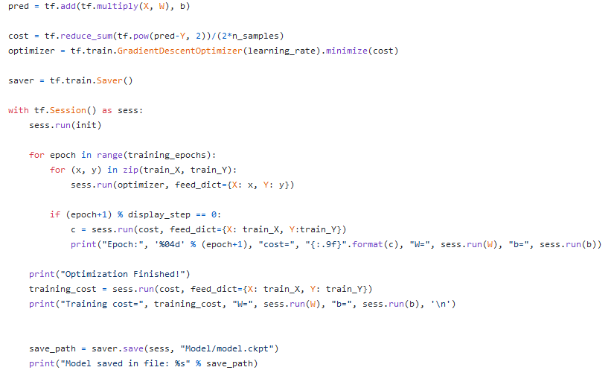

1. Linear Regression is used to predict the future values. This whole model was fully coded by me in python using libraries such as tensorflow, pandas, scikit-learn, numpy and matplotlib.

* [Python Model](https://github.com/Xenos5282/Digital-Medicine-Project/blob/master/model.py)
* Equation used in the model is Y=WX+B where

1. Y is the dependent variable (Population, sex ratio, age distribution or longevity).
2. X is the explanatory variable (Year).
3. W is the weight or slope of the best fit line.
4. B is the intercept for the best fit line.
5. The above specified data was trained on the model described using Google Colab platform. The results and graph are displayed in the upcoming section.



Results:

1. India-

* **Population**

HISTORIC DATA:

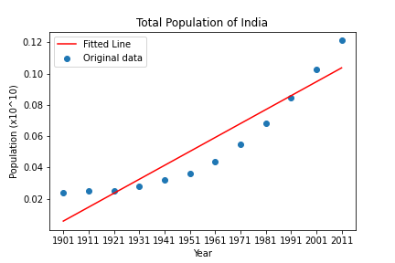

PREDICTED DATA:



* **Sex Ratio**

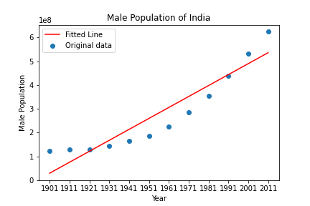HISTORIC DATA:

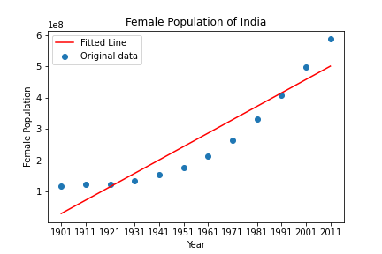

PREDICTED DATA:



* **Life Expectation**

HISTORIC DATA:

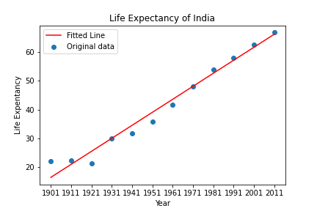

PREDICTED DATA:

* **Age Distribution**

HISTORIC DATA:

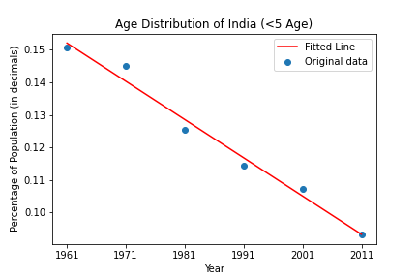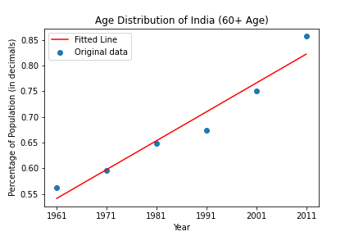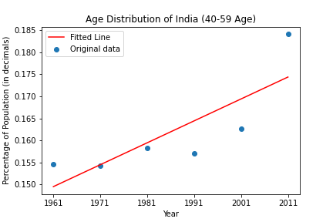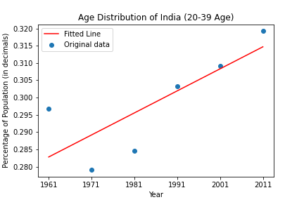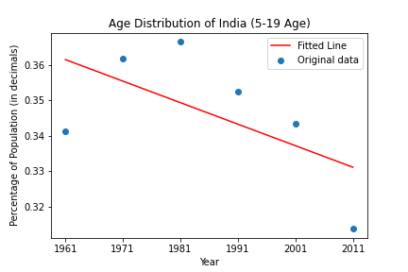

PREDICTED DATA:



1. State Level-

* **Population**







* **Sex Ratio**







* **Life Expectancy**





Observations:

1. **From 2020-2050 how will the population change in the country and per state?**

Compared to the estimates above, the country's population is growing steadily until the year 2050. The rate of growth depends on various variables, such as mortality rate, birth rate, literacy rate, fertility rate etc. As for the states, some of the bigger and more developed states such as Andhra Pradesh, Kerala, and Punjab have lower population growth while other states such as Madhya Pradesh, Bihar, and Uttar Pradesh have lower growth. A lower literacy rate can have a huge impact on population growth rates for states like Bihar. When people are more educated, the understanding grows, the rise in health care contributing to a lower rate of population growth.

1. **How will the age distribution change in the country and per state?**

The youth population is gradually declining according to the country's general

trend, and the population is growing between the age group 20-50. This is because the rate of population growth peaked about the year 2000 and has since decreased, though the population is still growing. Nearly 50 per cent of the total population in states like Bihar and Jharkhand is in the 0-20 age group. This is due to the high

rate of population growth, as shown above. Such states will spend more in the population segment in order to prepare them for a better future. In states such as Kerala and Tamil Nadu that have a lower rate of population growth, the majority of the population belongs to the 20-59 year age group.

1. **What is the Male to Female ratio for the country and per state?**

A similar trend with sex ratio can be observed. The sex ratio, due to the discovery of sex determination machines and unnecessary abortions, leans more towards the male side for the world. States like Uttar Pradesh and Bihar have a higher sex ratio and a much lower sex ratio for states like Tamil Nadu and Kerala. This could again be focused on factors relating to literacy.

1. **What will be the Longevity (Life expectancy) for the country and per state?**

The country's longevity is increasing steadily as healthcare and medication are improving along with higher literacy rates. Effective literacy rates and strong healthcare like Kerala have higher durability compared to states like Bihar.

As the country's literacy rate increases along with the economy, the people will receive better healthcare, which will then improve longevity.



Closing Arguments:

The project has helped open my eyes to the vastness and vacillating variations across the states of our country, sometimes within the states itself. The data provides quite a comprehensive picture of the current situation as well as the future and it is critical that we learn from this data and ameliorate the current conditions in our country when it comes to healthcare.

From the results of the model it's clear that the population of India will continue to increase at a rapid rate. States like Bihar, UP, Maharashtra being the major driving factors behind the growth. A glance at the life expectancy data shows us that there is a wide variation in life expectancies of different states, showcasing the gulf in availability of basic amenities.

When it comes to the age groups and longevity, the age bracket of 20-59 will be crucial, as an increase in population in this bracket means a better demographic of the working class, something which will be a vital component of our push to elevate our economy. The Government should plan to put in place policies that will benefit the working class and take care of their healthcare, giving them more options and better benefits in terms of insurance plans and premiums, enforcement of better company policies regarding establishing a safety and health working environment. Investment in facilities that help boost cardiovascular fitness could go a long way in ensuring the working class remains healthy, with current data suggesting more than 80 percent of pre mature cardiac arrest deaths could have been avoided if cardiovascular fitness wasn't neglected.

It is predicted that the age group of 60+ will also see an increase in population. Pushing the retirement age back and investing in healthcare for the senior citizens of our country is something which we should plan for. Funding research initiatives that tackle common, life threatening diseases like cancer would help immensely. Awareness programs across states for boosting self-care and immunity for senior citizens would help ensure that the most vulnerable are being taken care of.

A glance at the data shows a sharp decline in the 0-19 bracket. Thus it would make sense if the government redirects the funds allocated for the healthcare expenditure in this bracket (eg. Maternity clinics, vaccine programs) to other areas which are in more urgent and dire need of funds. The recent COVID pandemic has laid bare the inefficiencies in our current healthcare infrastructure. There is a serious need to invest heavily in having a robust framework of infrastructure to handle diseases of this scale. Also it's high time the policies focus on also including the welfare of our real heroes, the frontline workers in the healthcare sector and ensure provisions for their betterment. In a densely populated country like us, initiatives to develop and enhance the healthcare infrastructure from the grassroots level is absolutely necessary. Last but not the least, investment in data mining and database management is important as data is a valuable resource and one which helps us get clarity on what our goals should be and how our efforts to achieve those should be shaped optimally.

Healthcare is a basic right and if India is to become a developed country, and complement the strides it has made in other fields, investment and focusing on an overhaul in the healthcare sector is a must.