**Week 1 Assignment**

**Due:** Sept 9 2019 (23:59)

1. Login Canvas
2. Click on Week 1 Exercise within the Week 1 folder to start the exercise
3. Open/download the Week 1 Assignment file
4. Start the Python program
5. Create a new project, and name the folder as “**week1assignment**”
6. Create a Python file named “week1 assignment_[your sid]”

* Please write a Python program that calculates the profits tax of a corporation in HK with the following:
  + The program will ask the user to input the assessable profit, in the year of 2018/19, of his/her corporation.
  + The program will calculate (using the following formula) ad display the profits tax that the corporation need to pay for the profits tax for the year of 2018/19

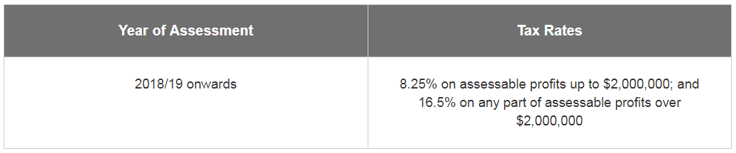

* After you finish,
  + take a screenshot (e.g., using “Print Screen” function and the Paint tool) of your whole PyCham environment, including all the codes and the program output.
  + Save your screenshot as a jpg file, named “week1assignment_[your sid].jpg”

1. Submit your two files to CANVAS in the Week 1 Assignment within the Week 1 folder
   1. week1assignment_[your sid].py
   2. week1assignment_[your sid].jpg