**Problem statement:**

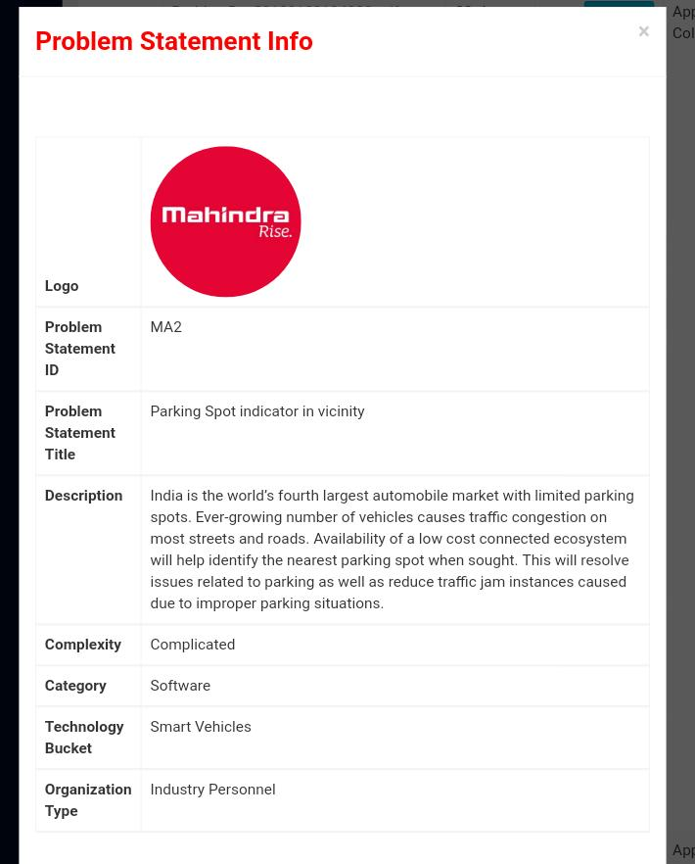

**Prototype :**

Now a days India is majorly facing parking problems. The prime reason is that the user is unaware of the proper parking scenario. By this module, we can solve this problem by providing the user with an information about the closest parking spot using GPS. The information of all the parking spots is provided to this module using crowd sourcing(obtain by enlisting the services of a large number of people, either paid or unpaid, typically via the Internet.). Also the data sets can be collected from RTO, BMC and other government agencies as a future scope of this project. There will be a poll option given for each parking spot to verify whether the information is authentic or not , ones having more number of likes indicate an authentic spot and the ones which are disliked are ruled out.

**Dependencies:**

Internet

GPS  
Cheap server

**Technology Stack:**

• Python

• Python Frameworks(Flask)

• Android Studio

• Open Source android libraries

• GPS

• Mongo Db

•Google Map Api

**Use Case Description**:

• User registeres itself on the app through portal.

• User's mobile phone will detect the nearby available parking slots where user can book himself for the parking.

• User will get the billing details once the slot is booked.

• User have the facility to provide the feedback of parking, so that the portal can verify whether the parking is authorized or not.

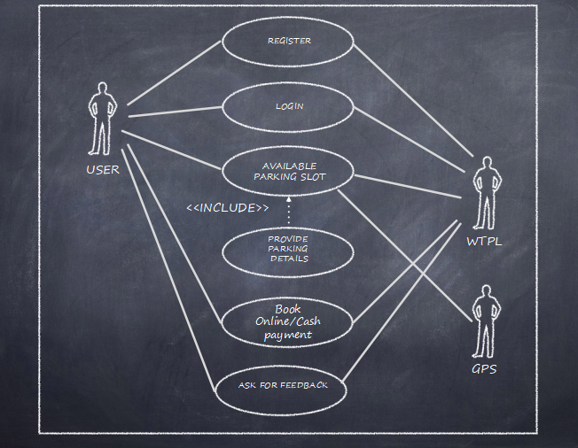

**Assumptions and Cost:**

User: An integrated dashboard(Rs.4000)/smartphone

Datasets: From webscraping and crowdsourcing are genuine.

Man power for operating the system.

Parking lot Owner: Arduino with add-on modules: approx Rs. 700

Rf Id scanner(Rs. 100)

Rf card(Rs. 2)

Paytm account.

**Future scope:**

Provides statistical data of particular parking lot at particular time

Live number of users navigating to the same parking lot

Voice interaction

Cheap Automation of parking lot

**Team in action:**

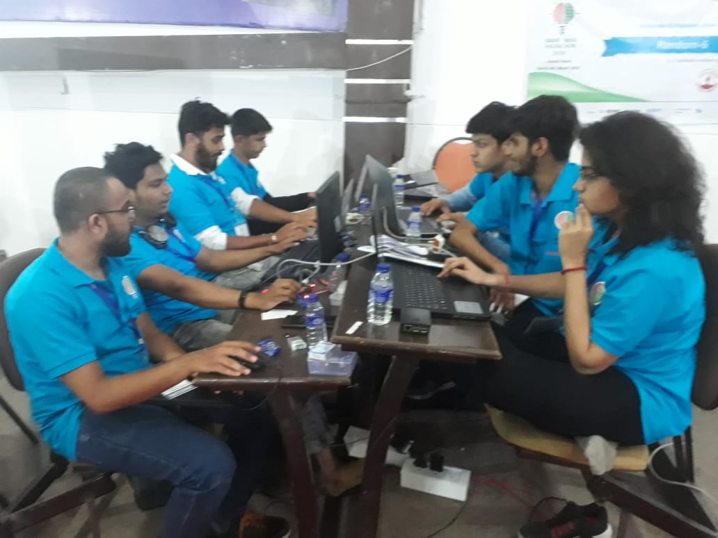

**Circuit diagram for RF-Id scanner:**

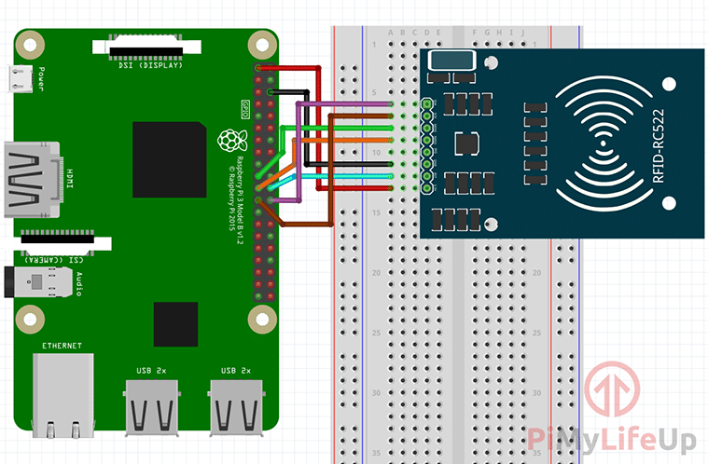

**Project Model:**

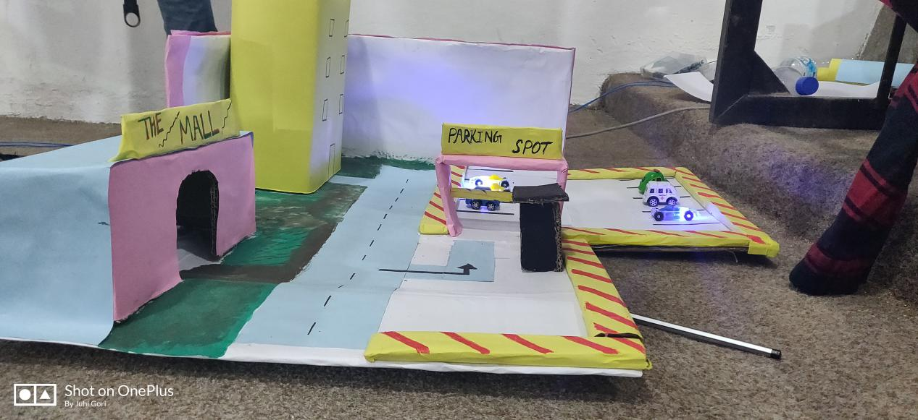

**Outcomes:**

Solves the problem of traffic because this system helps to prevent haphazard and illegal parking.

Helps to monetize the parking lot which are not well known.

A licence owner can collaborate with our system and will be provided with an admin panel which gives him/her the entire access of database without having any knowledge of how the database works. i.e It provides a layer of abstraction to the user.