

**SUPERIOR UNIVERSITY LAHORE**

**FACALITY OF CS & IT**

**DEPARTMENT OF SOFTWARE ENGINEERING**

Computer Networks

Final Project Report

Author(s)

Muhammad Sameer BSEM-F21-129

Haseeb

Yonus

#####

**Supervisor**

Daniyal Qamar

Space Communication System - Computer Networks Lab Project

# Project Overview

A comprehensive network-based simulation of Earth-to-Satellite communication implementing TCP/IP protocols and error handling mechanisms. This project:

* Simulates real-world space communication challenges
* Implements industry-standard protocols and error handling
* Demonstrates practical networking concepts in space applications

# Network Architecture

## Physical Layer

The physical layer utilizes simulated radio waves operating in the Ka-band (26.5-40 GHz) range. Key features include:

* QPSK modulation for efficient data transmission
* Ka-band frequency simulation
* Real-world signal propagation modeling

## Data Link Layer

The system implements TCP/IP protocol within a Client-Server Architecture, featuring:

* Default operation on port 65432
* Frame structure:
  + 2-byte header
  + 10-byte payload
  + 4-byte checksum
* Total packet size of 10 bytes

## Network Layer

The network architecture includes:

* Support for both IPv4 and IPv6 addressing
* Direct point-to-point routing
* QoS implementation through priority-based packet handling

## Transport Layer

Transport operations include:

* Custom TCP reliability features
* Sliding window protocol for flow control
* Modified TCP Reno for congestion management

# Key Components

## 1. Earth Station (Client)

The Earth Station functions as a TCP client with:

* Comprehensive message handling capabilities
* Automatic error recovery and retransmission
* Real-time signal strength visualization
* Dynamic power adjustment
* Doppler shift compensation

## 2. Satellite (Server)

The Satellite component features:

* TCP server functionality
* Real-time packet integrity verification
* Multiple transmission session handling
* Orbital position simulation
* Link budget calculations

# Network Reliability Features

System reliability is maintained through:

* Automatic reconnection mechanisms
* Real-time packet acknowledgment
* Session persistence
* Data integrity verification
* Weather condition simulation
* Adaptive coding and modulation
* Load balancing capabilities

## Safety Measures

Safety protocols include:

* Robust timeout handling
* Connection verification
* Error boundary checking
* Resource cleanup procedures
* Safe transmission termination
* Fallback mechanisms
* Emergency shutdown procedures

# Cisco Packet Tracer Simulation

## Network Topology

The space communication system is simulated using:

* Two dedicated routers representing Earth Station and Satellite
* Custom DCE/DTE serial connections mimicking space links
* Multiple switches for ground station distribution
* End devices simulating control terminals

## Configuration Details

The simulation implements:

* Static routing with defined metrics
* Serial interfaces with custom clock rates
* OSPF areas for network segmentation
* ACLs for security implementation

# Core Components

## Earth Station

* Cisco 2911 Router (Primary Control)
* Layer 3 Switch (Distribution)
* 3x Workstations (Mission Control)
* Redundant Servers
* Dual Dish Antennas

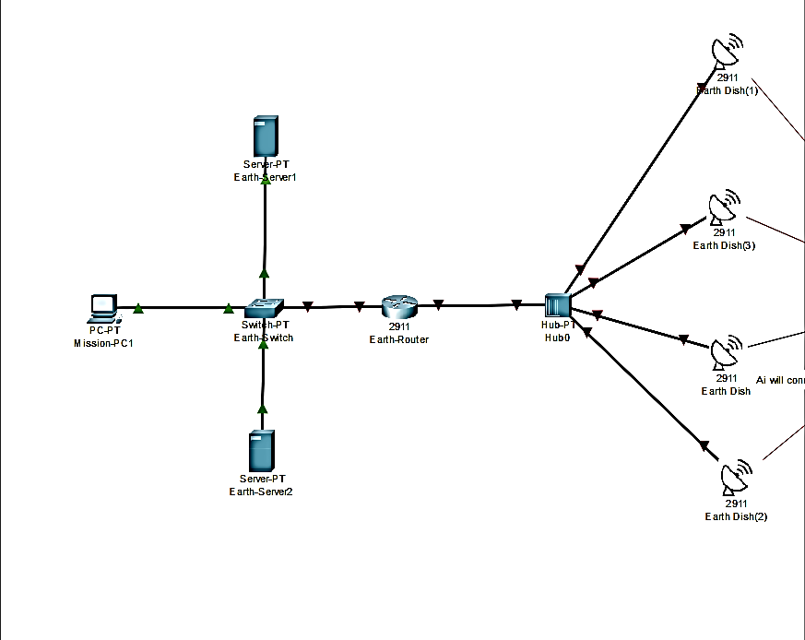

## Space Segment

* 2x AI-enabled Satellites
* Multiple IoT Devices
* Backup Communication Module

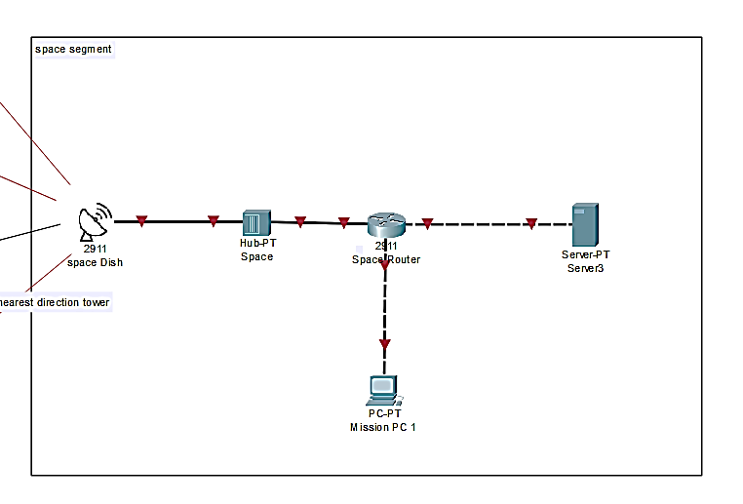

## Enhanced IP Scheme

Earth Core: 10.1.0.0/16

Space Segment: 172.16.0.0/16

Satellite Mesh: 192.168.0.0/16

# Advanced Features

## High Availability

standby 1 ip 10.1.0.1

standby 1 priority 110

standby 1 preempt

## QoS Implementation

class-map match-all CRITICAL-DATA

match ip dscp ef

policy-map SPACE-QOS

class CRITICAL-DATA

priority 256

## Security Measures

1. IPSec Tunnels
2. Access Control Lists
3. Port Security
4. VLAN Segregation

## Performance Optimizations

* Implement OSPF for dynamic routing
* Configure load balancing
* Enable compression for data transmission
* Deploy redundant paths

# Monitoring

show performance

show satellite status

show link statistics

## Advanced Testing

1. Failover scenarios
2. Bandwidth stress testing
3. Latency measurements
4. Signal degradation simulation

## Future Enhancements

* Integration with ground radar systems
* AI-based traffic optimization
* Automated failover procedures
* Deep space communication protocols

**References**

* NASA Network Standards
* Cisco Space Communications Guide
* ITU Space Regulations

Note: Cisco 2911 routers and hubs are used for simulation purposes in Packet Tracer to represent antenna connections.