

refresh icon

cross, delete, remove icon

add, sign icon



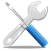



Cuentas



cross, delete, remove icon



refresh icon



add, sign icon