assessment 2: Team project

COSC2196 – Introduction to Information Technology A2

Contents

Team Profile 2

Team Name 2

Team Members 2

Niki Arrogante 2

Tamara Brice 2

Debborah Bryce 2

Samuel Claydon 2

Caden Maxwell 2

Jake Waterson 2

# Team Profile

## Team Name

Our team collectively decided to name ourselves **Team25**. It was named after the group number we joined in Canvas. It’s easy to remember, straightforward, and involves a nice, rounded number that everyone can appreciate.

## Team25 Members

The six members of Team25 are:

### Niki Arrogante

Sydney-born and raised, Niki is currently a full-time student following years working in various sectors including telecommunications and logistics. He is a big fan of virtual reality and hopes to find ways to implement the technology in new, exciting ways. Outside of studies, he enjoys gaming, motorcycles, and spending time with his two-year old daughter and partner.

Ideal Job: Hardware/Software Developer (VR)

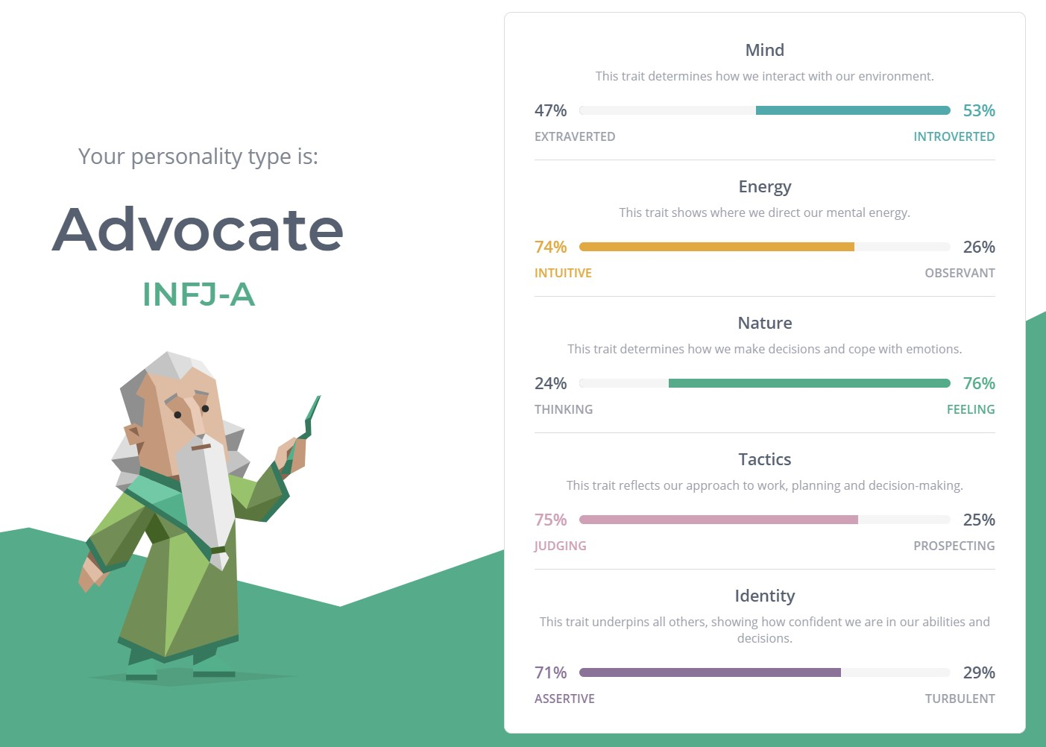

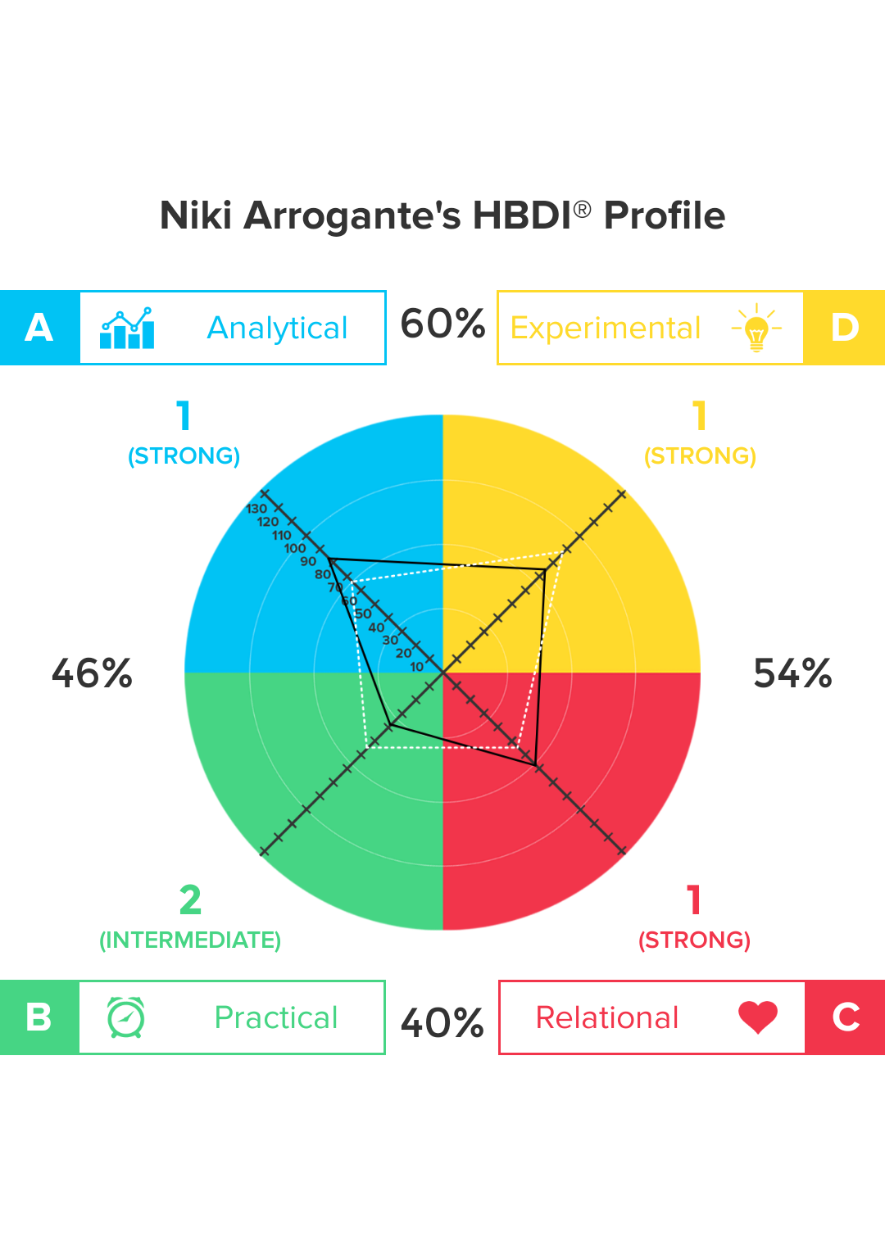

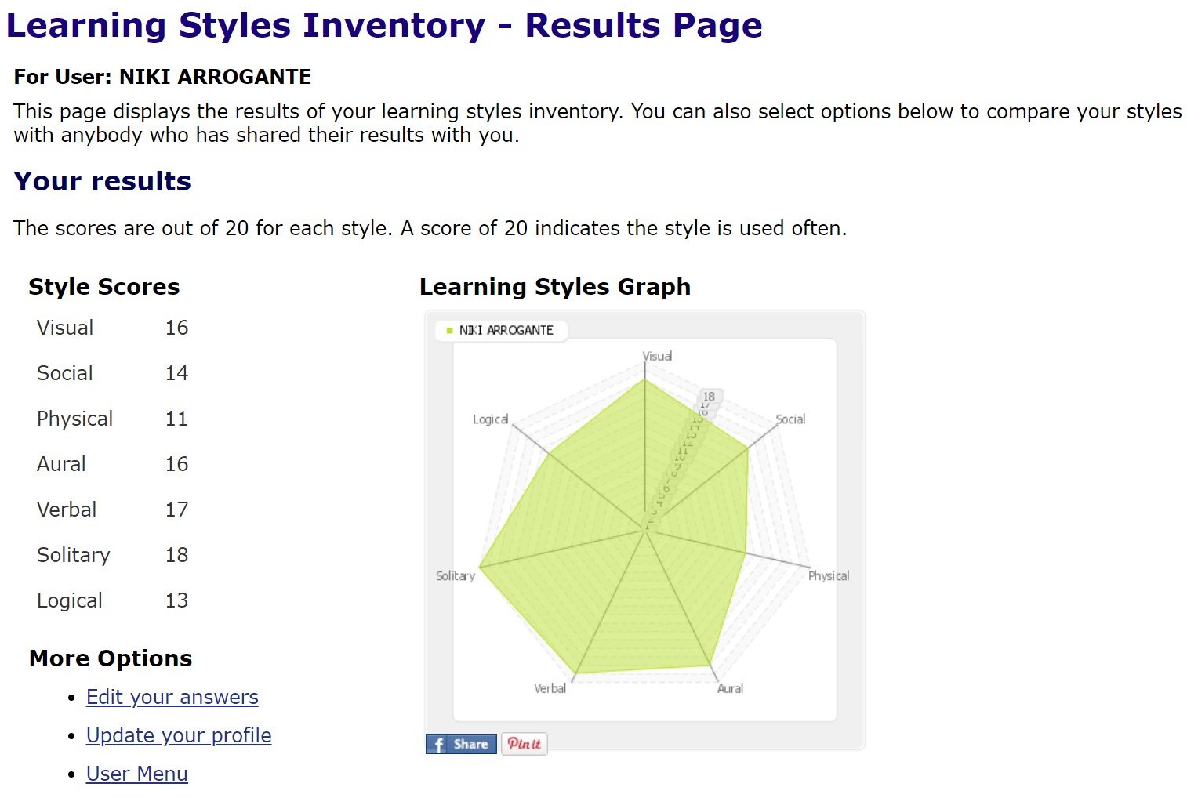

### Tamara Brice

Tamara has been working in the field of Telecommunications for 12 years. Throughout her role she has worked almost exclusively with enterprise and government contracts specializing in cisco managed networks and WiFi. Outside of work she spends a great deal of time working on Rally Cars and volunteering with the Australian Communications Radio Monitors (ACRM for Short), The Adelaide Brown Coats and Shine SA where they run events to raise money for charities. She first got interested in IT during high school when she started building her own gaming machines. She got heavily into gaming, 3d modelling and making mods for games. Tamara hasn’t had a great opportunity to further her PC programming skills since school focusing entirely on networking equipment and misses making small apps and programs.

### Debborah Bryce

Mum of four kids, two cats, and two dogs, Debborah was born and raised in Australia with English Scottish heritage. Debborah plays netball on the weekends and currently works in IGA. She is fascinated with modern technology and enjoy learning new skills, languages and reading.

Ideal Job: Data Analyst

### Samuel Claydon

Sam lives in Tasmania in a rural town called Kempton with a population of around 400 people, he was born in Tasmania loves living there. He’s 23 years old and currently taking 2 courses online, this introduction to IT course and an academic and professional communications course. He loves playing games with friends and likes to read. Ever since a family friend gave him their old computer, he’s loved playing video games and his love of games combined with knowing someone who is great at repairing computers is what made him want to pursue a career in IT. He doesn’t have any professional experience in IT but is very excited to learn.

Ideal Job: Computer repair technician.

### Caden Maxwell

#### Personal Information

My name is Caden Maxwell my student number is s3853897 and I am part of team 25. I live in Wagga Wagga NSW, I was born in Australia however my father is from New Zealand. I have just completed High School and my HSC, where the focus of my studies were IT-related subjects. This included; Information and Digital Technology, Software Design and Development and Information Processes and Technology, during these studies, I also worked towards achieving my Cert III for IT.

Ideal Job: Software developer (gaming and/or general applications)

### Jake Waterson

## Comparing Test Results

## Comparing Ideal Jobs

## Tools

Our team first assigned ourselves in Canvas to Team 25. Discussions were minimal as we were preparing for our first assignments, but after discussion we decided that our tools would include **Microsoft Teams**, **GitHub**, and **Trello**.

Within [Microsoft Teams](https://teams.microsoft.com/l/team/19%3adae7093f81814e8382f89f14f1afb602%40thread.tacv2/conversations?groupId=df9a1261-3af1-45a1-8b78-c360f7343451&tenantId=d1323671-cdbe-4417-b4d4-bdb24b51316b), we organised separated channels to log our work in different divisions of the assessment and opened a chatroom to have our weekly team meetings. Meeting minutes were logged after each meeting for posterity and absent members to make sure we were always up to date with our work and expectations.

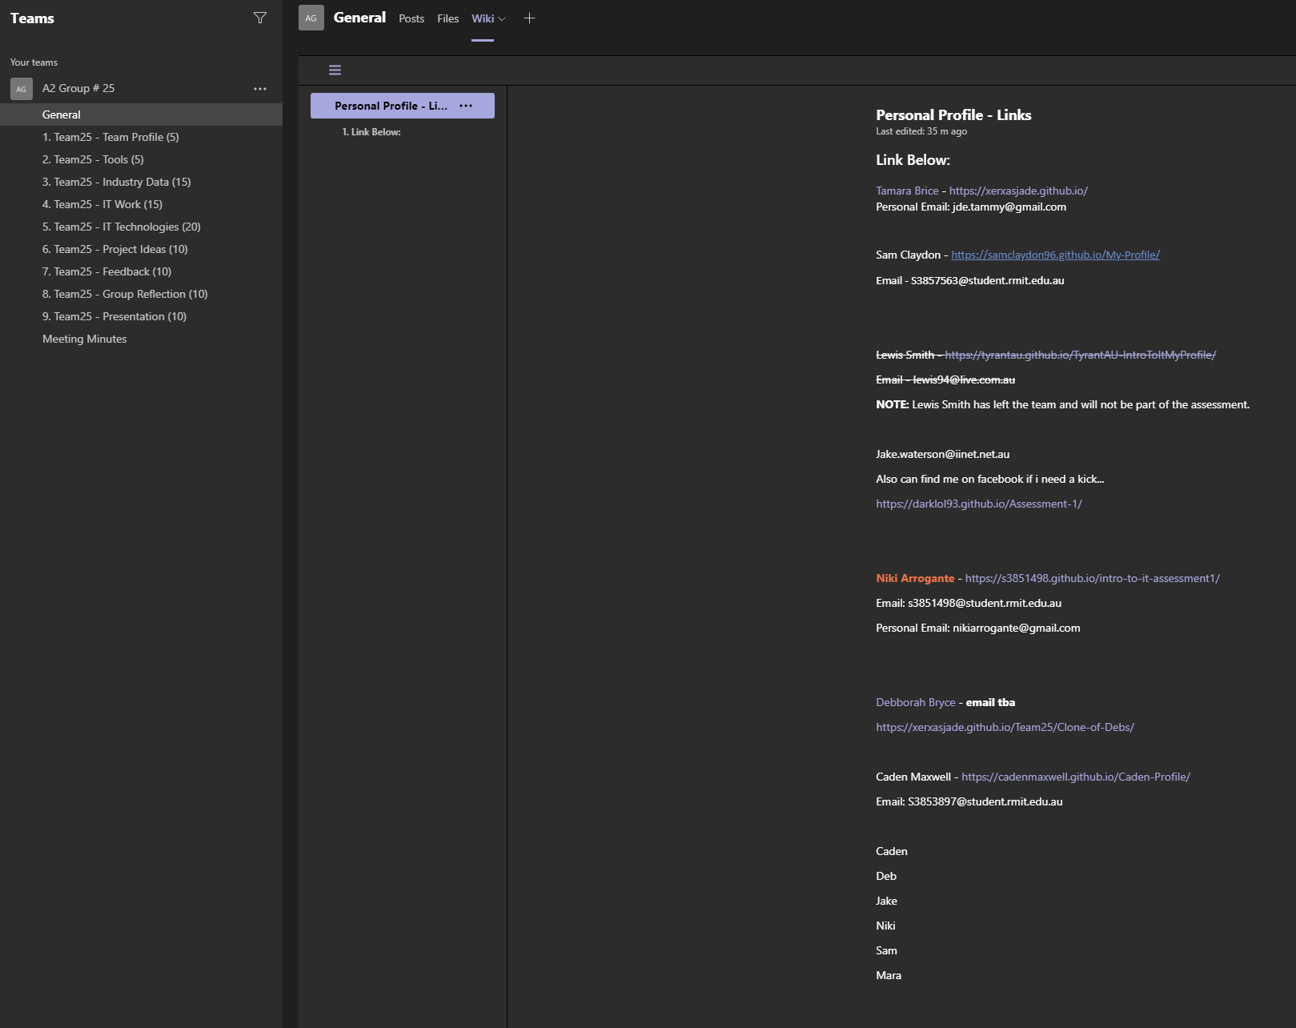

A [GitHub](https://github.com/XerxasJade/Team25) was set up to facilitate the team website, and act as our repository for our work.