1. Overview
The Xeryon SDK is a cross-platform C++ library designed to provide a unified interface for controlling Xeryon controllers across multiple hardware families and communication protocols.
The SDK abstracts controller differences and communication mechanisms while exposing a consistent motion control API to application developers.
Supported controller families include (but are not limited to):
- XD-OEM
- XD-M
- XD-C
- Future Xeryon controllers

2. Design Goals

Primary Goals
- One SDK for all controllers
- Simple and clear public API
- Hardware abstraction
- Support single-axis and multi-axis controllers
- Cross-platform compatibility
- Protocol independence
- Transport independence
- Minimal runtime overhead

Secondary Goals
- Easy extensibility
- Stable API surface
- Clean architecture
- Minimal dependencies
- logging support (Optional)

3. Non-Goals
The SDK does NOT:
- Expose low-level hardware registers
- Depend on platform-specific APIs
- Require GUI frameworks
- Bind the API to a specific controller model
- Embed protocol details in public interfaces

4. High-Level Architecture
The SDK follows a layered architecture:
[Diagram: Xeryon SDK Layered Architecture]

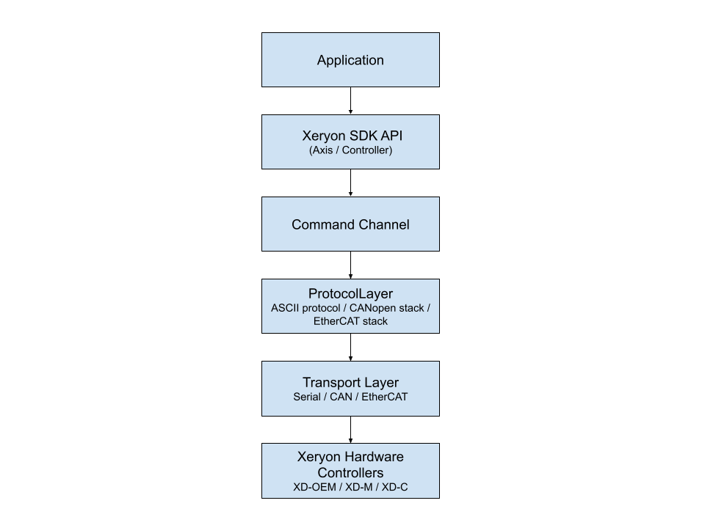

5. Core Concepts

5.1 Axis
An Axis represents a controllable motion channel.
An axis abstraction exists independently of controller topology:
- single-axis controller → one axis
- multi-axis controller → multiple axes
The Axis abstraction hides hardware complexity from users.
[Diagram: Controller and Axis Relationship]

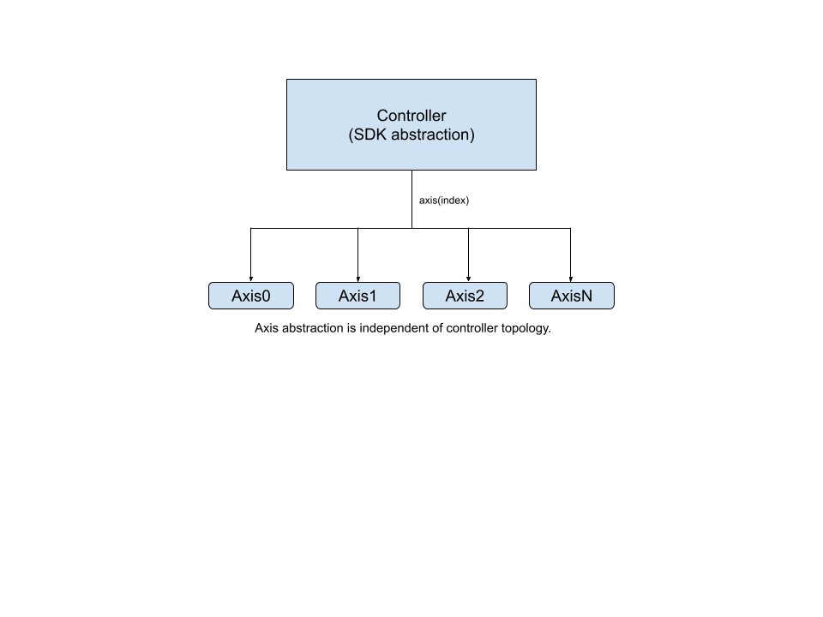

5.2 Controller (SDK Abstraction)
A controller represents a physical hardware device.
Responsibilities:
- manage axes
- translate commands
- expose controller capabilities
- handle device-specific behavior
Examples:
- Controller ctrl("COM3", 115200)
Controllers are interchangeable implementations beneath a common interface.

5.3 Command Channel
CommandChannel is a single unified interface for sending commands and receiving responses from the device, independent of transport (Serial, SPI, I2C, etc.) or protocol (ASCII, binary, etc.).
It sits between the control layer (Axis, Controller) and the communication stack, so higher-level code does not need to know how data is actually transmitted.
It provides two core operations:
- send(cmd) → send a command without expecting a response
- query(cmd) → send a command and get a response
Internally, it ensures thread-safe access and delegates actual communication to the underlying protocol and transport layers.

5.4 INFO (Realtime Feedback)
INFO enables realtime controller feedback.
Used for:
- position updates
- motion state reporting
- diagnostics
- monitoring
Design characteristics:
- asynchronous reception
- non-blocking operation
- event-driven internally
- optional consumption by application
INFO handling is independent of transport type.

6. Layer Breakdown

6.1 Public API Layer
Provides user-facing interfaces:
Axis
Controller
Distance

Example:
Controller ctrl("COM3", 115200);
Axis& axis = ctrl.axis();
axis.setDPOS(5_mm);
axis.index(1);

The public API does not expose protocols or transports.

6.2 Axis Layer
Responsibilities:
- motion operations
- state queries
- settings access
Axis converts user actions into commands via controller.
[Diagram: Command to Hardware Communication Flow]

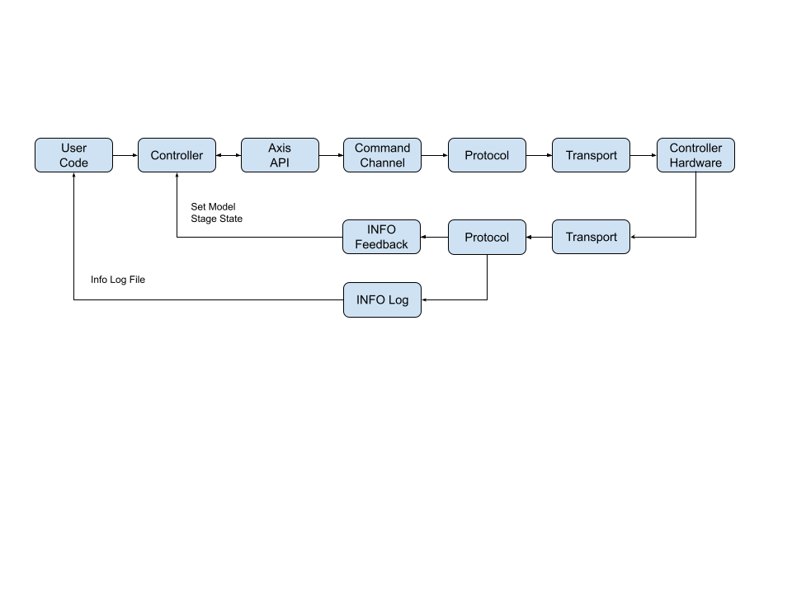

6.3 Command Channel
Responsibilities:
- Provides a single API for device communication (send, query)
- Ensures thread-safe command execution
- Forwards commands to the underlying protocol layer (e.g., ASCII, binary)
- Handles request/response transactions for queries
- Abstracts away transport details (serial, SPI, I2C, etc. via protocol stack)
- Acts as a synchronization point for concurrent command access
- Provides consistent logging of outgoing commands
- Decouples higher-level logic (Controller, Axis) from communication implementation

6.4 Protocol Layer
The protocol layer is the bridge between raw transport (serial/USB/etc.) and structured communication (commands + streaming data).
It ensures that bytes in/out become meaningful system events.
Examples:
- ASCII protocol
- Other protocol (Future scope)
Responsibilities:
- Converts raw transport I/O into structured ASCII lines
- Runs a reader thread that continuously reads device output
- Separates command responses vs streaming info data
- Matches query responses with pending commands
- Routes non-command data to InfoListener
- Handles thread-safe send/query operations
- Implements timeout-based request/response handling
- Normalizes protocol keys for matching (CMD, AXIS:CMD, etc.)

6.5 Transport Layer
The Transport layer is the lowest communication layer responsible for raw byte exchange with hardware devices over a physical or virtual medium (e.g. Serial/USB).
It is completely protocol-agnostic.
Supported transports:
- Serial (COM / tty)
- Other Transport (Future scope)
Responsibilities:
- Opens and configures hardware communication channels (COM / tty)
- Handles OS-specific serial I/O (Windows + Linux abstraction)
- Provides raw write/read byte streaming
- Buffers incoming data until complete lines (\n) are formed
- Ensures non-blocking / timeout-based reads
- Flushes stale or unwanted RX data when required
- Hides platform differences from upper layers

7. Multi-Protocol Support
Transport mechanisms differ in behavior:
Transport | Command Based
Serial | Yes
CANopen | Object dictionary
EtherCAT | Process data
GPIO | Signal driven
Internal adapters ensure the public API remains identical regardless of protocol.

8. Cross-Platform Strategy
Supported operating systems:
- Windows
- Linux
- macOS
Platform-specific implementations remain internal.
Example:
serial_win.cpp
serial_posix.cpp

Applications use a unified interface across all platforms.

9. Logging
The SDK provides minimal logging through a single macro:
XLOG(...)

Logging characteristics:
- compile-time enable/disable
- zero overhead when disabled
- no external dependencies
CMake option:
option(XERYON_ENABLE_LOG "Enable SDK logging" ON)

When disabled, XLOG compiles to no operation.

10. Extensibility
Adding a new controller requires:
- Controller implementation
- Command mapping
- Capability definition
Adding a new transport requires:
- Transport implementation
No public API modification is required.

11. Threading Model
Design assumptions:
- communication is non-blocking
- INFO processing is asynchronous
- applications may poll state safely
Thread management remains internal to the SDK.

12. Error Handling
Errors are represented using:
- status objects
- exceptions for fatal failures
- recoverable runtime errors when possible
Transport failures are isolated from application logic.

13. Build System
The SDK uses CMake.
Features:
- cross-platform builds
- optional logging
- installable package (TBD)
- examples and tests
Exported target:
xeryon::xeryon

14. Design Decisions Summary
Decision | Reason
Axis abstraction | unify single and multi-axis controllers
Command-centered architecture | aligns with controller documentation
Transport abstraction | enables multi-protocol support
Controller implementations | scalable hardware support
Minimal logging | embedded-friendly design
Cross-platform first | unknown customer environments

15. Future Extensions
Potential future additions:
- TBD
Architecture supports extension without redesign.

16. Guiding Principle
The SDK abstracts hardware complexity while preserving controller capability and performance.

17. Development Guidelines

17.1 Repository Structure
/sdk
/include → Public headers
/src → Core implementation
/controller → Controller logic
/axis → Axis abstraction
/communication → Protocol implementations
/transport → Hardware drivers
/logging → XLOG implementation

/examples → SDK usage examples
/tests → Unit tests
/CMakeLists.txt → Build configuration

Purpose:
- Prevents folder chaos later
- Helps onboarding instantly

17.2 Runtime Workflow
1. Application creates XController
2. Controller discovers hardware controllers
3. Axis objects are created
4. Commands issued through Command Model
5. Protocol layer encodes commands
6. Transport sends data
7. Feedback propagates upward
8. Shutdown releases resources
[Diagram: Runtime Execution Flow]
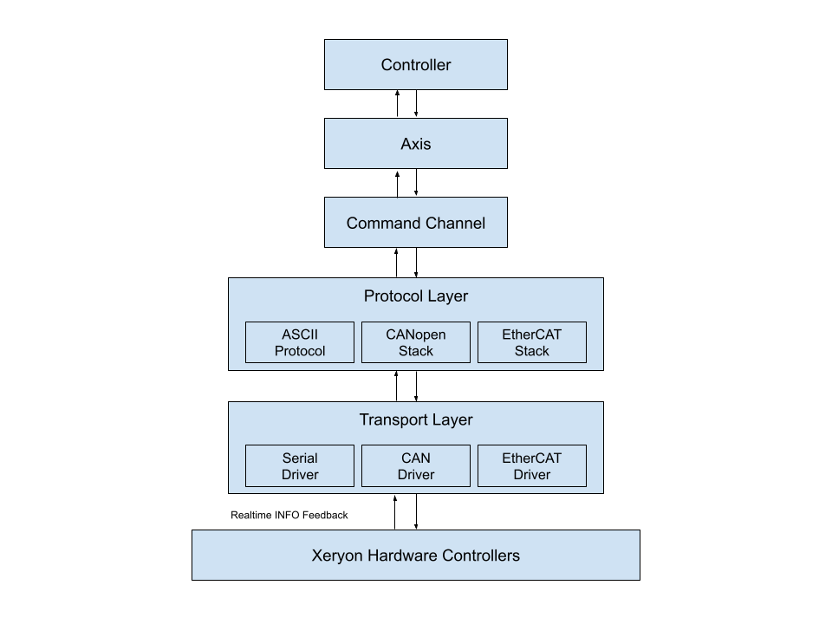

17.3 Versioning Policy
Versioning follows Semantic Versioning:

MAJOR → Breaking API changes
MINOR → Backward-compatible features
PATCH → Bug fixes and internal improvements

Public API stability guaranteed within the same MAJOR version.

