Fish Detection and Monitoring System
*Note: Sub-titles are not captured in Xplore and should not be used

Danuphat Parnpradit
Robotic and Automation System Enginnering
Kasetsart University Sriracha Campus
Chon Buri, Thailand
danuphat.p@ku.th
Thanakrit Wongkha
Robotic and Automation System Enginnering
Kasetsart University Sriracha Campus
Chon Buri, Thailand
thanakrit.wo@ku.th
Sajakorn chutikarnmongkol
Robotic and Automation System Enginnering
Kasetsart University Sriracha Campus
Chon Buri, Thailand
sajakorn.c@ku.th
Thanakon Chaichana
Robotic and Automation System Enginnering
Kasetsart University Sriracha Campus
Chon Buri, Thailand
thanakon.chai@ku.th

Abstract— This paper presents a real time fish detection and counting system using a GoPro camera and machine learning techniques. The objective of this project is to achieve accurate fish counting in a tank environment with a target accuracy of at least 90 percent. The system captures live images through a GoPro camera via HTTP and processes the data using Python and computer vision methods. A trained object detection model is used to identify and count fish in each frame. The results are then displayed through a graphical user interface, allowing users to monitor fish activity in real time. The proposed system provides an efficient and automated solution for fish monitoring applications.
Keywords— fish detection, object detection, machine learning, computer vision, real time monitoring

Introduction
detection and counting system using a GoPro camera and machine learning techniques. Monitoring fish in a tank is important for research, aquaculture and system automation, but manual counting is time consuming and prone to error. Therefore, an automated solution is needed to improve efficiency and accuracy.

The proposed system captures live images from a GoPro camera through an HTTP connection and processes them using Python and computer vision techniques. An object detection model based on pretrained model YOLO is used to detect and count fish in each frame. The processed results are then sent to a graphical user interface developed using Pygame or Tkinter, where users can monitor the system in real time.

The main objective of this project is to achieve at least 90 percent accuracy in fish counting while maintaining real time performance. This system aims to provide a simple, reliable, and cost effective solution for automated fish monitoring.

Proposed System

Hardware Setup
The proposed system architecture is engineered to facilitate robust, real-time image acquisition and data routing. The primary visual sensor utilizes a high-definition GoPro camera, strategically positioned to capture an unobstructed field of view of the aquatic environment. To manage data bridging and edge-level tasks, the topology incorporates two Raspberry Pi Zero 2W single-board computers, which act as intermediary network nodes. The core computational workload is delegated to a centralized desktop workstation, which is provisioned with sufficient processing resources to handle continuous, high-throughput video streams and execute complex computer vision algorithms.

Software and Image Processing
The software infrastructure is designed to seamlessly integrate data transmission, frame extraction, and automated visual analytics. Continuous high-resolution image frames are captured by the GoPro sensory node and transmitted to the central computational unit via an HTTP-based network protocol. Upon reception, the video stream is ingested into an advanced image processing pipeline developed using the Open Source Computer Vision Library (OpenCV) in Python. This pipeline subjects each frame to rigorous object detection and classification algorithms to isolate individual piscine targets. The system subsequently executes real-time inference to achieve highly accurate automated enumeration (counting) and taxonomic classification (species identification) of the fish within the monitored tank environment.

Experimental Setup and Evaluation
Before you begin to format your paper, first write and save the content as a separate text file. Complete all content and organizational editing before formatting. Please note sections A-D below for more information on proofreading, spelling and grammar.
Keep your text and graphic files separate until after the text has been formatted and styled. Do not use hard tabs, and limit use of hard returns to only one return at the end of a paragraph. Do not add any kind of pagination anywhere in the paper. Do not number text heads-the template will do that for you.

Hardware Configuration and Network Topology
The proposed system architecture is engineered to facilitate robust, real-time image acquisition and data routing. The primary visual sensor utilizes a high-definition GoPro camera, strategically positioned to capture an unobstructed field of view of the aquatic environment. To manage data bridging and edge-level tasks, the topology incorporates two Raspberry Pi Zero 2W single-board computers, which act as intermediary network nodes. The core computational workload is delegated to a centralized desktop workstation provisioned with sufficient processing resources to handle continuous, high-throughput video streams and execute complex computer vision algorithms.

Test Object Design and Fabrication
Artificial fish models are employed to ensure repeatable and controlled evaluation. The models are fabricated using 3D printing, enabling precise control over geometry, scale, and surface characteristics.

Two representative marine species are selected: the Whale shark and the Manta ray. These species provide distinct visual features for detection, including the elongated, patterned body of the whale shark and the wide, planar shape of the manta ray. The models are printed using PLA material, offering a balance between structural rigidity and ease of fabrication. Surface color and texture can be adjusted to approximate real-world visual conditions.

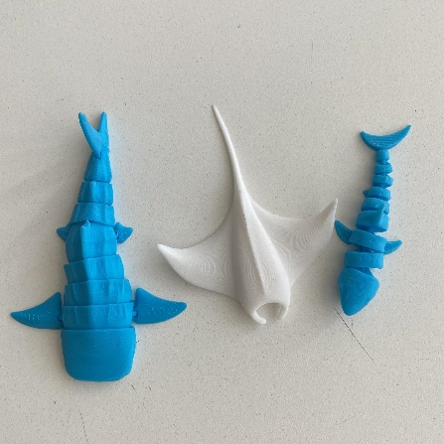
Figure 1 presents the 3D-printed fish models used in this study.

Underwater Deployment Method
To ensure consistent positioning during experiments, each model is anchored using a weighted object. A thin wire is used to connect the 3D-printed fish to a submerged weight (e.g., a stone), keeping the model fixed within the camera’s field of view.

This approach prevents unintended movement caused by water disturbances while allowing controlled adjustment of depth and orientation. As a result, the system can capture stable and repeatable image data for performance evaluation.

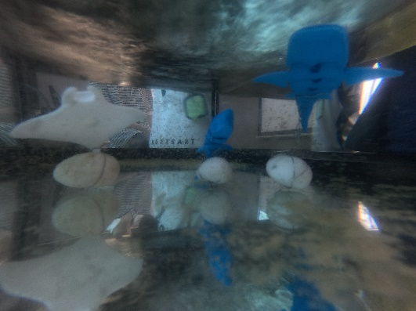
Figure 2 illustrates the underwater deployment setup.

Model Training and Hyperparameters
For object detection and classification, the system utilizes the YOLO26s (yolo26s.pt) architecture. The model was trained for 60 epochs with a batch size of 6 and an input resolution of 640x640 pixels on a dedicated GPU. Although the optimizer was initially set to an automated configuration, the actual training run utilized the AdamW optimizer with a learning rate of approximately 0.001429 and a momentum of 0.9. To enhance the model's robustness against varying underwater visual conditions and potential occlusions, several data augmentation techniques were applied, most notably Mosaic augmentation (1.0) and Random Erasing (0.4).

Software Implementation and User Interface
The software infrastructure integrates data transmission, frame extraction, and automated visual analytics using a pipeline developed with the OpenCV library in Python. The system executes real-time inference to achieve automated enumeration (counting) and taxonomic classification (species identification) of the targets within the tank environment. The processed results are displayed through a graphical user interface developed using Pygame, enabling real-time monitoring.

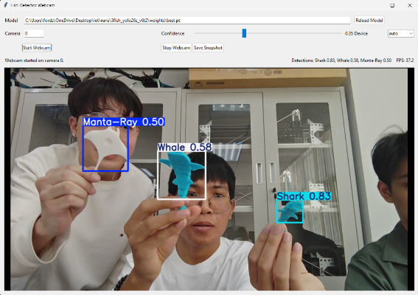
Figure 3 Real-time detection output on the GUI, showing automated enumeration and taxonomic classification of 3D-printed fish models.

Results and Discussion
After the text edit has been completed, the paper is ready for the template. Duplicate the template file by using the Save As command, and use the naming convention prescribed by your conference for the name of your paper. In this newly created file, highlight all of the contents and import your prepared text file. You are now ready to style your paper; use the scroll down window on the left of the MS Word Formatting toolbar.

Authors and Affiliations
The template is designed for, but not limited to, six authors. A minimum of one author is required for all conference articles. Author names should be listed starting from left to right and then moving down to the next line. This is the author sequence that will be used in future citations and by indexing services. Names should not be listed in columns nor group by affiliation. Please keep your affiliations as succinct as possible (for example, do not differentiate among departments of the same organization).

For papers with more than six authors: Add author names horizontally, moving to a third row if needed for more than 8 authors.

For papers with less than six authors: To change the default, adjust the template as follows.

Selection: Highlight all author and affiliation lines.

Change number of columns: Select the Columns icon from the MS Word Standard toolbar and then select the correct number of columns from the selection palette.

Deletion: Delete the author and affiliation lines for the extra authors.

Identify the Headings
Headings, or heads, are organizational devices that guide the reader through your paper. There are two types: component heads and text heads.
Component heads identify the different components of your paper and are not topically subordinate to each other. Examples include Acknowledgments and References and, for these, the correct style to use is “Heading 5”. Use “figure caption” for your Figure captions, and “table head” for your table title. Run-in heads, such as “Abstract”, will require you to apply a style (in this case, italic) in addition to the style provided by the drop down menu to differentiate the head from the text.
Text heads organize the topics on a relational, hierarchical basis. For example, the paper title is the primary text head because all subsequent material relates and elaborates on this one topic. If there are two or more sub-topics, the next level head (uppercase Roman numerals) should be used and, conversely, if there are not at least two sub-topics, then no subheads should be introduced. Styles named “Heading 1”, “Heading 2”, “Heading 3”, and “Heading 4” are prescribed.

Figures and Tables

Positioning Figures and Tables: Place figures and tables at the top and bottom of columns. Avoid placing them in the middle of columns. Large figures and tables may span across both columns. Figure captions should be below the figures; table heads should appear above the tables. Insert figures and tables after they are cited in the text. Use the abbreviation “Fig. 1”, even at the beginning of a sentence.
- Table Type Styles
Table Head | Table Column Head
 | Table column subhead | Subhead | Subhead
copy | More table copyª
- Sample of a Table footnote. (Table footnote)
- Example of a figure caption. (figure caption)
Figure Labels: Use 8 point Times New Roman for Figure labels. Use words rather than symbols or abbreviations when writing Figure axis labels to avoid confusing the reader. As an example, write the quantity “Magnetization”, or “Magnetization, M”, not just “M”. If including units in the label, present them within parentheses. Do not label axes only with units. In the example, write “Magnetization (A/m)” or “Magnetization {A[m(1)]}”, not just “A/m”. Do not label axes with a ratio of quantities and units. For example, write “Temperature (K)”, not “Temperature/K”.

Acknowledgment (Heading 5)
The preferred spelling of the word “acknowledgment” in America is without an “e” after the “g”. Avoid the stilted expression “one of us (R. B. G.) thanks ...”. Instead, try “R. B. G. thanks...”. Put sponsor acknowledgments in the unnumbered footnote on the first page.

References
The template will number citations consecutively within brackets [1]. The sentence punctuation follows the bracket [2]. Refer simply to the reference number, as in [3]—do not use “Ref. [3]” or “reference [3]” except at the beginning of a sentence: “Reference [3] was the first ...”
Number footnotes separately in superscripts. Place the actual footnote at the bottom of the column in which it was cited. Do not put footnotes in the abstract or reference list. Use letters for table footnotes.
Unless there are six authors or more give all authors’ names; do not use “et al.”. Papers that have not been published, even if they have been submitted for publication, should be cited as “unpublished” [4]. Papers that have been accepted for publication should be cited as “in press” [5]. Capitalize only the first word in a paper title, except for proper nouns and element symbols.
For papers published in translation journals, please give the English citation first, followed by the original foreign-language citation [6].

- G. Eason, B. Noble, and I. N. Sneddon, “On certain integrals of Lipschitz-Hankel type involving products of Bessel functions,” Phil. Trans. Roy. Soc. London, vol. A247, pp. 529–551, April 1955. (references)
- J. Clerk Maxwell, A Treatise on Electricity and Magnetism, 3rd ed., vol. 2. Oxford: Clarendon, 1892, pp.68–73.
- I. S. Jacobs and C. P. Bean, “Fine particles, thin films and exchange anisotropy,” in Magnetism, vol. III, G. T. Rado and H. Suhl, Eds. New York: Academic, 1963, pp. 271–350.
- K. Elissa, “Title of paper if known,” unpublished.
- R. Nicole, “Title of paper with only first word capitalized,” J. Name Stand. Abbrev., in press.
- Y. Yorozu, M. Hirano, K. Oka, and Y. Tagawa, “Electron spectroscopy studies on magneto-optical media and plastic substrate interface,” IEEE Transl. J. Magn. Japan, vol. 2, pp. 740–741, August 1987 [Digests 9th Annual Conf. Magnetics Japan, p. 301, 1982].
- M. Young, The Technical Writer’s Handbook. Mill Valley, CA: University Science, 1989.

IEEE conference templates contain guidance text for composing and formatting conference papers. Please ensure that all template text is removed from your conference paper prior to submission to the conference. Failure to remove template text from your paper may result in your paper not being published.

