**Intro**

What is optimal polygon triangulation:

Optimal Polygon Triangulation refers to the process that divides a simple polygon into non-overlapping triangles such that a certain cost function is minimized (or optimized).

**Key Details:**

1. **Polygon Triangulation**:
   * A **simple polygon** is a polygon that does not intersect itself.
   * Triangulation is the process of subdividing the interior of the polygon into **non-overlapping triangles** by drawing diagonals (lines connecting non-adjacent vertices) between the polygon's vertices.
2. **Optimality Criteria**: The "optimality" depends on the cost function you are minimizing. Common criteria include:
   * **Minimizing total edge length**: Find a triangulation where the sum of the lengths of all diagonals and edges is minimized.
   * **Minimizing total area of triangles**: This is less common but sometimes relevant for specific applications.
   * **Maximizing minimum angles**: This avoids thin, sliver-like triangles, which are undesirable in finite element methods and other applications.

**Flowchart:**

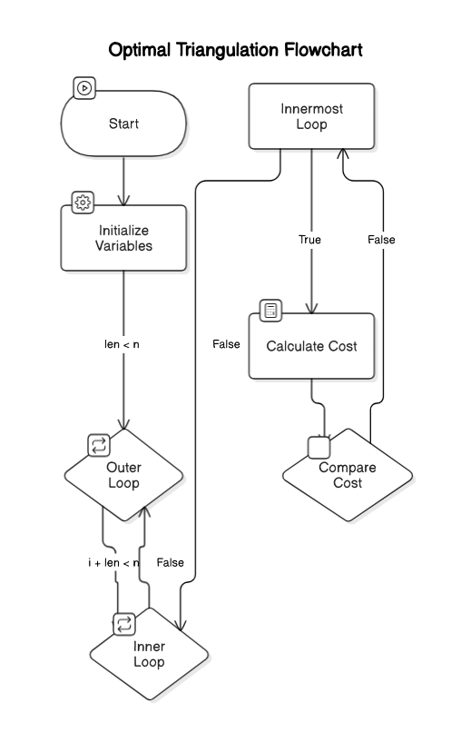

**PseudoCode:**

double computeOptimalTriangulation( ) {

for (int len = 2; len < n; ++len) {

for (int i = 0; i + len < n; ++i) {

int j = i + len;

dp[ i ][ j ] = numeric_limits<double>::infinity( );

for (int k = i + 1; k < j; ++k) {

double cost = dp[ i ][ k] + dp[ k ][ j ] +

trianglePerimeter( points[i], points[k], points[j] );

if (cost < dp [ i ][ j ] ) {

dp [ i ][ j ] = cost;

split [ i ][ j ] = k;

}

}

}

}

return dp[ 0 ][n - 1];

}

**Data Type & data section:**

The input to the **Optimal Polygon Triangulation** program is provided as a list of vertices with their geometric coordinates (x, y) . Each vertex represents a point in a 2D Cartesian plane, and the vertices are given in counterclockwise (or clockwise) order to form the polygon.

Input Types:

1. **Geometric Coordinates List:**The polygon is represented as a list of n vertices, where each vertex is defined by its *x* and *y* coordinates in the format *(x, y)* The input must form a simple polygon, meaning the edges do not intersect except at the vertices.
2. **Valid Input Format:**The input can be one of the following:
   * A convex polygon: All interior angles are less than 180 degrees.
   * A concave polygon: At least one interior angle is greater than 180 degrees.
   * A self-intersecting polygon (invalid): Polygons with intersecting edges are not accepted.

Example Input (Convex Polygon with 5 Vertices):

V1​=(0,0), V2​=(2,0), V3​=(3,1), V4​=(1,3), V5​=(−1,2)

Where:

* Each pair (x,y)(x, y)(x,y) represents a vertex of the polygon.
* The order of vertices ensures the edges connect sequentially to form the polygon.

**Step by Step Calculation:**

Initially DP Table and split table:

dp Table after len = 2

**dp Table:**

|  |  |  |  |  |  |
| --- | --- | --- | --- | --- | --- |
|  | V1 | V2 | V3 | V4 | V5 |
| V1 | 0 | 0 | 0 | 0 | 0 |
| V2 | 0 | 0 | 0 | 0 | 0 |
| V3 | 0 | 0 | 0 | 0 | 0 |
| V4 | 0 | 0 | 0 | 0 | 0 |
| V5 | 0 | 0 | 0 | 0 | 0 |

**Split Table:**

|  |  |  |  |  |  |
| --- | --- | --- | --- | --- | --- |
|  | V1 | V2 | V3 | V4 | V5 |
| V1 | -1 | -1 | -1 | -1 | -1 |
| V2 | -1 | -1 | -1 | -1 | -1 |
| V3 | -1 | -1 | -1 | -1 | -1 |
| V4 | -1 | -1 | -1 | -1 | -1 |
| V5 | -1 | -1 | -1 | -1 | -1 |

dp Table after len = 3

**dp Table:**

|  |  |  |  |  |  |
| --- | --- | --- | --- | --- | --- |
|  | V1 | V2 | V3 | V4 | V5 |
| V1 | 0 | 0 | 6.58 | 0 | 0 |
| V2 | 0 | 0 | 0 | 7.4 | 0 |
| V3 | 0 | 0 | 0 | 0 | 9.19 |
| V4 | 0 | 0 | 0 | 0 | 0 |
| V5 | 0 | 0 | 0 | 0 | 0 |

**Split Table:**

|  |  |  |  |  |  |
| --- | --- | --- | --- | --- | --- |
|  | V1 | V2 | V3 | V4 | V5 |
| V1 | -1 | -1 | 1 | -1 | -1 |
| V2 | -1 | -1 | -1 | 2 | -1 |
| V3 | -1 | -1 | -1 | -1 | 3 |
| V4 | -1 | -1 | -1 | -1 | -1 |
| V5 | -1 | -1 | -1 | -1 | -1 |

dp Table after len=4

**dp Table:**

|  |  |  |  |  |  |
| --- | --- | --- | --- | --- | --- |
|  | V1 | V2 | V3 | V4 | V5 |
| V1 | 0 | 0 | 6.58 | 15.73 | 0 |
| V2 | 0 | 0 | 0 | 7.4 | 16.41 |
| V3 | 0 | 0 | 0 | 0 | 9.19 |
| V4 | 0 | 0 | 0 | 0 | 0 |
| V5 | 0 | 0 | 0 | 0 | 0 |

**Split Table:**

|  |  |  |  |  |  |
| --- | --- | --- | --- | --- | --- |
|  | V1 | V2 | V3 | V4 | V5 |
| V1 | -1 | -1 | 1 | 2 | -1 |
| V2 | -1 | -1 | -1 | 2 | 3 |
| V3 | -1 | -1 | -1 | -1 | 3 |
| V4 | -1 | -1 | -1 | -1 | -1 |
| V5 | -1 | -1 | -1 | -1 | -1 |

dp Table after len=5

**dp Table:**

|  |  |  |  |  |  |
| --- | --- | --- | --- | --- | --- |
|  | V1 | V2 | V3 | V4 | V5 |
| V1 | 0 | 0 | 6.58 | 15.73 | 23.3639 |
| V2 | 0 | 0 | 0 | 7.4 | 16.41 |
| V3 | 0 | 0 | 0 | 0 | 9.19 |
| V4 | 0 | 0 | 0 | 0 | 0 |
| V5 | 0 | 0 | 0 | 0 | 0 |

**Split Table:**

|  |  |  |  |  |  |
| --- | --- | --- | --- | --- | --- |
|  | V1 | V2 | V3 | V4 | V5 |
| V1 | -1 | -1 | 1 | 2 | 3 |
| V2 | -1 | -1 | -1 | 2 | 3 |
| V3 | -1 | -1 | -1 | -1 | 3 |
| V4 | -1 | -1 | -1 | -1 | -1 |
| V5 | -1 | -1 | -1 | -1 | -1 |

**Final result:**

Minimum cost of triangulation: **23.36**

Optimal triangulation steps (Applying recursion using split Table):

Triangle: (0, 3, 4)

Triangle: (0, 2, 3)

Triangle: (0, 1, 2)

**Time Complexity:**

Breakdown of Loops:

1. **Outer Loop (len loop):**
   * Iterates from 2 to n-1 (where n is the number of vertices in the polygon).
   * Total iterations: O(n)
2. **Middle Loop (i loop):**
   * For each len, i ranges from 0 to n-len-1.
   * The number of iterations decreases as len increases. In total, this loop runs approximately O(n) times for each len.
3. **Inner Loop (k loop):**
   * For each pair (i, j), k ranges from i+1 to j-1.
   * The number of iterations is proportional to the length of the segment being considered, len−1len - 1len−1.
   * For all pairs (i, j) combined, this contributes O(n) iterations.

Total Time Complexity:

* **The three nested loops together result in:**

Thus, the overall time complexity is:

**O(n3)**

The time complexity of the computeOptimalTriangulation function is **O(n3).** This is typical for dynamic programming solutions involving polygon triangulation.

**Why we have chosen dynamic programming to solve this problem:**

We have many ways to solve this problem, for instance: Brute Force Enumeration, Dynamic Programming, Greedy Algorithms, Convex Hull-Based Methods but we go with Dynamic Programming. As its ability to take advantage of the problem's optimal substructure and overlapping subproblems, making it a highly efficient and systematic approach.

Choosing the Best Method from All:

* **Brute Force Enumeration:** Only good for very small n ( n<10) or theoretical validation. Only used for very small polygons, as this method is computationally expensive. Also this method is impractical for larger polygons (n>10) due to exponential complexity(Time Complexity is O(n!)) .
* **Dynamic Programming:** Best for exact solutions with moderate input sizes   
  (n < 1000). Also this method is ideal if you need a guaranteed optimal triangulation. Guarantees the optimal solution with a reasonable runtime for typical input sizes. It’s time complexity is **O(n3)** where n is the number of vertices & space complexity is **O(n2)** for the dp table.
* **Greedy Algorithms:** Only good to use when speed is more important than exact optimality. It is faster than dynamic programming & doesn’t guarantee the optimal solution for general cost functions. This method is suitable for real-time applications ( for example, rendering in computer graphics). It’s time complexity in most cases is **O(n2).** In Dynamic Programming we break the polygon into smaller sub-problems, solve each sub-problem optimally, and combine results. So ultimately we can get a optimal solution which we can’t get from other methods & our main target is to get the optimal solution whatever this method’s time complexity [**O(n3)**] is greater than Greedy Algorithm [**O(n2)**] as Greedy method doesn’t ensure optimality.

**Real Life example:**

Here are some notable examples where dynamic programming (DP)-based polygonal triangulation techniques are useful:

• Computer Graphics and 3D Rendering: Triangulation is used to divide 2D polygons (often representing cross-sections or faces of 3D objects) into triangles for easier processing and rendering. Example: OpenGL or DirectX.

• Robotics and Pathfinding: A robot navigating a 2D environment needs to plan a collision-free path. This environment is often represented as a polygonal region with obstacles which allows efficient navigation & shortest-path calculations.

• Game Development: Triangulated surfaces simplify calculations for light & shadow projections, which are critical for creating realistic environments.

• Architecture and Urban Planning: Architects use triangulation to design & analyze structures like domes, bridges, and roofs.

• Art and Animation: Character's face can be represented as a polygonal mesh & triangulation enables smooth deformations for expressions.

• Network Optimization: In network design, sensor coverage areas are represented as polygons. Triangulation helps divide the coverage area into simpler regions to optimize communication & power consumption.

**Conclusion:**

Polygonal triangulation using dynamic programming is an efficient and reliable method to solve the problem by leveraging its optimal substructure and overlapping subproblems. DP ensures optimal solutions, reduces computational redundancy, and achieves a time complexity of O(n³), making it ideal for real-world applications like 3D modeling, GIS, robotics, and structural analysis. Its systematic approach simplifies complex polygons into manageable subproblems, ensuring accuracy and scalability in practical scenarios.