1. Abstract/Summary

2. Introduction and Background

A classification of the residual stresses into three orders or types, related to the scale on which one considers the material, was proposed by Macherauch and Kloss [2].

• Residual stresses of the first order, or type I residual stresses, are homogeneous over a very large number of crystal domains of the material. Such stresses are also termed macrostresses σI R . The internal forces related to this stress are balanced on all planes. The moments related to these forces are equal to zero around all axes.

• Residual stresses of the second order, or type II residual stress, are homogeneous within small crystal domains of the material (a single grain or phase). The internal forces related to these stresses are in balance between the different grains or phases.

• Residual stresses of the third order, or type III residual stress, are homogeneous on the smallest crystal domains of the material (over a few interatomic distances). The internal forces coupled to these stresses are in balance in very small domains (such as around dislocations or point defects). Type II and III residual stresses are collectively termed microstresses σII R and σIII R .

In the case of real materials, the actual residual stress state at a point comes from the superposition of stresses of type I, II and III stresses [3–5, 7], as is illustrated in Figure 3.1. D

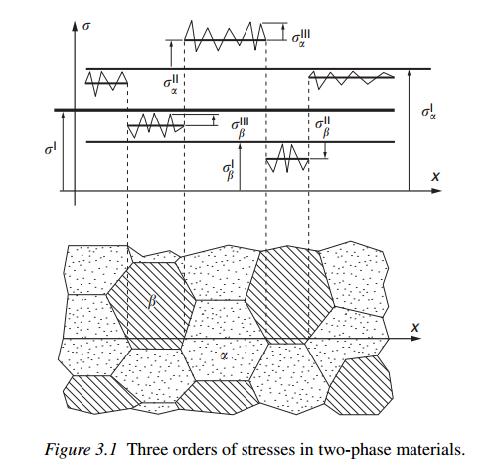

One must measure a stress-free version of the material with the same experimental configuration used to measure the stressed material in order to remove any systematic 2θ shifts present. While such deviations from the absolute d-spacings measured can be made small, strains are also quite small and one should not try to rely on published values of lattice parameters. Another reason published values cannot be used is that, for many materials of engineering interest, the lattice parameter will vary with thermo-mechanical treatment. This can occur due to the formation of precipitates that can change the composition of phases. Differences in the stacking fault density can also change the stress-free value, in some materials [9, 10]. Another problem is that the value of d0 can vary with location in a material due to differences in thermo-mechanical treatment with position (which may have produced the residual stresses).

3. Experiment Details

4. Results and Data Analysis

5. Discussion

6. Conclusions

7. References

8. Appendices (if necessary)

http://www.tiniusolsen.com/pdf/Pamphlet4.pdf