There have been added additional functions.

char *_strrev(char *s);
This function takes a character pointer which may not be allocated in the text-segment (read-only for string literals). The heap is a good example of where string manipulation is allowed. The _strrev() function returns a character pointer to the first element of the reversed string (this is equal to the argument s). An example usage is listed down here.
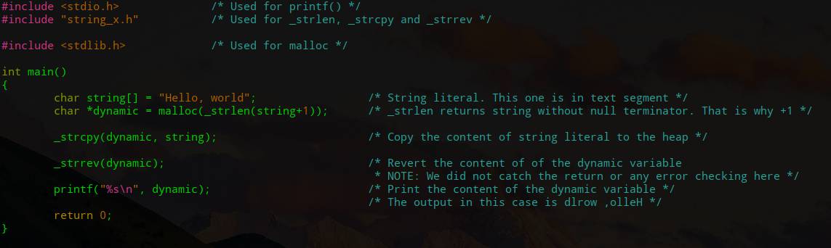

Tekst

