Game Design Document

Here are the elements that need to be included in your Game Design Document.

Flappy Ahgase

Xhoana Koca

**Game Pitch**

The game is about a green baby bird Ahgase. The main player Ahgase represents the fandom of a boy group named Got7. The bird is holding a green flag on one of the wings and is rooting for the group but as the game continues there are some obstacles that the Ahgase has to pass. The Ahgase has to pass through the anti-fans and also pass through a column. The main objective of this game is for the Ahgase to pass as many anti fans as possible and to not fall to its death.

**Objective**

The Objective of the game is to pass through many anti-fans to get as many scores as possible and to beat the past high score that was set.

**Controls**

The player can control the game by using the up, left and right arrows. The up arrow will allow the Ahgase to fly and the left and right arrow will help the player when passing through the obstacles. In order for the bird to fly the player needs to press the up arrow and keep tapping it so the bird doesn’t die.

**Gameflow**  
This main screen of the game displays the player, and the background. The obstacles and the background keep repeating and it seems like the player is on movement. The player can jump up and also move to the left and right. When the player goes off camera the game will display a Game Over and the player dies. If the player continues to pass through to obstacles the game will continue otherwise if the players collides with the obstacles the game will come to an end.

**Screenshots**

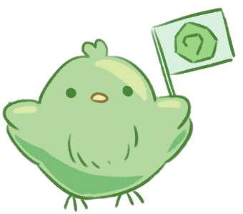The player.

The main screen when the player opens the game.  
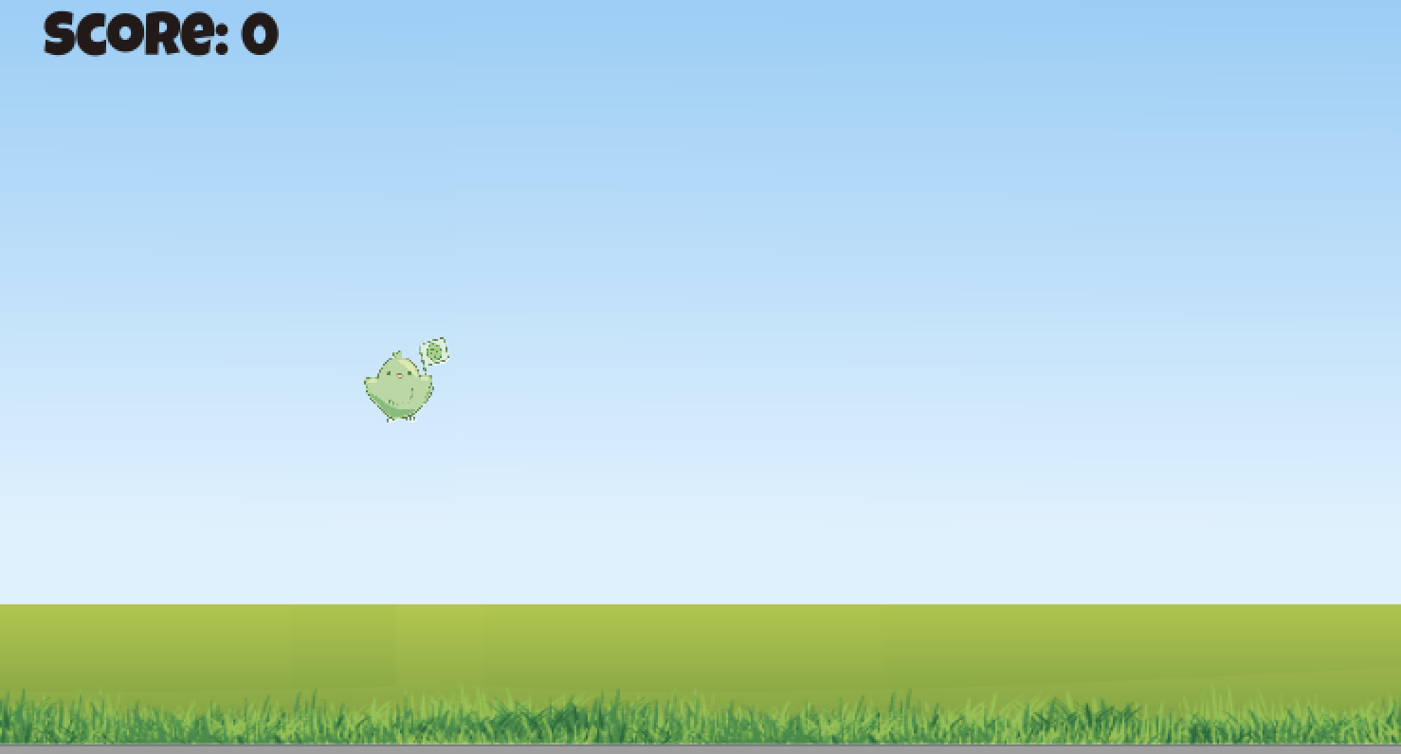

The screen when the obstacles are displayed.

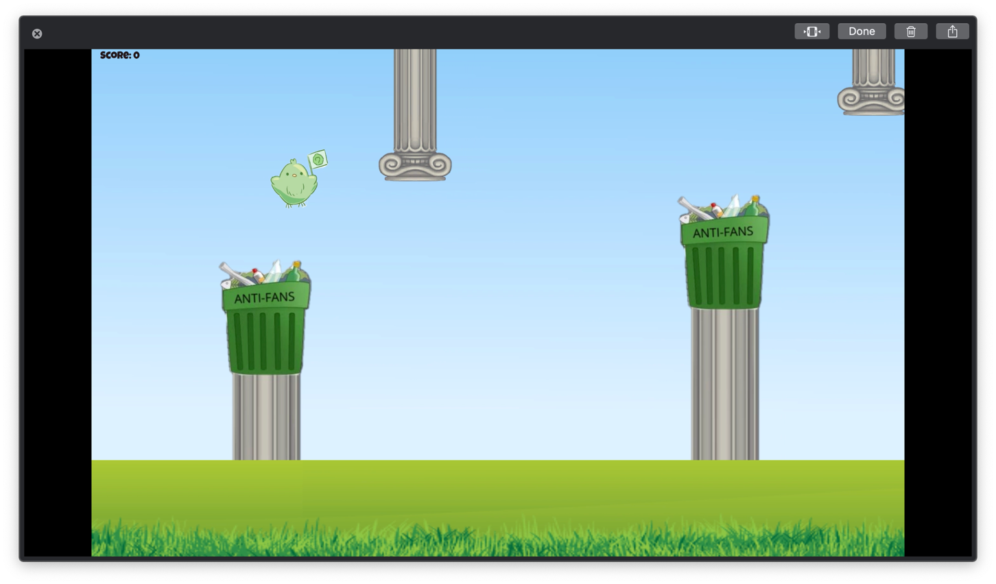

If the player goes off screen its game over.

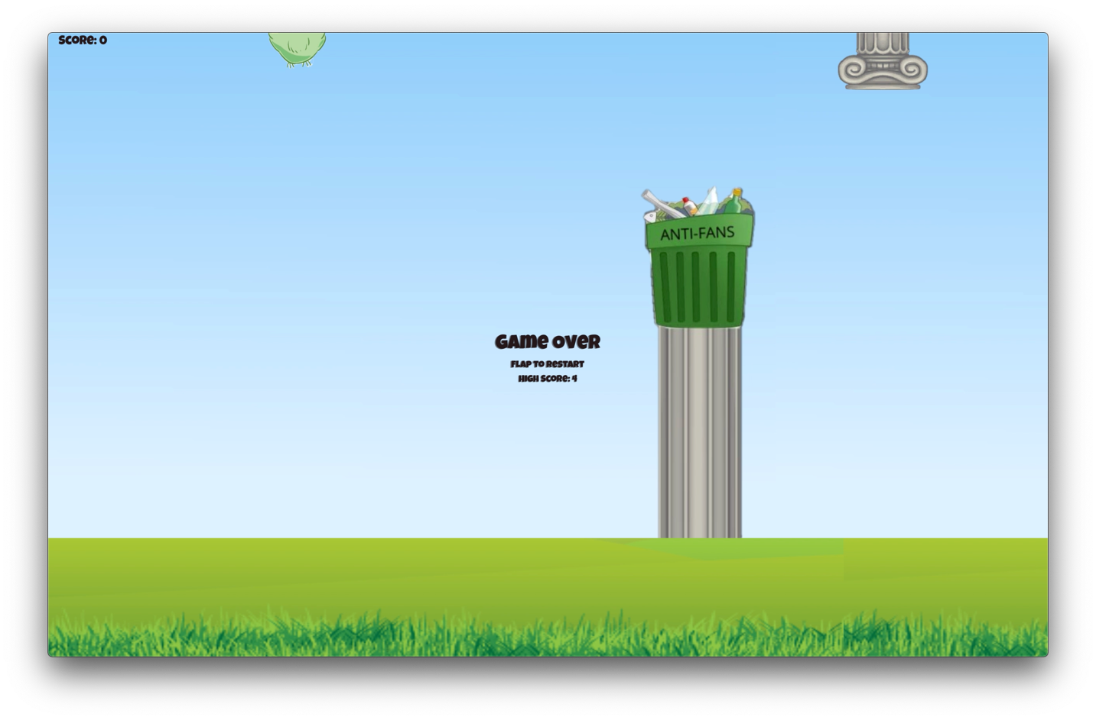

If the player collides with the obstacles its game over.

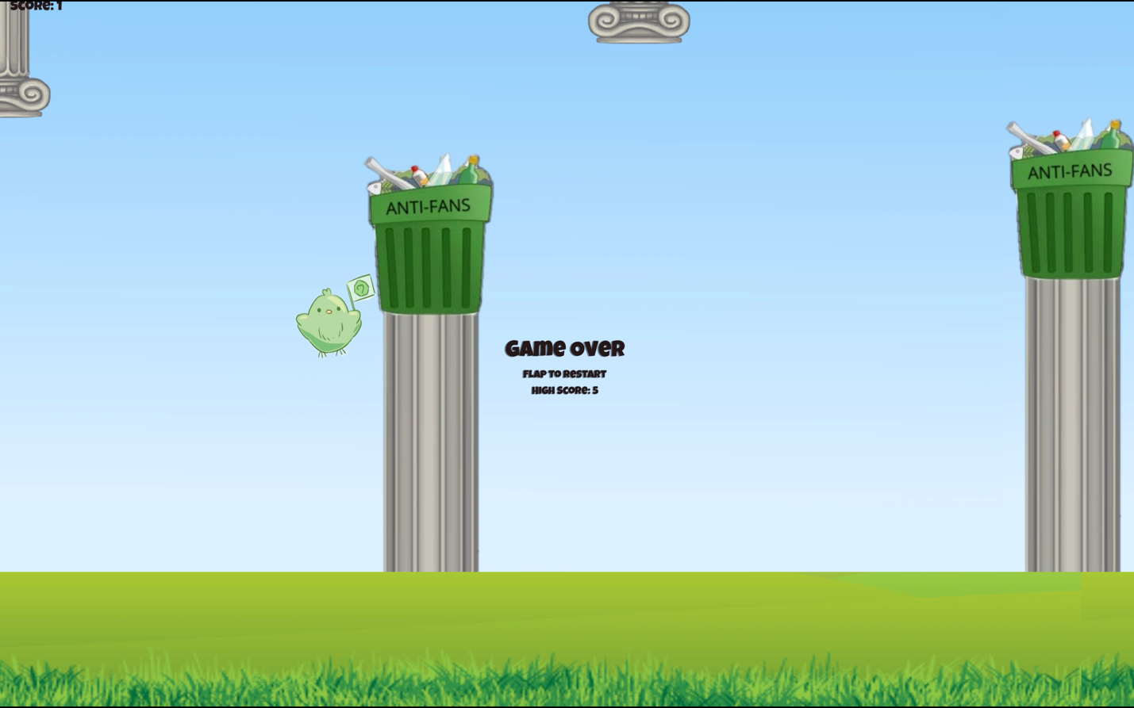

Once the player gets more scores than the previous time the highest score will change.

