**蓝桥杯微信题解答**

**第一周微信题**

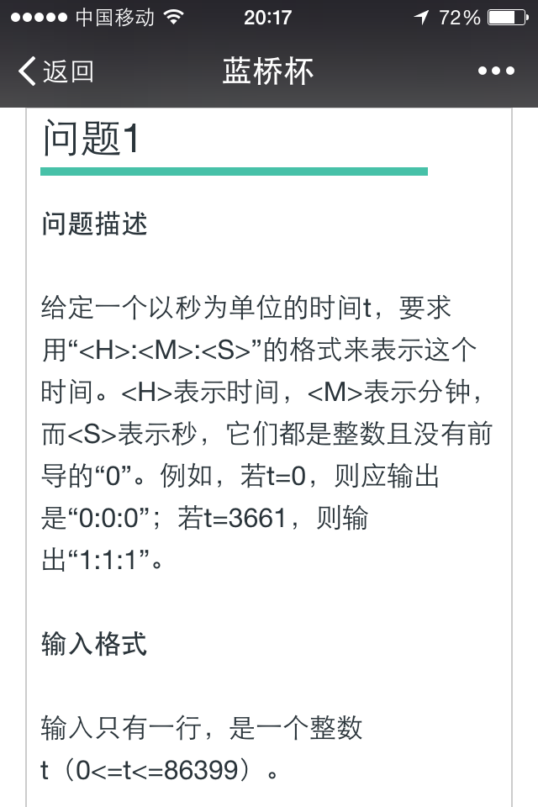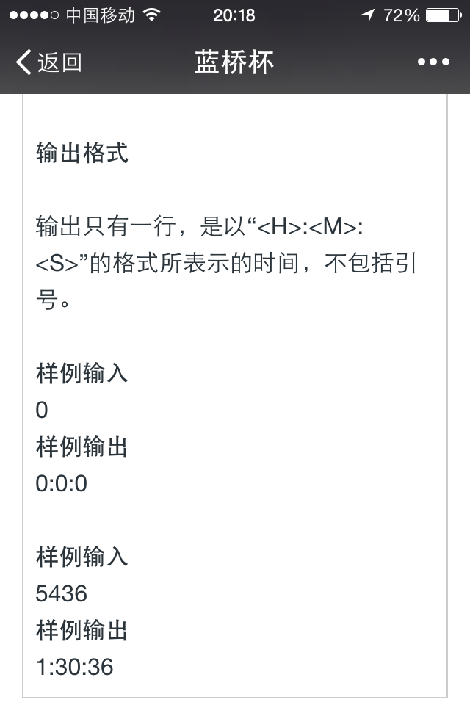

#include <stdio.h>

int main()

{

int t,h=0,m=0,s=0;

scanf("%d",&t);

if(t>=0&&t<=86399)

{

if(t>=3600)

{ h=t/3600;

t=t-3600*h;

}

if(t>=60)

{ m=t/60;

t=t-60*m;

}

s=t;

printf("%d:%d:%d\n",h,m,s);

}

return 0;

}

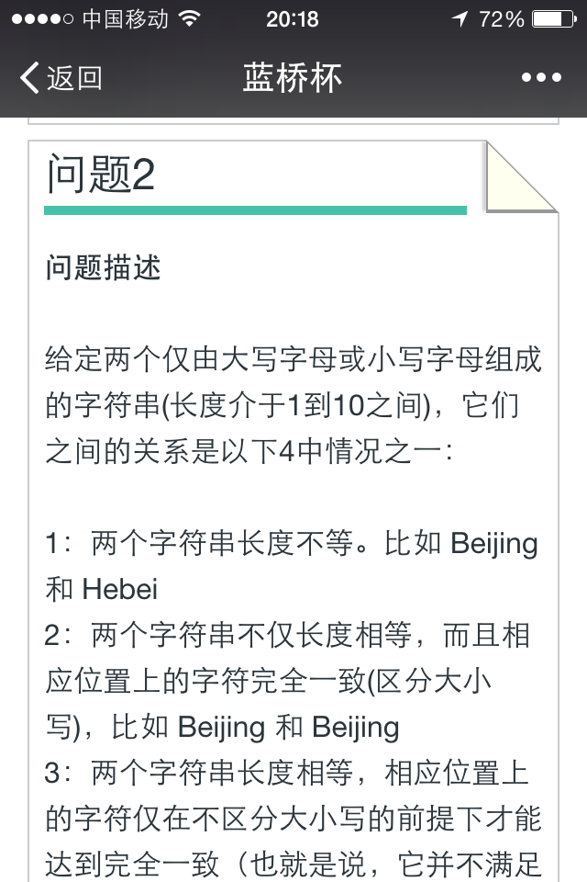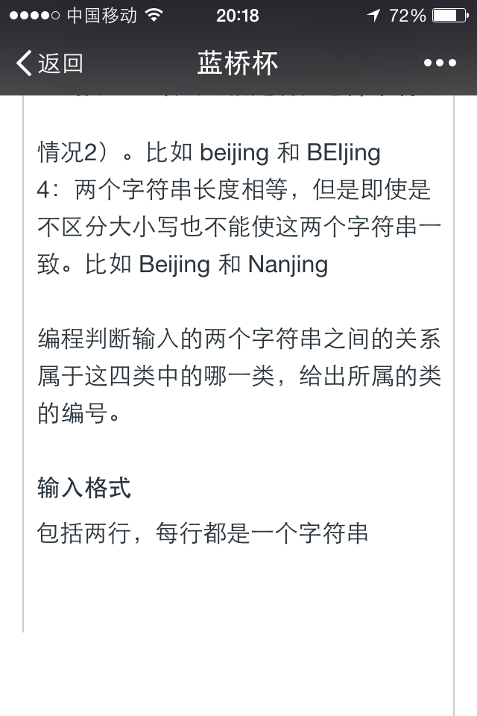

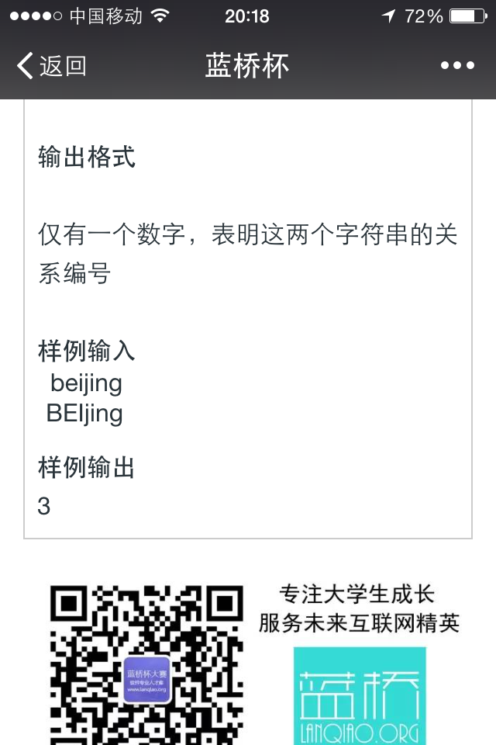

#include <stdio.h>

#include <stdlib.h>

#include <string.h>

int main()

{

char x[10],y[10];

int i=0,n=0;

scanf("%s",x);

scanf("%s",y);

if(strcmp(x,y)==0)

n=2;

else if(strlen(x)==strlen(y))

{

for(i=0;x[i]!='\0';i++)

{

if((x[i]==(y[i]+32))||(x[i]==(y[i]-32))||(x[i]==y[i]))

continue;

else

{

n=4;break;

}

}

if(i==strlen(x))

n=3;

}

else

n=1;

printf("%d\n",n);

return 0;

}

**第二周微信题**

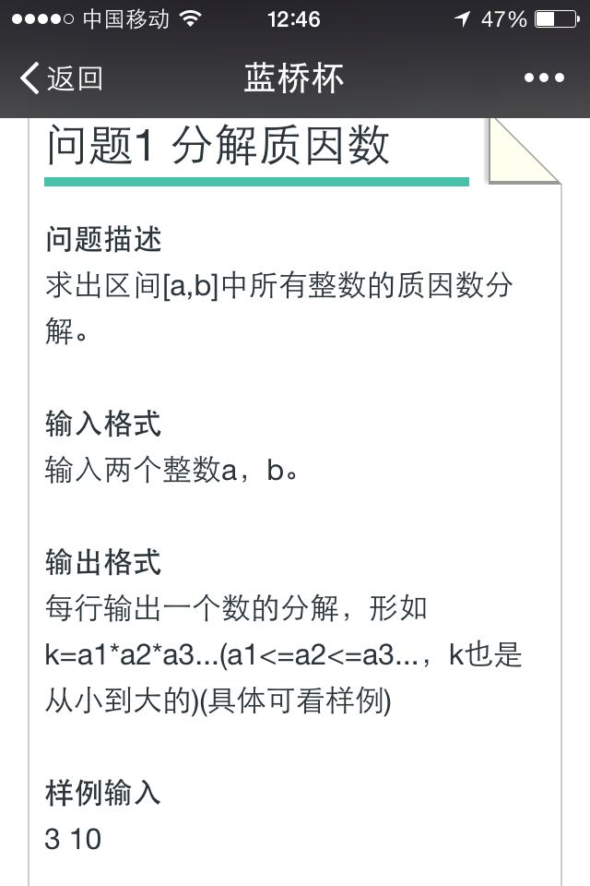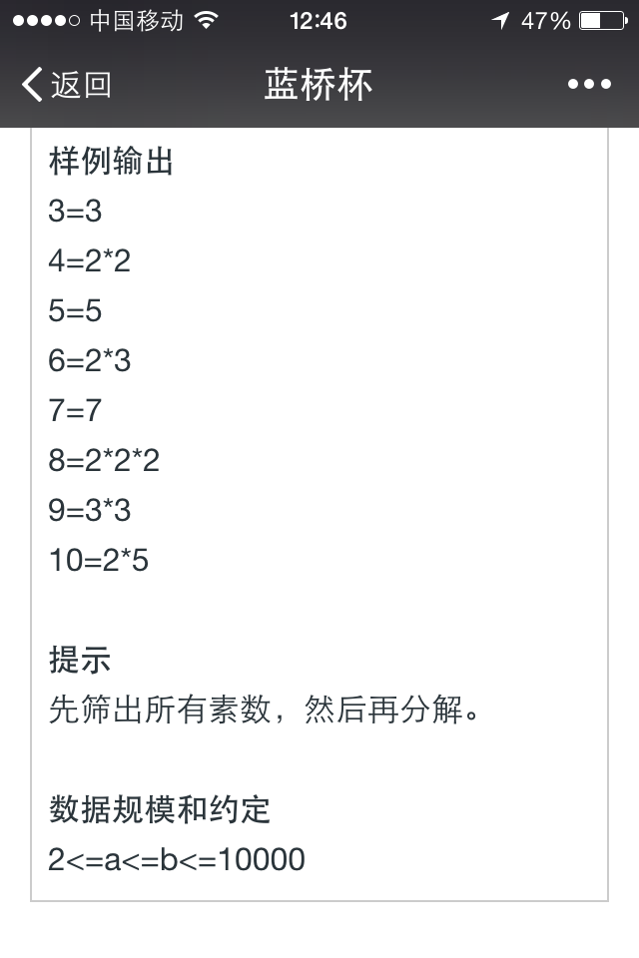

#include<stdio.h>

int sushu(s)

{

int si;

for(si=2;si<s;si++)

{ if(s%si==0)

break;

}

if(s==si)

return 1;

else

return 0;

};

int main()

{

int a,b,x=0,i=0,j=0,su[1250]={0};

scanf("%d %d",&a,&b);

for(i=2;i<10000;i++)

{

if(sushu(i)==1)

{ su[j]=i;

j++;

}

}

for(i=a;i<=b;i++)

{

x=i;

printf("%d=",i);

for(j=0;su[j]<=x;j++)

{

if(x%su[j]==0)

{

printf("%d",su[j]);

x=x/su[j];

j--;

if(x!=1)

{

printf("*");

}

else

printf("\n");

}

}

}

return 0;

}

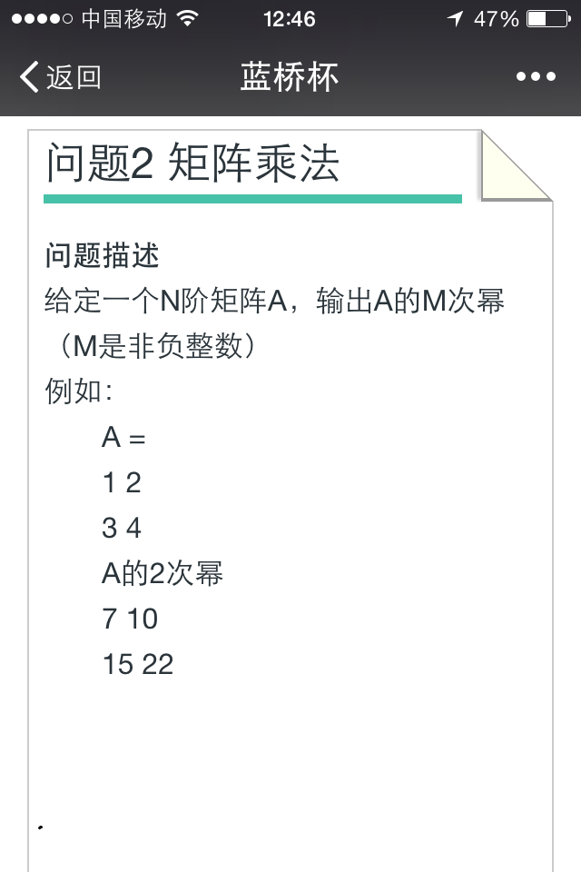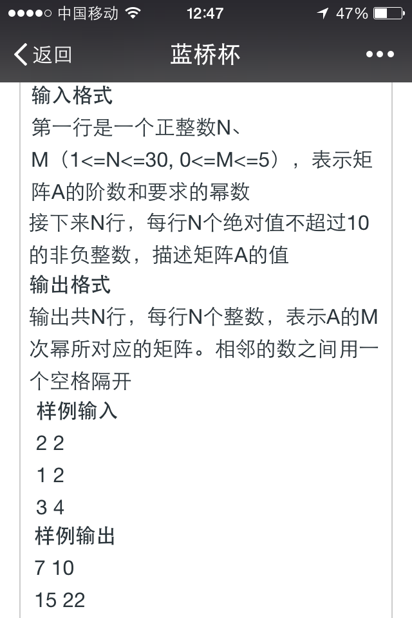

#include<stdio.h>

int main()

{

int n,m,i=0,j=0,k=0,l=0,a[30][30]={1},b[30][30]={0},c[30][30]={0},s=0;

scanf("%d %d",&n,&m);

for(i=0;i<n;i++)

{

for(j=0;j<n;j++)

{

scanf("%d",&a[i][j]);

b[i][j]=a[i][j];

c[i][j]=1;

}

}

for(i=2;i<=m;i++)

{

for(j=0;j<n;j++)

{

for(k=0;k<n;k++)

{

for(l=0;l<n;l++)

{

s=s+(a[j][l]*b[l][k]);

}

c[j][k]=s;

s=0;

}

}

for(j=0;j<n;j++)

{

for(k=0;k<n;k++)

{

b[j][k]=c[j][k];

}

}

}

for(i=0;i<n;i++)

{

for(j=0;j<n;j++)

{

printf("%d ",c[i][j]);

}

printf("\n");

}

return 0;

}

**第三周微信题**

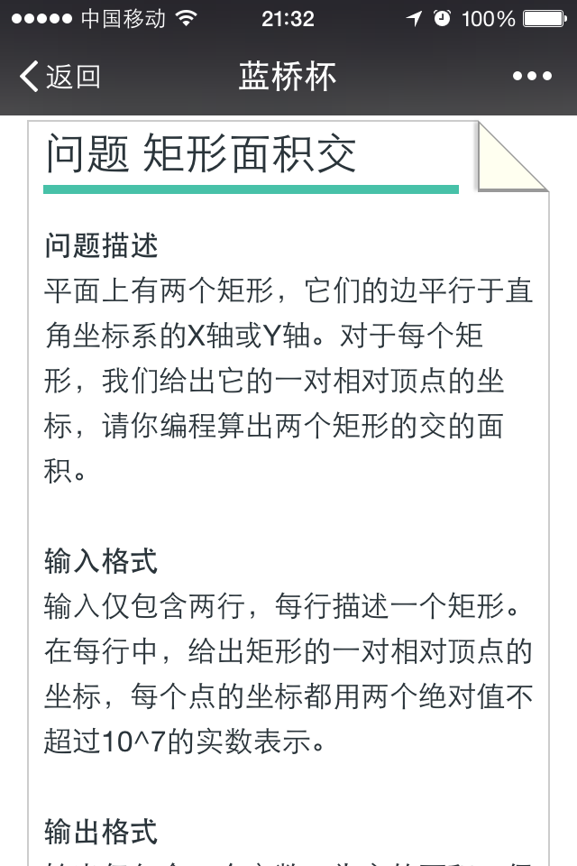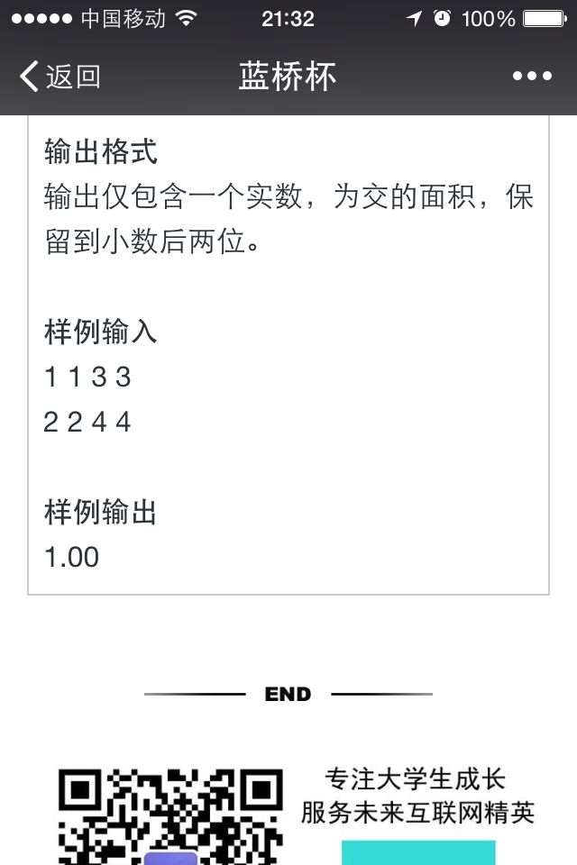

#include<stdio.h>

int main()

{

int x1,x11,x12,x2,x21,x22,y1,y11,y12,y2,y21,y22;

float x,y;

scanf("%d %d %d %d",&x11,&y11,&x12,&y12);

scanf("%d %d %d %d",&x21,&y21,&x22,&y22);

if(x11>x12)

x1=x11;

else

x1=x12;

if(x21<x22)

x2=x21;

else

x2=x22;

if(y11>y12)

y1=y11;

else

y1=y12;

if(y21<y22)

y2=y21;

else

y2=y22;

if(x1>x2)

x=x1-x2;

else

x=x2-x1;

if(y1>y2)

y=y1-y2;

else

y=y2-y1;

printf("%.2f\n",x*y);

return 0;

}

**第四周微信题**

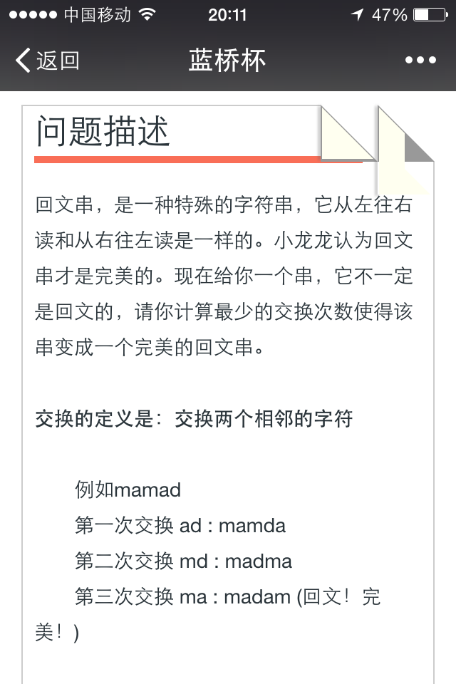 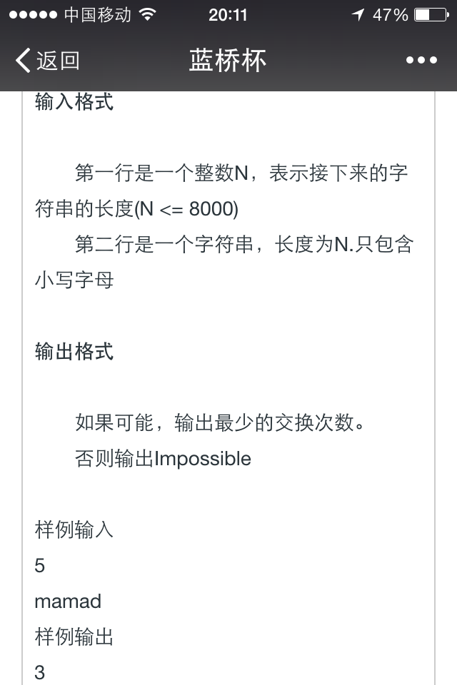

方法一：

#include<stdio.h>

char x='0';

int changes(char s[],char x,int n)

{

int i,change=0,j,k;

for(i=0;i<n/2;i++)

{

if(s[i]==x)

{

for(j=i;j<n-i-1;j++)

if(s[n-i-1]==s[j])

break;

change+=j-i;

for(k=j;k>i;k--)

s[k]=s[k-1];

s[i]=s[n-i-1];

}

else

{

for(j=n-i-1;j>=i;j--)

if(s[i]==s[j])

break;

change+=n-i-1-j;

for(k=j;k<n-i-1;k++)

s[k]=s[k+1];

s[n-i-1]=s[i];

}

}

return change;

}

int main()

{

int n,i,k=0,b[26]={0},j;

char y,s[8000]={0};

scanf("%d",&n);

scanf("%s",s);

for(i=0;i<n;i++)

{

j=s[i]-'a';

b[j]++;

}

for(j=0;j<26;j++)

{

if(b[j]%2!=0)

{

k++;

x=j+'a';

}

}

if(k>=2)

printf("Impossible\n");

else

printf("%d\n",changes(s,x,n));

return 0;

}

**//感谢吴志文提供的答案。**

方法二：

#include<iostream>

#include<cstring>

using namespace std;

int c[5000];

int main()

{

int a;

memset(c,0,sizeof(c));

cin >> a;

string b;

cin >> b;

int d, e = 0, jishu = 0, oushu = 0;

for (d = 0; d < b.length(); d++)

{

c[b[d]]++;

}

for (d = 0; d < 5000; d++)

{

if (c[d] != 0)

{

if (c[d] % 2 == 0)

{

oushu++;

}

else

jishu++;

}

}

if (oushu == 0 || (oushu>0 && jishu>1))

cout << "Impossible" << endl;

else

{

char aa = '1';

int buzhou = 0, j, k = 0, l;

for (d = 0; d < 5000; d++)

{

if (c[d] % 2 != 0)

{

aa = d;

}

}

for (j = 0; j < a / 2; j++)

{

if (b[j] == aa)

{

for (k = j; k < a - j - 1; k++)

{

if (b[a - j - 1] == b[k])

{

break;

}

}

buzhou = buzhou + k - j;

for (l = k; l > j; l--)

b[l] = b[l - 1];

b[j] = b[a - j - 1];

}

else

{

for (k = a - j - 1; k >= j; k--)

{

if (b[j] == b[k])

break;

}

buzhou = buzhou + a - j - 1 - k;

for (l = k; l < a - j - 1; l++)

b[l] = b[l + 1];

b[a - j - 1] = b[j];

}

}

cout << buzhou << endl;

cout << b << endl;

}

}

**//感谢孙楷提供的答案。**

**第五周微信题**

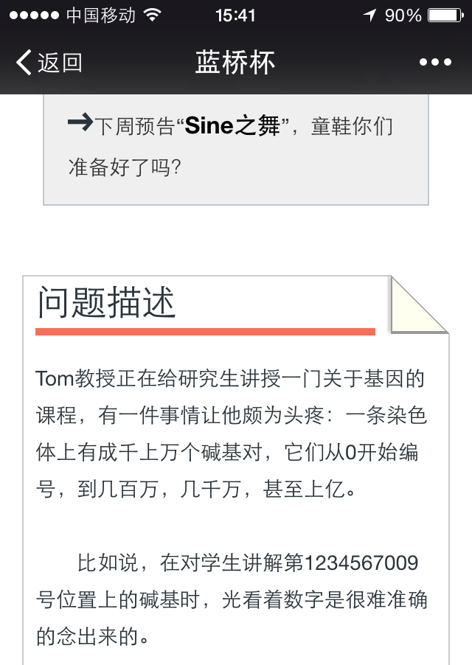 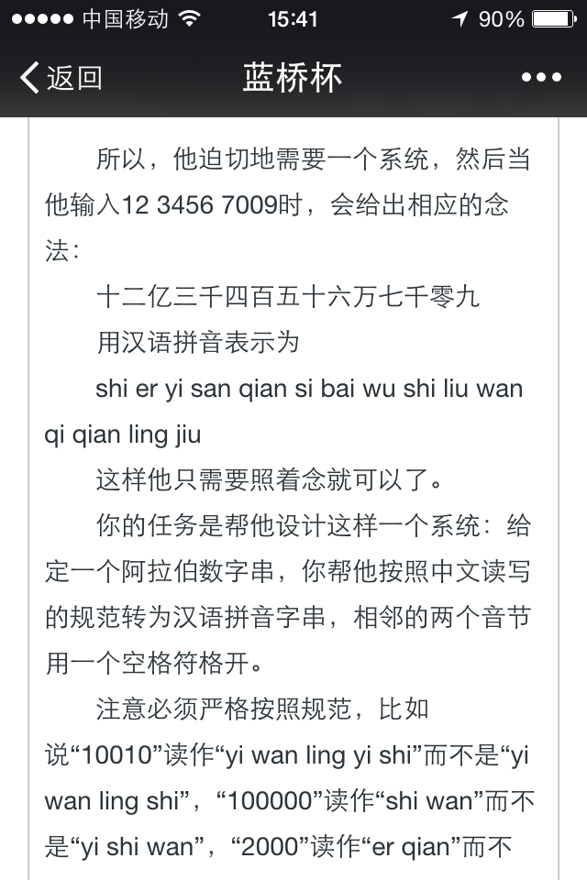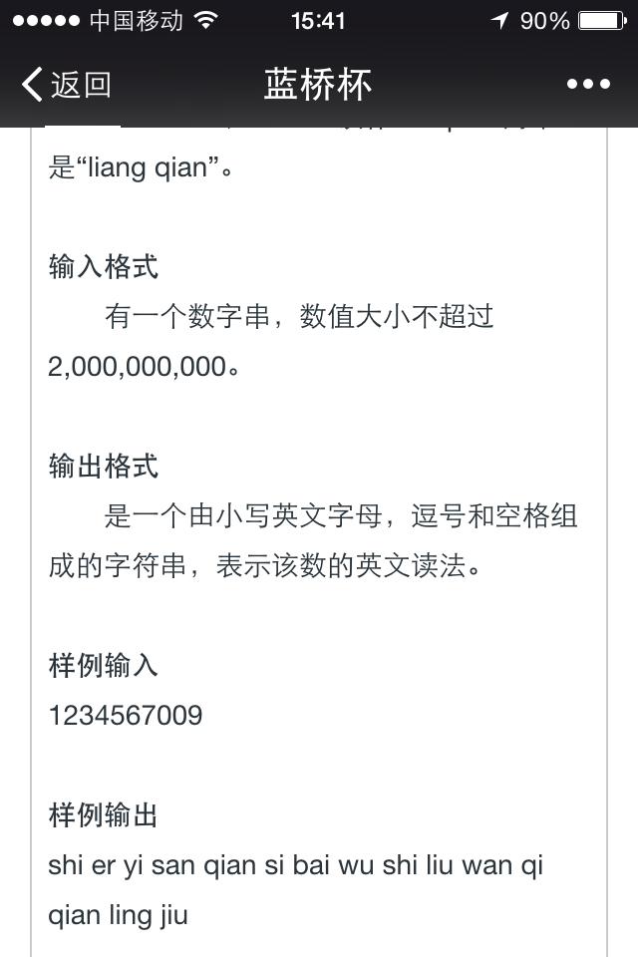

#include<stdio.h>

int main()

{

int x,n,m=0,h,i,a[10]={0};

char* dw[]={"","shi","bai","qian","wan","shi","bai","qian","yi","shi"};

char* ds[]={"ling","yi","er","san","si","wu","liu","qi","ba","jiu","liang"};

scanf("%d",&x);

n=x;

for(i=0;n>=1;i++)

{

a[i]=n%10;

n=n/10;

}

h=i-1;

for(i=h;i>=0;i--)

{

if(a[i]==0&&i==4)

{

printf("%s ",dw[i]);

}

else if(a[i]==0)

{

m=1;

}

else if(a[i]==0)

{

m=1;

}

else if(m==1&&a[i]!=0)

{

printf("%s %s %s ",ds[0],ds[a[i]],dw[i]);

m=0;

}

else if((i==3||i==7)&&a[i]==2)

{

printf("%s %s ",ds[10],dw[i]);

}

else if((i==1||i==5||i==9)&&a[i]==1)

{

printf("%s ",dw[i]);

}

else if(i==0)

{

printf("%s",ds[a[i]]);

}

else

printf("%s %s ",ds[a[i]],dw[i]);

}

return 0;

}

**第六周微信题**

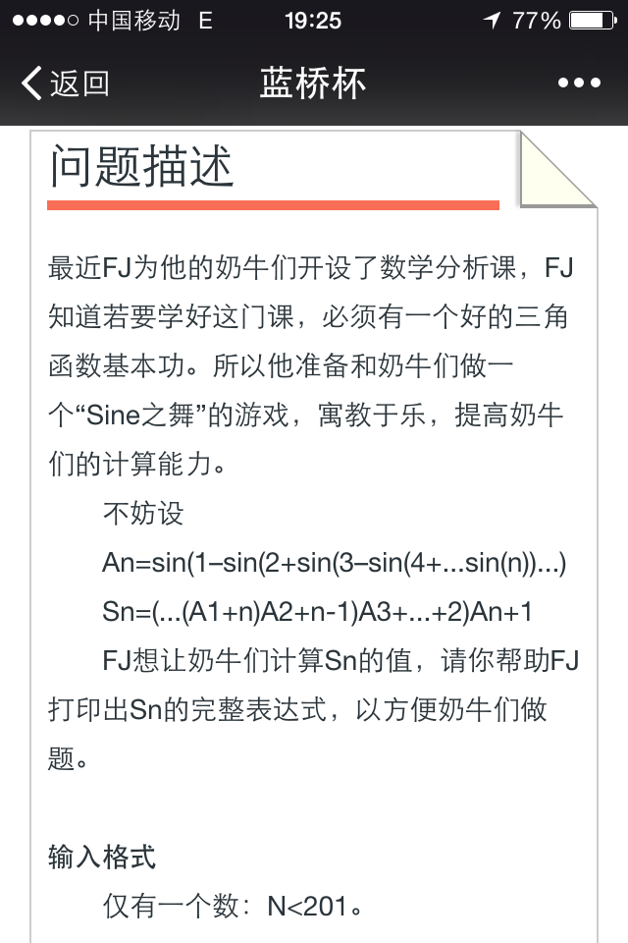 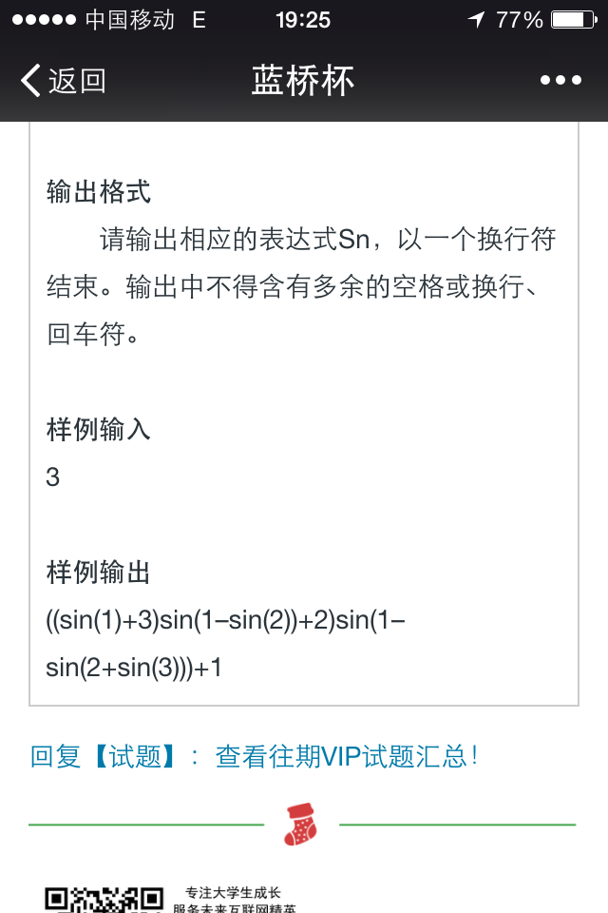

#include <iostream>

using namespace std;

void An(int xd,int n)

{

int i;

if(xd<=n)

{

if(xd==1)

{

cout<<"sin("<<xd;

An(xd+1,n);

cout<<")";

}

else

{

if(xd%2==0)

{

cout<<"-sin("<<xd;

An(xd+1,n);

cout<<")";

}

else

{

cout<<"+sin("<<xd;

An(xd+1,n);

cout<<")";

}

}

}

}

int main()

{

int i,n;

cin>>n;

for(i=1;i<n;i++)

{

cout<<"(";

}

for(i=1;i<=n;i++)

{

if(i==1)

{

An(1,i);

cout<<"+"<<n+1-i;

}

else

{

cout<<")";

An(1,i);

cout<<"+"<<n+1-i;

}

}

cout<<endl;

return 0;

}

**//感谢吴志文提供的答案。**