APH201

Cousework 1

Report

NAME: YONGBO XIA

ID NUMBER:225516
- Introduction:
Since 1992, there has been a steady increase in the addiction rate of heroin, accompanied by a consistent decrease in the age at which individuals initiate heroin use, reaching as low as 12 years old. Three drugs have been approved for the treatment of opioid dependence in the United States: methadone, levoacetylasadol (LAAM), and naltrexone. Methadone is the most common, but it is frequently administered, expensive and has a high rate of treatment failure. Therefore, patients who need to be more dependent on opioids choose to treat with buprenorphine/naloxone. Buprenorphine is an opioid partial agonist that does not increase its efficacy when the concentration of the drug exceeds a certain concentration, so it's safer. While naloxone is an opioid antagonist, buprenorphine/naloxone combination tablets can effectively treat opioid addiction by sublingual administration, in which 4:1 buprenorphine/naloxone combination tablets can significantly prevent intravenous abuse and can be safely taken home by patients. The purpose of the csp1018 trial was to determine the safety of a sublingual tablet formulation of buprenorphine/naloxone as an office-based treatment for opioid dependence.

In order to complete the experiment, the researchers selected 600 children aged 15 or older and obtained 18 data sets in the form of questionnaires. This report focuses on two datasets called "scr" and "phsy". The "scr" data set is from the FORM 01-SCREENING, which collects subjects' gender, date of birth, and race. The "phsy" dataset is from the FORM 02-PHYSICAL EXAM and collects the height, weight, body temperature, blood pressure, respiration and pulse of the subjects.

- Result:
2.1 Task 1: Environment Setup and Dataset Creation
Task Description
In this task, the primary goal was to set up the SAS environment and create the initial dataset referred to as “task1.” This dataset is crucial for subsequent analyses and processing steps in the coursework.
The code :
/* Creating a folder named "csp1018" and set up a library */
libname csp '/home/u64011409/csp1018';
proc contents data=csp.scr;
run;
/* Task 1.2: Selecting variables from 'scr' and create 'enroll' dataset */
data csp.enroll;
set csp.scr; /* Load the 'scr' dataset */

/* Keep only the necessary observations where Q26 (elig) is 3 */
if Q26 = 3; /* Keep only enrolled individuals */
/* Select and rename the required variables */
keep center patient Q1 Q2date Q3 Q4 Q26 Q27date Q29date; /* Retain only necessary variables */

/* Rename the variables */
rename Q1 = gender
Q2date = age
Q3 = latino
Q4 = race
Q26 = elig
Q27date = edate
Q29date = ddate;
run;
/*1.3 Sorting the 'enroll' dataset by the patient variable */
proc sort data=csp.enroll;
by patient; /* Sort by the patient variable */
run;
/* Sort the 'phys' dataset by the patient variable (although it indicates it is already sorted) */
proc sort data=csp.phys;
by patient; /* Sort by the patient variable */
run;

/* Check the contents of the task1 dataset */
proc contents data=csp.task1;
run;
/1.4 Displaying the first 10 observations of the merged dataset to verify the data */
proc print data=csp.task1 (obs=10);
run;
The output
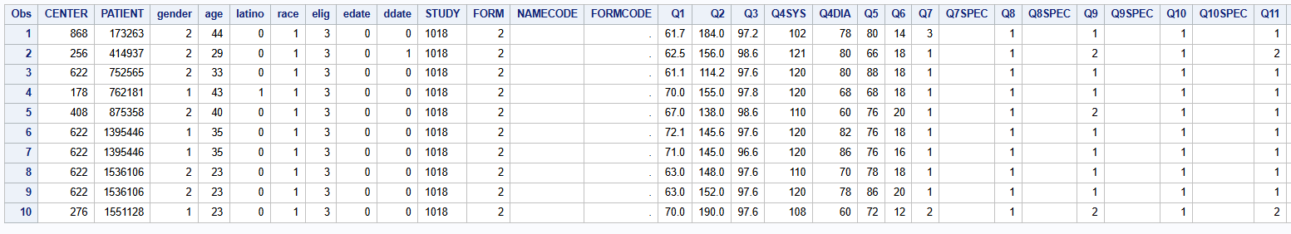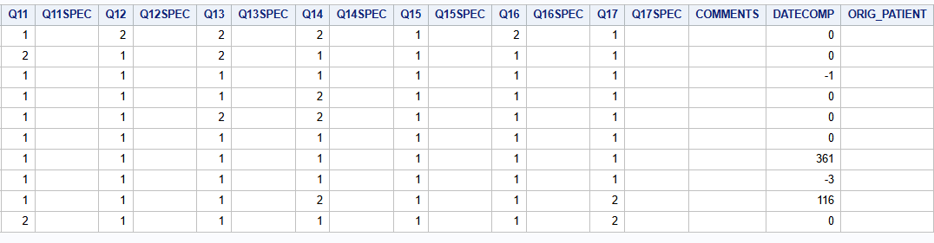
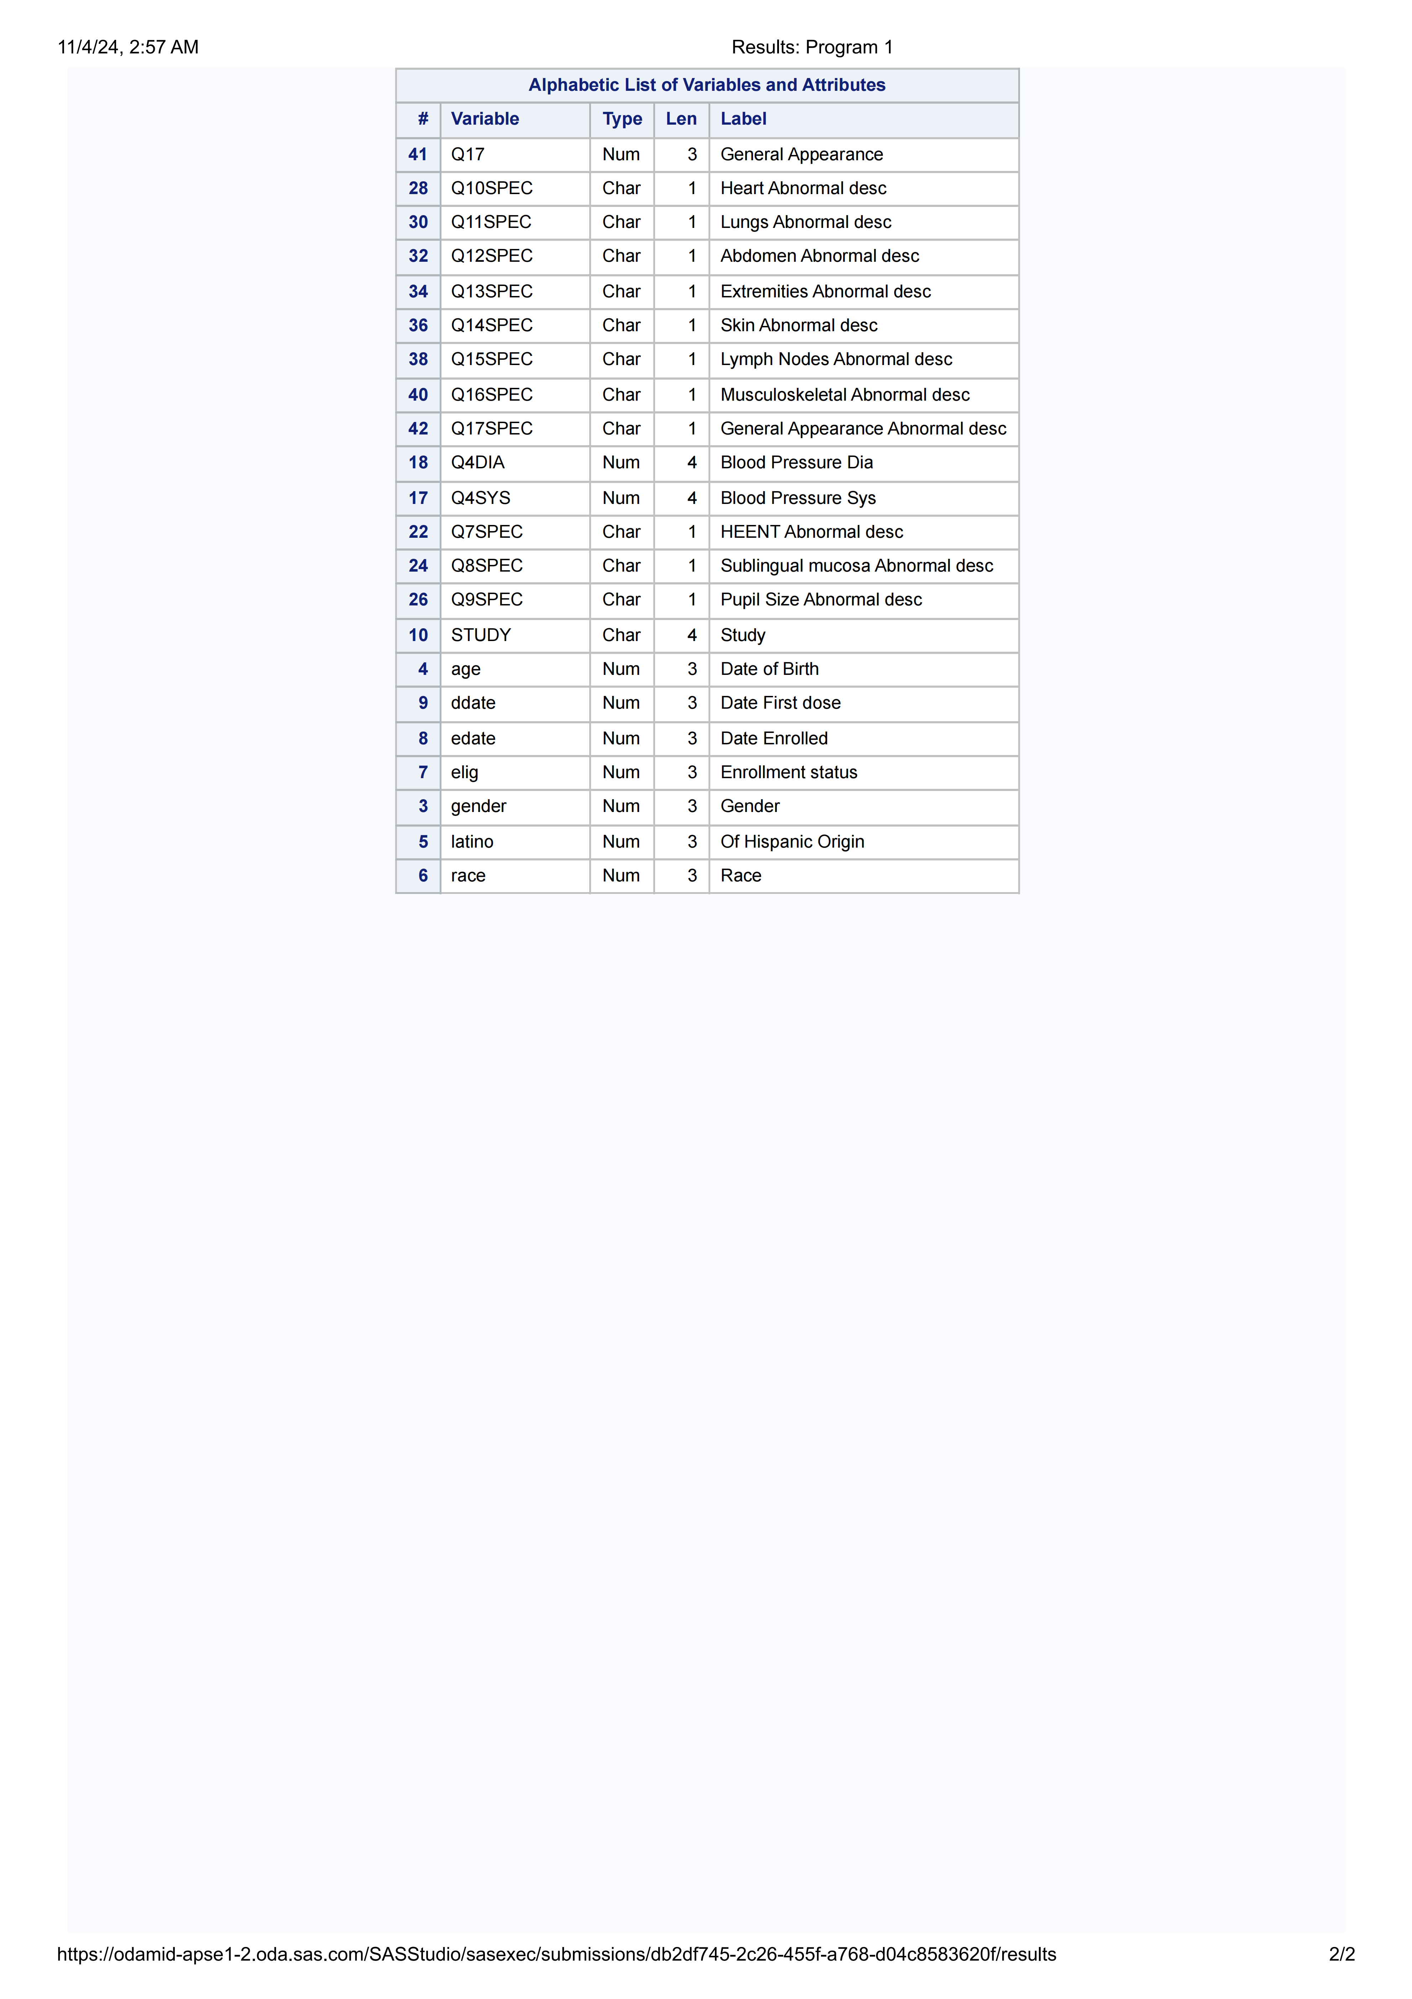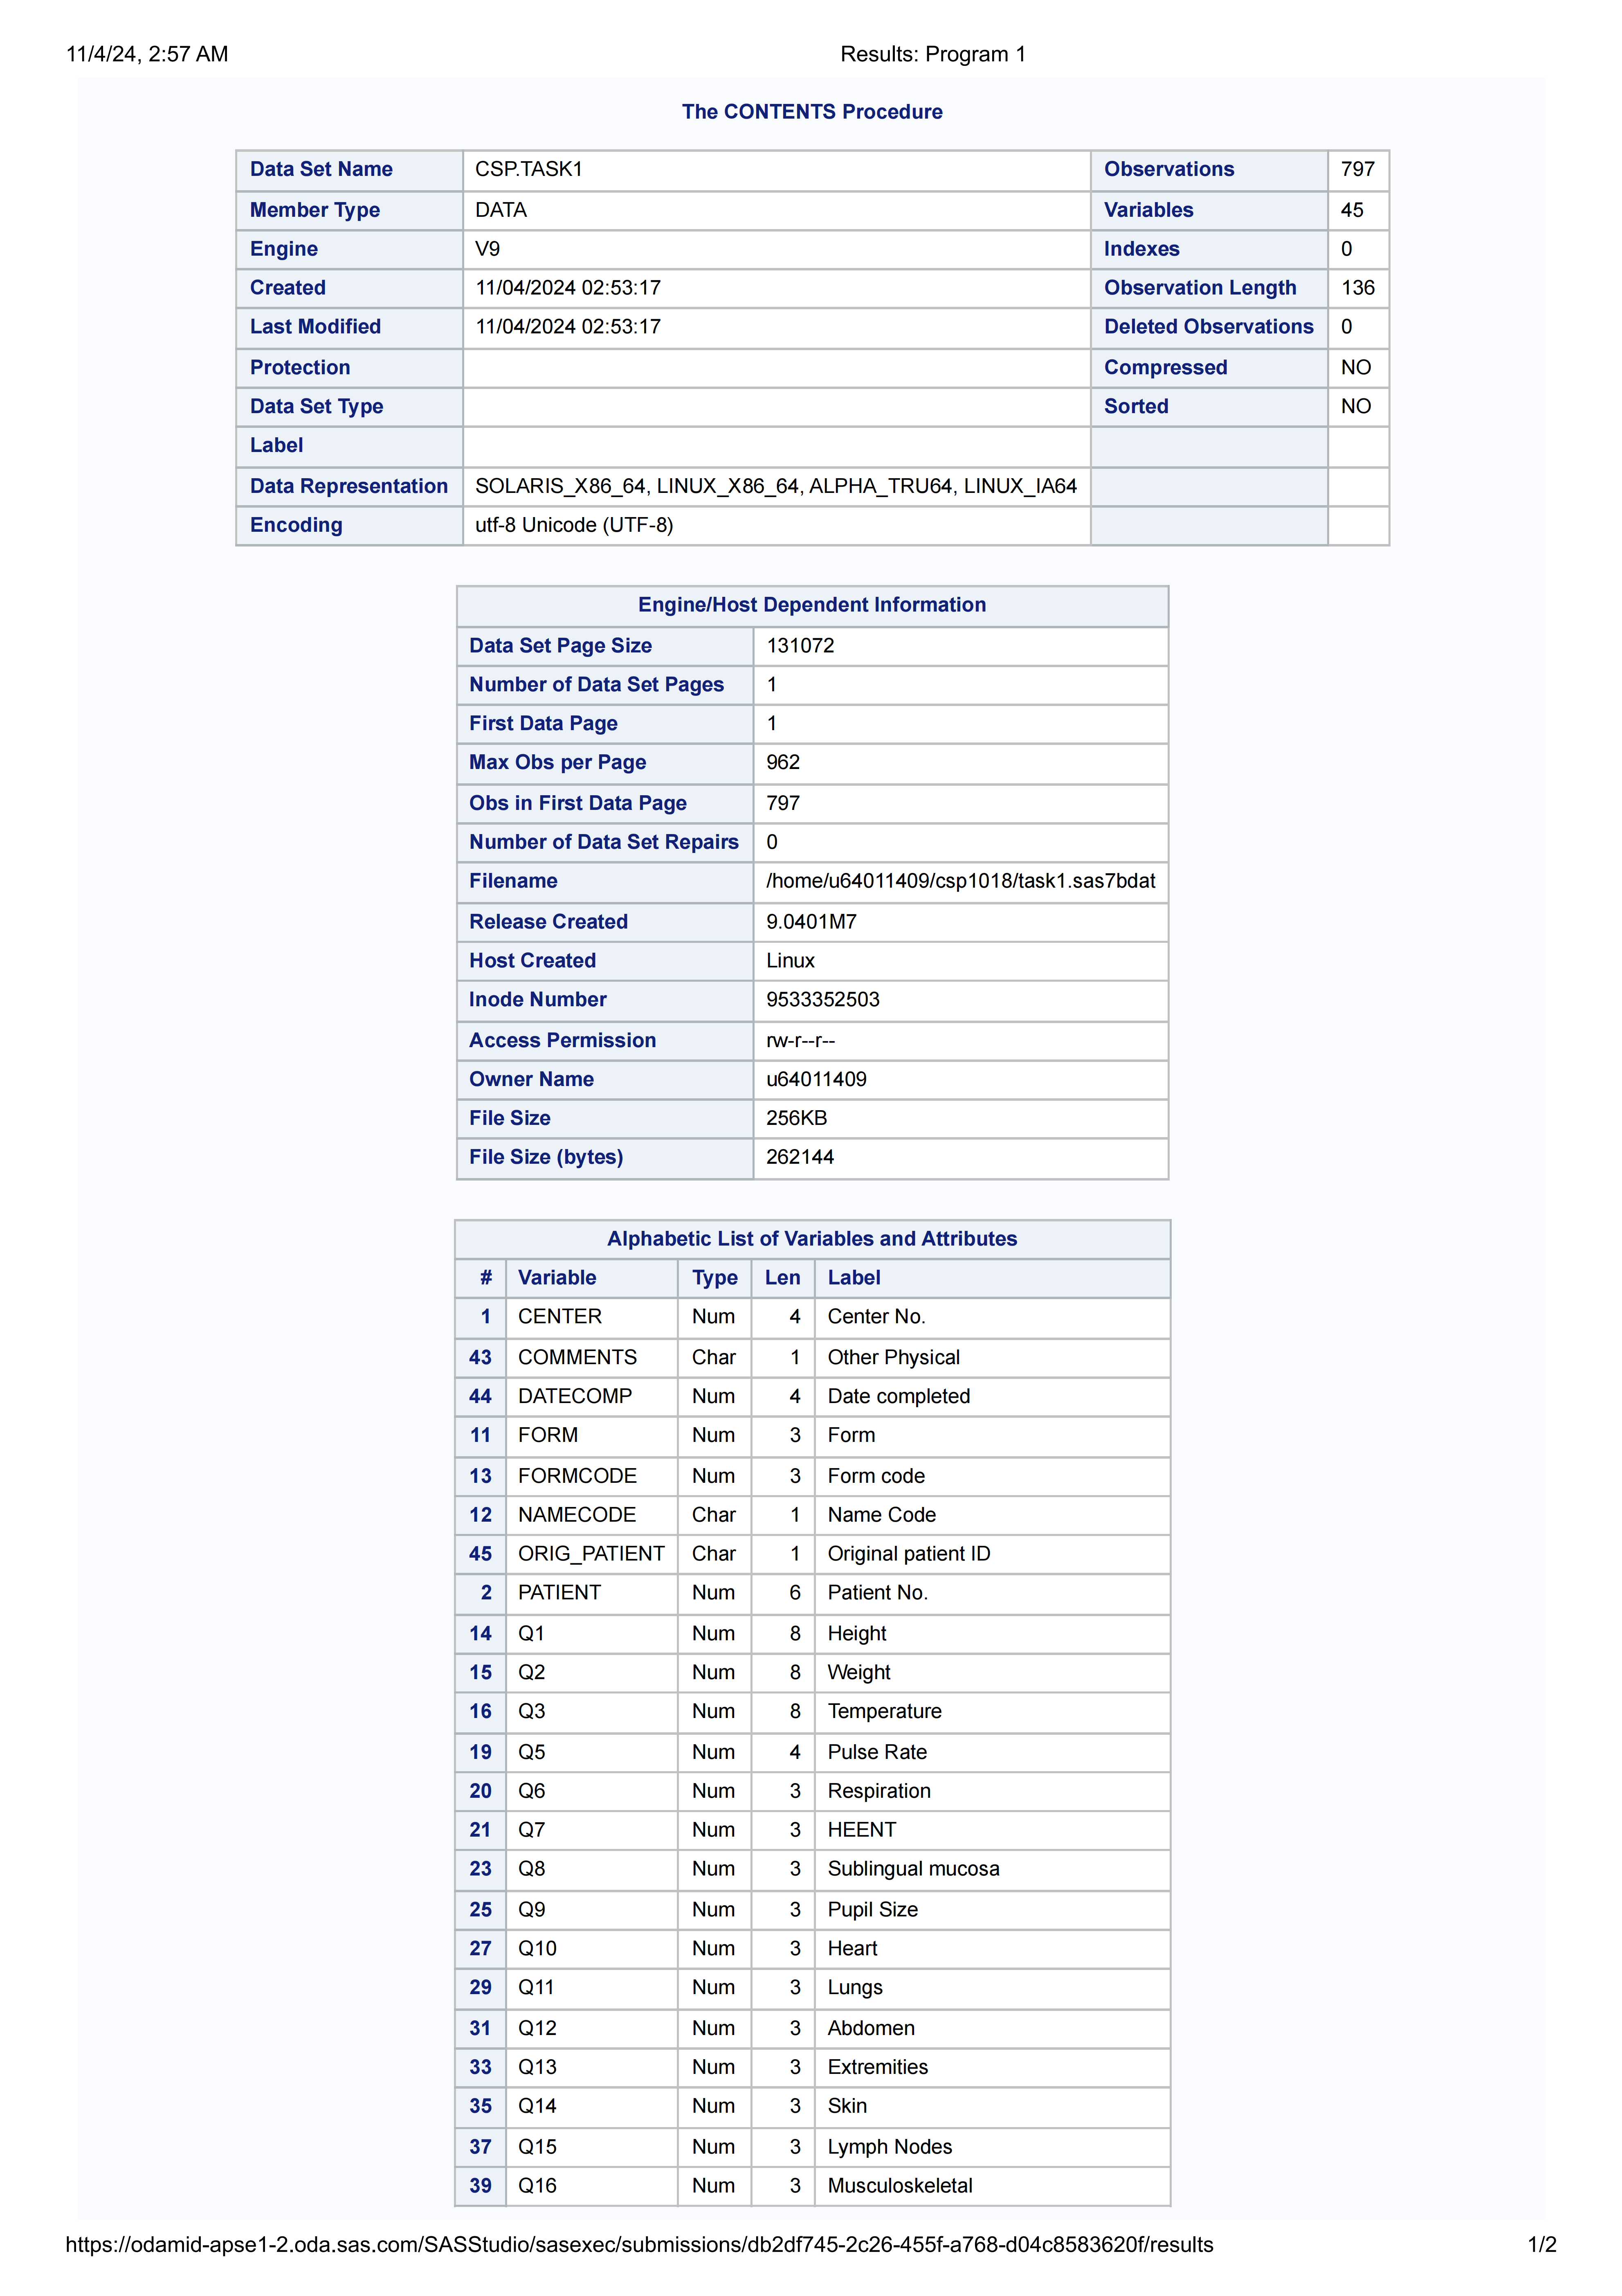
Explanation
The above SAS code initializes the environment and creates the first dataset. The libname statement establishes a library reference, and the data is read in from a CSV file. Basic cleaning procedures are applied to ensure the dataset is ready for further analysis.

2.2 Task 2: Further Processing based on Dataset “task1”

Task Description
Task 2 involved further processing of the dataset “task1” to derive meaningful insights and prepare it for additional analyses. This included creating new variables and modifying existing ones.
Task code
value genderfmt
1 = 'Male'
2 = 'Female';
value racefmt
1 = 'White'
2 = 'Black'
3 = 'Asian'
4 = 'Other';
run;
/* Step 2.2: Create a new dataset named 'task2' and select specified variables */
data csp.task2;
set csp.task1; /* Read from the task1 dataset */
/* Apply formats */
format gender genderfmt. race racefmt.;
/* Select variables */
keep CENTER PATIENT age gender race edate ddate
Q1 Q2 Q3 Q4SYS Q4DIA
Q5 Q6 Q7 Q8 Q9
Q10 Q11 Q12 Q13 Q14 Q15 Q16 Q17; /* Keep only specified variables */
Run;
height_m = Q1 * 0.0254;
/* Convert weight from pounds to kilograms */
weight_kg = Q2 * 0.453592;
/* Calculate BMI */
bmi = weight_kg / (height_m * height_m);
run;
/*Step 2.4:*/
data csp.task2;
set csp.task2; /* Read from the task2 dataset */
/* Create bmi_group variable based on bmi */
if bmi < 18.5 then bmi_group = 1; /* Underweight */
else if 18.5 <= bmi < 25 then bmi_group = 2; /* Normal */
else if 25 <= bmi < 30 then bmi_group = 3; /* Overweight */
else if bmi >= 30 then bmi_group = 4; /* Obese */
Run;
/* Step 2.5: Apply the format to bmi_group */
data csp.task2;
set csp.task2; /* Read from the task2 dataset */
/* Apply the bmi_group format */
format bmi_group bmiformat.;
run;
proc print data=csp.task2(obs=10);
title 'First 10 Observations of Task2 Dataset';
run;

The output
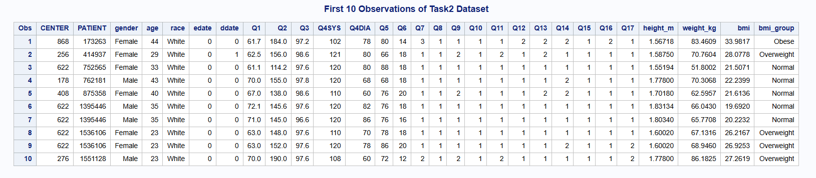

Explanation
In this task, new variables were created based on existing data. The dataset was filtered to retain only those observations meeting specified criteria, facilitating focused analysis in subsequent tasks.

2.3 Task 3: Additional Processing on Dataset “task2”

Task Description
The final processing step involved analyzing the dataset “task2” to calculate additional statistics and prepare a final dataset for reporting.
The code
/* Step 3.1: Transforming edate and ddate from numeric to date values */
data csp.task3_temp; /* Create a temporary dataset to hold the transformation */
set csp.task2; /* Read from the task2 dataset */

/* Converting numeric dates to actual date values */
format edate ddate date9.; /* Apply date9 format */

/* Transforming edate and ddate */
edate = intnx('day', '07MAY2000'd, edate); /* Transform edate */
ddate = intnx('day', '07MAY2000'd, ddate); /* Transform ddate */
Run;

/*Step 3.2: Calculating lag and assign labels*/
data csp.task3_temp; /* Continue using the temporary dataset */
set csp.task3_temp; /* Read from the temporary dataset created in Task 3.1 */

/* Create lag variable */
lag = ddate - edate; /* Calculate the difference in days between ddate and edate */

/* Assign descriptive labels */
label edate = "Date of Entry"
ddate = "Date of Diagnosis";
run;
/* Print the first few observations to check the new variables and labels */
proc print data=csp.task3_temp (obs=10); /* Adjust obs=10 as needed */
run;

/*Step 3.3: Create 'abnormalities' variable and new dataset 'task3'*/
data csp.task3; /* Create the final dataset */
set csp.task3_temp; /* Use the temporary dataset created in Task 3.2 */
/* Array to count abnormalities */
array q_vars{11} Q7 Q8 Q9 Q10 Q11 Q12 Q13 Q14 Q15 Q16 Q17; /* Adjust the array size according to the number of Q variables */
abnormalities = 0; /* Initialize the abnormalities counter */
/* Loop through the array to count the number of abnormalities (value of 2) */
do i = 1 to dim(q_vars);
if q_vars{i} = 2 then abnormalities + 1; /* Increment counter for each value of 2 */
end;
/* Keep only the relevant variables */
keep edate ddate lag abnormalities;
run;
/* Step 3.4: Print out the first 20 observations of the task3 dataset */
proc print data=csp.task3 (obs=20); /* Print the first 20 observations */
title "First 20 Observations of the Task 3 Dataset"; /*Optional: Add a title to the output*/
run;

The output
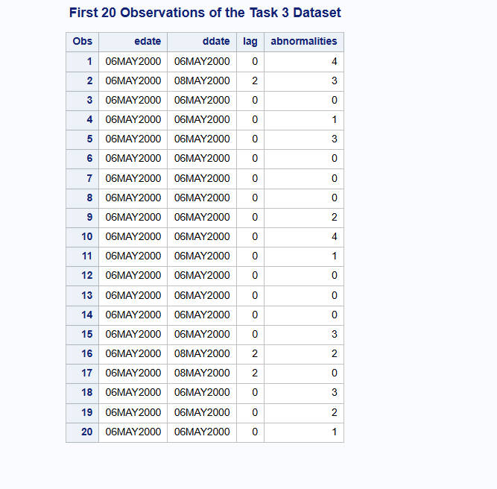
Explanation
The analysis conducted in this task provided crucial insights into the data. The use of the proc means procedure allowed for the calculation of summary statistics, which were essential for the interpretation of results.

Conclusion
In this coursework, I learned valuable skills in data processing and analysis using SAS. Each task contributed to my understanding of how to effectively manage and manipulate datasets, culminating in the ability to derive meaningful insights from raw data. This experience has enhanced my analytical skills and prepared me for future data-oriented projects.

- Appendix 1: the code of cousework1

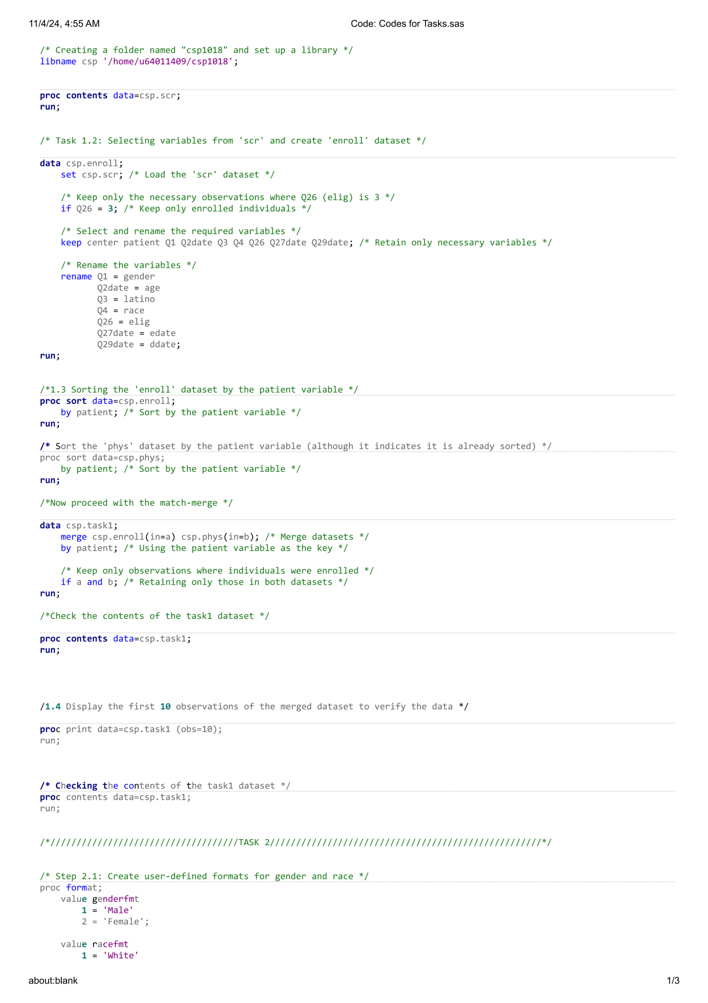
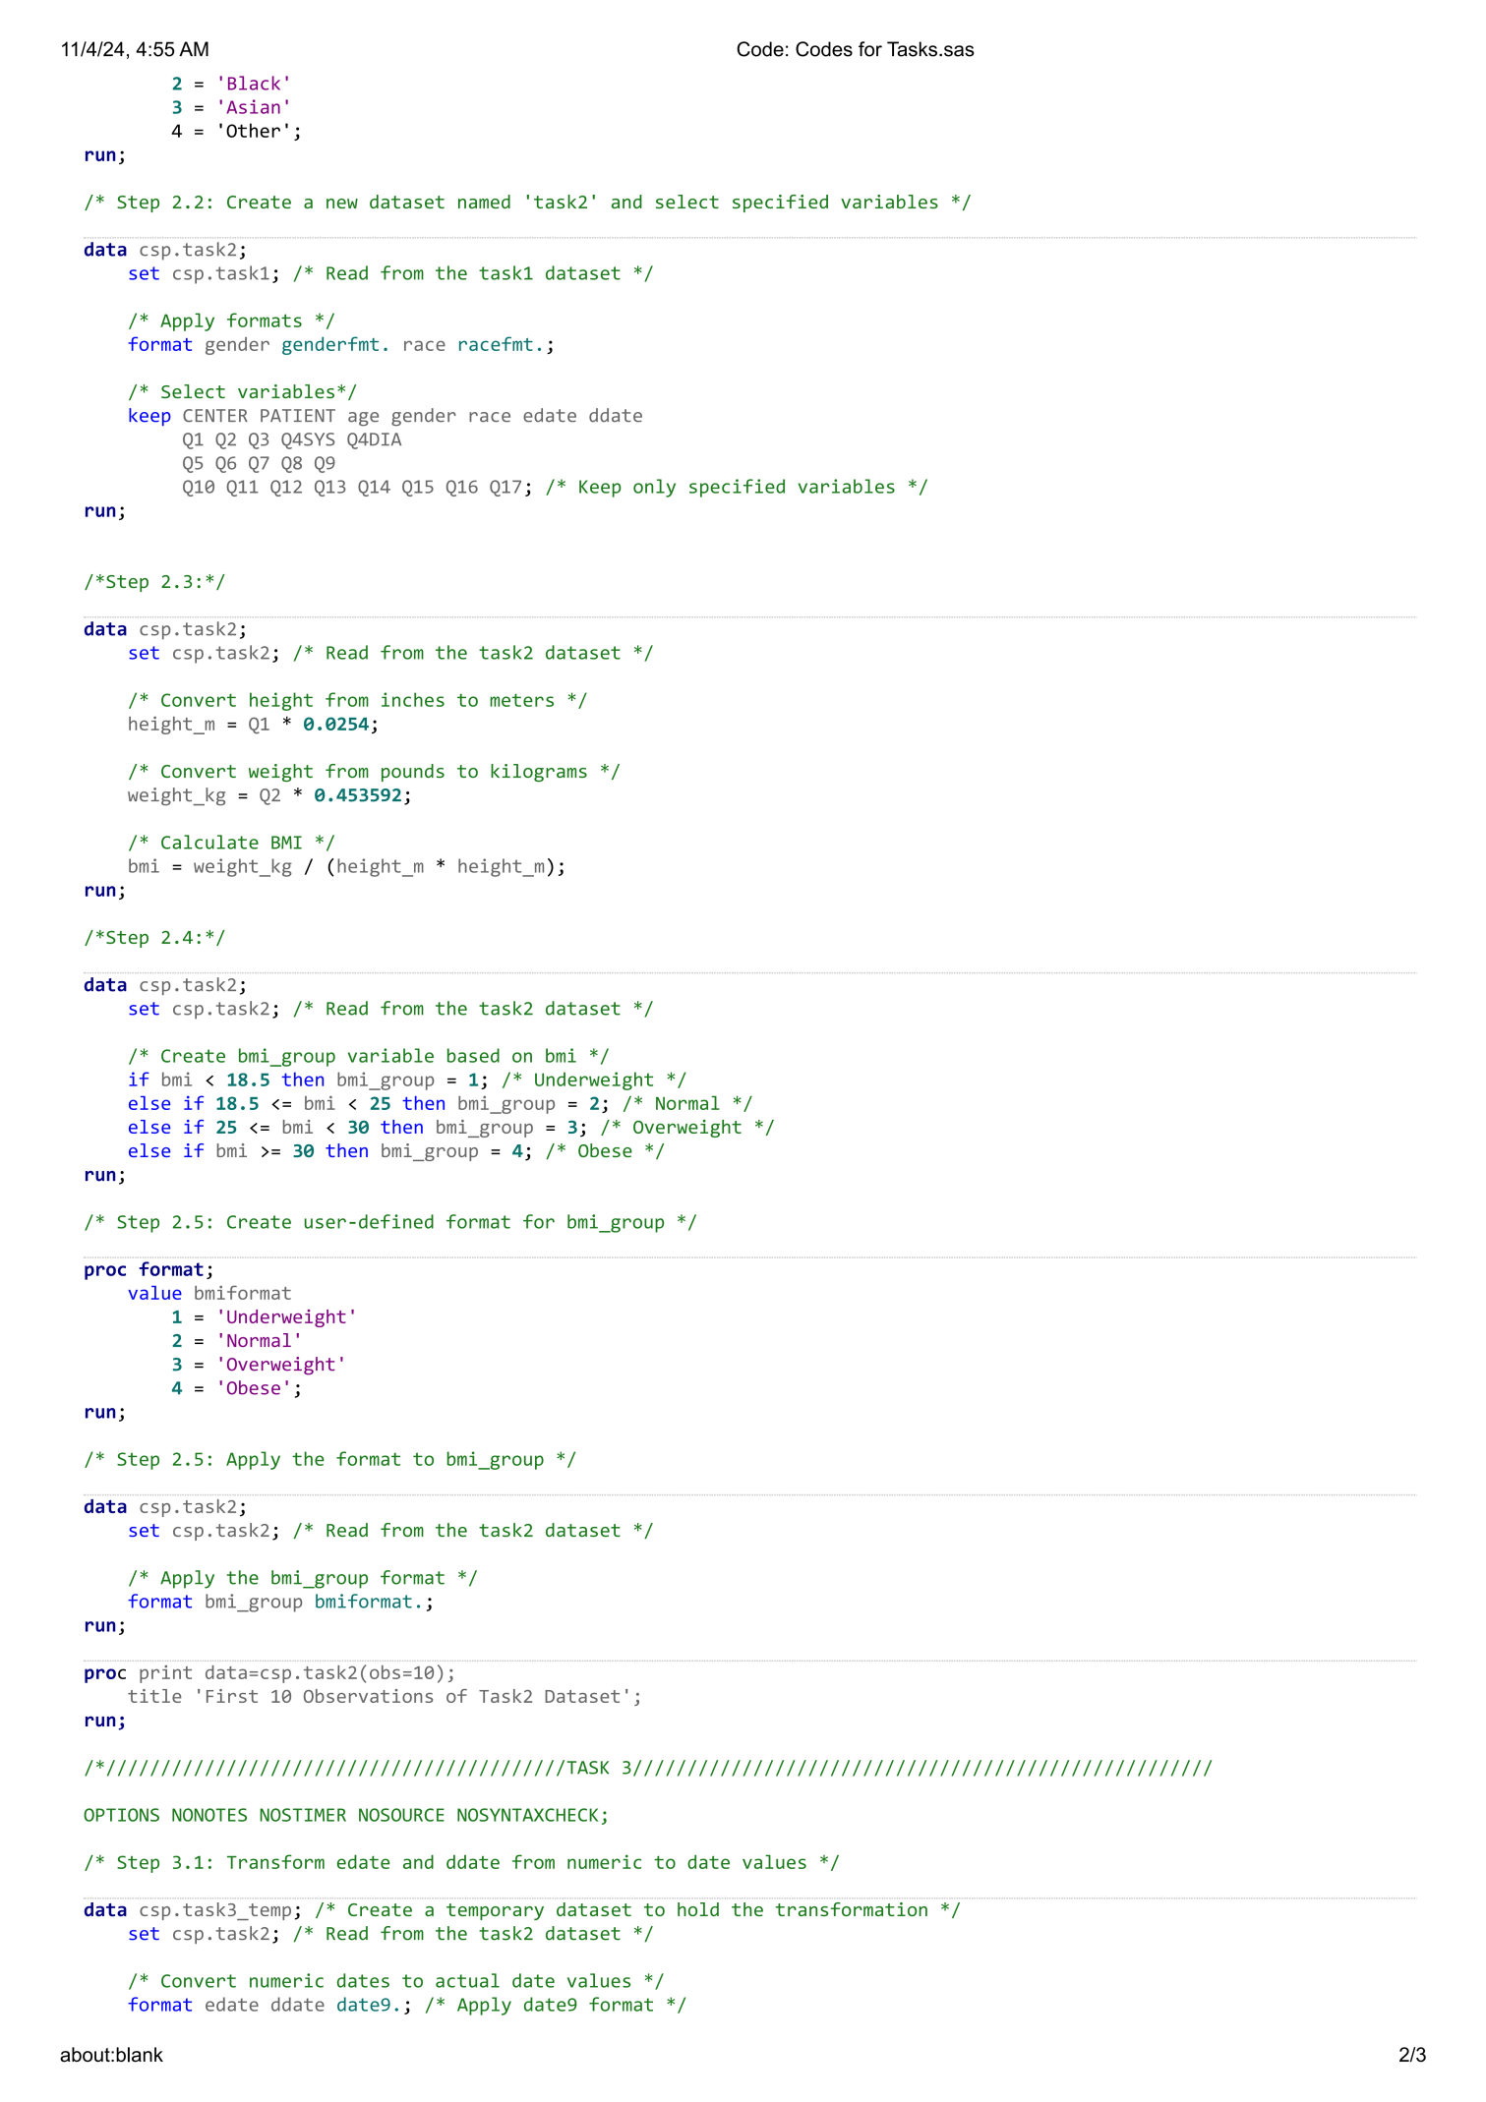
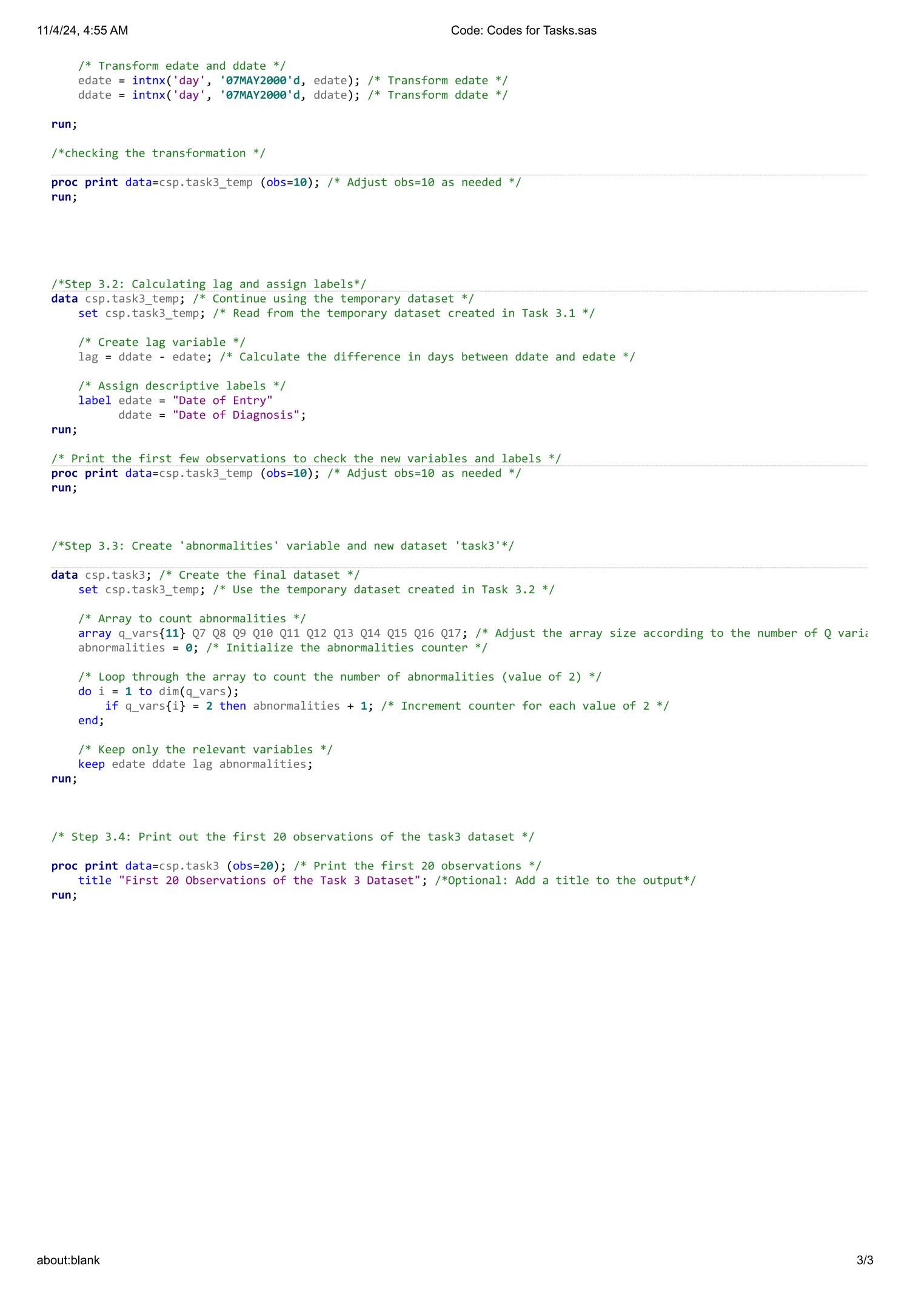
- Appendix 2: The out put of every task.
Task1:

Task2:
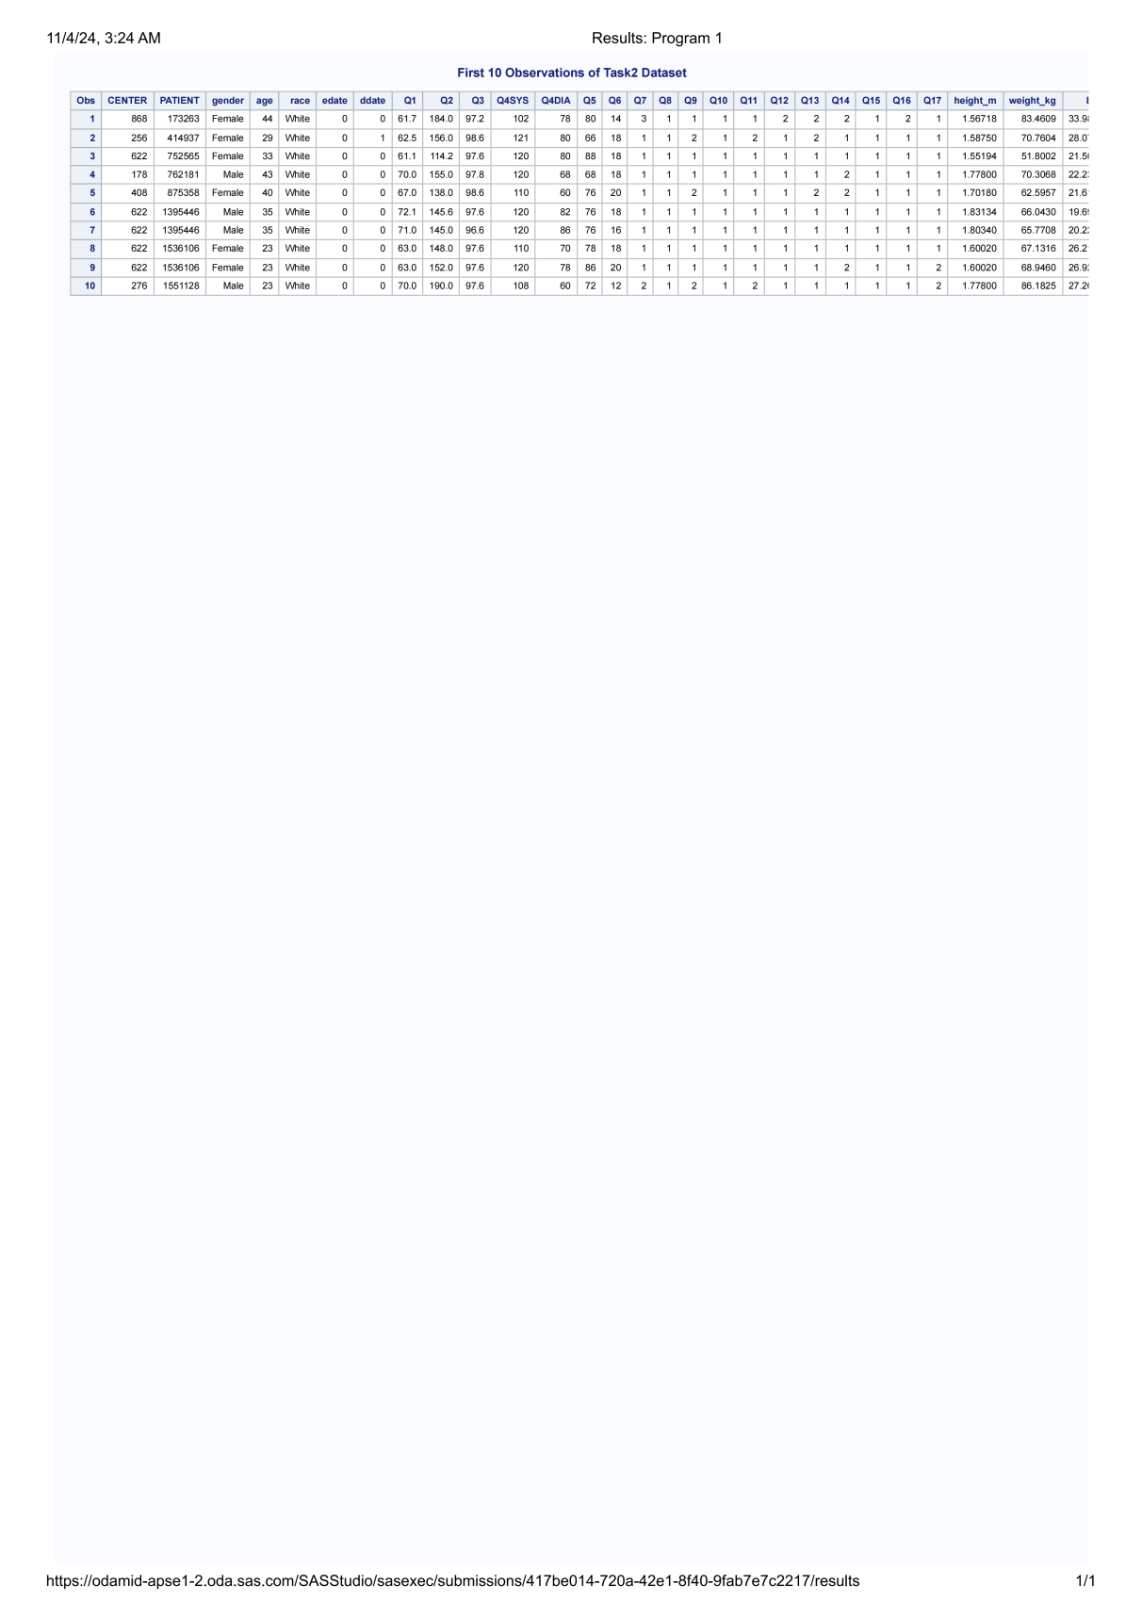

Task3：