This coursework chooses the data of Changping station.
- Data Preparation and Descriptive Statistics
  - Creat Boxplot
In this section, the data of Changping station in February 2015 were selected

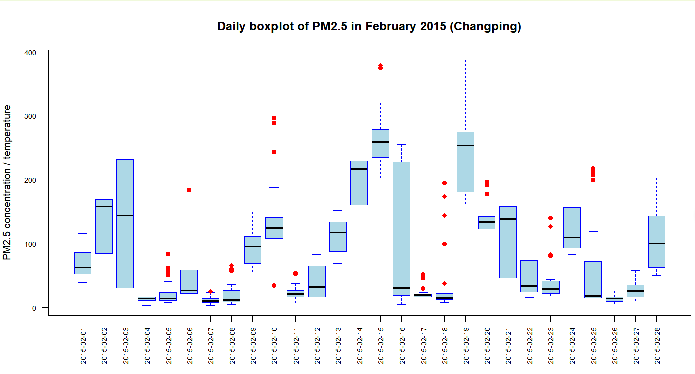
Figure 1. Daily Boxplot of PM2.5.

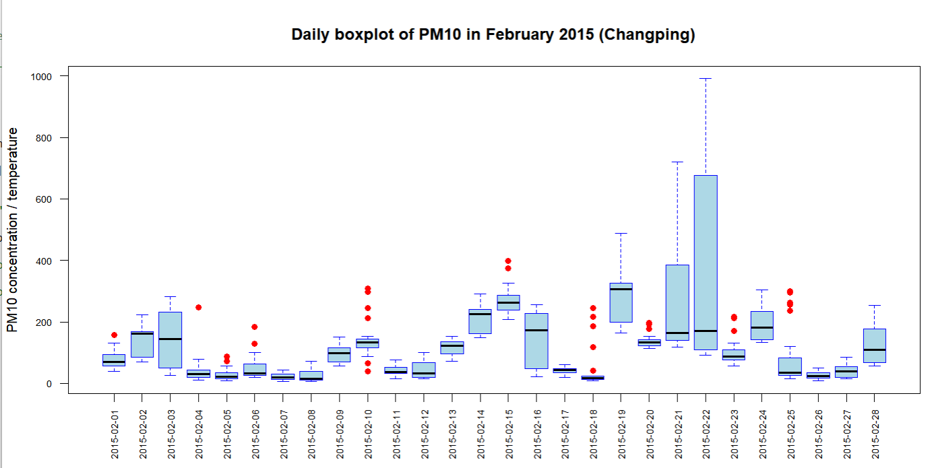
Figure 2. Daily Boxplot of PM10.

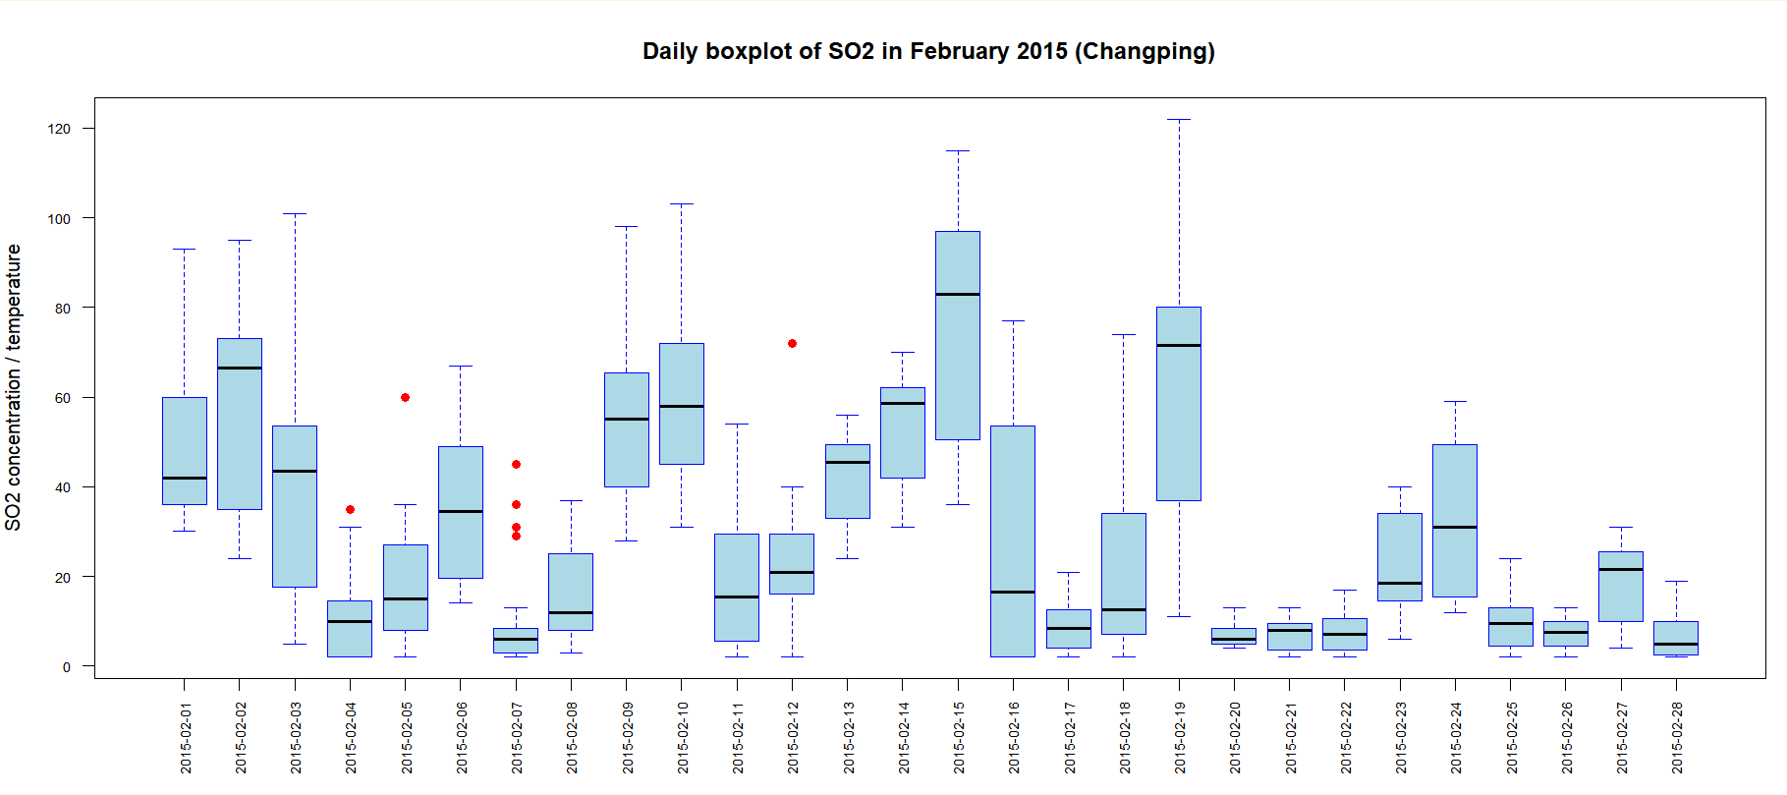
Figure 3. Daily Boxplot of SO2.

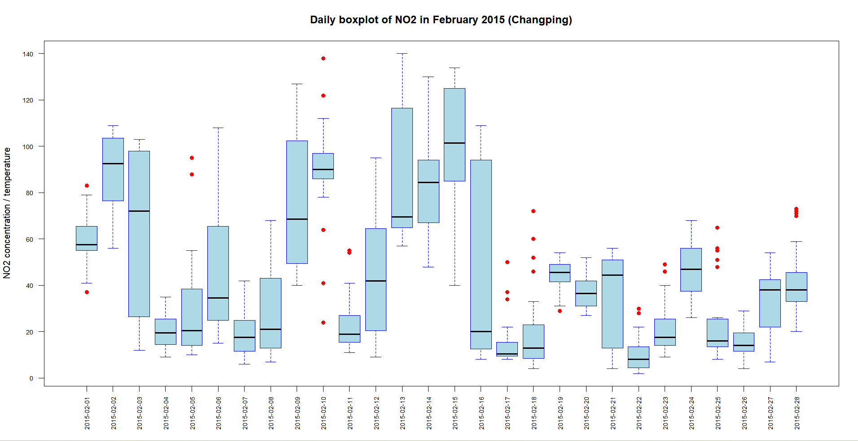
Figure 4. Daily Boxplot of NO2

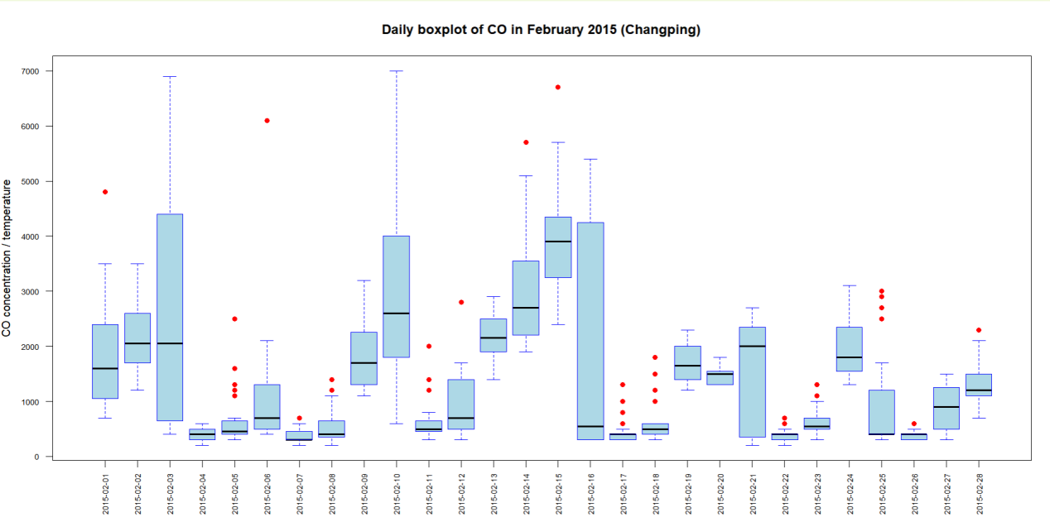
Figure 5. Daily Boxplot of CO

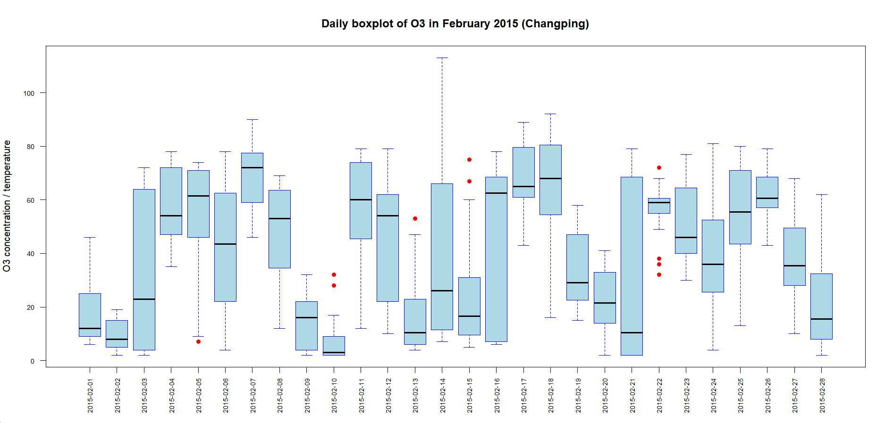
Figure 6. Daily Boxploy of O3

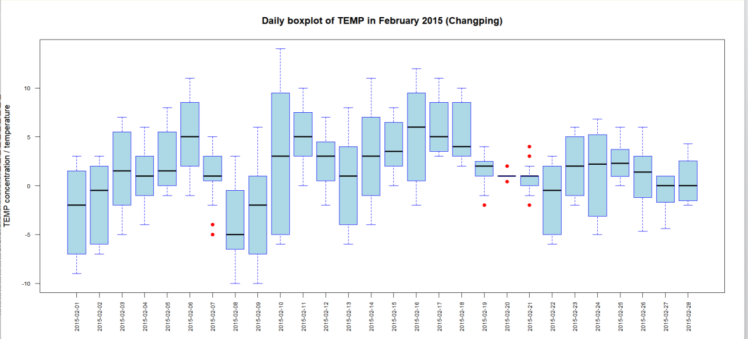
Figure 7. Daily Boxplot of TEMP

Figures 1 to 7 show that daily air pollutant concentrations in Changping swung sharply throughout February 2015. From early February to the middle of the month, PM2.5, PM10, ${SO}_{2}$, ${NO}_{2}$, and CO all reached high levels. The boxplots for PM2.5, PM10, and CO display quite broad boxes on some days, along with lots of outliers. This shows that these pollutants did not just vary a lot between days, they also fluctuated strongly within a single day. Temperature, by contrast, was much steadier, mainly moving between sub-zero and low positive values, as is typical for winter. Overall, the boxplots make it clear that air quality in Changping during February 2015 was marked by sharp short-term swings and many high-pollution episodes.

  - Summary statistics table

Statistic | $$r_{PM2.5}$$ | $$r_{PM10}$$ | $$r_{{SO}_{2}}$$ | $$r_{{NO}_{2}}$$ | $$r_{CO}$$ | $$r_{O_{3}}$$ | $$r_{TEMP}$$
Count (n) | 1460 | 1460 | 1460 | 1460 | 1460 | 1460 | 1460
Mean | 0.5450 | 0.3738 | 0.3294 | 0.1538 | 0.2464 | 0.4588 | 0.0281
Std. Dev. | 1.8284 | 1.2529 | 1.2185 | 0.6836 | 0.9021 | 2.2202 | 3.3857
Min | -0.9799 | -0.9799 | -0.9489 | -0.8836 | -0.9241 | -0.9423 | -25.0000
25% (Q1) | -0.4048 | -0.3431 | -0.3195 | -0.2445 | -0.2727 | -0.2931 | -0.1520
Median | 0.1131 | 0.0928 | 0.0000 | 0.0345 | 0.0833 | 0.0000 | -0.0134
75% (Q3) | 0.8475 | 0.7152 | 0.5000 | 0.3535 | 0.5000 | 0.3922 | 0.1048
Max | 36.6667 | 17.6061 | 11.5000 | 9.1250 | 9.5000 | 33.7500 | 86.0000
Skewness | 7.4091 | 4.3278 | 3.4276 | 3.1695 | 3.2375 | 7.4060 | 15.8329
Kurtosis | 113.5244 | 40.0375 | 17.2409 | 25.1424 | 20.6353 | 76.7714 | 362.7187
Table 1. Descriptive Statistics for Daily Proportional Change.

When calculating daily proportional changes, if Inf, NaN, or NA values appear, they are filled by interpolation using the previous value.

Table 1 shows that all seven variables have 1,460 valid observations. The standard deviations reveal that $r_{TEMP}$, $r_{O_{3}}$, and $r_{PM2.5}$ fluctuate more strongly, and their standard deviations are 3.3857, 2.2202, and 1.8284, respectively. This indicates that the daily proportional changes of temperature, ozone, and PM2.5 are less stable.

The skewness values are all positive, so each distribution is right-skewed overall.
$r_{TEMP}$ (15.8329), $r_{PM2.5}$ (7.4091), and $r_{O_{3}}$ (7.4060) are far more skewed than the other variables. What this means is that on most days the change rates stay low, but a few days experience large positive changes.

For kurtosis, $r_{TEMP}$, $r_{O_{3}}$, and $r_{PM2.5}$ stand out with very high values—362.7187, 114.5244, and 76.7714. These point to strong peakedness and heavy tails, suggesting that noticeable extreme observations are likely present in the data.

Overall, the daily proportional change rates in the full dataset show clear volatility and outlying features. (Table 1 was produced from R output; see the Appendix for the R output.)

- Linear Regression for One-Day-Ahead Prediction of PM2.5
  - Report the full regression output
Table 2 was produced from R output; see the Appendix for the R output.

Variable | Coefficient | Std. Error | t-statistic | p-value
Intercept | 0.5683 | 0.0522 | 10.8830 | <2e-16 ***
$$r_{PM2.5}(t)$$ | -0.0901 | 0.0401 | -2.2490 | 0.0246 *
$$r_{PM10}(t)$$ | -0.0326 | 0.0612 | -0.5330 | 0.5943
$$r_{{SO}_{2}}(t)$$ | 0.0989 | 0.0484 | 2.0430 | 0.0413 *
$$r_{{NO}_{2}}(t)$$ | 0.1678 | 0.1093 | 1.5350 | 0.1250
$$r_{CO}(t)$$ | -0.1505 | 0.0772 | -1.9500 | 0.0514
$$r_{O_{3}}(t)$$ | 0.0266 | 0.0225 | 1.1790 | 0.2387
$$r_{TEMP}(t)$$ | -0.0084 | 0.0140 | -0.5970 | 0.5507
$$R^{2}$$ | 0.0158
Adjusted $R^{2}$ | 0.0110
F-statistic | 3.3170
P-value for F-test | 0.0017
Table 2. OLS regression results for one-day-ahead prediction of PM2.5

- Important Statistics Explain
Based on Table 2, at the 5% significance level, two predictors significantly affect the PM2.5 daily proportional change of next day: the PM2.5 daily proportional change of current day ($r_{PM2.5}(t)$, p = 0.0246) and the SO2 daily proportional change of the current day ($r_{{SO}_{2}}(t)$, p = 0.0413). The regression coefficient for $r_{PM2.5}(t)$ is -0.0901. Holding other variables constant, a one-unit increase in the PM2.5 daily proportional change of today is linked to a 0.0901-unit decrease in the PM2.5 daily proportional change of next day. This points to a negative relationship. The coefficient for $r_{{SO}_{2}}(t)$ is 0.0989. This means there is a positive relationship between the SO2 daily proportional change of the current day and the PM2.5 daily proportional change of next day. With other variables held constant, a one-unit rise in the SO2 daily proportional change of the current day corresponds to a 0.0989-unit increase in the PM2.5 daily proportional change of next day.

- The coefficient of determination
The overall explanatory power of model is limited. The multiple $R^{2}$ is 0.0158, so the model explains only about 1.58% of the variation in the PM2.5 daily proportional change of next day. The adjusted $R^{2}$ is 0.0110. This tells us that, after accounting for the number of predictors, the model does not really outperform a baseline model with just an intercept.

- The F-statistic
The F-test yields a p-value of 0.0017, which means that, the overall model have a statistically significant effect on the PM2.5 daily proportional change. Still, because both $R^{2}$ and adjusted $R^{2}$ are low, the model is statistically significant but offers very limited practical explanatory power

  - Multicollinearity
Table 3 was produced from R output; see the Appendix for the R output.

 | $$r_{PM2.5}(t)$$ | $$r_{PM10}(t)$$ | $$r_{{SO}_{2}}(t)$$ | $$r_{{NO}_{2}}(t)$$ | $$r_{CO}(t)$$ | $$r_{O_{3}}(t)$$ | $$r_{TEMP}(t)$$
$$r_{PM2.5}(t)$$ | 1.0000 | 0.7342 | 0.4118 | 0.6068 | 0.5865 | -0.1852 | 0.0057
$$r_{PM10}(t)$$ | 0.7342 | 1.0000 | 0.4246 | 0.6518 | 0.6058 | -0.1859 | 0.0231
$$r_{{SO}_{2}}(t)$$ | 0.4118 | 0.4246 | 1.0000 | 0.5546 | 0.5226 | -0.1572 | 0.0517
$$r_{{NO}_{2}}(t)$$ | 0.6068 | 0.6518 | 0.5546 | 1.0000 | 0.6611 | -0.3032 | 0.0226
$$r_{CO}(t)$$ | 0.5865 | 0.6058 | 0.5226 | 0.6611 | 1.0000 | -0.2681 | -0.0085
$$r_{O_{3}}(t)$$ | -0.1852 | -0.1859 | -0.1572 | -0.3032 | -0.2681 | 1.0000 | -0.0009
$$r_{TEMP}(t)$$ | 0.0057 | 0.0231 | 0.0517 | 0.0226 | -0.0085 | -0.0009 | 1.0000
Table 3. Pearson correlation coefficient matrix

Table 3 presents the Pearson correlation matrix. We can see some degree of multicollinearity among a few of the pollutant variables.

The highest correlation, 0.7342, appears between the daily proportional changes of PM2.5 and PM10. This suggests that their trends move together fairly closely, likely because the two share similar sources.

In addition, the correlation between NO2 and CO is 0.6611, that between PM10 and NO2 is 0.6518, that between PM10 and CO is 0.6058, that between PM2.5 and NO2 is 0.6068, and that between PM2.5 and CO is 0.5865. All of these values point to moderate or strong positive relationships among these pollutants.

By contrast, O3 is negatively correlated with most of the pollutant variables. In particular, its correlations with NO2 and CO are -0.3032 and -0.2681. This indicates that the variation pattern of ozone may differ from that of combustion-related pollutants.

Overall, the correlation matrix shows that information overlaps among some predictors. What this means is that these predictors share a good deal of information. Such overlap can make regression coefficients unstable and inflate standard errors, which may then cause individual coefficients to become non-significant in the multiple regression. Because the contributions of the predictors are intertwined, it is hard to tease out their independent effects. Consequently, even if some pollutants actually influence the next-day PM2.5 change, their individual effects may not show up in the current model.

  - Evaluate model adequacy
- The assumptions of linearity
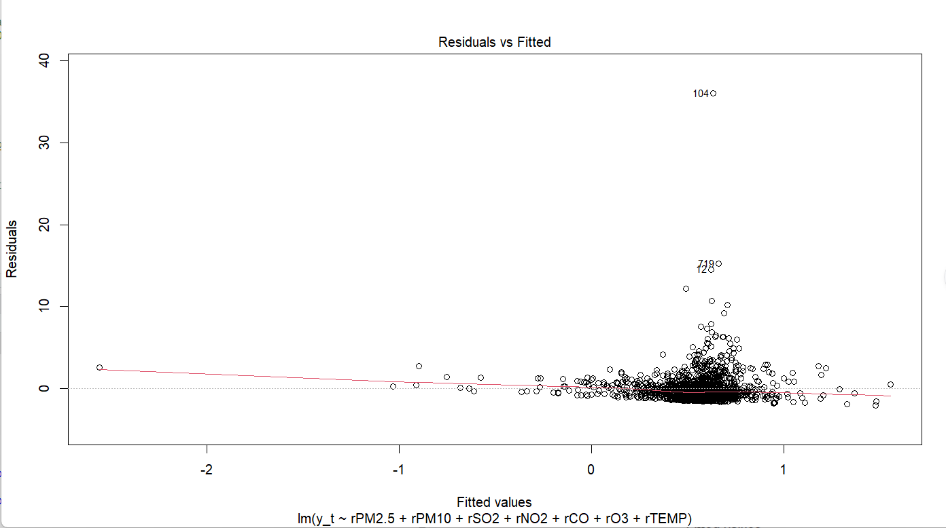
Figure 8. Residuals versus fitted values.

The residual vs. fitted plot shows that most residuals are scattered around zero. This indicates that the model does not have a clear systematic bias for most observations, and the linear relationship is reasonable to a certain degree.
However, the residuals are not entirely random. In some ranges of the fitted values, the spread of the residuals becomes noticeably larger, and extreme observations also appear. This suggests that the model fails to fully capture all the variation in the data.
Therefore, the linearity assumption holds some reasonableness overall, but it is not ideal. The model fit still has limitations.

- The normality assumption

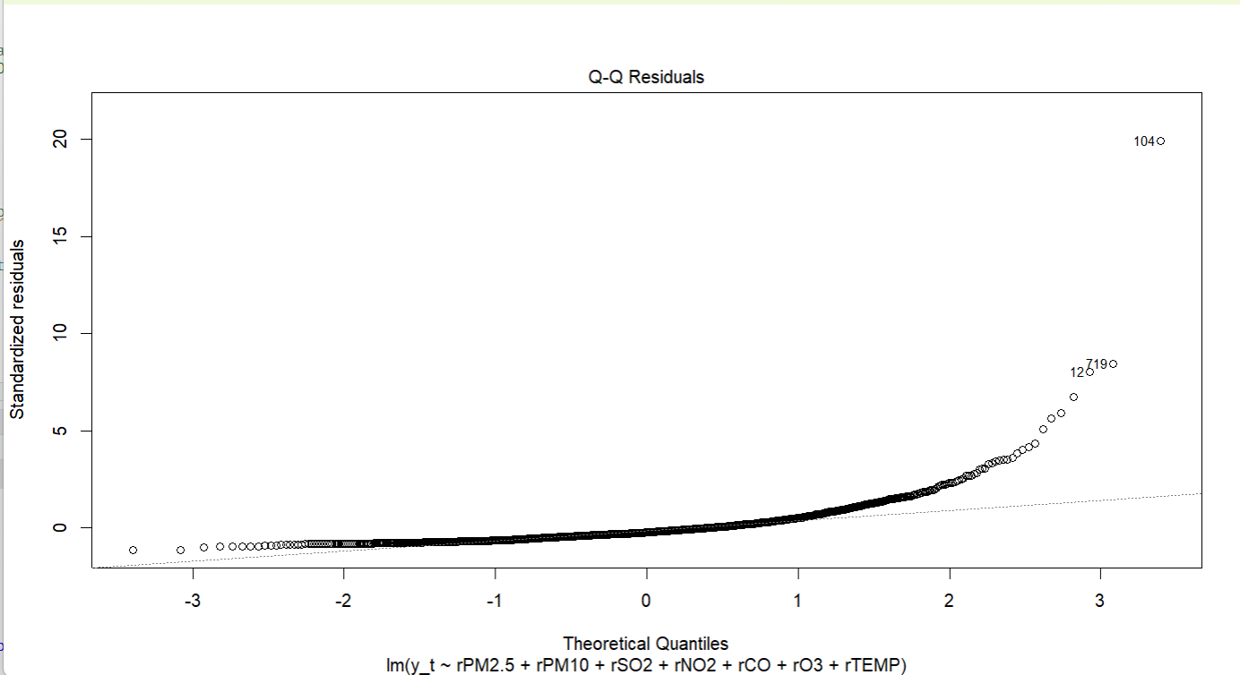
Figure 9. Q-Q Plot

Figure 9 shows that the residual points do not lie along the reference line. Points in the middle part stay relatively close to the line, but clear deviations occur at both ends, especially in the right tail. Several points fall far above the reference line. This indicates the presence of extreme positive outliers and a pronounced heavy-tailed feature in the residuals. This result shows that the residual distribution is clearly right-skewed and does not satisfy the normality assumption.Thus, the normality assumption for the model residuals is not met.Given the high skewness and kurtosis values of several variables from the earlier descriptive statistical analysis, we can infer that the data contain notable non-normal characteristics and extreme observations.

- PCA-Based Regression
  - Standerdise

Statistic | $$r_{PM2.5}$$ | $$r_{PM10}$$ | $$r_{{SO}_{2}}$$ | $$r_{{NO}_{2}}$$ | $$r_{CO}$$ | $$r_{O_{3}}$$ | $$r_{TEMP}$$
Count (n) | 1459 | 1459 | 1459 | 1459 | 1459 | 1459 | 1459
Mean | 0 | 0 | 0 | 0 | 0 | 0 | 0
Std. Dev. | 1 | 1 | 1 | 1 | 1 | 1 | 1
Min | -0.8343 | -1.0809 | -1.0493 | -1.5188 | -1.2979 | -0.6307 | -7.3897
25% (Q1) | -0.5185 | -0.5721 | -0.5321 | -0.5819 | -0.5760 | -0.3385 | -0.0533
Median | -0.2355 | -0.2247 | -0.2707 | -0.1755 | -0.1813 | -0.2064 | -0.0123
75% (Q3) | 0.1651 | 0.2726 | 0.1396 | 0.2921 | 0.2805 | -0.0306 | 0.0227
Max | 19.7515 | 13.7518 | 9.1654 | 13.1254 | 10.2560 | 14.9902 | 25.3839
Skewness | 7.4091 | 4.3281 | 3.4268 | 3.1725 | 3.2376 | 7.4044 | 15.8275
Kurtosis | 113.5093 | 40.0391 | 17.2329 | 25.1722 | 20.6359 | 76.7269 | 362.4677
Table 4. Standardized Matrix Statistics Summary

Standardization is necessary because different variables have different units and ranges of variation. If PCA is applied directly to the raw data, variables with larger variance will dominate the construction of the principal components, and this can mask the information carried by other variables.By transforming all variables into standardized variables (with mean zero and standard deviation one), we remove the scale differences and give each variable equal importance in the PCA.

From Table 4, we can see that after standardization, every variable has a mean of 0 and a standard deviation of 1. This confirms that the process has successfully eliminated the differences in units and scales across the variables. At the same time, the skewness and kurtosis of each variable stay largely unchanged. This shows that standardization does not alter the distribution shape of the original data.

  - PCA Report
- Eigenvalue
Table 5 was produced from R output; see the Appendix for the R output.

Principal Component | Eigenvalue
PC1 | ${\hat{λ}}_{1}$=3.4211
PC2 | ${\hat{λ}}_{2}$=1.0053
PC3 | ${\hat{λ}}_{3}$=0.9185
PC4 | ${\hat{λ}}_{4}$=0.6761
PC5 | ${\hat{λ}}_{5}$=0.3929
PC6 | ${\hat{λ}}_{6}$=0.3286
PC7 | ${\hat{λ}}_{7}$=0.2575
Table 5. The Eigenvalue of Each Principal Component

The seven eigenvalues of the sample correlation matrix are presented in Table 5

- The Proportion of total variance explained by each principal component and the
cumulative proportion.

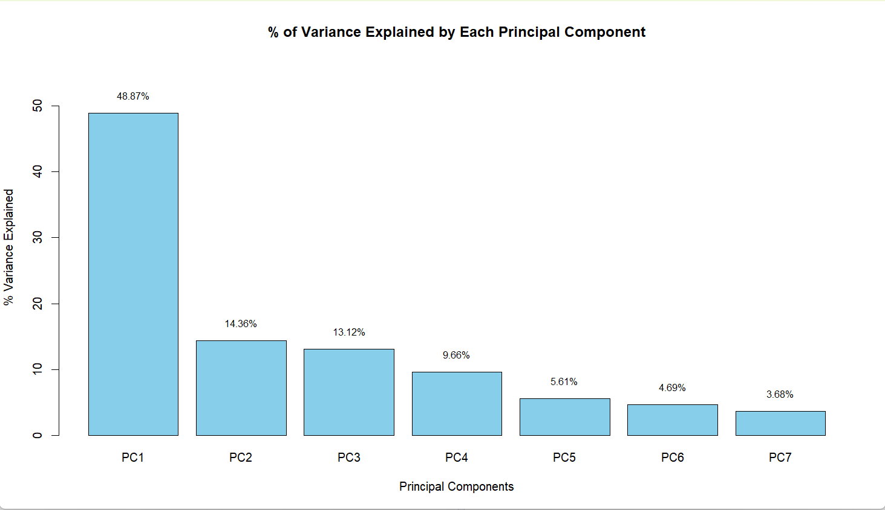
Figure 10. The Variance Explained by Each Principal Component.

From Figure 10, we can see the percentage of variance that each principal component explains on its own. The first principal component accounts for 48.87% of the total variance, the largest share. This means it captures close to half of the information in the seven standardized predictor variables. The second principal component (PC2) and the third (PC3) explain 14.36% and 13.12% of the variance, respectively. The individual contributions of the remaining components are small and decrease gradually.

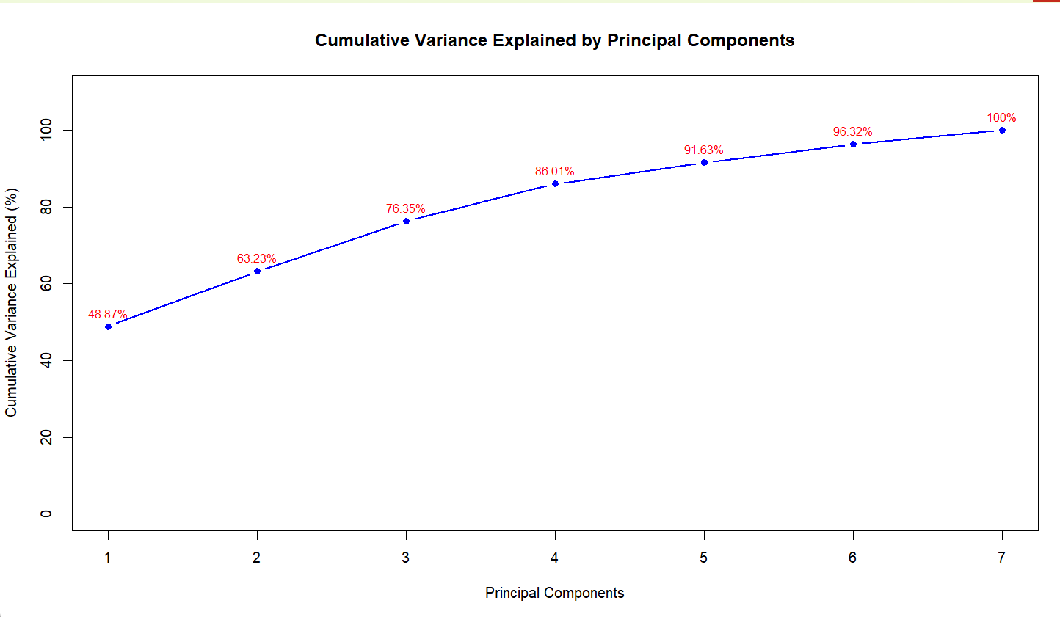
Figure 11. The Cumulative Variance Explained by Principal Components.

Figure 11 presents the cumulative percentage of variance explained by the seven principal components. The first three components together explain 76.35% of the variance. When the fourth component is added, the cumulative explained variance reaches 86.01%. This means that the first four components can retain most of the information from the original seven variables. The marginal contributions of the later components are relatively small.

- A scree plot of the eigenvalues

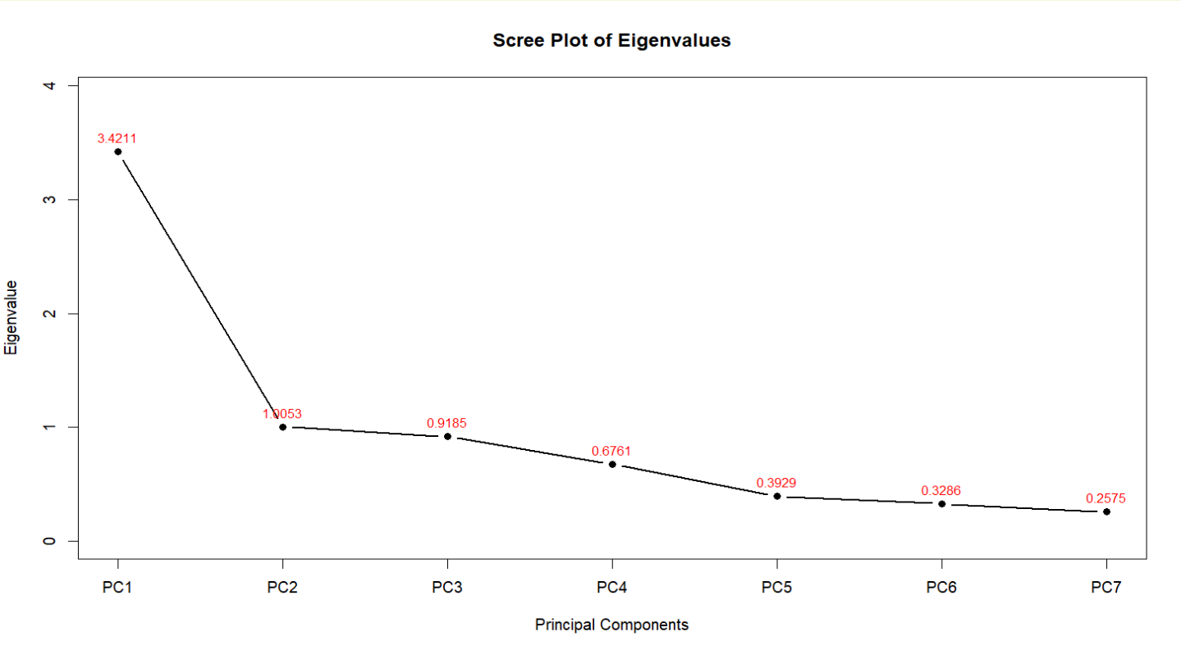
Figure 12. The scree plot of the eigenvalues

From Figure 12, we can see that the first principal component has the largest eigenvalue, 3.4211. It explains nearly half of the total variance in the original seven standardized variables. The eigenvalues of the second and third components are 1.0053 and 0.9185, respectively. The variance they explain drops noticeably. The eigenvalues of the fourth to seventh components decrease gradually, and their contributions are small. This indicates that the first three or four components capture the main information in the data, while the later components offer only limited marginal contributions.

- Choose Components
Based on the cumulative variance plot in Figure 11, the first four principal components together explain 86.01% of the variance, which exceeds the 80% threshold. Therefore, it is appropriate to retain the first four components for subsequent analysis, that is, k = 4. This choice achieves dimensionality reduction while keeping most of the key information from the original seven predictor variables.

  - Laoding Matrix Analysis
Table 6 was produced from R output; see the Appendix for the R output.

 | Comp.1 | Comp.2 | Comp.3 | Comp.4
$$r_{PM2.5}$$ | 0.4420 | 0.0253 | 0.1937 | 0.4221
$$r_{PM10}$$ | 0.4531 | 0.0016 | 0.1898 | 0.3876
$$r_{{SO}_{2}}$$ | 0.3721 | -0.0986 | 0.0854 | -0.7994
$$r_{{NO}_{2}}$$ | 0.4663 | 0.0000 | -0.0291 | -0.0808
$$r_{CO}$$ | 0.4503 | 0.0446 | 0.0075 | -0.1005
$$r_{O_{3}}$$ | -0.2010 | -0.1028 | 0.9528 | -0.0828
$$r_{TEMP}$$ | 0.0162 | -0.9885 | -0.1021 | 0.0953
Table 6. Loading Matrix

Table 6 shows the loading matrix for the first four retained principal components.
The first principal component is mainly built from the daily proportional changes of PM2.5, PM10, NO2, CO, and SO2. All these variables carry positive loadings. So PC1 can be seen as a factor that represents changes in the overall pollution level.

The second principal component is almost entirely driven by the daily proportional change of TEMP, with a loading of -0.9885. Therefore, PC2 can be understood as a temperature change factor. The third principal component is dominated by the daily proportional change of O3, with a loading of 0.9528. This indicates that the component mainly reflects changes in ozone or photochemical pollution.

In the fourth principal component, SO2 has a strong negative loading (-0.7994), while PM2.5 (0.4221) and PM10 (0.3876) show positive loadings. Thus, PC4 can be interpreted as a contrast factor between changes in SO2 and changes in particulate matter.

  - One-Day-Ahead Regression
- Result
Table 7 was produced from R output; see the Appendix for the R output.

Variable | Coefficient | Std. Error | t-statistic | p-value
Intercept | 0.5402 | 0.0474 | 11.390 | < 2e-16 ***
Comp.1 | -0.0665 | 0.0256 | -2.594 | 0.0096 **
Comp.2 | -0.0002 | 0.0473 | -0.004 | 0.9965
Comp.3 | 0.0254 | 0.0495 | 0.513 | 0.6083
Comp.4 | -0.1849 | 0.0577 | -3.205 | 0.0014 **
$$R^{2}$$ | 0.0117
Adjusted $R^{2}$ | 0.0090
F-statistic | 4.316
P-value for F-test | 0.0018
Table 7. Summary of Output

According to Figure 7, among the four retained principal components, Component 1 and Component 4 are significant at the 5% level. Their p-values are 0.0096 and 0.0014, respectively. The coefficient of Component 1 is -0.0665. Holding other components constant, a one-unit increase in Component 1 is linked to an average drop of 0.0665 units in the next-day PM2.5 daily proportional change.The coefficient of Component 4 is -0.1849, also showing a significant negative relationship.

By contrast, the p-values of Component 2 and Component 3 are large. This means their independent roles in explaining the next-day PM2.5 change are not evident. The model yields an R² of 0.0117 and an adjusted R² of 0.0090. These values point to limited overall explanatory power for the PCA regression model. Yet the F-test gives a p-value of 0.0018, which tells us that the model as a whole still has statistical significance.

- Compare
Table 8 was produced from R output; see the Appendix for the R output.

Model | Predictors | $$R^{2}$$ | Adjusted $R^{2}$
OLS regression | 7 original predictors | 0.0158 | 0.0110
PCA regression | First 4 PCs | 0.0117 | 0.0090

Table 8. Comparetion Table.

Compared with the full OLS regression model in Section 2 that used seven original predictors, the PCA regression model has slightly lower explanatory power.
The full OLS model gives an $R^{2}$of 0.0158 and an adjusted $R^{2}$ of 0.0110. The PCA regression model using the first four principal components gives an R² of 0.0117 and an adjusted $R^{2}$ of 0.0090. This means that when the number of predictors is reduced from seven to four, the ability to explain the next-day PM2.5 proportional change decreases, but the drop is small.

So, the PCA dimension reduction does not lead to a clear loss of predictive power.
The first four principal components already explain 86.01% of the total variance in the original seven standardized predictors, and the components are orthogonal to each other. PCA regression therefore offers some advantages in reducing variable dimensions and easing multicollinearity. However, the $R^{2}$ values are low for both models. This tells us that whether we use original variables or principal components, the overall explanatory power of the linear model for the next-day PM2.5 proportional change remains quite limited.

APPENDIX:
R Code:
Coursework_code.R
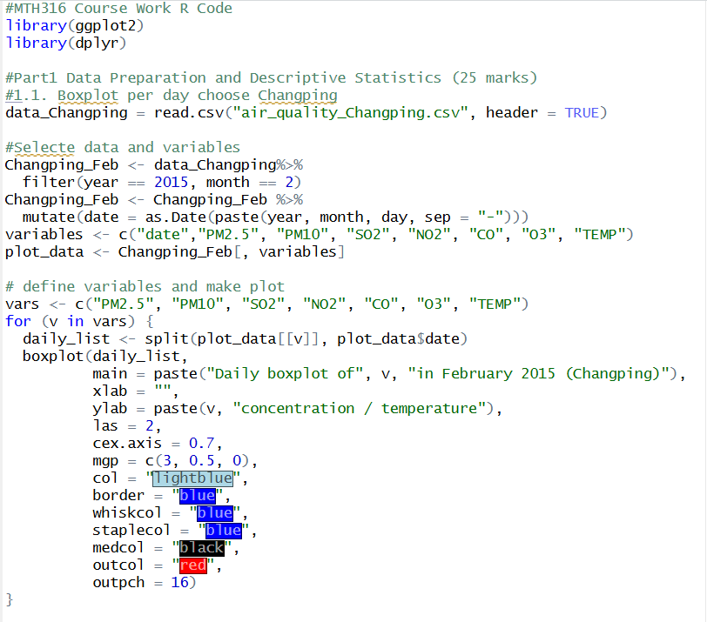
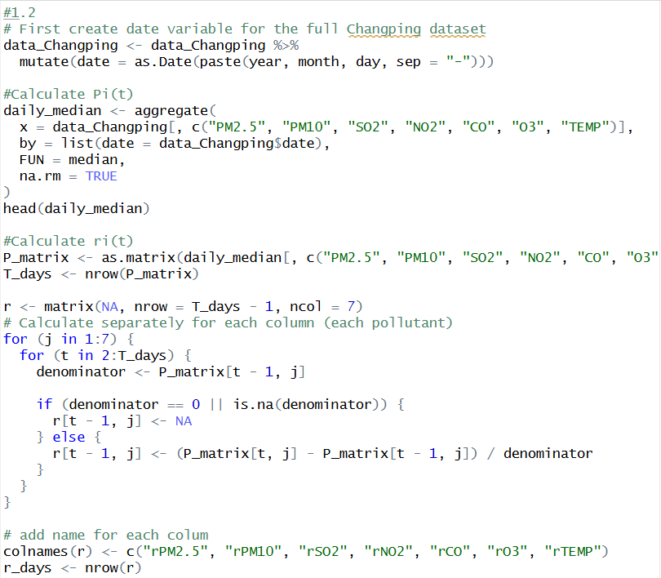
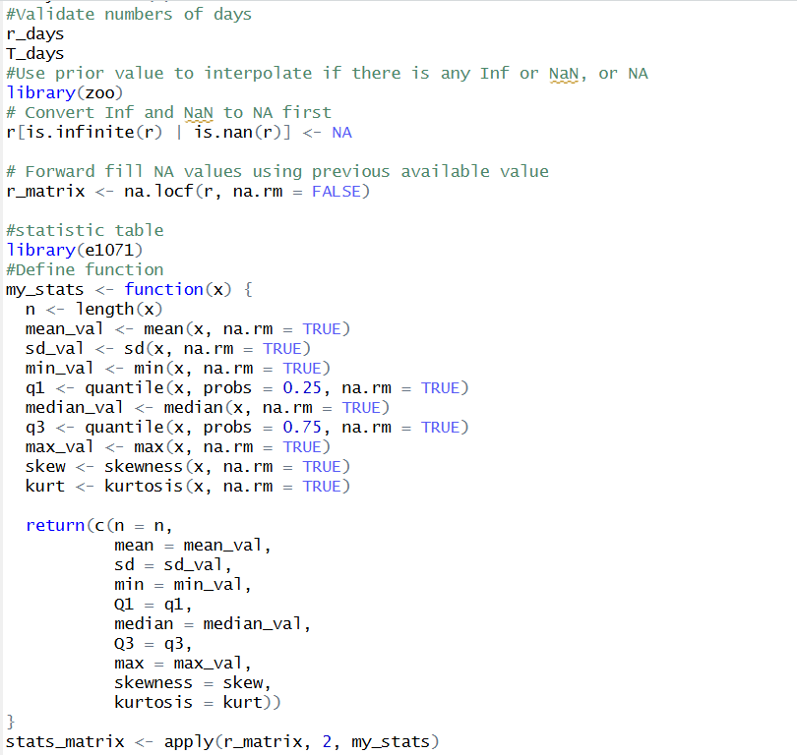

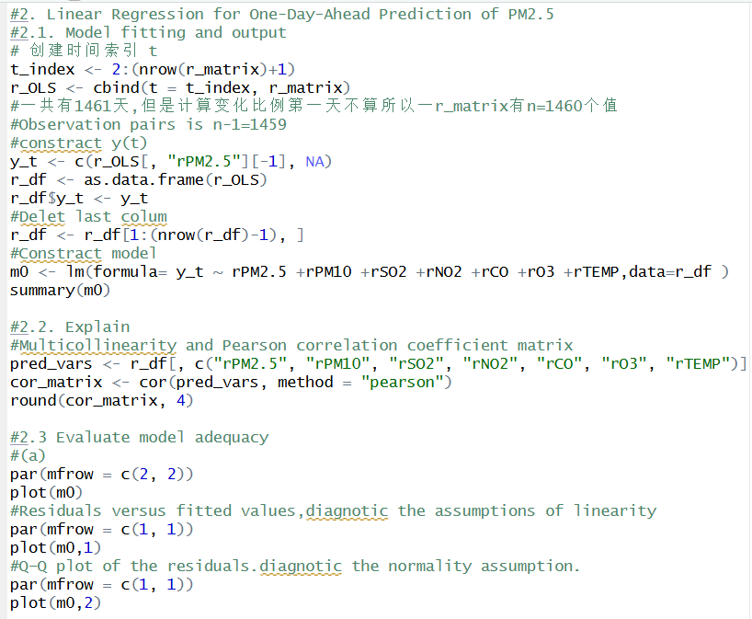
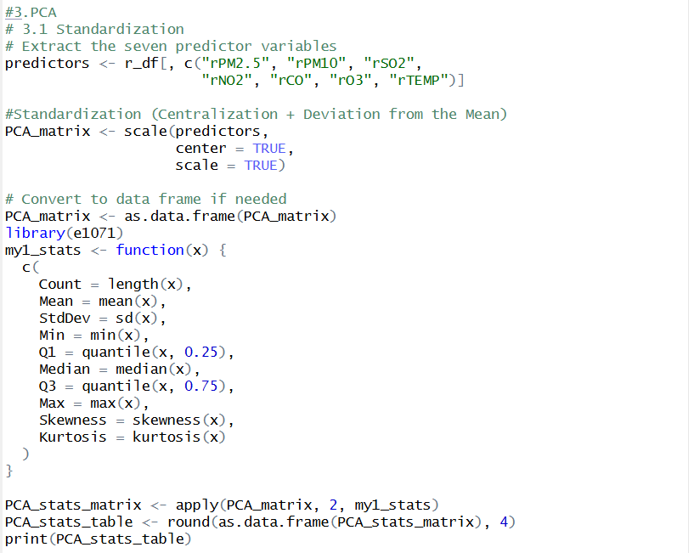
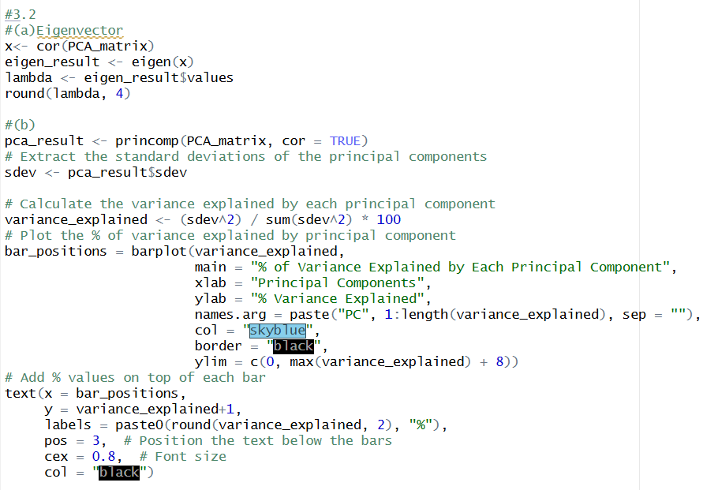
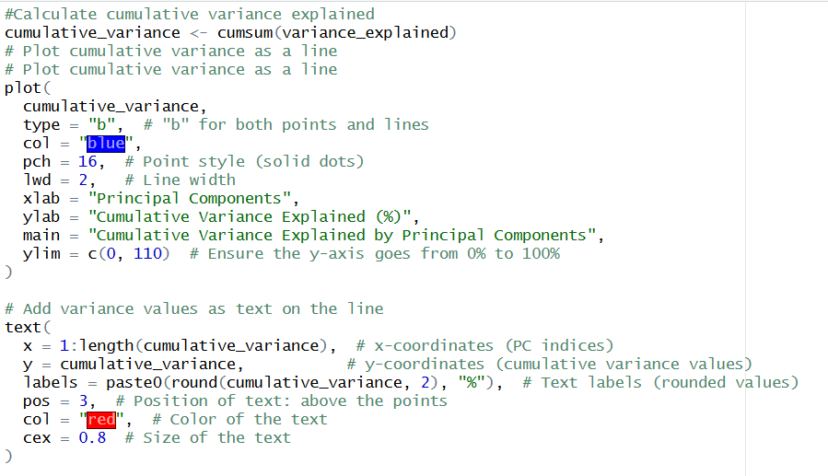
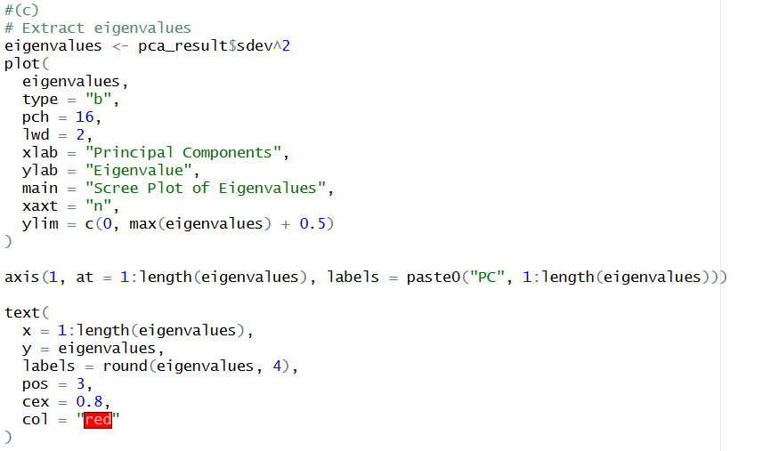
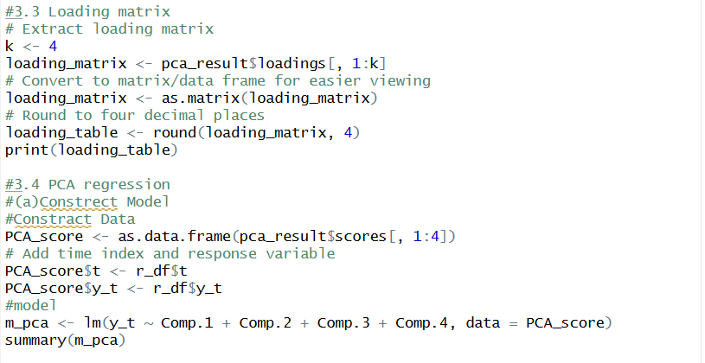

R Output:
Table 1 output:
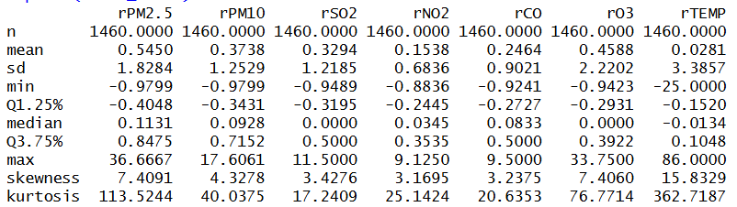

Table 2 output:
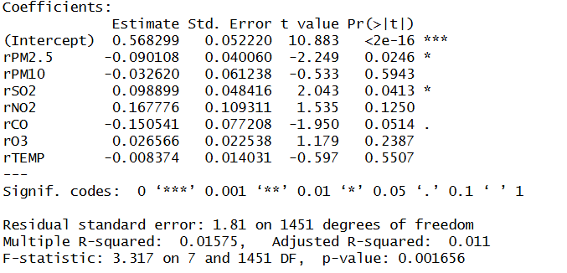

Table 3 output:
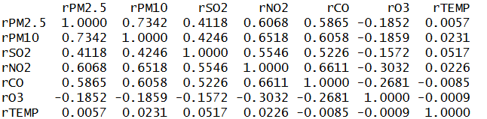

Table 4 output:
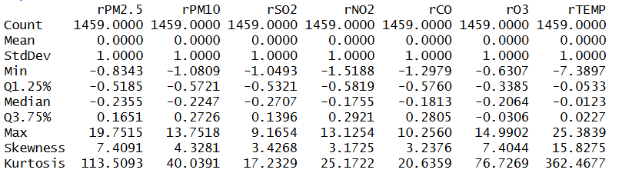

Table 5 output:

Table 6 output:
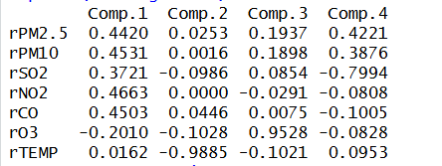

Table 8 output:
