1. **Look into how to develop a python package, prepare to convert my MBIL to a python package. Try testing with a small package.**
2. Register in <https://pypi.org/>

XiaJiang

1. Create a repository in github, it is not mandatory, but it can help to introduce your own package to public and get some feedback
2. Create function.py and __init__.py, specific directory is as below:

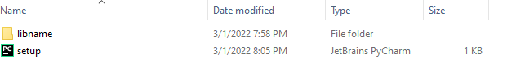

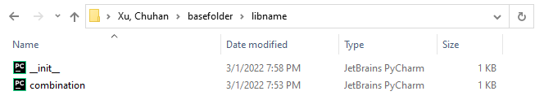

1. Create a project folder which contains a package (folder) with all application related files that needed to be deployed, and there additional files: LICENSE.txt, setup.py, and the readme.md. The sphinx docs folder was not included.
2. Create the setup.py to set the package information like description and author.

The content of the setup.py for our first version depoyed to pypi.org is as follows:

1. Run setup.py as below

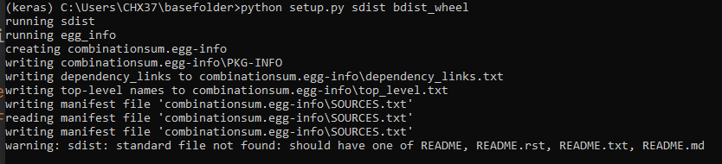

1. Right click the project fold, and choose “new terminal at folder” (no need if you are already at the right folder at the terminal)
2. At the term run

python setup.py sdist

to setup the dist folder which contains the .tar.gz file.

1. This is what we need to upload our package to pypi

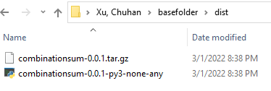

1. Install twine package which is the tool we need to use

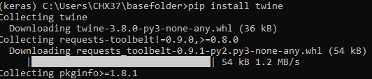

1. Upload it to twine with the code below

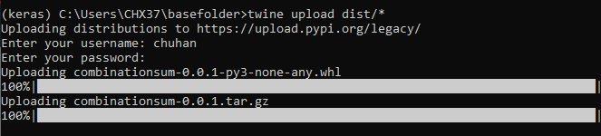

1. Success

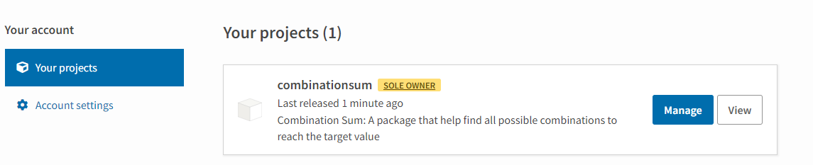

1. Use the pip install combinationsum to install it

