**Meeting agenda.**

1. Revised sphinx documentation about default values.
2. Tested BDeuScore for interaction sets.
3. Discuss information gain questions that Chuhan has.

**Progress made in the past week.**

**Issues/Questions and Comments**

1. should include attributes in documentation

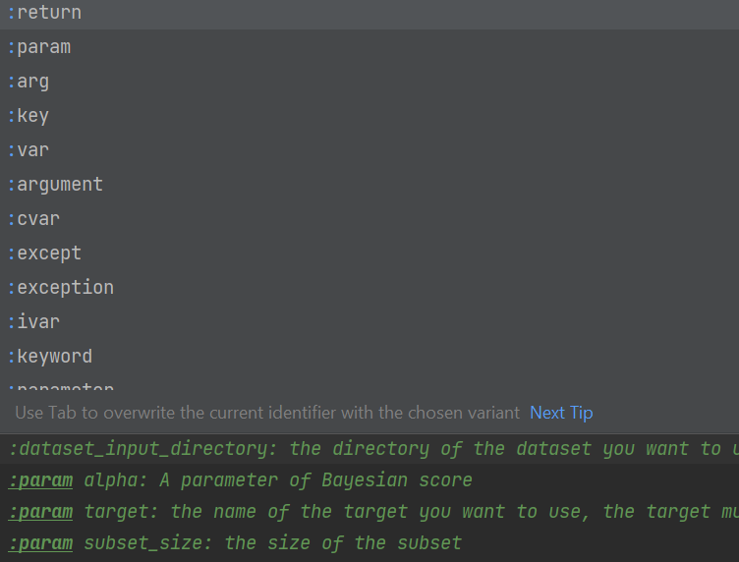

1. should include default values and explanation in documentation.
2. How to capture content in “def __init__” function, which is currently ignored by Sphinx.

**Ongoing tasks that cover more than a week**

Converting MBIL java to MBIL python package.

Still working on

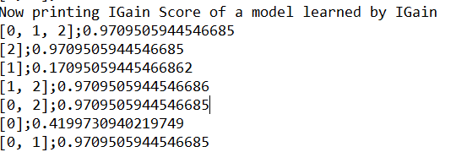

When the subset only include one single feature, the result is not right

**Specific tasks for the coming week**

See ongoing tasks

**Less urgent tasks**