a.

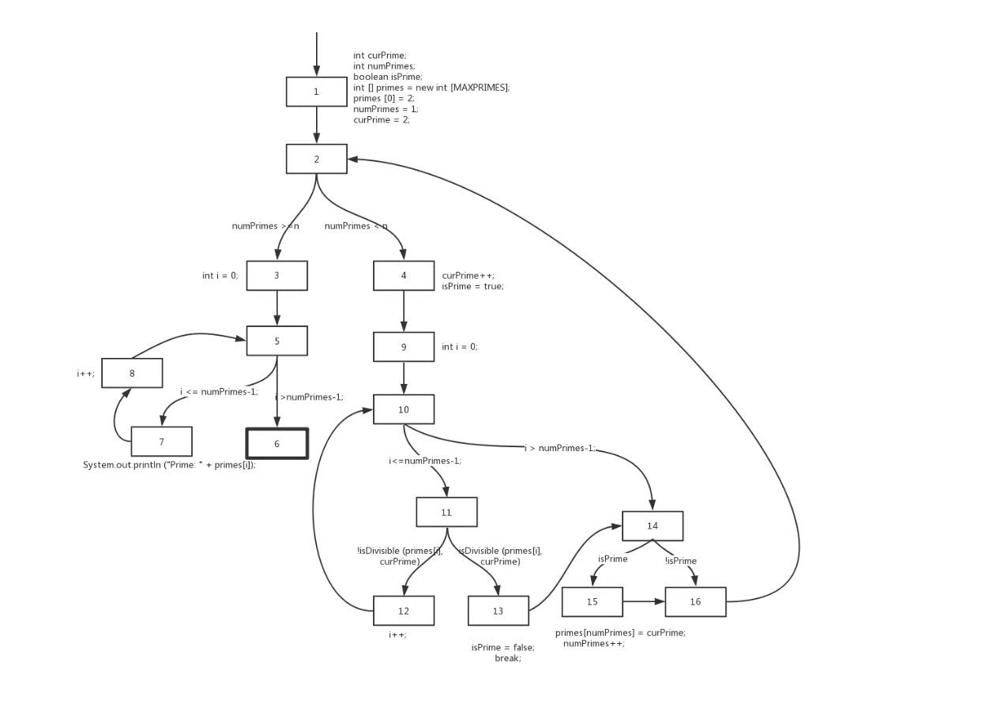

b.

将MAXPRIMES的值设为4，t2会发生越界错误，t1不会。

c.

n=1

d.

节点覆盖：  
{1,2,3,4,5,6,7,8,9,10,11,12,13,14,15,16}

边覆盖：

{(1,2),(2,3),(2,4),(3,5),(5,7),(5,6),(7,8),(8,5),(4,9),(9,10) ,(10,11),(10,14),(11,12),(11,13),(12,10),(13,14),(14,15),(14,16),(15,16),(16,2)}

主路径覆盖：

[1,2,4,9,10,11,12]

[1,2,4,9,10,14,15,16]

[1,2,4,9,10,14,16]

[1,2,4,9,10,11,13,14,15,16]

[1,2,4,9,10,11,13,14,16]

[1,2,3,5,7,8]

[1,2,3,5,6]

[2,4,9,10,11,13,14,15,16,2]

[2,4,9,10,11,13,14,16,2]

[2,4,9,10,14,15,16,2]

[2,4,9,10,14,16,2]

[4,9,10,11,13,14,15,16,2,3,5,7,8]

[4,9,10,11,13,14,15,16,2,3,5,6]

[4,9,10,11,13,14,16,2,3,5,7,8]

[4,9,10,11,13,14,16,2,3,5,6]

[4,9,10,14,15,16,2,3,5,7,8]

[4,9,10,14,15,16,2,3,5,6]

[4,9,10,14,16,2,3,5,7,8]

[4,9,10,14,16,2,3,5,6]

[10,11,12,10]

[11,12,10,14,15,16,2,3,5,7,8]

[11,12,10,14,15,16,2,3,5,6]

[11,12,10,14,16,2,3,5,7,8]

[11,12,10,14,16,2,3,5,6]

[5,7,8,5]

[7,8,5,6]

e.

path(t1)=[1,2,3,5,6]

path(t2)=[1,2,3,5,7,8,5,6]

path(t3)=[1,2,4,9,10,14,16,2,3,5,6]

path(t4)=[1,2,4,9,10,14,16,2,3,5,7,8,5,6]

path(t5)=[1,2,4,9,10,14,15,16,2,3,5,6]

path(t6)=[1,2,4,9,10,14,15,16,2,3,5,7,8,5,6]

path(t7)=[1,2,4,9,10,14,16,2,3,5,6]

path(t8)=[1,2,4,9,10,14,16,2,3,5,7,8,5,6]

path(t9)=[1,2,4,9,10,11,13,14,15,16,2,3,5,6]

path(t10)=[1,2,4,9,10,11,13,14,15,16,2,3,5,7,8,5,6]

path(t11)=[1,2,4,9,10,11,13,14,16,2,3,5,6]

path(t12)=[1,2,4,9,10,11,13,14,16,2,3,5,7,8,5,6]

path(t13)=[1,2,4,9,10,11,12,10,14,15,16,2,3,5,6]

path(t14)=[1,2,4,9,10,11,12,10,14,15,16,2,3,5,7,8,5,6]

path(t15)=[1,2,4,9,10,11,12,10,14,16,2,3,5,6]

path(t16)=[1,2,4,9,10,11,12,10,14,16,2,3,5,7,8,5,6]

path(t17)=[1,2,4,9,10,11,12,10,11,13,14,15,16,2,3,5,7,8,5,6]

path(t18)=[1,2,4,9,10,11,12,10,14,15,16,2,3,5,7,8,5,6]

点覆盖：t17

边覆盖：t3，t17

主路径覆盖：t1,t2,t5,t6,t7,t8,t9,t10,t11,t12,t13,t14,t15,t16,t17

所以满足节点覆盖但不满足边覆盖的测试路径是

[1,2,4,9,10,11,12,10,11,13,14,15,16,2,3,5,7,8,5,6]

f.

满足边覆盖但不满足主路径覆盖的测试路径是

[1,2,4,9,10,11,12,10,11,13,14,15,16,2,3,5,7,8,5,6]

[1,2,4,9,10,14,15,16,2,3,5,6]

附加：基于Junit及Eclemma（jacoco）实现一个主路径覆盖的测试,测试结果截图如下：

