IT5015 Information Systems

1. Requirement Analysis Overview:

# Company Overview

**New Horizons Cinemas** has several cinema complexes in different cities, each with multiple theaters and each theater with different amount of seats, showing different movies.

# Purpose of the report.

The purpose of the report is to detail the analysis done on **New Horizons Cinemas** and its stakeholders to help provide the best service to its customers and grow the company.

Creating a database for a cinema involves a thorough requirement analysis to determine the data needs, structure, and functionality.

# Report Overview

Firstly, we used PESTLE and Stakeholder Analysis to gather information on the macro-environment and from all relevant stakeholders that can impact on the business. We analyzed the data and considered the implications. We identify and engage with the stakeholders to understand their data needs. We determine the functional and nonfunctional requirements and the user's needs.

Secondly, we did an SDLC, System development Life Cycle, to describe the process that will be followed to implement the database.

Thirdly, we did a conceptual design analysis to understand the problem we are trying to solve and come up with a proposed solution.

Lastly, we made the database.

2. Information Gathering.

**PESTLE**, a tool used to assess the macro-environmental factors that can impact an organization.

**Political:** Research government policies and regulations that may affect the business.

**Economic:** Study and analyze consumer spending patterns and consider things like recessions.

**Social:** Study the demographics including age and gender. Look at consumer behavior and lifestyle trends and understand how social changes might affect movie preferences.

**Technology:** Investigate and analyze the organization's tech capabilities and infrastructure and investigate new disruptive technologies emerging.

**Environmental:** Investigate the company's sustainability and ecological operations that may affect its reputation. Investigate regulations.

**Legal:** Legal, laws and regulations that can affect the company.

Pestle is normally used in the beginning of a strategic planning process. It assesses how the external factors can impact the project. The information gathered will help the company make informed decisions, help them identify potential risk and develop strategies to mitigate the risk and to make the best use of possible opportunities based on the external landscape.It is also used for scenario planning where multiple scenarios could be explored to develop a flexible plan.

**Example: Economic**

* Information: Economic data shows that there is a steady decrease in consumer spending and a decrease in employment rate.
* Implications: The cinemas might want to consider a hiring freeze, add more deals to attract more people.

**Example: Environmental**

* Information: An analysis reveals an increased regulatory pressure to be sustainable and to reduce the carbon footprint.
* Implications: The cinema might want to consider changing the old fluorescent lights to led lights, use recycled cups, straws and popcorn holders.

**Stakeholder analysis:** It is a very important part of project management and strategic planning. It involves identifying, understanding, and engaging with individuals or groups who can influence or have an interest in the project.

**Surveys and Questionnaires:** To get feedback from a large number of people we use surveys, in person or online and emails. This helps us with their opinions, preferences and concerns.

**Interviews:** This is in person or in groups discussions to get in-depth and quality data about the stakeholders’ interests and concerns.

**Focus groups:** Bringing together a small diverse group of stakeholders. This is very useful for generating ideas and confronting common concerns.

**Document analysis:** This involves going through past communications, emails, and reports. This helps to identify past pinch points, frustrations, and formal agreements.

**Observations:** Through observing stakeholders, you can observe their natural interactions and needs.

**Social media and online analytics:** By monitoring social media you can get real time insight into public opinion and concerns.

**Stakeholder workshops:** This brings together key stakeholders to collaborate and brainstorm.

Stakeholder analysis helps manage expectations, build relationships, make informed decisions, and ensure the success of the project.

**Example: Surveys and Questionnaires**

* Information: Customer preferences could be collected such as preferred genre, show time and concession choice
* Implications: This helps the cinema prioritize which movies to show, what time is the best and to customize the concessions.

**Document analysis:**

* Information: Going through emails it was noted that a lot of employees request a change in shift finish times during the middle of the week when the cinema is not busy.
* Implication: Understanding the employees’ needs and the business needs can help create a positive work environment.

3. System development life cycle

The System Development Life Cycle (SDLC) consists of several phases with each having activities. This is not always a linear process. For example, after testing you might have to go back to design. Other methodologies like Agile can be used to better accommodate the needs.

The below is typical of the Waterfall style.

**Planning Phase:**

* Defining project scope and objectives. Set the foundation for what the system should achieve.
* Evaluate the feasibility of the new system to see if it is worth doing.

**Analysis Phase:**

* User equiremenrts.by doing observations, surveys and interviews find out what the user needs and the system requirement.
* Create flow charts or data flow diagrams to visualize and document how data flows.

**Design Phase:**

* Architectural design. Develop the architecture and high-level structure of the system, components, and their interactions.
* User interface design. Design the user interface and make sure it is user friendly, intuitive and aligns with the user needs.

**Development Phase:**

* Coding and programming: Write the actual code for the program based on the design,
* Database Development: Create the database including tables, relationships, and data access methods.

**Testing Phase:**

* Unit testing: In isolation test individual components and modules to ensure they are working.
* Integration testing: Verify that the system functions as a whole and that all the components work together.

**Deployment Phase**:

* User training: Train the users and administrators on how to use and manage the new system.
* Installation and configuration: Install the new system and ensure that it meets the requirements.

**Maintenance and Support Phase:**

* Bug fixing and updates. Fix reported issues as they arise and implement updates.
* Performance monitoring: Continuously monitor performance and make adjustments to ensure the best performance.

4. Conceptual Design.

Designing a data model, including ERD, to solve a problem normally involves the following steps:

1. **Understand the problem**, gather all the data, and define the scope of the data model.

A well-designed and maintained database is essential for managing movie information, scheduling screenings, tracking ticket sales and improving customer experience.

We need a database that the new web application can pull data from to the users.

The data should be able to show the cinema information and show the movie screening.

The users should have access to a search function to search for cinemas and movie schedules. Additionally, management needs a function to make sure the theaters are being optimally utilized.

1. **Business rules**, how the data should be organized, stored and related.

* Show Cinema Information
  + complex information, location, and theaters
    - Auckland, (name of theater, address, phone number and email address), 6 Theaters
    - Wellington, (name of theater, address, phone number and email address), 4 Theaters
  + Theater Information, Seating and Sound quality.
    - Name, Seating capacity (20-500) and sound system (such as Sony SDDS, Dolby Digital EX, THX, Dolby Atmos).
* View all theaters in one location - Function.
* A Search functions.
  + Cinema Complex, by City
  + Theater in a city, by Seating Capacity or by Sound System.
* A Search Movie Schedule.
  + Search by Title, Location, Cinema Complex, Weekday, Date, and time, Movie Screened, and Ticket Price.
  + Movie Title, director, release year, duration, and link to IMDB web for the movie.
* Show Movie Screening information.
  + Theater, date, time, ticket prices, movie information.
  + What movie is screened at which theater, at what time and on which day.
  + Search by title, by day or time.
* Monitor Movie Screenings.
  + How many movies are screened per day or per week in each location and each theater. Day, week or average.
* Only one ticket price.

1. **Identify entities**, primary components of the data model.

* Cinema Complex, which city.
* Theater
* Screen
* Movie
* Show time.
* Ticket

.

1. Create **a first-cut ERD**, simple design presenting the entities and their relationships. This was created using

MySQL Workbench.

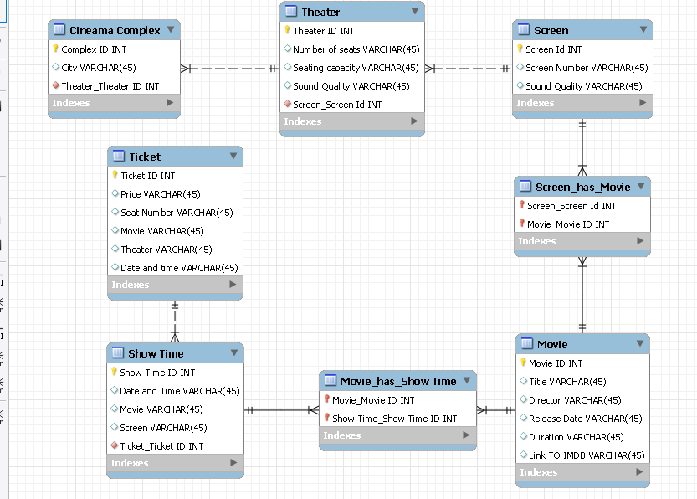

1. **List entities**, all the entities identified.

* Entity: **Cinema Complex**
  + Attribute: Complex ID
  + Attribute: City
  + Attribute: Address
  + Attribute: Phone number
  + Attribute: Email address
* Entity: **Theater**
  + Attribute: Theater ID
  + Attribute: Number of screens
* Entity: **Screen**
  + Attribute: Screen ID
  + Attribute: Screen Number
  + Attribute: Sound Quality
  + Attribute: Seating capacity
  + Attribute: Number of seats booked.
* Entity: **Movie**
  + Attribute: Movie ID
  + Attribute: Title
  + Attribute: Director
  + Attribute: Release date
  + Attribute: Duration
  + Attribute: Link to IMDB website
* Entity: **Showtime**
  + Attribute: Showtime ID
  + Attribute: Date and time
  + Attribute: Movie
  + Attribute: Screen
* Entity: **Ticket**
  + Attribute: Ticket ID
  + Attribute: Price
  + Attribute: Seat number
  + Attribute: Movie
  + Attribute: Theater
  + Attribute: Date and time

1. **Define relationships**, how the entities are related.

* Features, between movie and screen. One movie can be displayed on many screens.
* Scheduled at, between show time and screen. One show time scheduled on one screen.
* Plays between showtime and movie. One showtime plays one movie.

1. **Describe relationships**, in words.

**Features**, between movie and screen:

* Description: Each screen can show multiple movies and each movie can be shown on multiple screens. This describes how a movie is allocated to a screen within a cinema. This allows for scheduling of movies to screens based on showtime and availability.
* Cardinality: One screen features many movies and one movie features on many screens.

**Scheduled at**, showtime and screen:

* Description: Each showtime is scheduled on one screen and each screen can host multiple screen times. This means that each screen is assigned to a particular showtime. Each showtime is scheduled on one specific screen and each screen can host multiple showtimes during the day. It ensures that each movie has a certain time for its screening.
* Cardinality: One movie on many screens and one screen hosts multiple showtimes.

**Plays**, showtime and movie:

* Description: Each showtime features one movie and each movie can feature on multiple showtimes. That means which movie is being played during a particular showtime. It allows staff and customers to see which movie is being shown during a specific time.
* Cardinality: On show time plays one movie, one movie is played on many show times.

1. **Cardinality**, how many instances of one entity. A movie has 1 director, but the director can have many movies.
   1. Each cinema complex has many theaters, but each theater can only belong to one cinema complex.
   2. Each theater has many screens, but each screen can only belong to one theater.
   3. Each screen can display multiple movies and each movie can be displayed on multiple screens.
   4. Each movie can have multiple showtimes, but only one movie can be displayed on one screen at a time.
   5. Each customer can only have one ticket to a screening but can have multiple tickets to multiple screenings at different times.

These relationships clarify how the entities in the cinema’s management interact with each other. This ensures that the movies are assigned to screens, showtimes are allocated to screens, movies are being played during showtimes and customer tickets.

1. **Use a CASE tool**, Computer Aided Software Engineering.

Please see the separate file.

New Horizons Cinemas MySQL Workbench.mwb

