**PHYS 8750**

**HW1**

**Due September 3, 2020**

1. Consider backward-Euler differencing and trapezoidal differencing schemes for the damping-oscillation problem:

1) Estimate the order of accuracy for these two difference schemes.

2) Derive A-stability criteria for these two difference schemes, compare your results with the figure below.

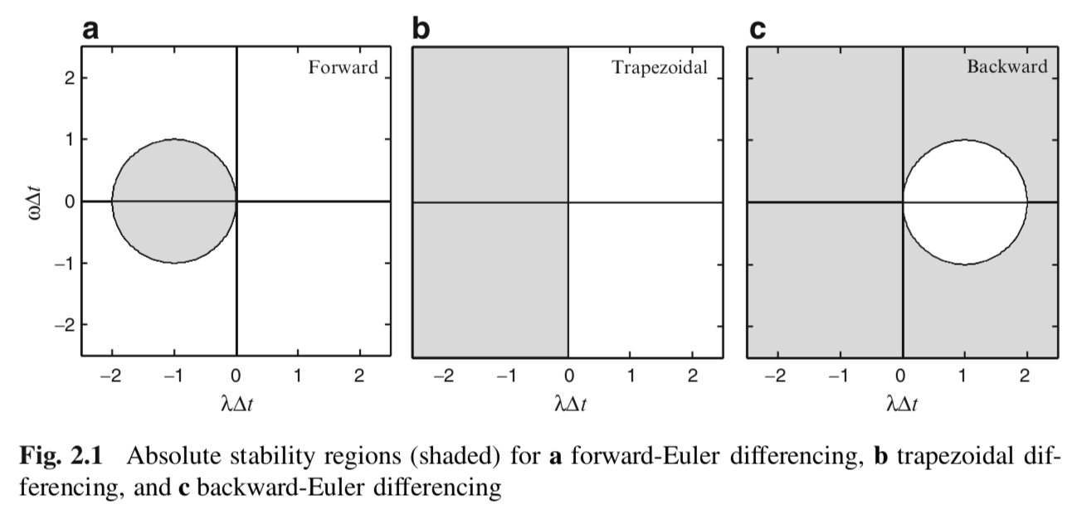

2. Modify the code (AStabilityConvergence_ODE_FT.m) and make it work for backward differencing schemes. Choose different $∆t$ and compare which one leads to the best convergence, which ones leads to unstable solution (you may refer to the matlab code provided).

3. Modify the code (AStabilityConvergence_ODE_FT.m) and make it work for trapezoidal differencing schemes. Choose different $∆t$ and compare which one leads to the best convergence, which ones leads to unstable solution (you may refer to the matlab code provided). In this case, try positive .

4. Compare with forward, backward and trapezoidal schemes, and discuss what you find.