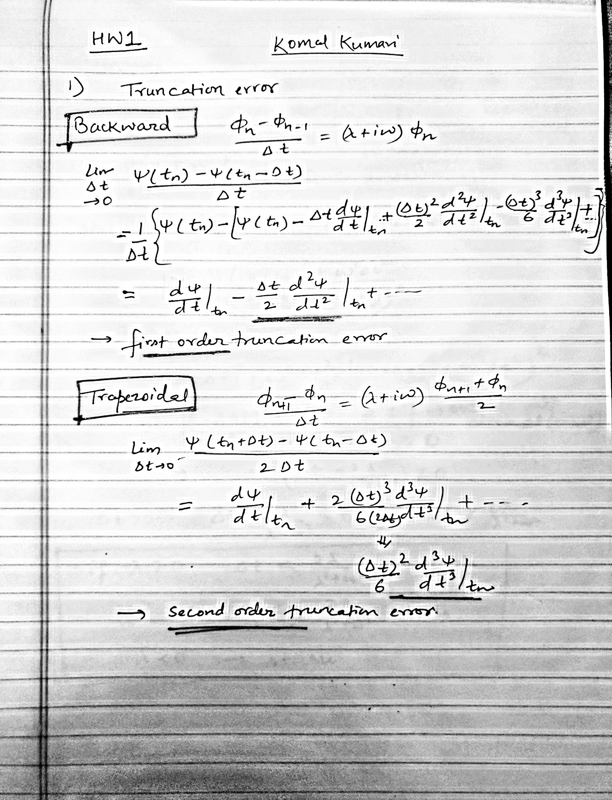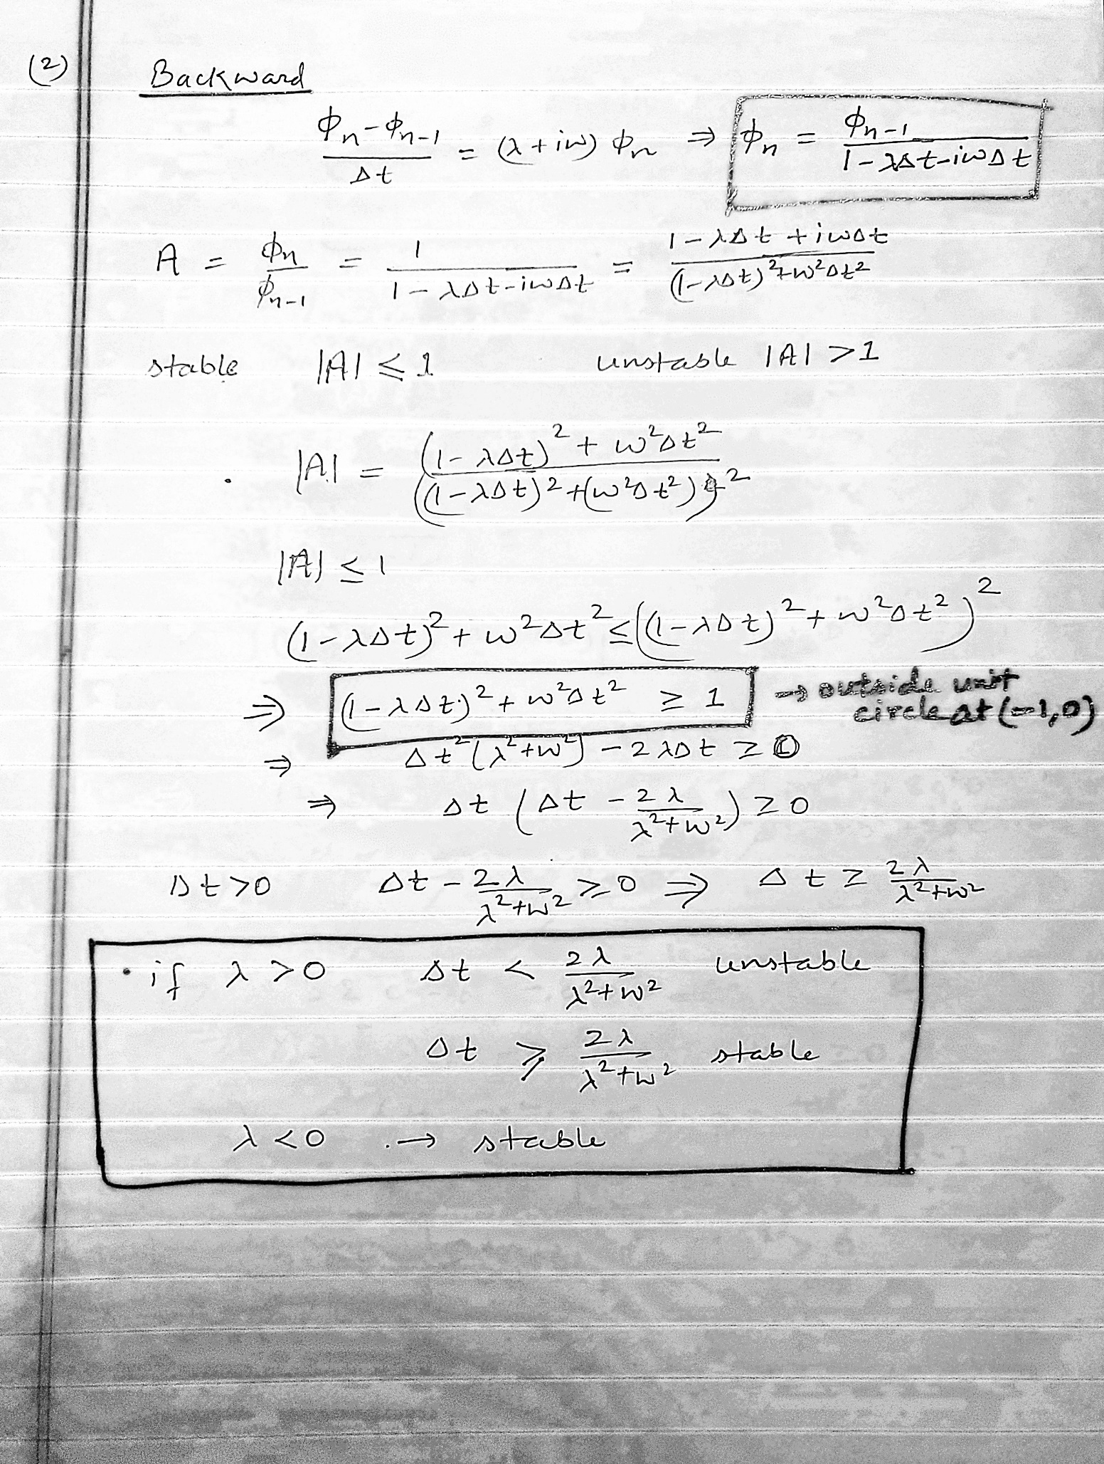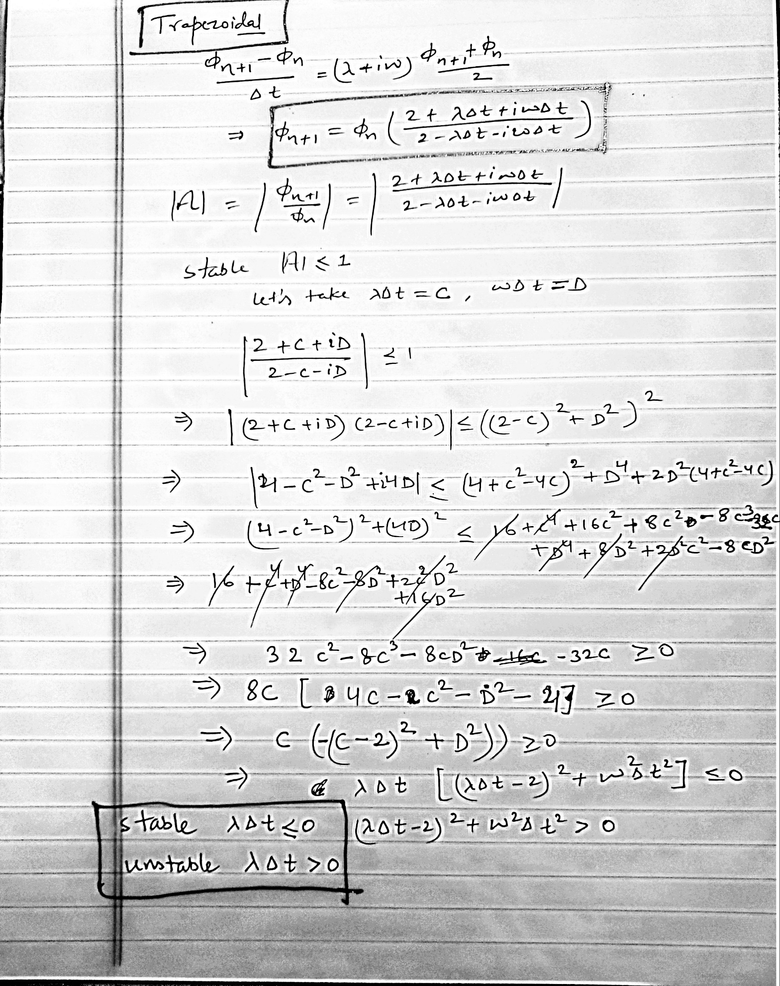

3. Backward (top) and Trapezoidal (bottom):

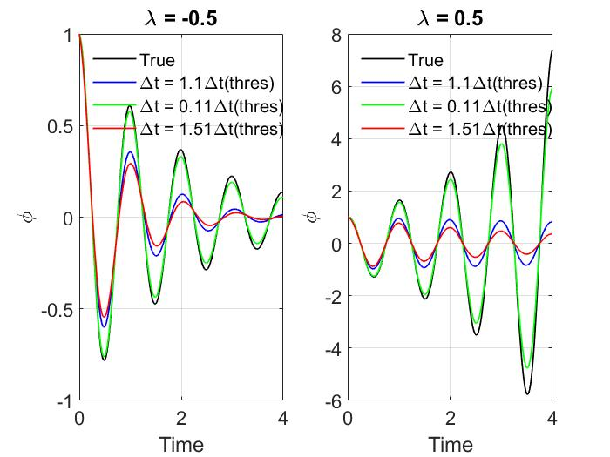

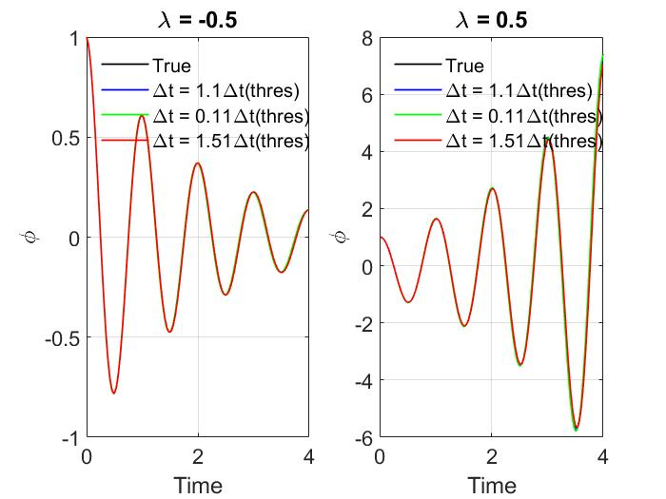

Backward-

For λ>0, 1.1Δt and 1.51Δt are stable while 0.11Δt is unstable. All choices of Δt for λ<0 provides stable solution shown in top plot, which is consistent to the findings regrading A-stability condition for backward scheme shown in second part.

Also, the findings looked opposite to forward differencing scheme.

Trapezoidal-

As shown in the second part regarding A-stability condition in trapezoidal scheme, we found the stable condition for λ<0 while unstable for λ>0 which is also reflected in the bottom plot.

The accuracy is better than both forward and backward differencing scheme due to second order truncation error.