**PHYS 8750**

**HW4**

**2D-Advection (Chapter 4.2)**

**Due October 22, 2020**

1. 1) Derive the truncation error using the forward-in-time and upstream scheme to solve the 2-D advection problem:

$$\frac{∂ψ}{∂t}+U\frac{∂ψ}{∂x}+V\frac{∂ψ}{∂y}=0$$

Explain where the distortion of the solution comes from.

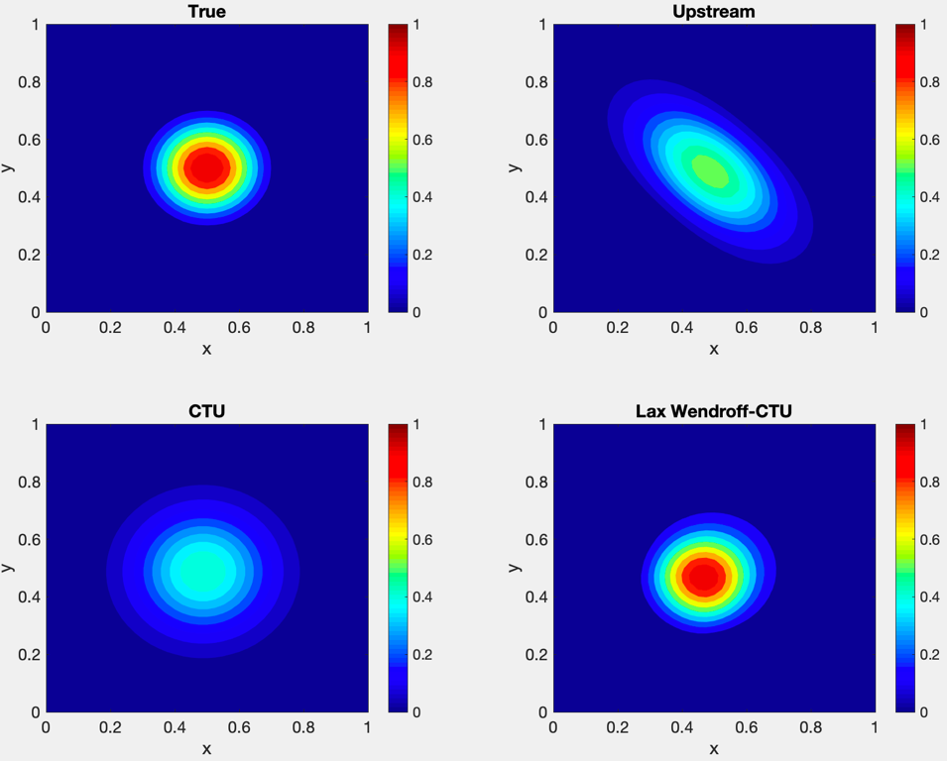

2) Derive the truncation error of the Corner Transport Upstream (CTU) method and explain how it helps the problem of the upstream case and what is the shortage of CTU itself.

3) Discuss why Lax-Wendroff + CTU gives the best solution for the 2-D advection problem (constant wind speeds).

*Note: please show the details of your work.*

2. Run the code “Advection_2D_MethodComp.m” and practice and answer the following questions:

1) Change $μ$ and $ν$ (mu and nu in code) from 0.5 to 0.6, and comment on what you obtain.

2) Open Question: modify the codes to fourth-order Takacs scheme or using fourth-derivative spatial filtering to Lax-Wendroff+CTU scheme. Any improvement to remove the small ripples?

If not, any ideas about the possible strategy to achieve the goal?

3. Modify the code “ShallowWater_PDE_Stagger_HW.m” and make it to store u at even time levels and store h at odd time levels. Any differences observed with the results from the original code?