**FastAPI**

**操作**

echo "# Linux_1114572" >> README.md

git init

git add README.md

git add main.py

git commit -m "first commit"

git branch -M main

git remote add origin https://github.com/Xiang0128/Linux_1114572.git

git push -u origin main

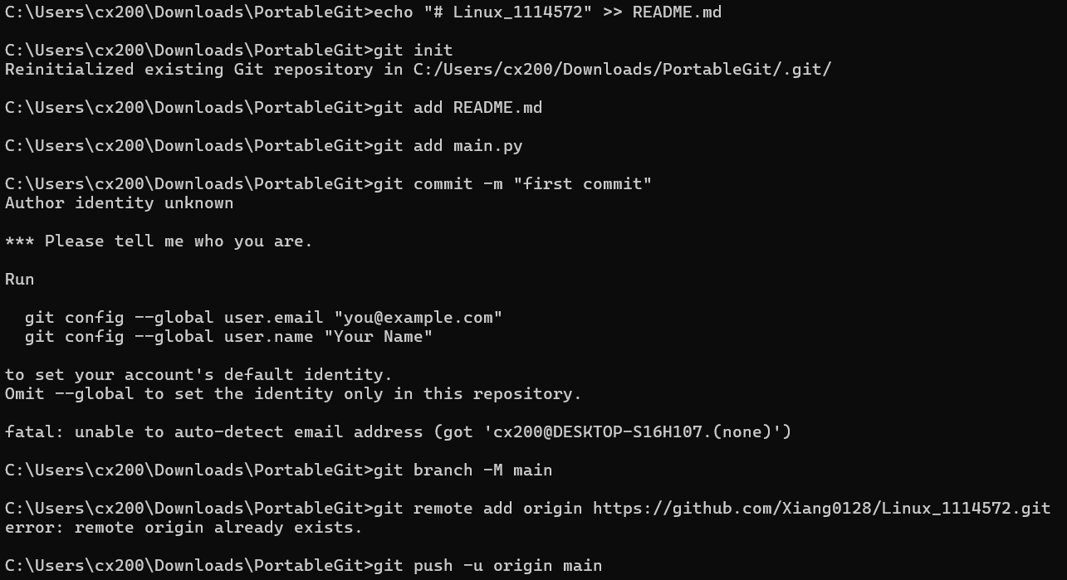

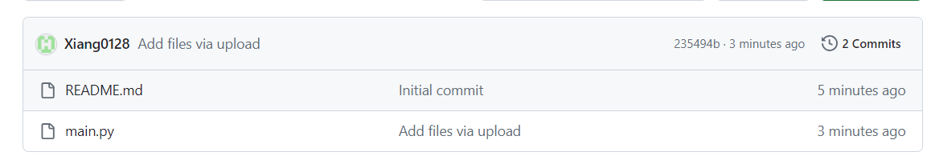

sudo apt-get install git

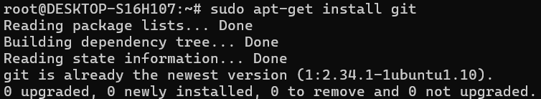

mkdir var

cd var

mkdir www

cd www

mkdir html

cd html

git clone https://github.com/Xiang0128/1114572Linux.git

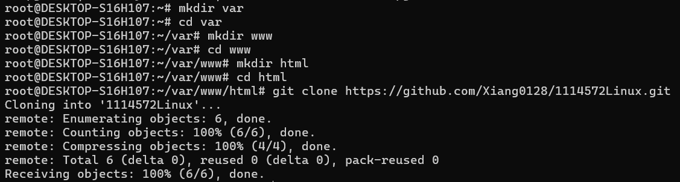

sudo apt install python3-venv

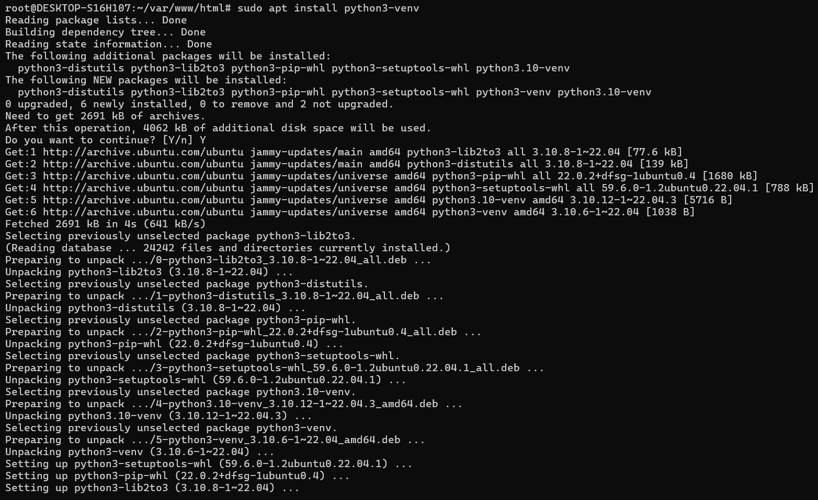

python3 -m venv env

source ./env/bin/activate

pip3 install fastapi

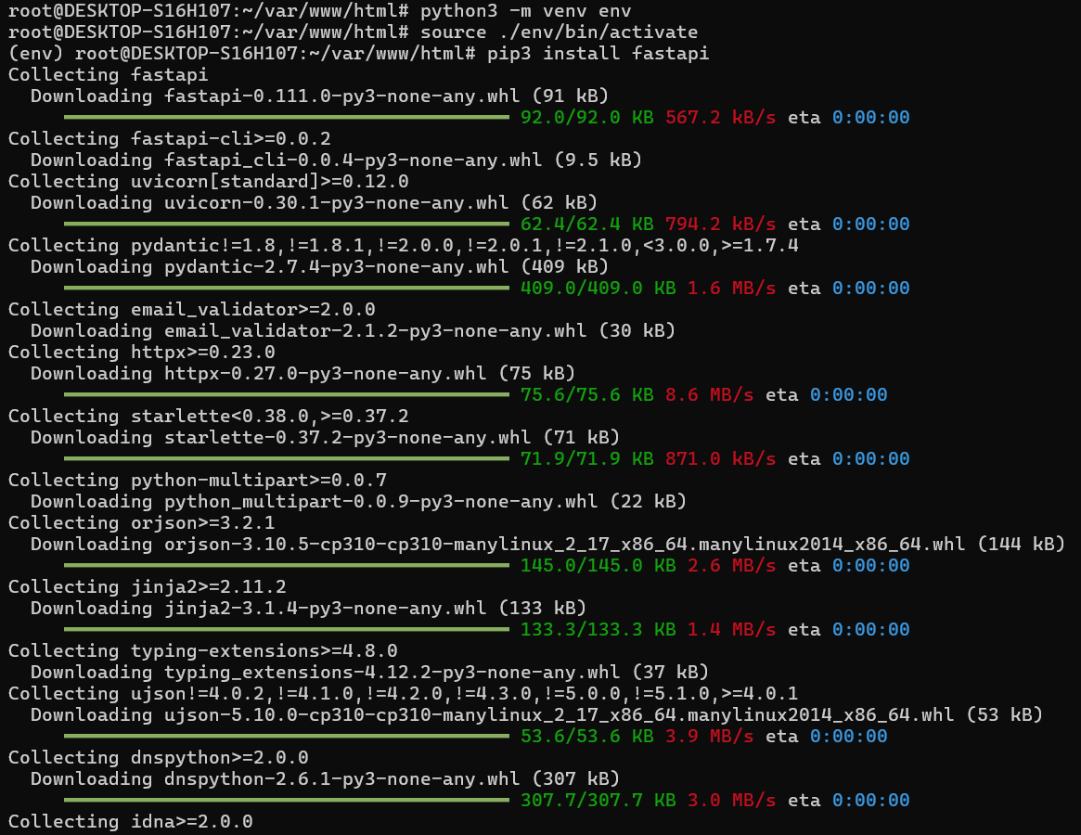

pip3 install uvicorn==0.16.0

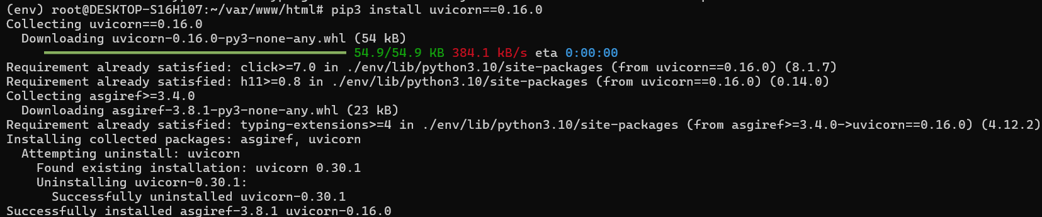

apt install unicorn

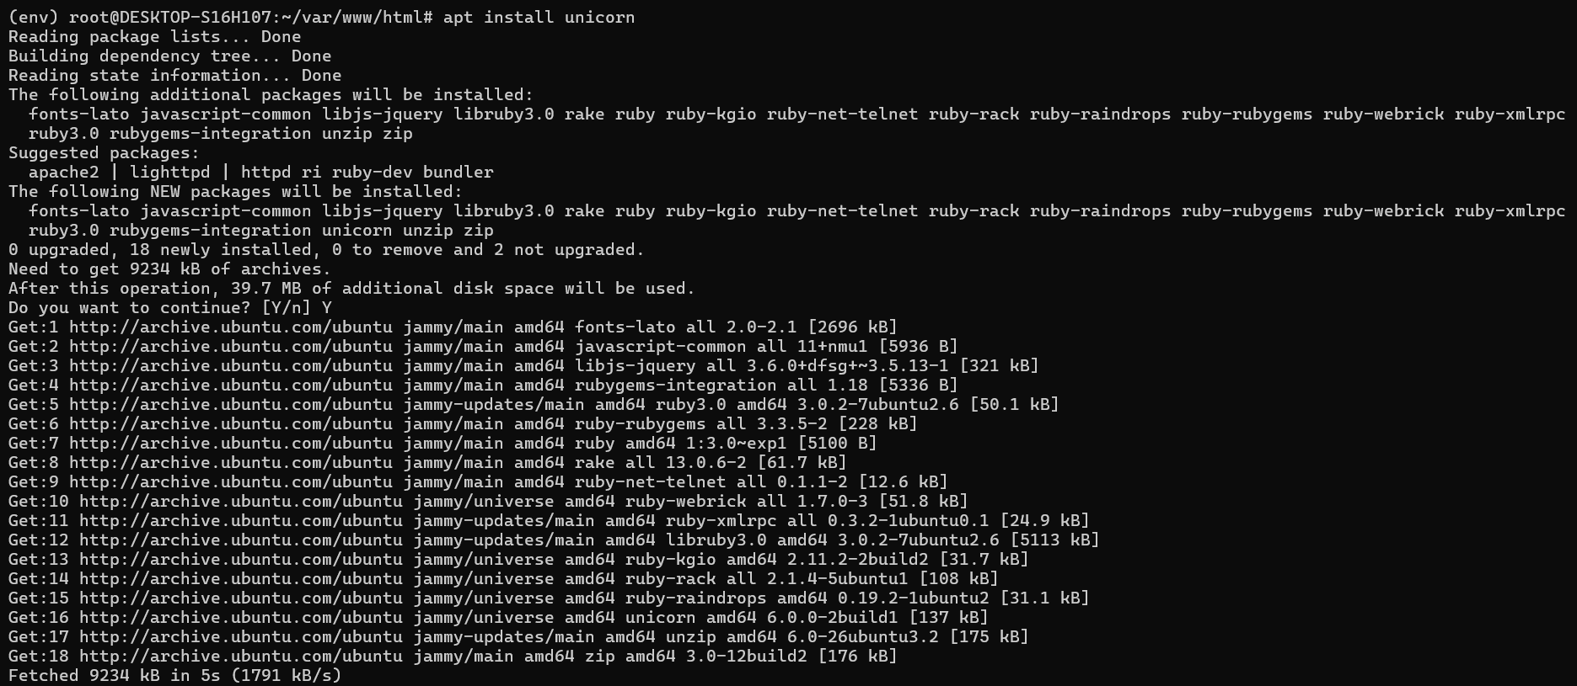

deactivate

apt install unicorn

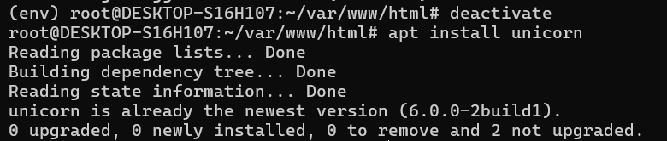

apt install python3-pip

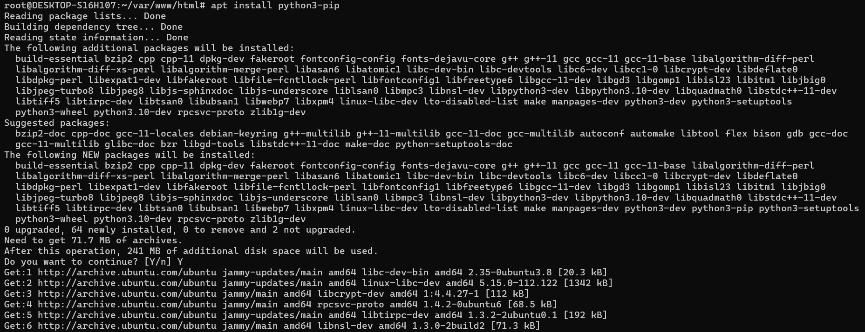

pip3 install uvicorn==0.16.0

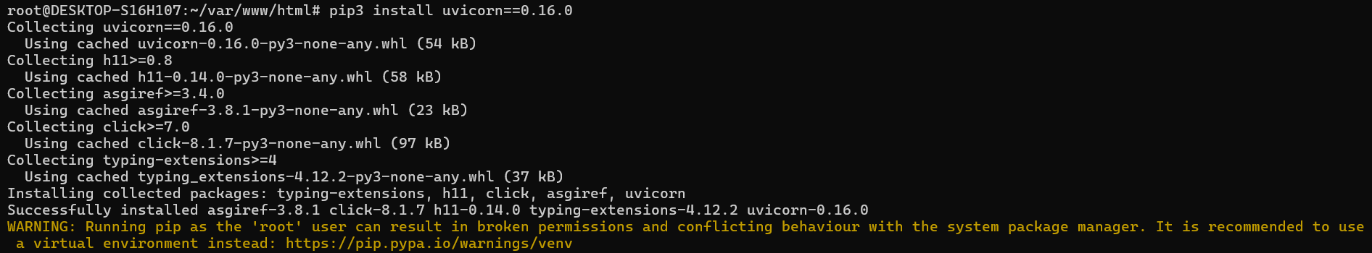

pip install fastapi uvicorn

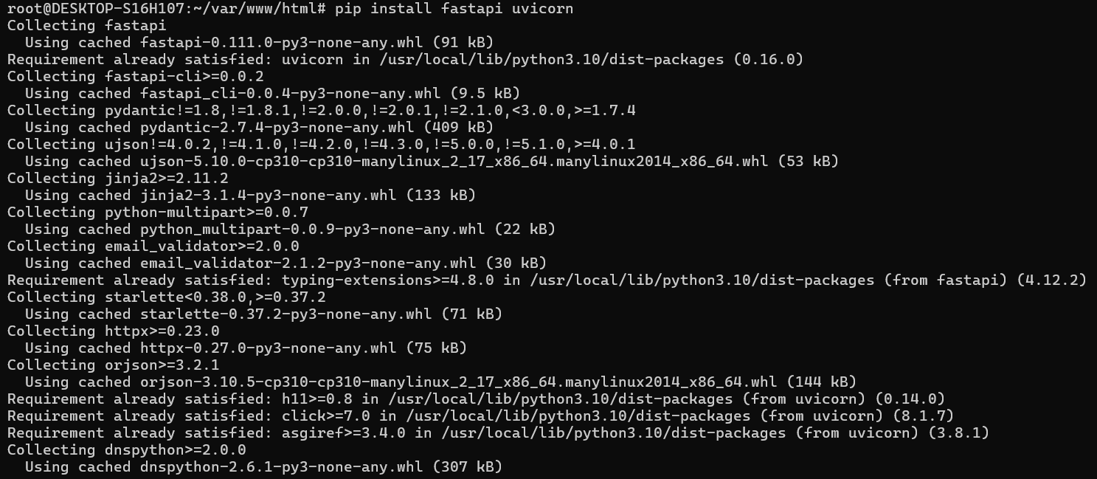

cd 1114572Linux

apt install unicorn

pip3 install uvicorn==0.16.0

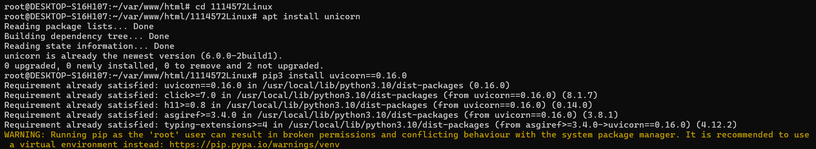

pip install fastapi uvicorn

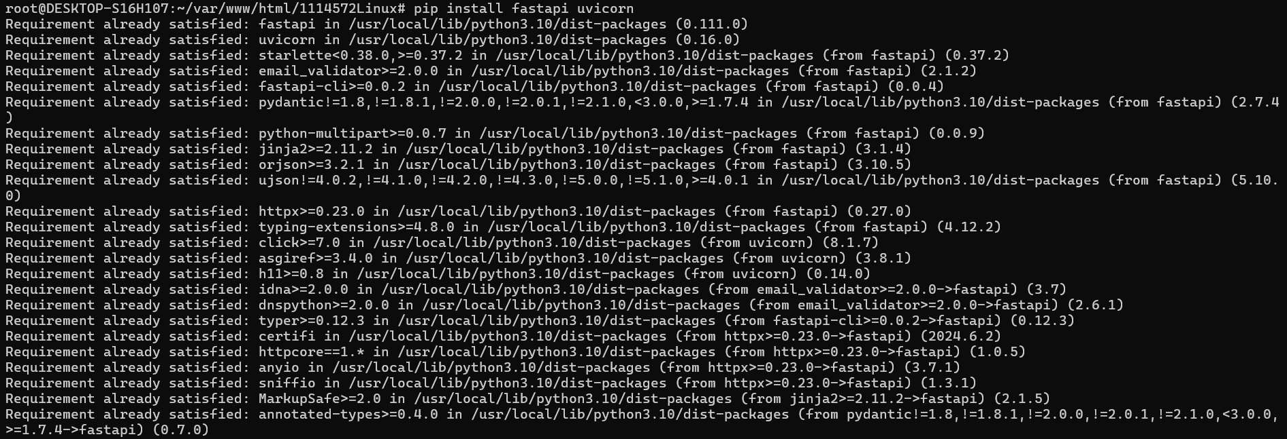

uvicorn main:app

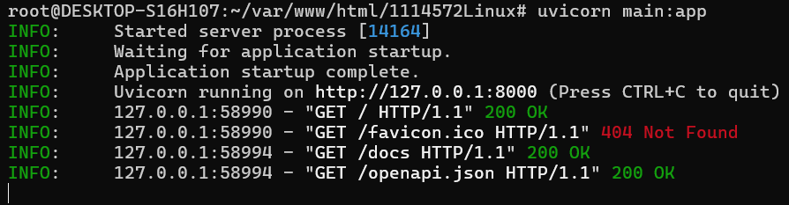

瀏覽器輸入以下網址：

http://127.0.0.1:8000/docs#

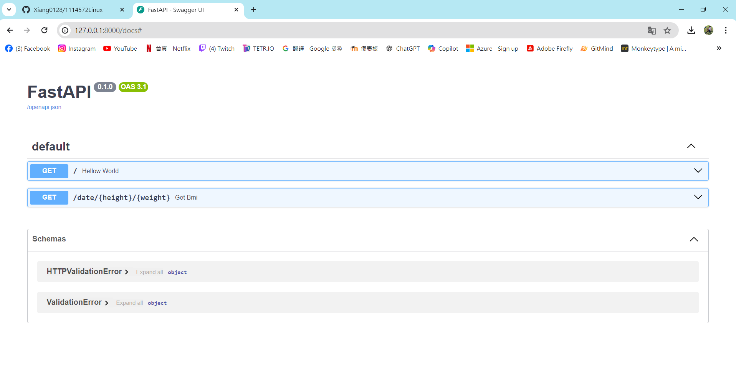

**Wordpress**

**操作**

sudo apt update && sudo apt upgrade

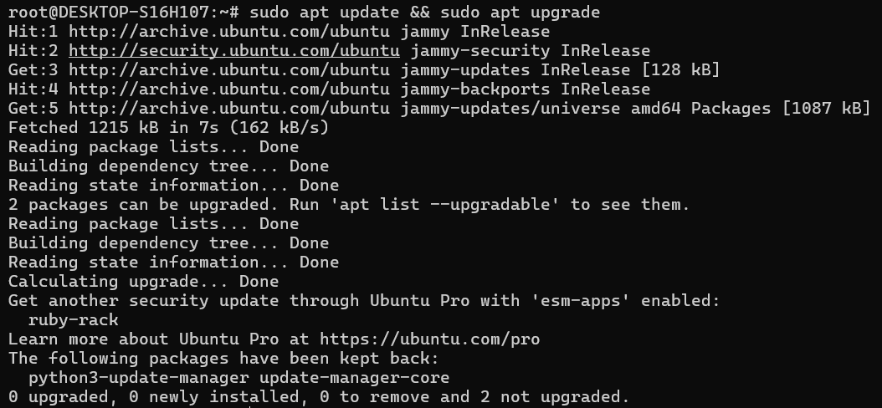

sudo apt install apache2 mysql-server php libapache2-mod-php php-mysql

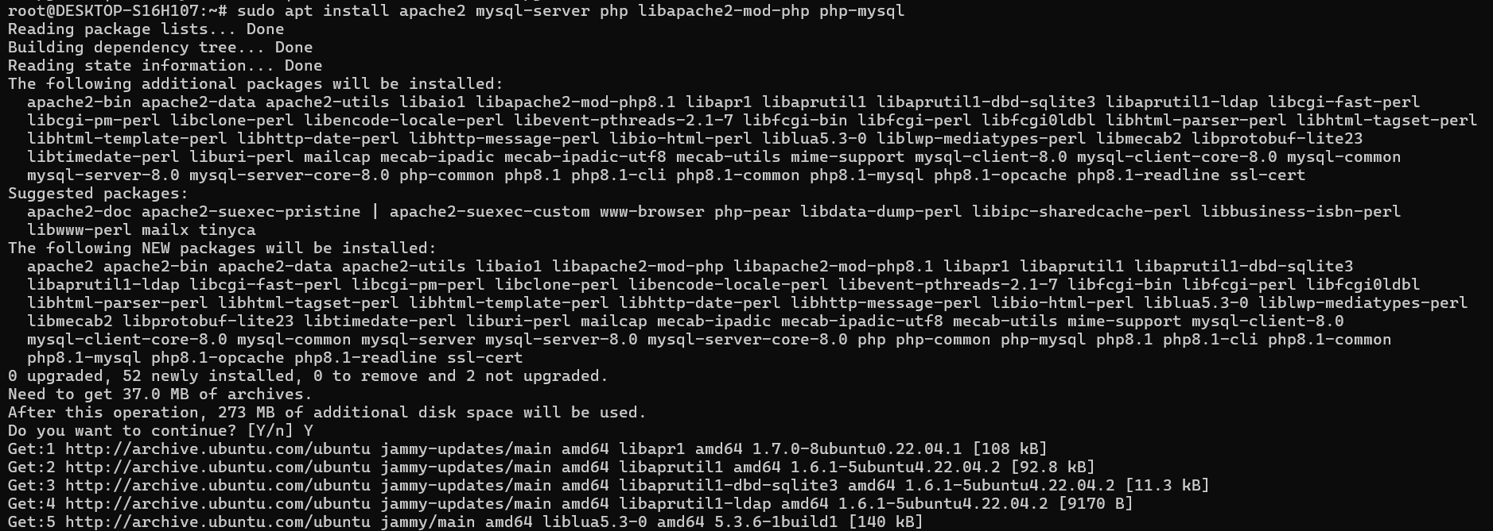

sudo nano /var/www/html/info.php



輸入：

<?php

phpinfo();

?>

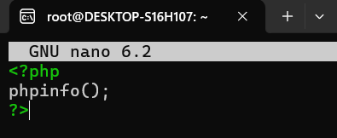

sudo apt install phpmyadmin

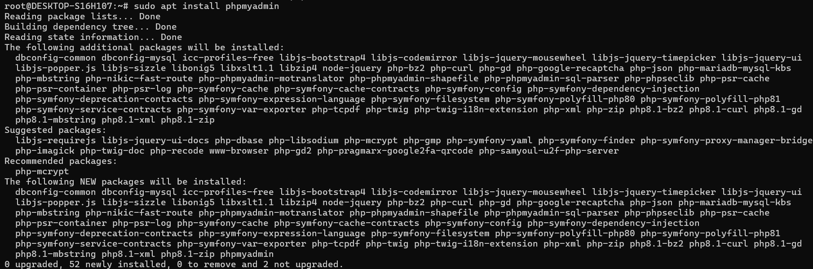

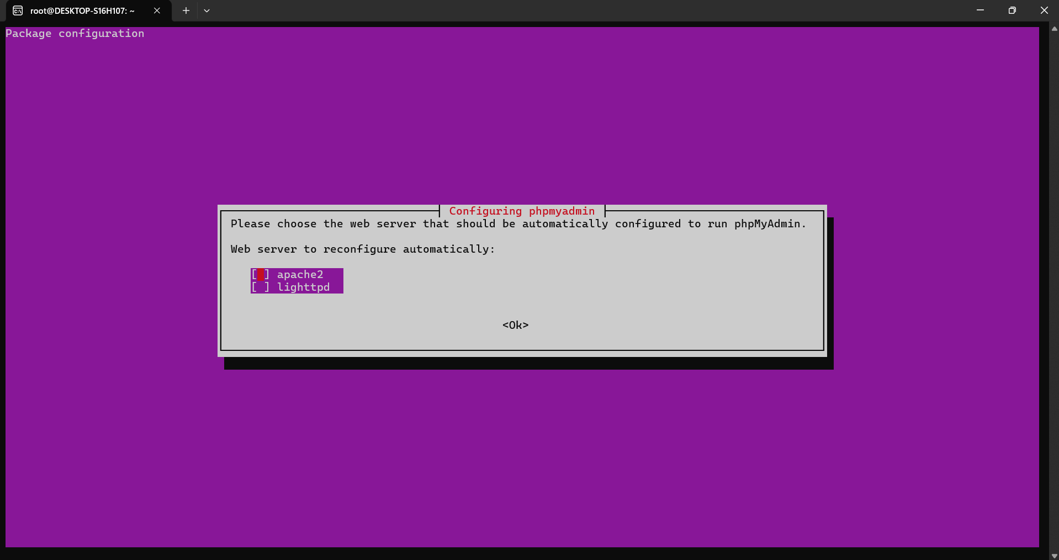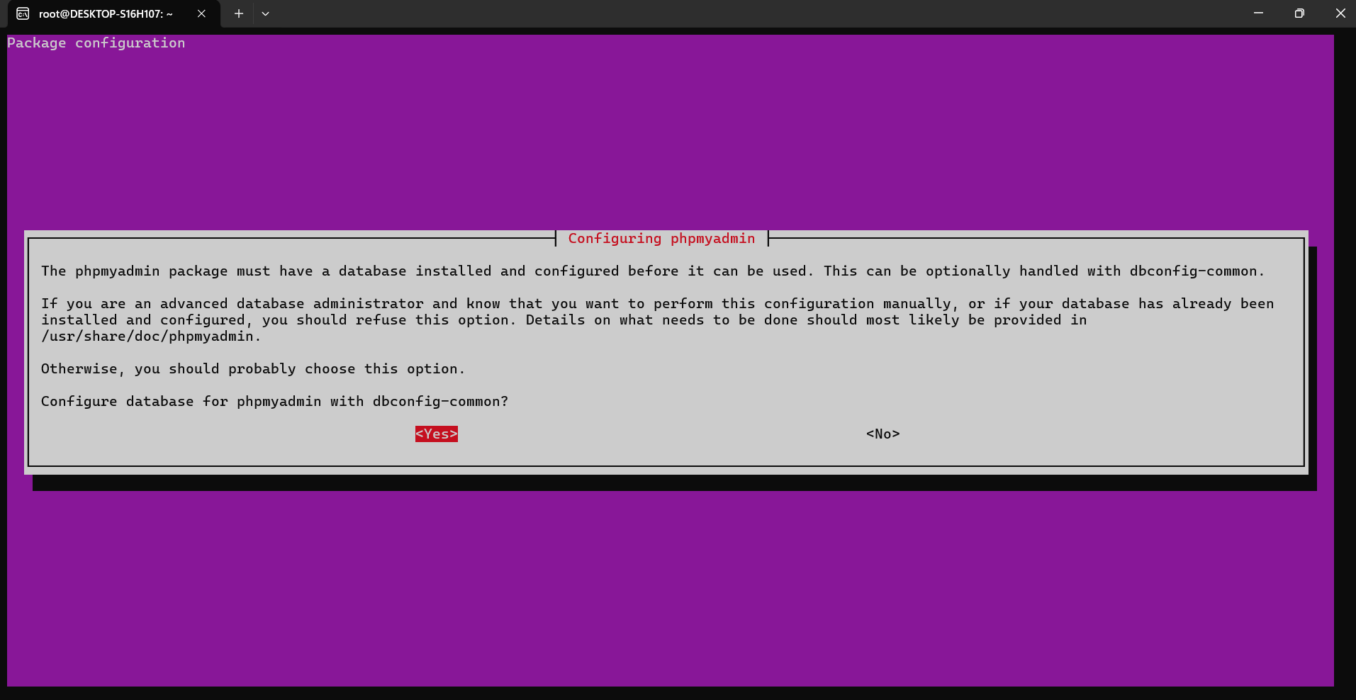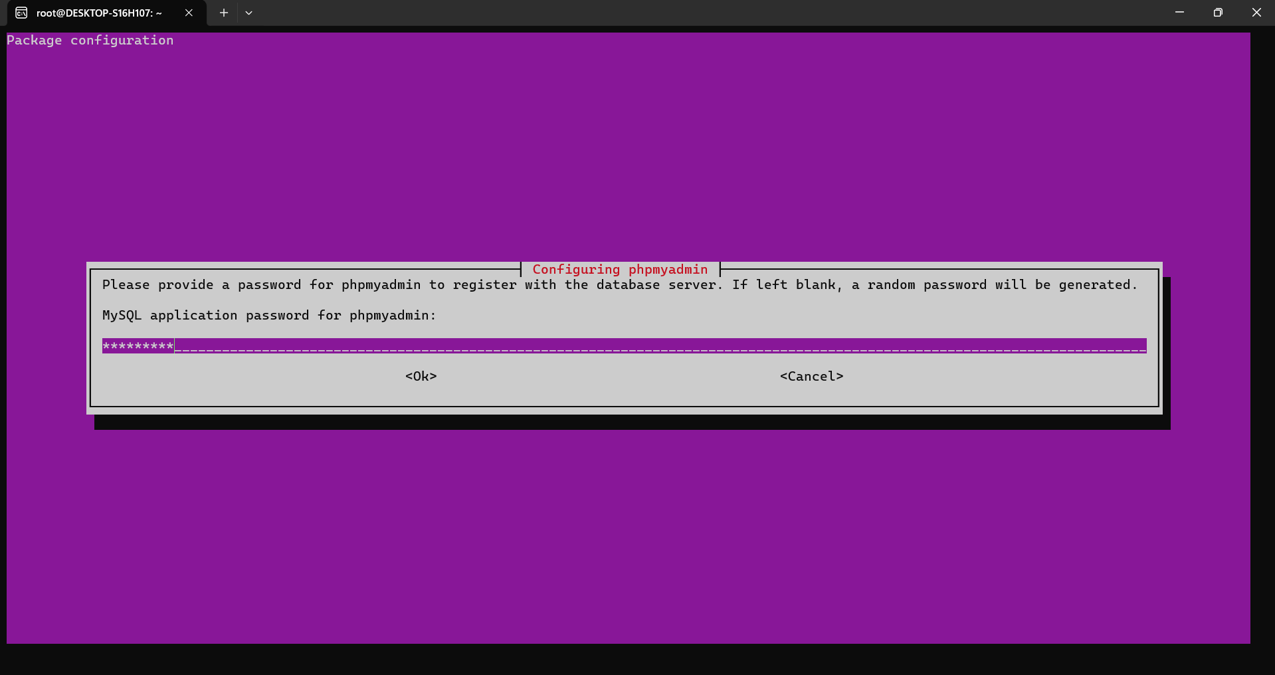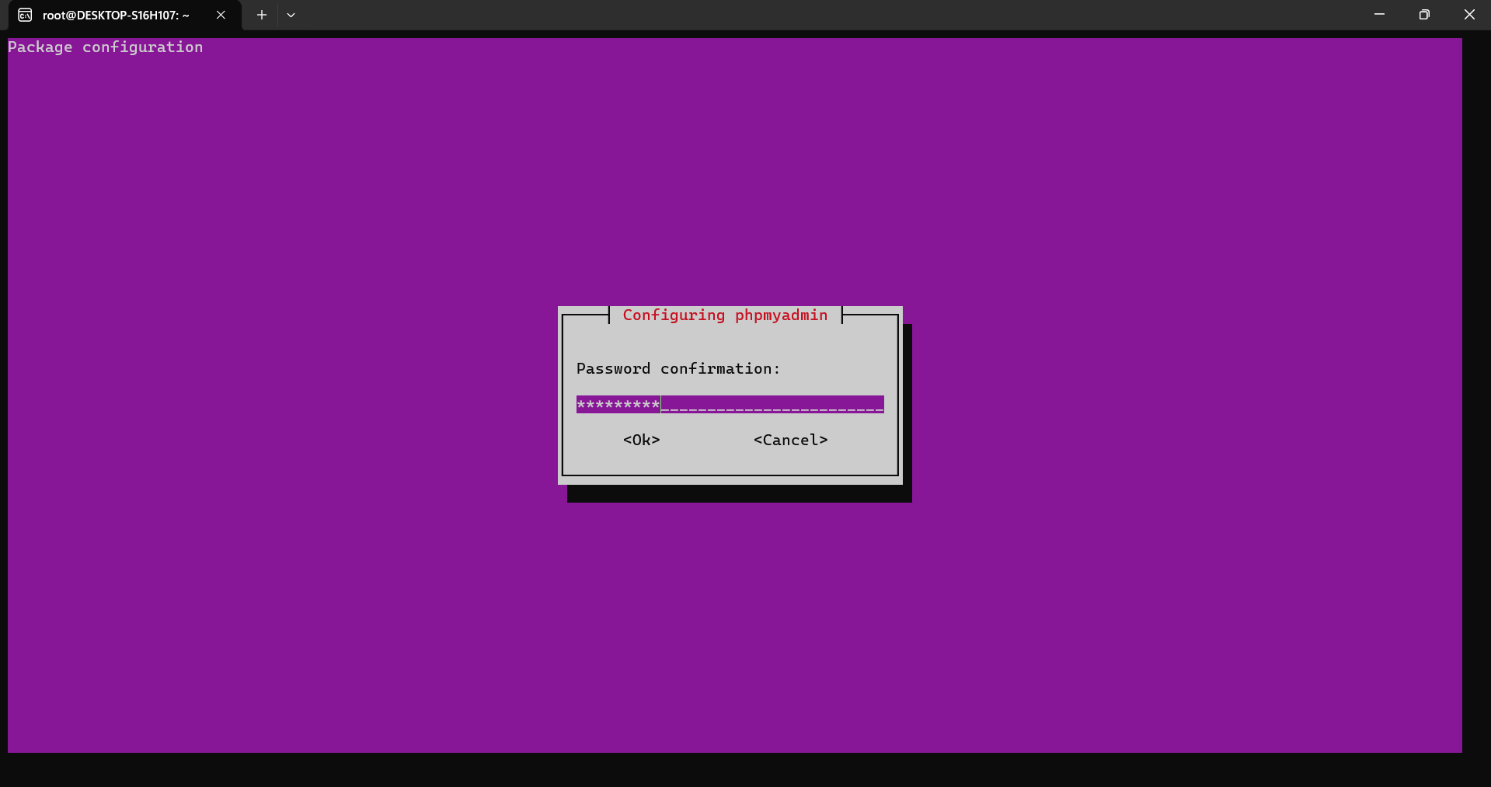

sudo mysql -u root mysql

UPDATE user SET plugin='mysql_native_password' WHERE User='root';

FLUSH PRIVILEGES;

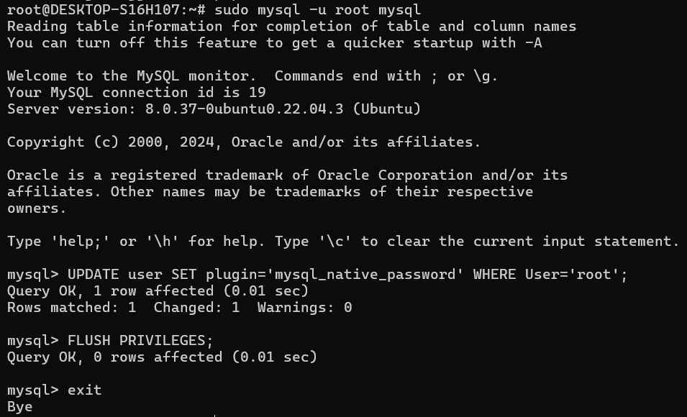

sudo mysql_secure_installation

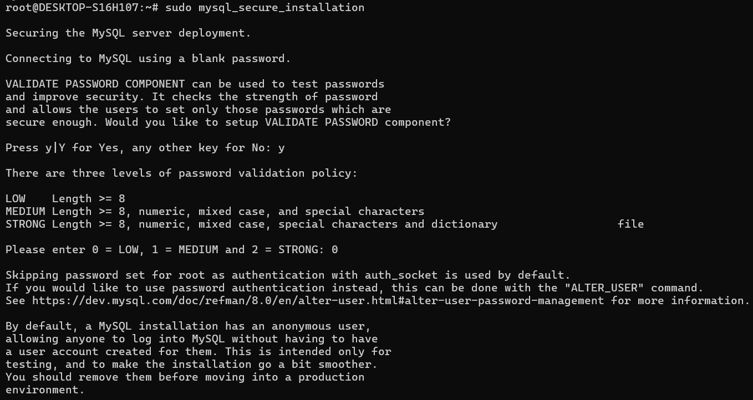

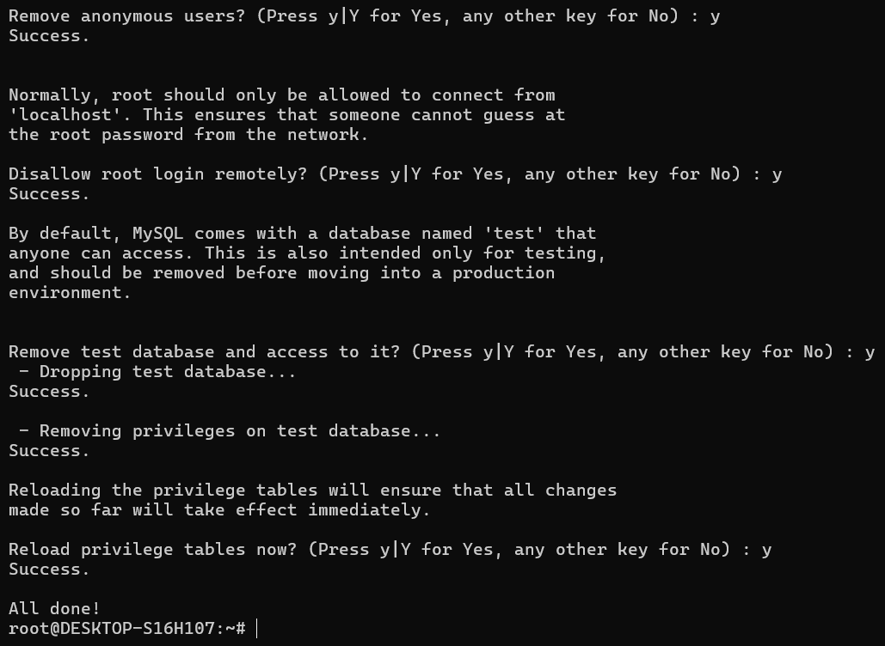

sudo mysql -u root -p

CREATE DATABASE wordpress CHARACTER SET utf8 COLLATE utf8_unicode_ci;

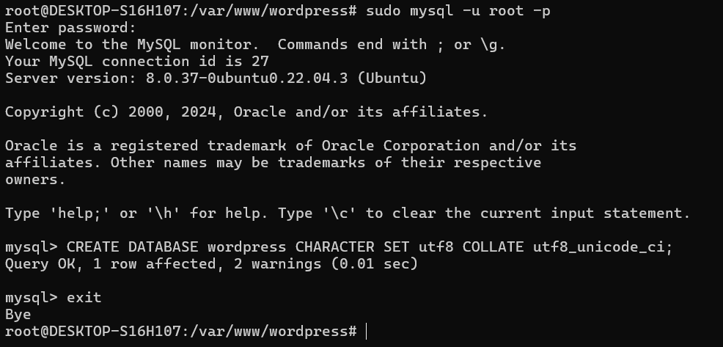

wget https://tw.wordpress.org/wordpress-6.0.1-zh_TW.tar.gz

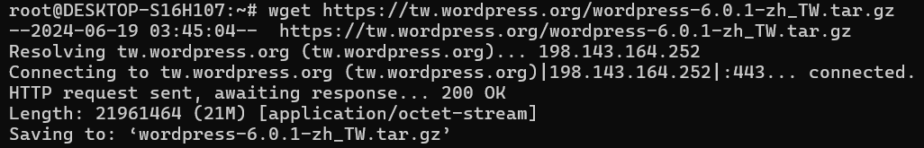

tar -zxvf wordpress-6.0.1-zh_TW.tar.gz

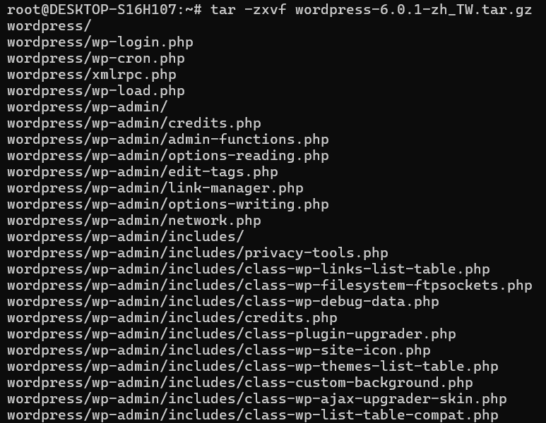

sudo cp -r wordpress /var/www/



cd /var/www/wordpress

sudo nano /etc/apache2/sites-available/000-default.conf



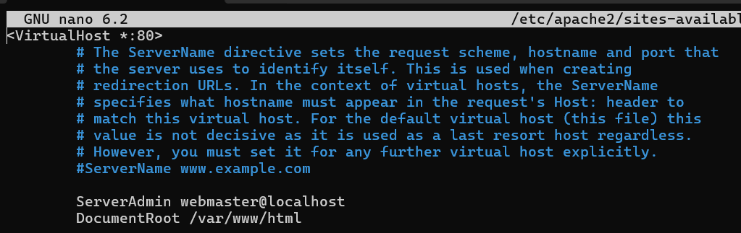

將/var/www/html改為/var/www/wordpress

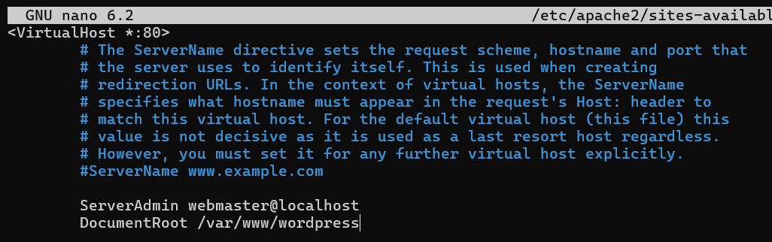

sudo service apache2 restart



hostname -I



瀏覽器輸入以下網址：

http://172.30.123.110/wp-admin/setup-config.php

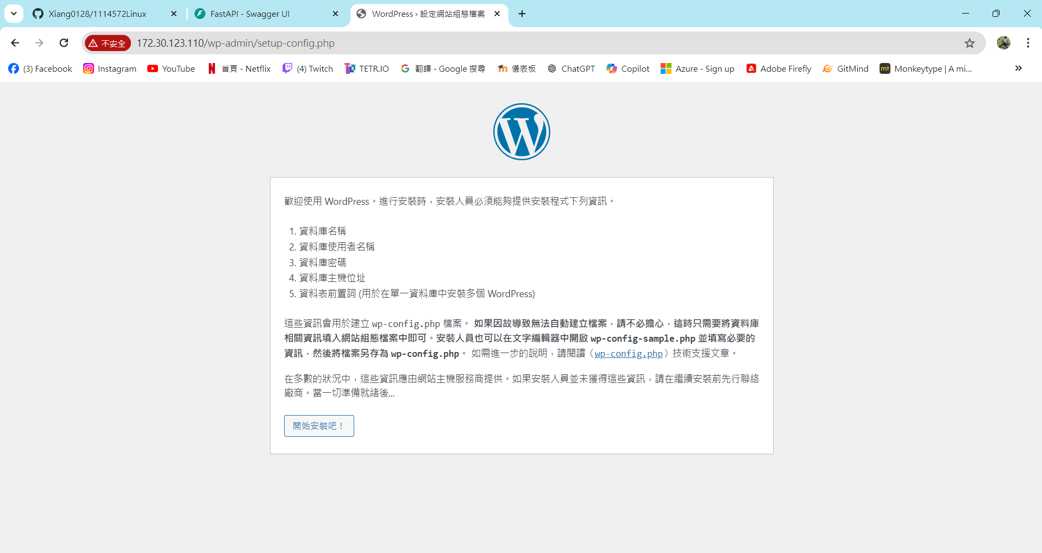

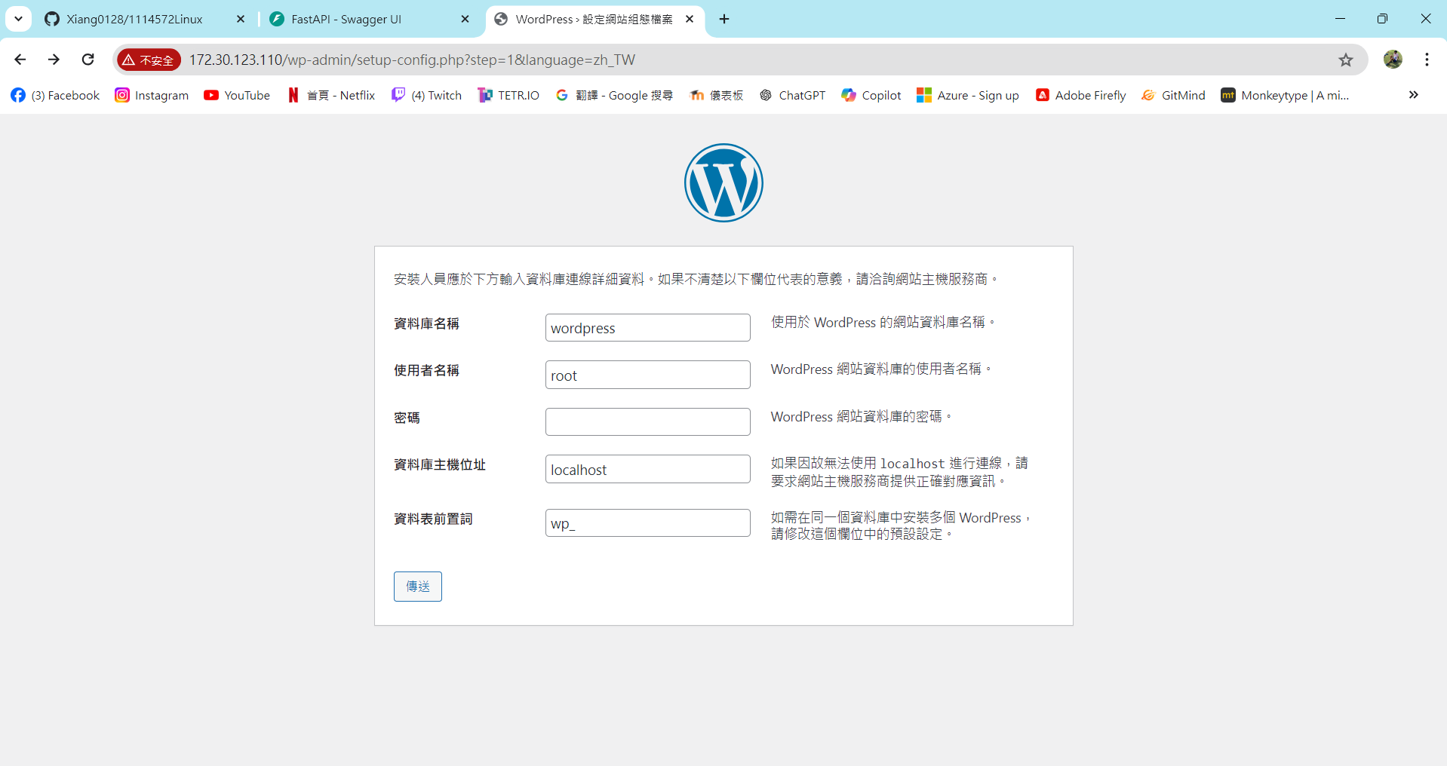

sudo nano /var/www/wordpress/wp-config.php



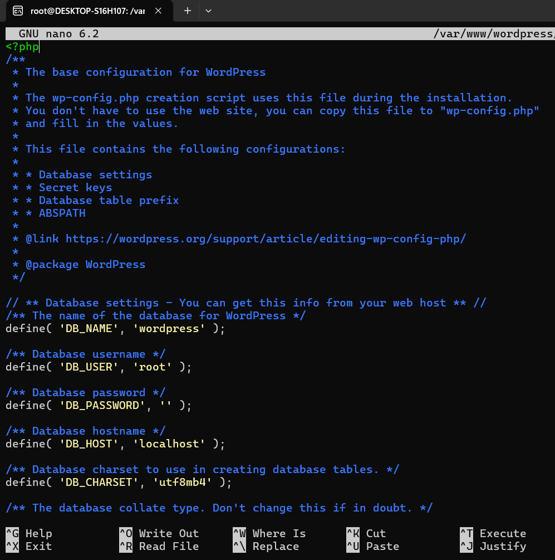

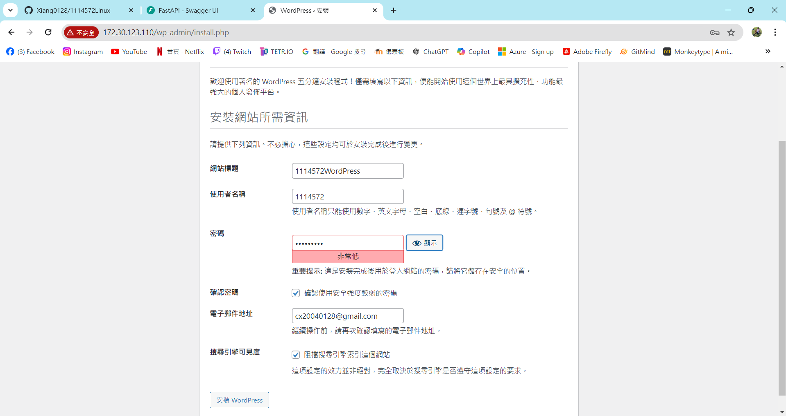

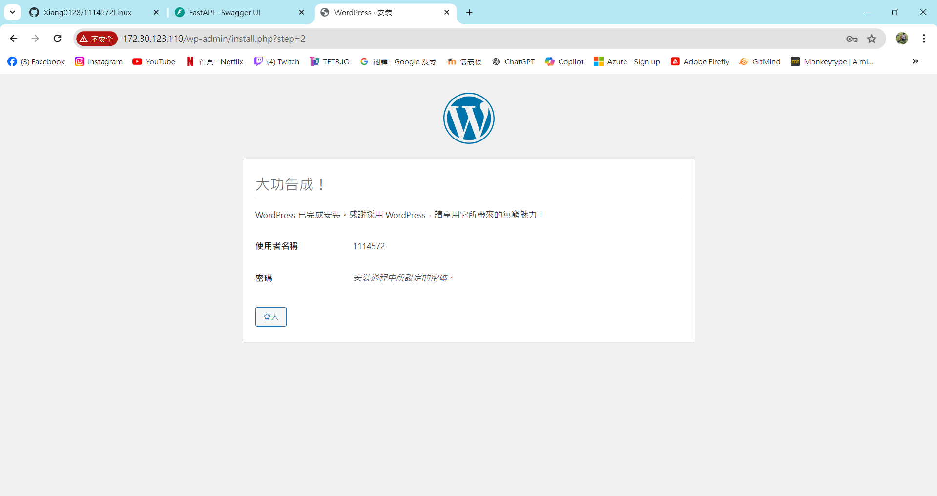

**登入WordPress**

