1.

Ans：vim ~/myname.txt

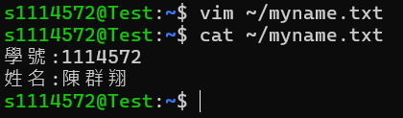

(a) Ans：file /etc/passwd /etc/pam.d /etc/rc0.d /dev/vcs >> myname.txt

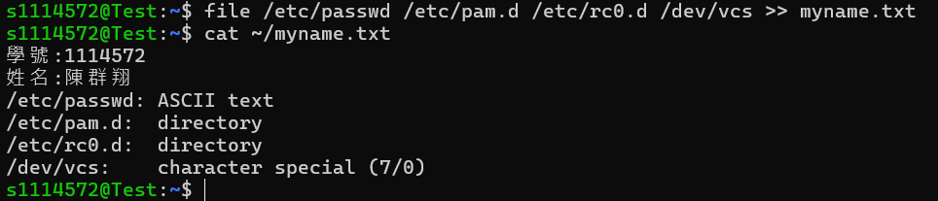

(b) Ans：ll -d /etc/????? >> myname.txt

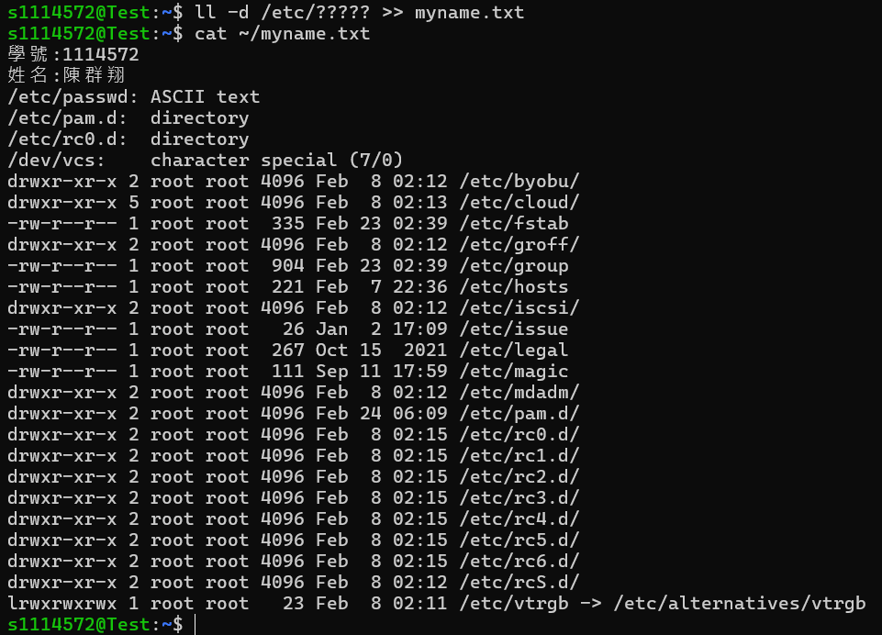

(c) Ans：(1) ll -d /etc/*[0-9]*[0-9]* (2) file /etc/*[0-9]*[0-9]*

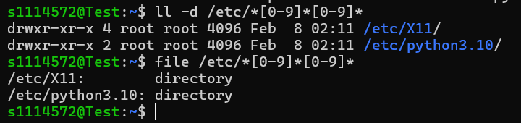

2.

Ans：(1) sudo mkdir /opt/-newdir (2) sudo rm -r /opt/-*

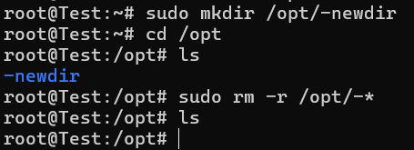

3.

Ans：(1) mkdir class03 (2) cd class03

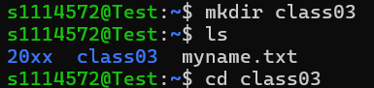

a. Ans：

touch mytest_{class1,class2,class3}_{week1,week2,week3}_{one,two,three,four}.txt

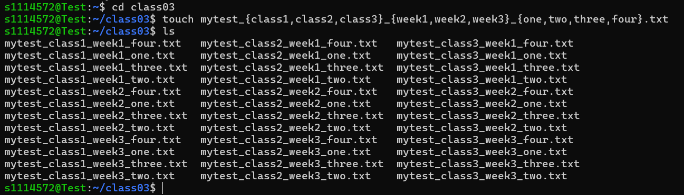

b. Ans：

(1) mkdir class1/ (2) mkdir class1/week2 (3) cp *class1_week2* class1/week2

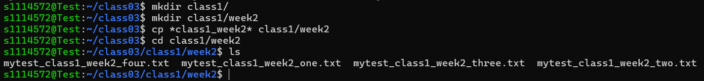

c. Ans：

mv *class1*.* class1/

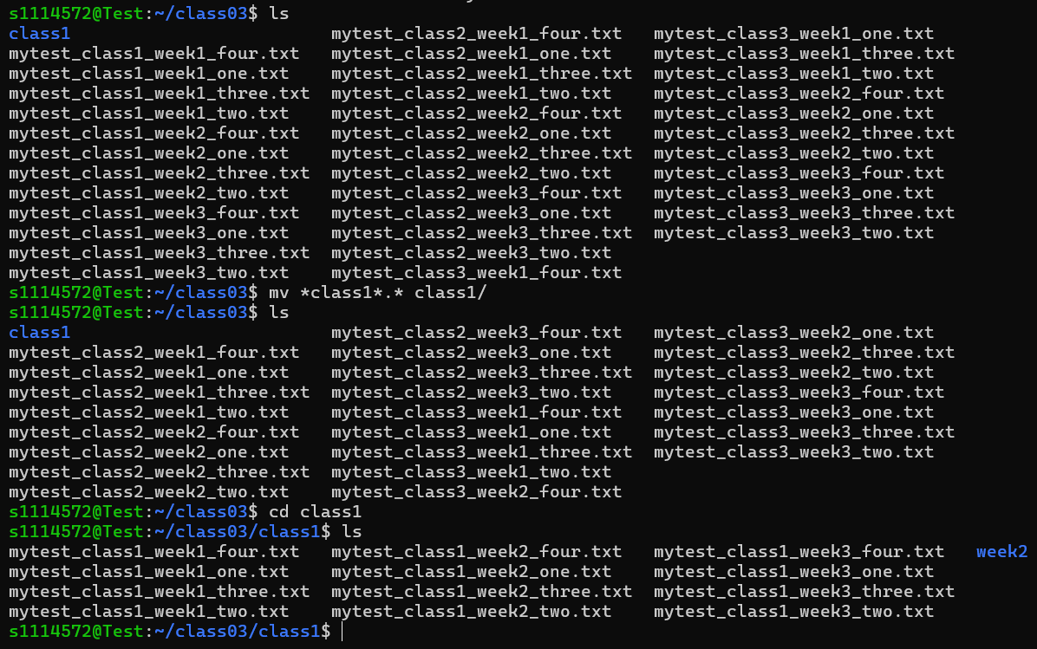

d. Ans：(1) mkdir one (2) mv *one*.* one

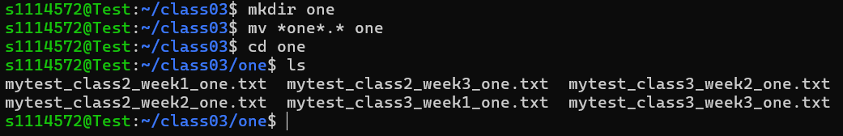

e. Ans：(1) mkdir others (2) mv *mytest*.* others

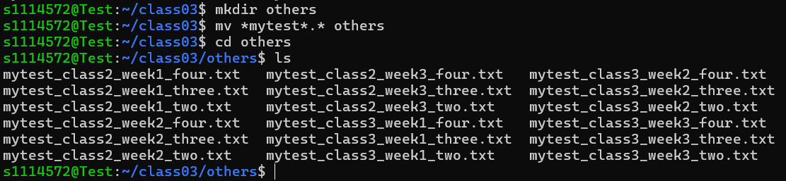

4.

Ans：(1) mkdir userid (2) cd userid (3) mkdir ksuid0{01..20}

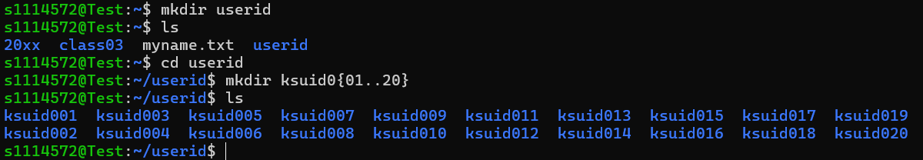

5.

a. Ans：(1) mkdir ./-myhome (2) cp .b* ./-myhome

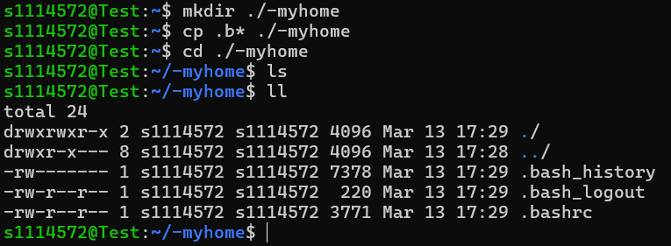

b. Ans：cp -r /etc/systemd .

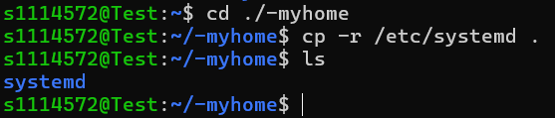

c. Ans：rm -rf systemd/network

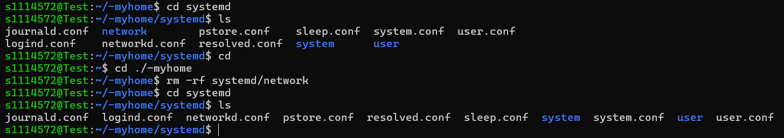

d. Ans：(1) tail -n 5 /etc/profile >> myetc.txt (2) tail -n 5 /etc/services >> myetc.txt

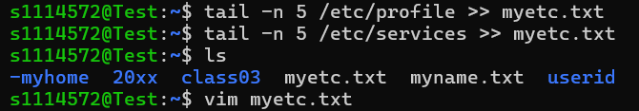

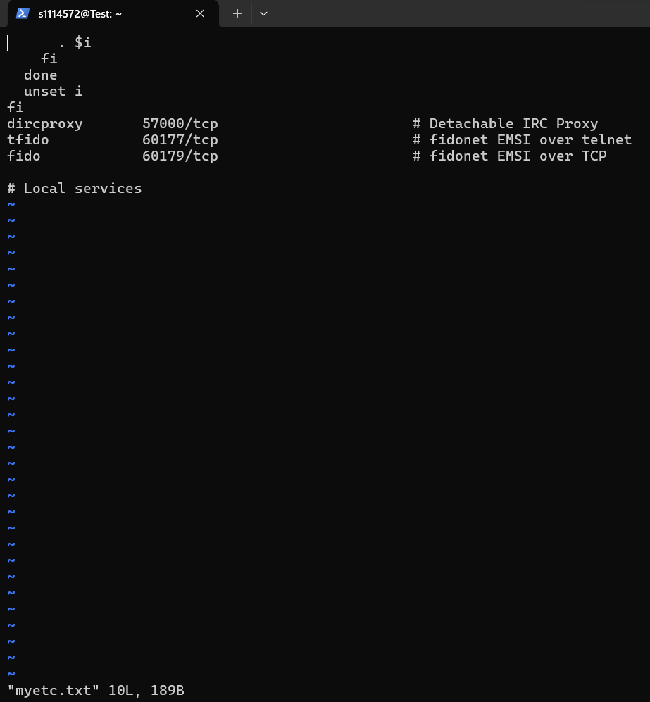

e. Ans：(1) cp myetc.txt myetc2.txt (2) vim myetc2.txt

操作：

(1) 按 i 加入 I can use vim 的文字

(2) 按esc

(3) 按：wq!

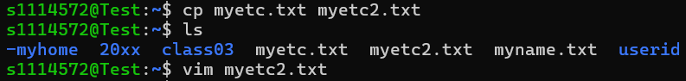

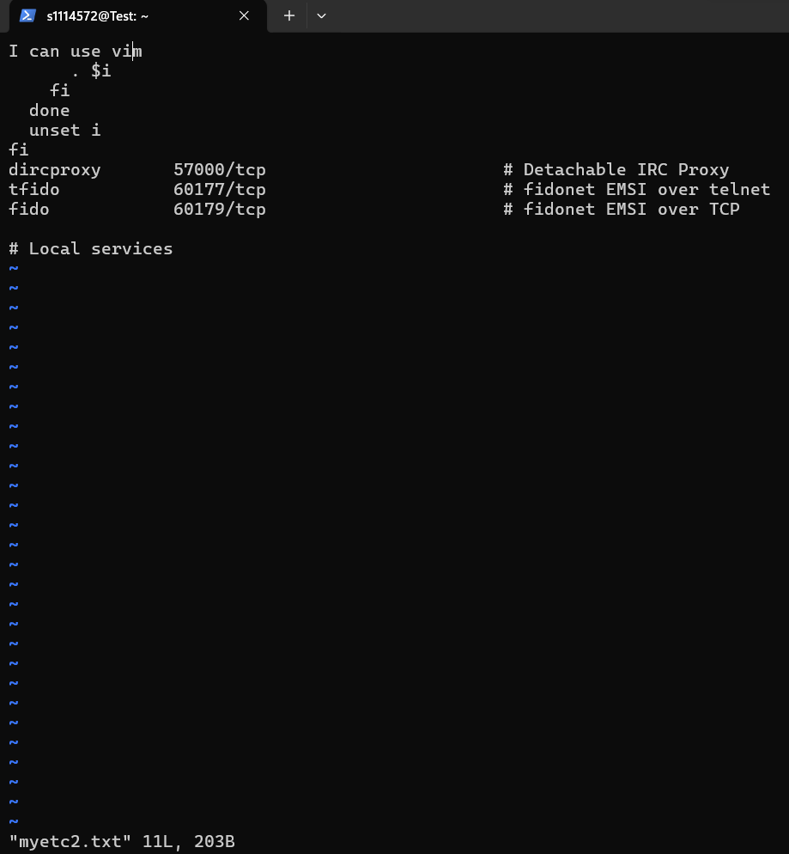

6.

Ans：vim mytext.txt

操作：

(1) 按 i 輸入一行字(1114572)

(2) 按esc

(3) 按gg

(4) 按yy

(5) 按100p

(6) 按：wq!

