1.

a. Ans：

(1) 查詢指令：dpkg -S /etc/sudoers

(2) 查詢結果：sudo: /etc/sudoers



b. Ans：

(1) 查詢指令：sudo debsums sudo

(2) 查詢結果：

/usr/bin/cvtsudoers OK

/usr/bin/sudo OK

/usr/bin/sudoreplay OK

/usr/include/sudo_plugin.h OK

/usr/lib/tmpfiles.d/sudo.conf OK

/usr/libexec/sudo/audit_json.so OK

/usr/libexec/sudo/group_file.so OK

/usr/libexec/sudo/libsudo_util.so.0.0.0 OK

/usr/libexec/sudo/sample_approval.so OK

/usr/libexec/sudo/sesh OK

/usr/libexec/sudo/sudo_intercept.so OK

/usr/libexec/sudo/sudo_noexec.so OK

/usr/libexec/sudo/sudoers.so OK

/usr/libexec/sudo/system_group.so OK

/usr/sbin/sudo_logsrvd OK

/usr/sbin/sudo_sendlog OK

/usr/sbin/visudo OK

/usr/share/apport/package-hooks/source_sudo.py OK

/usr/share/doc/sudo/CONTRIBUTING.md OK

/usr/share/doc/sudo/CONTRIBUTORS.md.gz OK

/usr/share/doc/sudo/HISTORY.md OK

/usr/share/doc/sudo/NEWS.Debian.gz OK

/usr/share/doc/sudo/NEWS.gz OK

/usr/share/doc/sudo/OPTIONS OK

/usr/share/doc/sudo/README.Debian OK

/usr/share/doc/sudo/README.md OK

/usr/share/doc/sudo/SECURITY.md OK

/usr/share/doc/sudo/TROUBLESHOOTING.md.gz OK

/usr/share/doc/sudo/UPGRADE.md.gz OK

/usr/share/doc/sudo/changelog.Debian.gz OK

/usr/share/doc/sudo/copyright OK

/usr/share/doc/sudo/examples/cvtsudoers.conf OK

/usr/share/doc/sudo/examples/pam.conf OK

/usr/share/doc/sudo/examples/sudo.conf OK

/usr/share/doc/sudo/examples/sudo_logsrvd.conf OK

/usr/share/doc/sudo/examples/sudoers OK

/usr/share/doc/sudo/examples/sudoers.dist OK

/usr/share/doc/sudo/examples/syslog.conf OK

/usr/share/lintian/overrides/sudo OK

/usr/share/man/man1/cvtsudoers.1.gz OK

/usr/share/man/man5/sudo.conf.5.gz OK

/usr/share/man/man5/sudo_logsrv.proto.5.gz OK

/usr/share/man/man5/sudo_logsrvd.conf.5.gz OK

/usr/share/man/man5/sudoers.5.gz OK

/usr/share/man/man5/sudoers_timestamp.5.gz OK

/usr/share/man/man8/sudo.8.gz OK

/usr/share/man/man8/sudo_logsrvd.8.gz OK

/usr/share/man/man8/sudo_plugin.8.gz OK

/usr/share/man/man8/sudo_root.8.gz OK

/usr/share/man/man8/sudo_sendlog.8.gz OK

/usr/share/man/man8/sudoreplay.8.gz OK

/usr/share/man/man8/visudo.8.gz OK

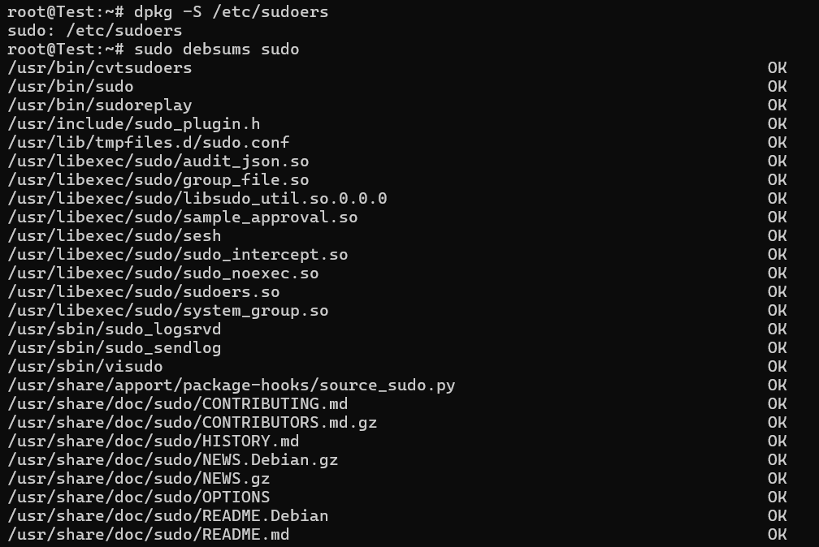

c. Ans：sudo apt-get install --reinstall sudo

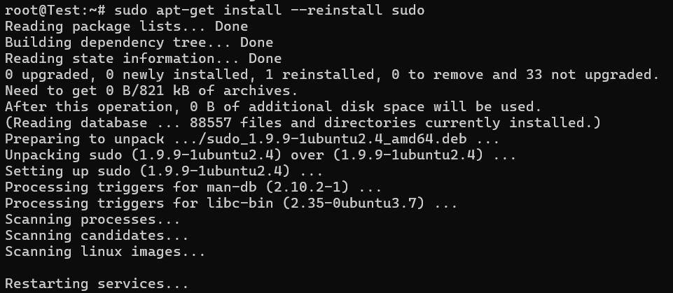

d. Ans：

(1) sudo apt-get update

(2) sudo apt-get install apt-file

(3) sudo apt-file update

(4) apt-file search misc_conv.3.gz

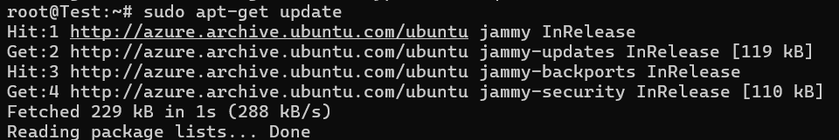

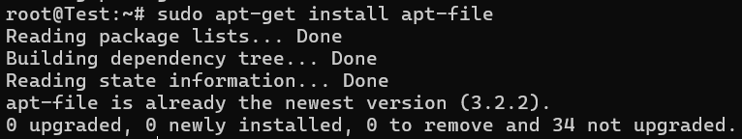

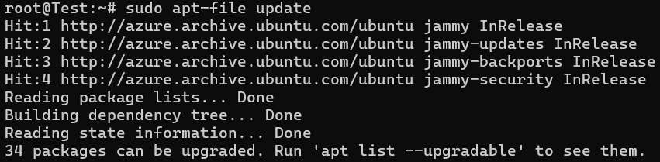



e. Ans：

(1) sudo zgrep "COMMAND=cat /etc/shadow" /var/log/auth.log* > /root/sudo_cat_shadow_log.txt

(2) cat /root/sudo_cat_shadow_log.txt



2.

a. Ans：nmcli connection delete eth0



b. Ans：

nmcli connection show

nmcli connection show eth0

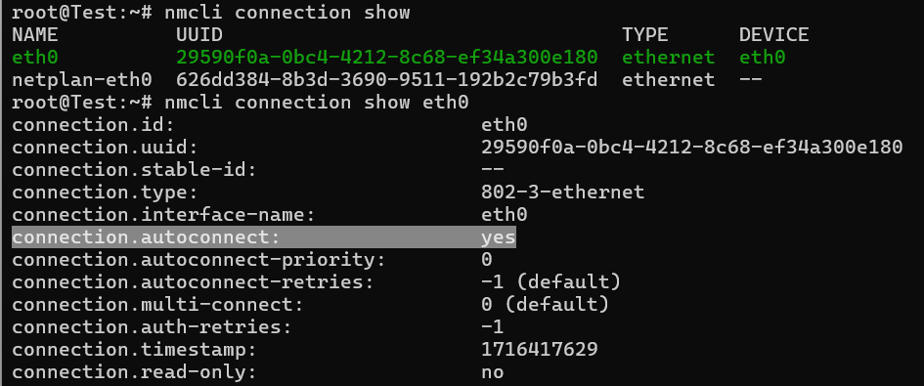

nmcli connection modify eth0 ipv4.method manual

nmcli connection show eth0 | grep ipv4.method



nmcli connection modify eth0 ipv4.address 192.168.251.123/24

nmcli connection show eth0



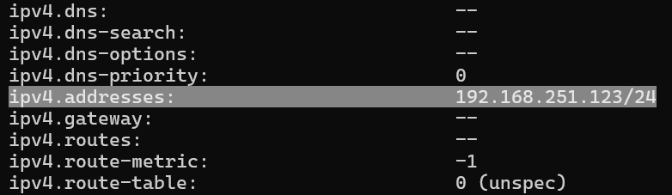

nmcli connection modify eth0 ipv4.gateway 192.168.251.250

nmcli connection show eth0 | grep ipv4.gateway



nmcli connection modify eth0 ipv4.dns 168.95.1.1

nmcli connection show eth0 | grep ipv4.dns

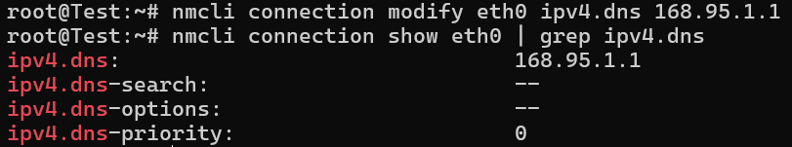

nmcli connection show eth0 | grep -A 7 ipv4.method

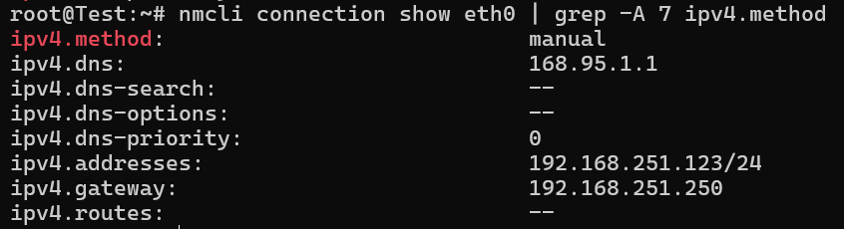

hostnamectl set-hostname std1114572.book.vbird

hostnamectl

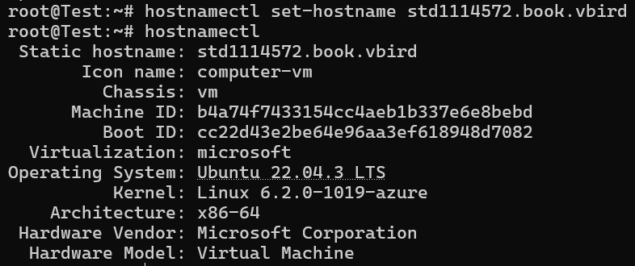

3.

a. Ans：sudo nano /etc/apt/sources.list



輸入：

deb http://ftp.ksu.edu.tw/debian/ stable main contrib non-free

deb http://ftp.ksu.edu.tw/debian/ stable-updates main contrib non-free

deb http://ftp.ksu.edu.tw/debian/ stable-backports main contrib non-free

deb http://ftp.ksu.edu.tw/debian-security/ stable/updates main contrib non-free

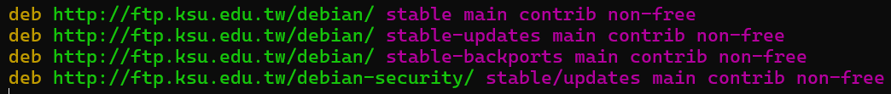

sudo apt update

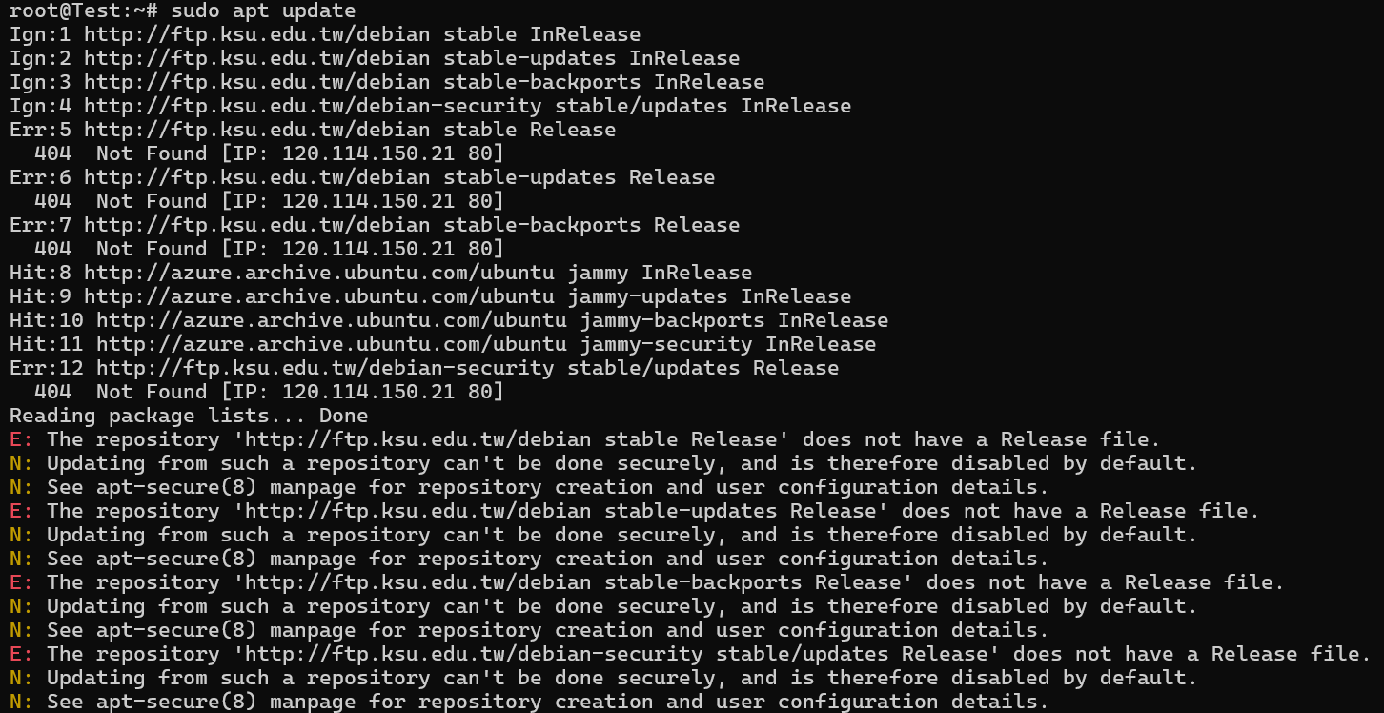

b. Ans：apt-cache search epel

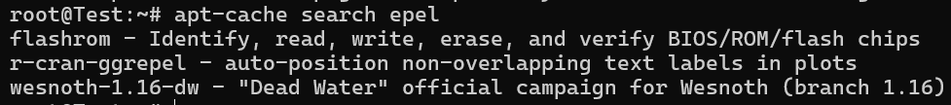

c. Ans：systemctl status cron

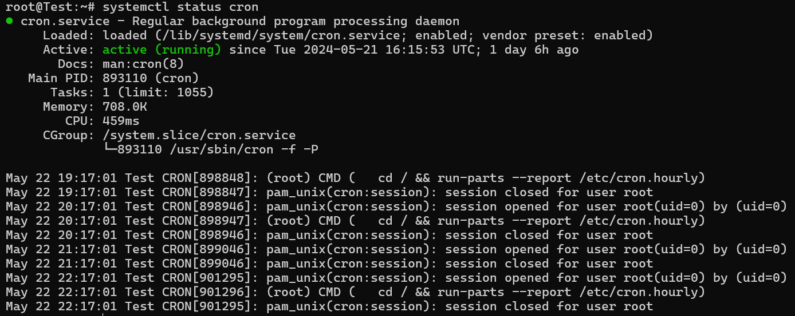

vim /etc/crontab



輸入：0 3 * * * root apt update && apt update -y

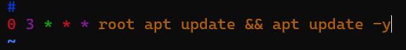

sudo service cron restart

sudo systemctl restart cron



d. Ans：sudo apt install netcdf-fortran

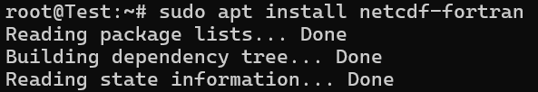

e. Ans：sudo apt install build-essential

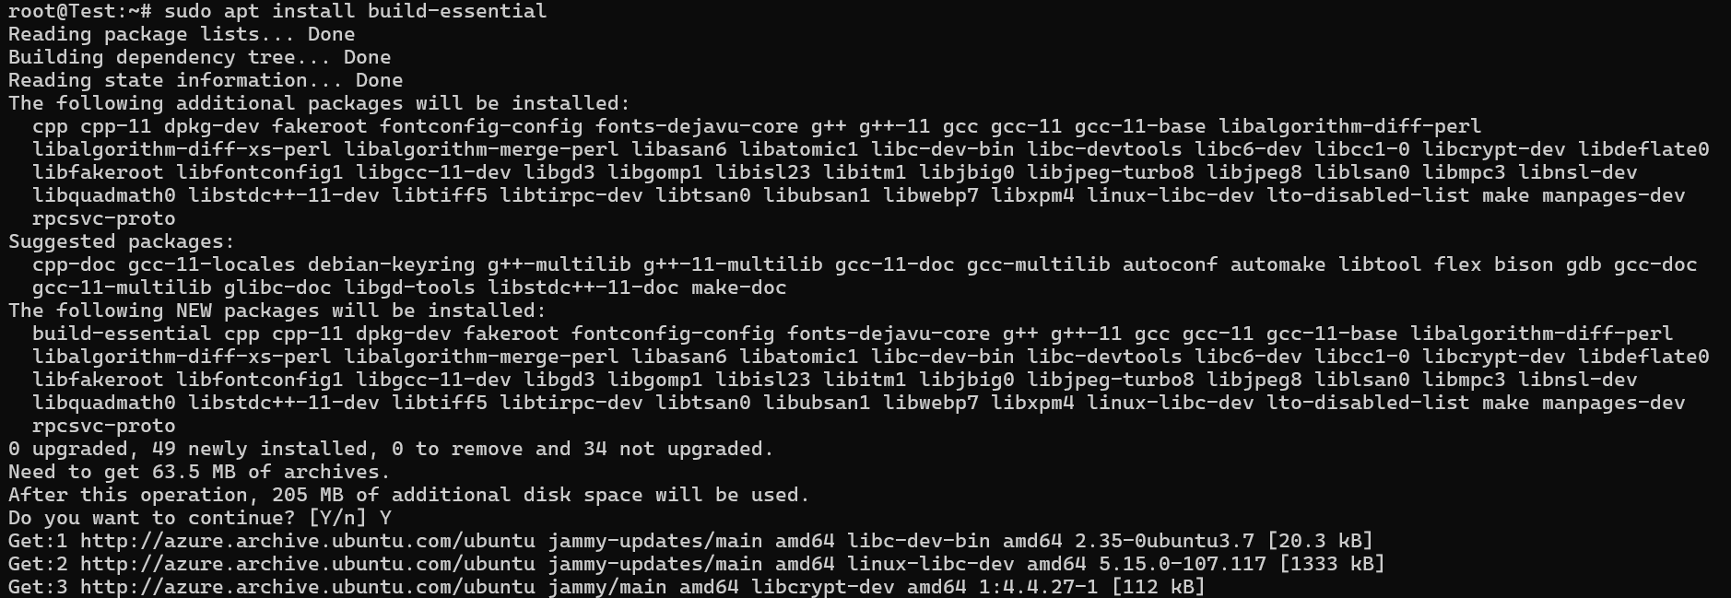

4.

a. Ans：

vi /etc/rsyslog.conf



輸入：auth.info /var/log/full.log

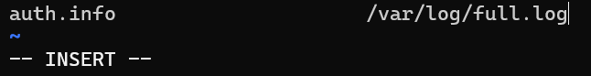

b. Ans：

vi /etc/logrotate.conf



輸入：compress

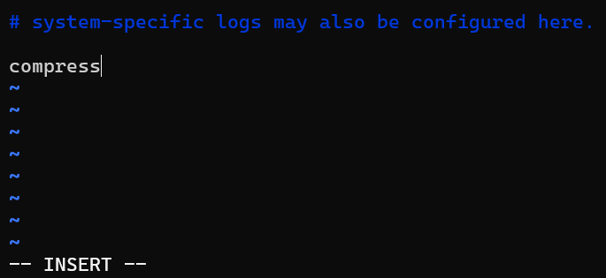

c. Ans：sudo apt install logwatch

