1.

a. Ans：

(1) awk '{print strftime("%Y-%m-%d %H-%M-%S", $1), $0}' /var/log/syslog

(2) date +%b' '%d' '%H:%M:%S

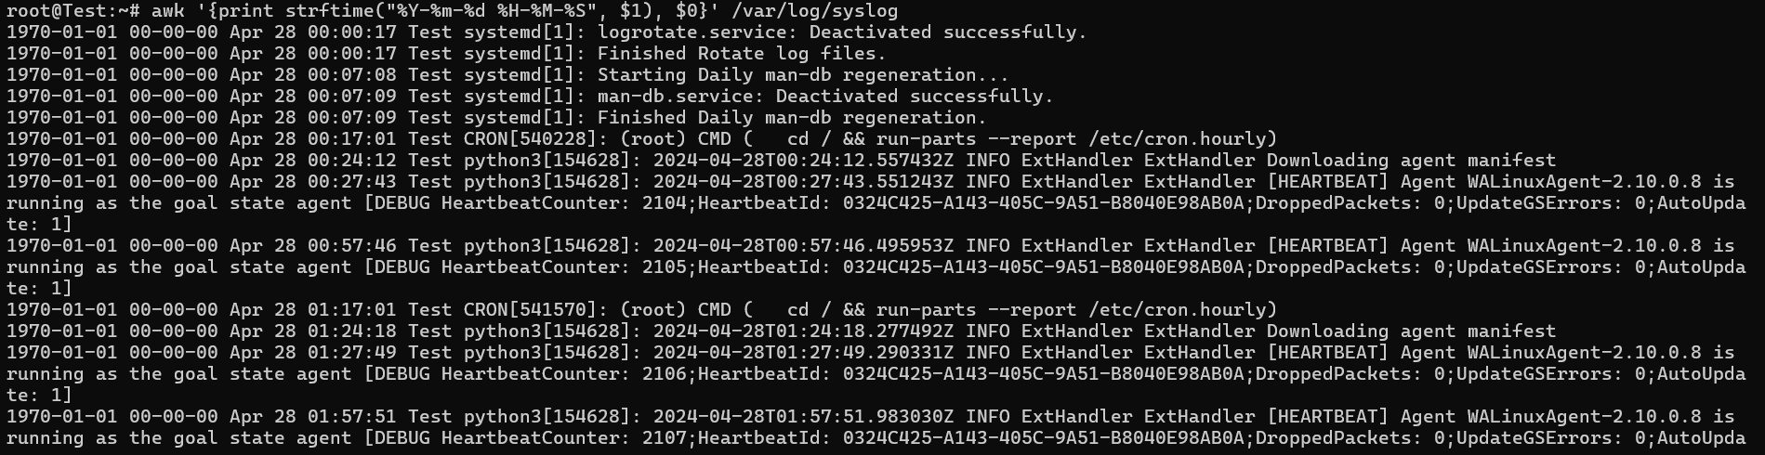

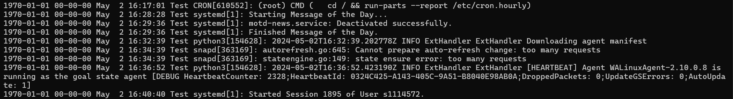

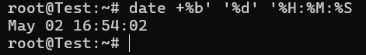

b. Ans：

(1) logday=$(date +'%b %d')

(2) echo logday=$(date +'%b %d')

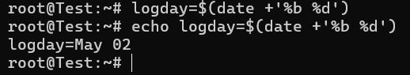

c. Ans：echo logday=$(date +'%b %d')

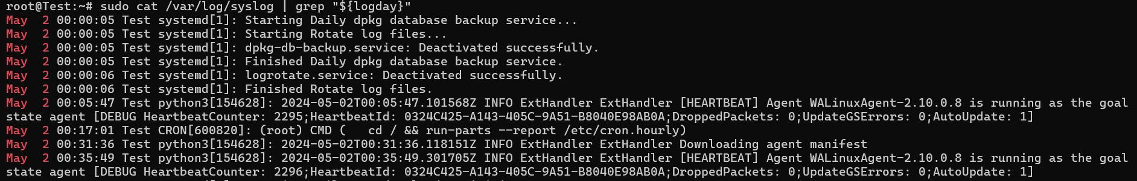

d. Ans：sudo cat /var/log/syslog | grep "${logday}" | grep -vE 'dbus-daemon|dbus\[[0-9]+\]'

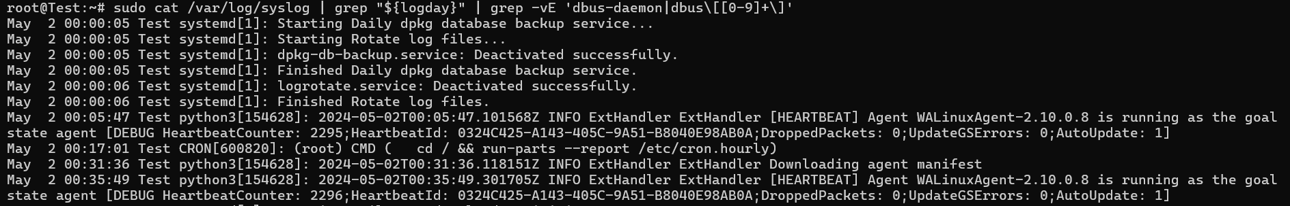

e. Ans：

(1) cp /etc/selinux/semanage.conf /etc/selinux/config.conf

(2) vim /etc/selinux/config.conf

(3) 輸入SELINUX=???

(4) sudo sed s/SELINUX=*/SELINUX=enforcing/ /etc/selinux/config.conf



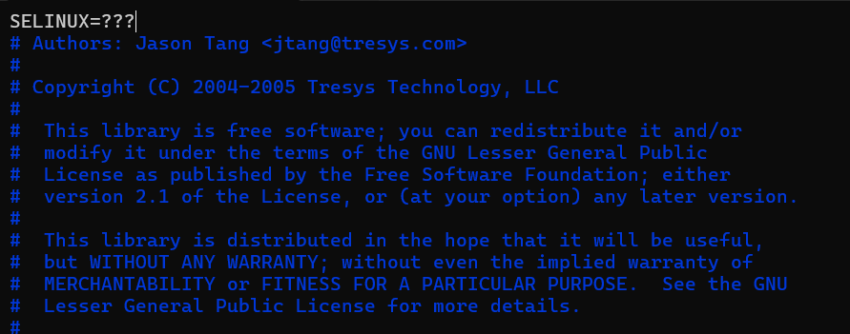

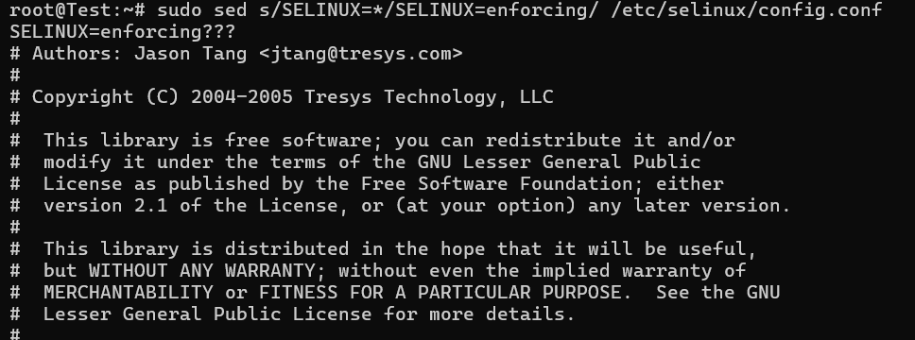

f. Ans：

(1) cat /etc/hosts | tr '[:lower:]' '[:upper:]' > /dev/shm/upperhosts

(2) vim /dev/shm/upperhosts



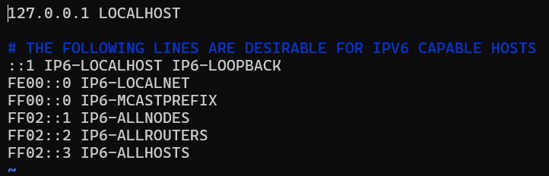

2. Ans：vim /usr/local/bin/myprocess



a.b. Ans：

輸入

#!/bin/bash

/bin/ps -Ao pid,user,cpu,tty,args

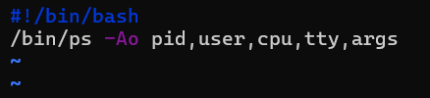

c. Ans：chmod a+x /usr/local/bin/myprocess



/usr/local/bin/myprocess

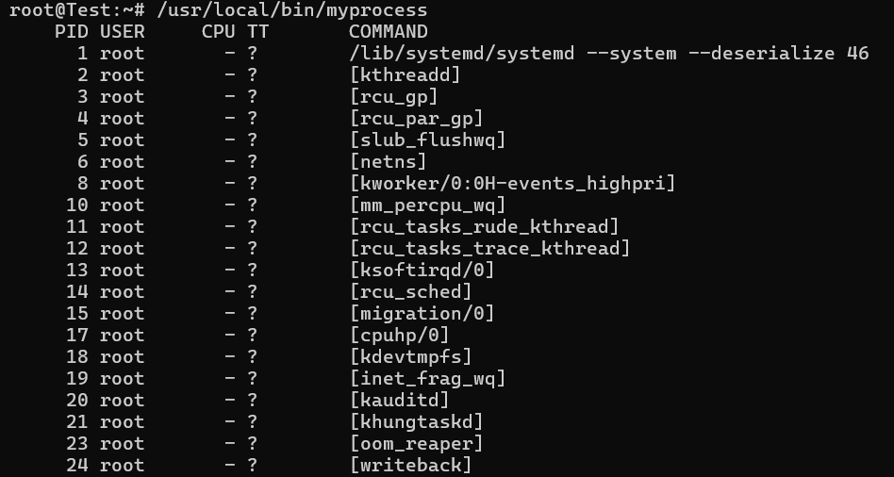

3. Ans：vim /usr/local/bin/mydate.sh



a.b.c.d.e. Ans：

輸入

#!/bin/bash

date +'%Y/%m/%d'

date +'%H/%M/%S'

date +'%s'

cal -m

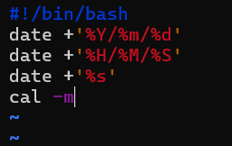

f. Ans：chmod a+x /usr/local/bin/mydate.sh



/usr/local/bin/mydate.sh

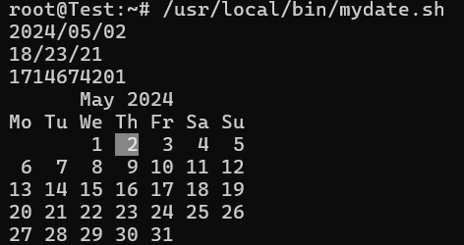

4. Ans：vim /usr/local/bin/listcmd.sh



b.c.d.e.f.g. Ans：

輸入

#!/bin/bash

echo -e "This shell script will list your command's full path name and permissions."

command=${1}

if [ "${command}" == "" ]; then

echo -e "Usage:${0} cmd_name"

exit 2;

fi

commandPath=$(which $command 2> /dev/null)

commandStatus=$(echo $?)

if [ "${commandStatus}" == "0" ]; then

echo -e $commandPAth

ls -l $commandPath

getfacl $commandPath

exit 0;

else

locateResult=$(locate -r /${command}$)

locateStatus=$(echo $?)

if [ "${locateStatus}" == "0" ]; then

ls -ld ${locateResult}

exit 0;

else

echo -e "Can't find file"

exit 10;

fi

fi

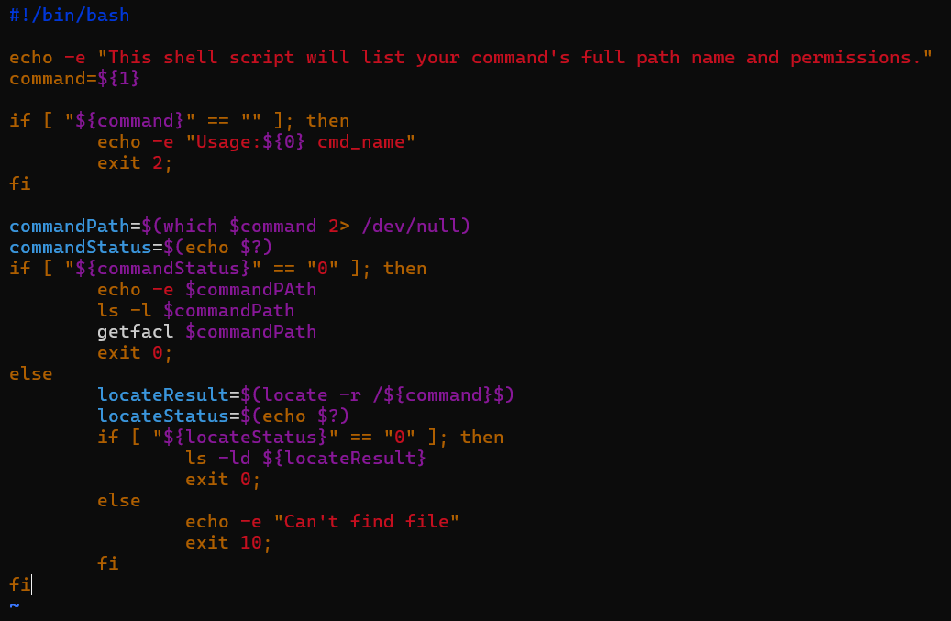

a. Ans：(做完b.c.d.e.f.g.後驗證)

(1) chmod a+x /usr/local/bin/listcmd.sh

(2) listcmd.sh passwd

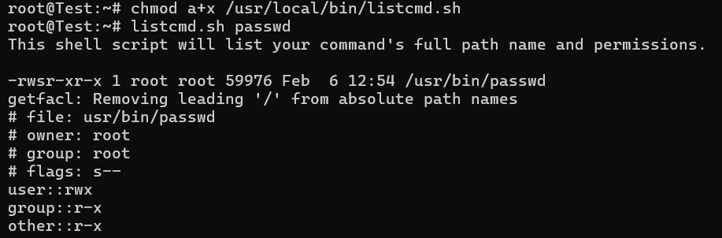

5. Ans：vim /usr/local/bin/myheha



a.b.c.d. Ans：

(1) 輸入

#!/bin/bash

case ${1} in

"hehe")

echo -e "I am haha"

;;

"haha")

echo -e "you are hehe"

;;

*)

echo -e "Usage:myheha hehe|haha"

;;

esac

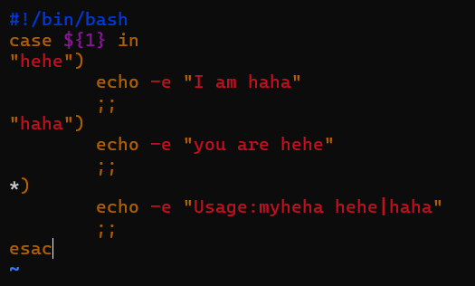

(2) chmod a+x /usr/local/bin/myheha

(3) myheha hehe

(4) myheha hahahahahah

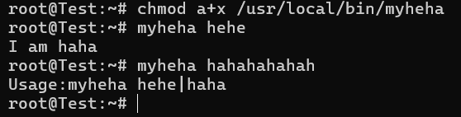

6. Ans：vim /usr/local/bin/yourbday.sh



a.b.c.d.e.f. Ans：

(1) 輸入

#!/bin/bash

command1=${1}

echo $command1

if [ "$command1" == "" ]; then

echo -e "Usage: yourbday.sh YYYY-MM-DD";

exit 0;

fi

birthdayTime=$(date --date=$command1 +"%s")

dateResult=$(echo $?)

if [ "$dateResult" -ne "0" ]; then

echo "Invalid date"

exit 0;

fi

currentTime=$(date +"%s")

if [ $currentTime -gt $birthdayTime ]; then

echo "(${currentTime} - ${birthdayTime})/86400/365.24" | bc -lq

else

echo -e "You are not a real human..."

fi

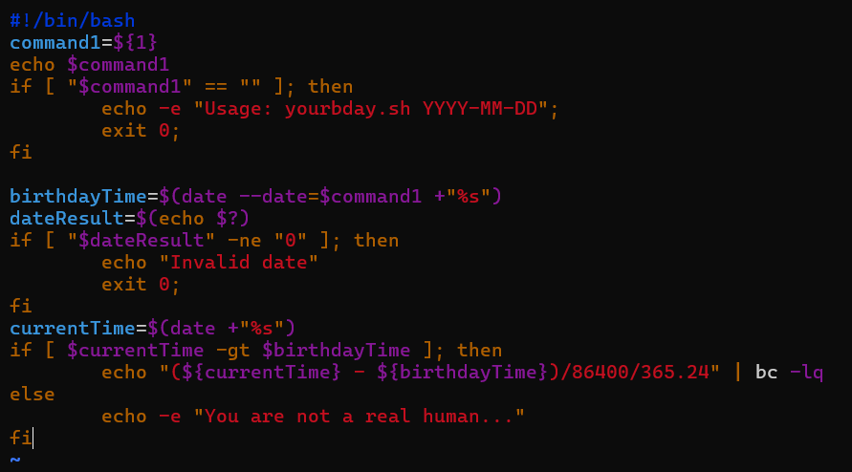

(2) chmod a+x /usr/local/bin/yourbday.sh

(3) yourbday.sh 2004-01-28

(4) yourbday.sh

(5) yourbday.sh 2030-08-16

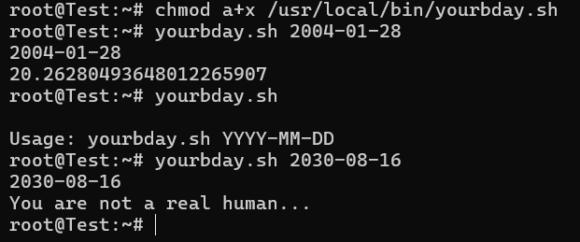

7. Ans：vim /usr/local/sbin/examcheck.sh



a.b.c. Ans：

(1) 輸入

#!/bin/bash

case ${1} in

"ok")

echo -e "Yes! You are right"

;;

"false")

echo -e "So sad... your answer is wrong..."

;;

*)

echo -e "Usage:examcheck ok|false"

;;

esac

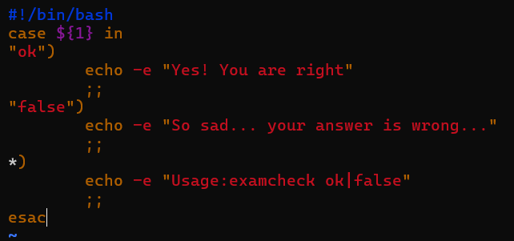

(2) chmod a+x /usr/local/sbin/examcheck.sh

(3) examcheck.sh ok

(4) examcheck.sh false

(5) examcheck.sh

