1.

a. Ans：getfacl /var/spool/mail/ >> ans04.txt

(1) 擁有者：root

(2) 群組：mail

(3) user權限：7分、group權限：7分、other權限：5分



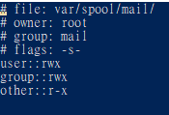

b. Ans：file /var/spool/mail/ >> ans04.txt

檔案類型：目錄檔(directory)



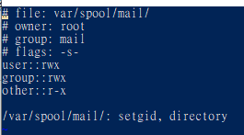

c. Ans：ls -ld /var/spool/mail/ >> ans04.txt

權限：drwxrwsr-x



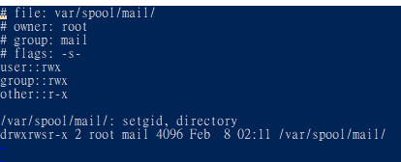

2.

a. Ans：

(1) groupadd examgroup

(2) useradd -g examgroup -p ItIsExam examuser1

(3) useradd -g examgroup -p ItIsExam examuser2

(4) useradd -g examgroup -p ItIsExam examuser3

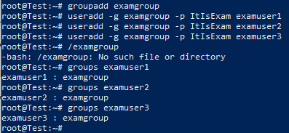

b. Ans：useradd -p ItIsExam examuser4



c. Ans：

(1) useradd -p ItIsExam examuser5 (2) userdel -r examuser5

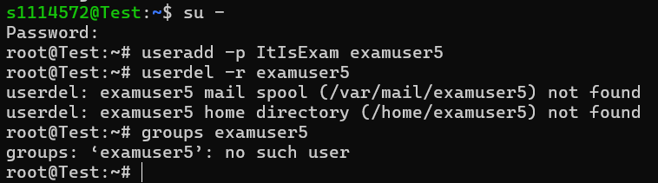

d. Ans：

(1) sudo groupadd -g 2060 rmgroup

(2) getent group | grep rmgroup

(3) sudo useradd -u 2050 -g 2060 myuser1

(4) sudo passwd myuser1

(5) id myuser1

(6) userdel myuser1

(7) id myuser1

(7) sudo useradd -u 2050 -g 2060 -p $(openssl passwd -crypt "ItIsExam") -M myuser1

(8) id myuser1

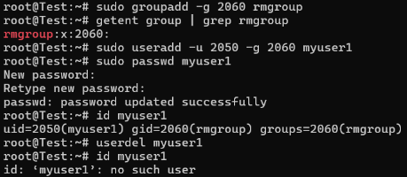



e. Ans：

(1) groupadd student

(2) usermod -a -G student examuser1

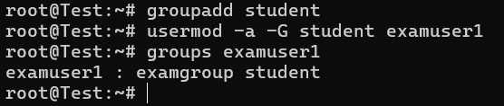

3.

a. Ans：

(1) cp -r /etc/security /home/examuser4

(2) cd /home/examuser4

(3) getfacl security

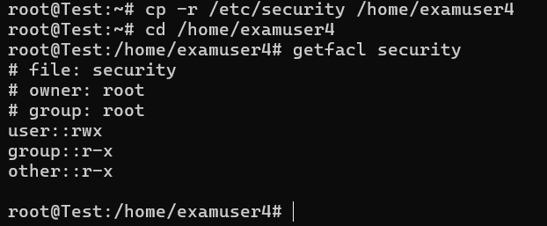

b. Ans：

(1) touch /srv/examcheck.txt

(2) chown examuser1 /srv/examcheck.txt

(3) chgrp examgroup /srv/examcheck.txt

(4) chmod 740 /srv/examcheck.txt

(5) getfacl /srv/examcheck.txt

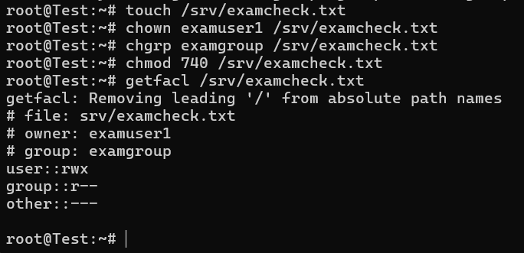

c. Ans：

(1) mkdir /srv/examdir

(2) chgrp examgroup /srv/examdir

(3) chmod 770 /srv/examdir/

(4) getfacl /srv/examdir/

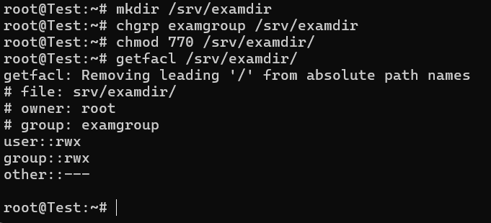

d. Ans：

(1) sudo cp /bin/more /usr/local/bin/mymore

(2) chgrp examgroup /usr/local/bin/mymore

(3) chmod g+x,o-x /usr/local/bin/mymore

(4) getfacl /usr/local/bin/mymore

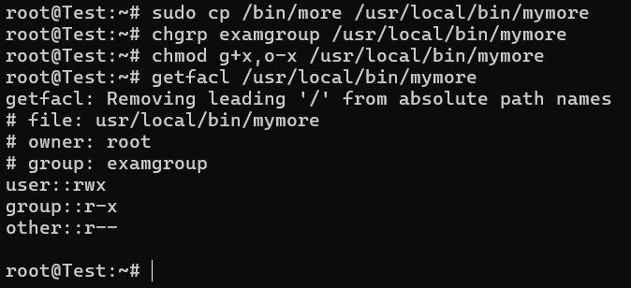

e. Ans：

(1) mkdir /examdata

(2) touch /examdata/change.txt

(3) chown sshd /examdata/change.txt

(4) chgrp users /examdata/change.txt

(5) chmod 640 /examdata/change.txt

(6) getfacl /examdata/change.txt

(7) sudo touch -t 201212210000 /examdata/change.txt

(8) ls -l /examdata/change.txt

