1. State whether each of the following is true or false. If false, explain why.

(1) Base-class constructors are not inherited by derived classes.

Ans:True

(2) An is-a relationship is implemented via composition.

Ans:False! The is-a relationship represents inheritance. The has-a relationship represents composition

(3) A Student class has an is-a relationship with the Faculty and Course classes.

Ans:False! It dose not make sense that a Student class is derived from class Faculty.

(4) Private members of a private base class are inaccessible to the derived class.

Ans:True

(5) A base class’s protected members can be accessed in the base-class definition, in derived-class definitions and in friends of the base class and its derived classes.

Ans:True

1. Draw an inheritance hierarchy for students at a university and , discuss the relationships that exist between the classes

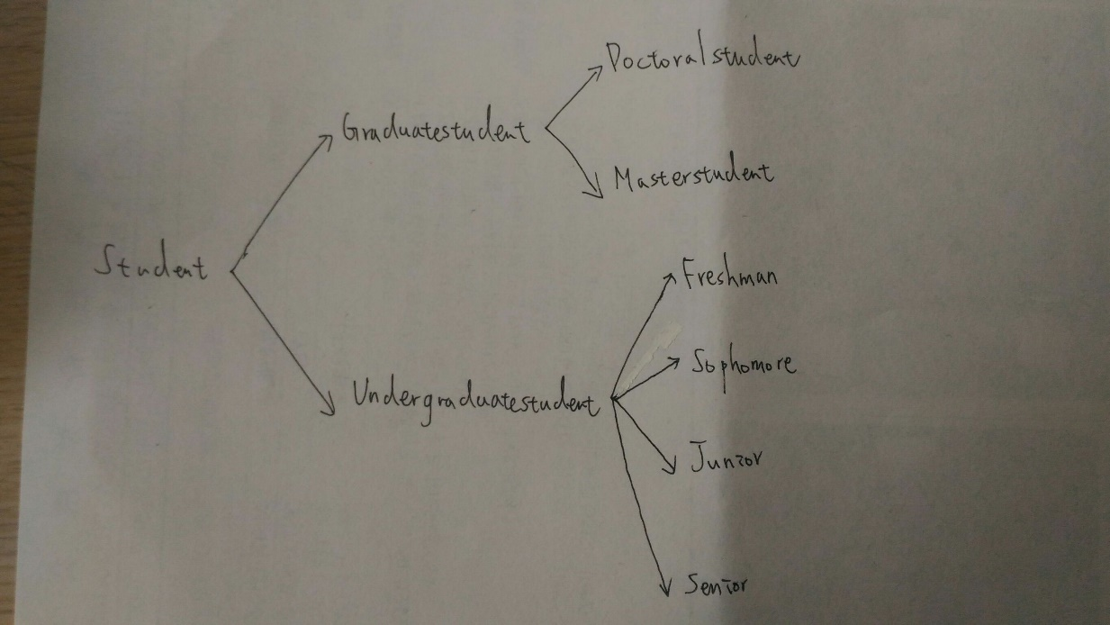

(1) Every inheritance of this inheritance hierarchy is single inheritance.

(2) For class Graduatestudent and Undergraduatestudent ,They are both derived from class Student.Hence, class Graduatestudent and Undergraduatestudent are derived classes,and class Student is a base class.

(3) For class Doctoralstudent and Masterstudent,They are both derived from class Graduatestudent. Moreover,by(2),We can conclude class Doctoralstudent and Masterstudent are derived classes, class Graduatestudent is a direct base class,and class Student is a indirect base class.

(4) For class Freshman,Sophomore,Junior and Senior,they are all derived from class Undergraduatestudent. Moreover,by(5),We can conclude class class Freshman,Sophomore,Junior and Senior are derived classes, class Undergraduatestudent is a direct base class,and class Student is an indirect base class.