**Deep Learning for Computer Vision**

**Homework 1**

**R10522606曾柏翔**

# Problem 1

1. Print the network architecture of your model.

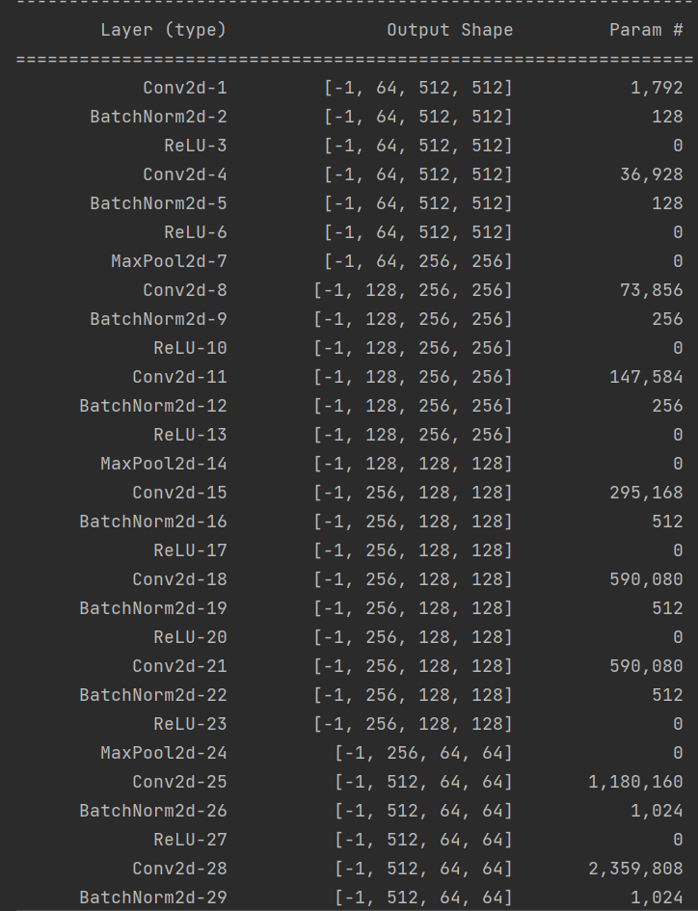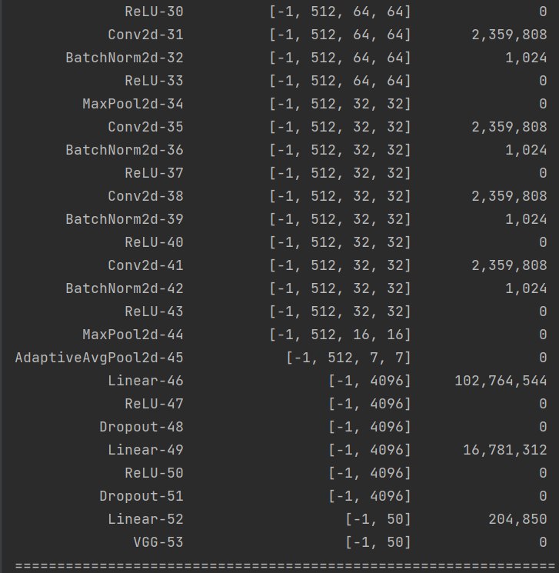

1. Report accuracy of model on the validation set.

→ Accuracy : 0.8268

1. Visualize the classification result on validation set by implementing t-SNE on output features of the second last layer. Briefly explain your result of the t-SNE visualization.

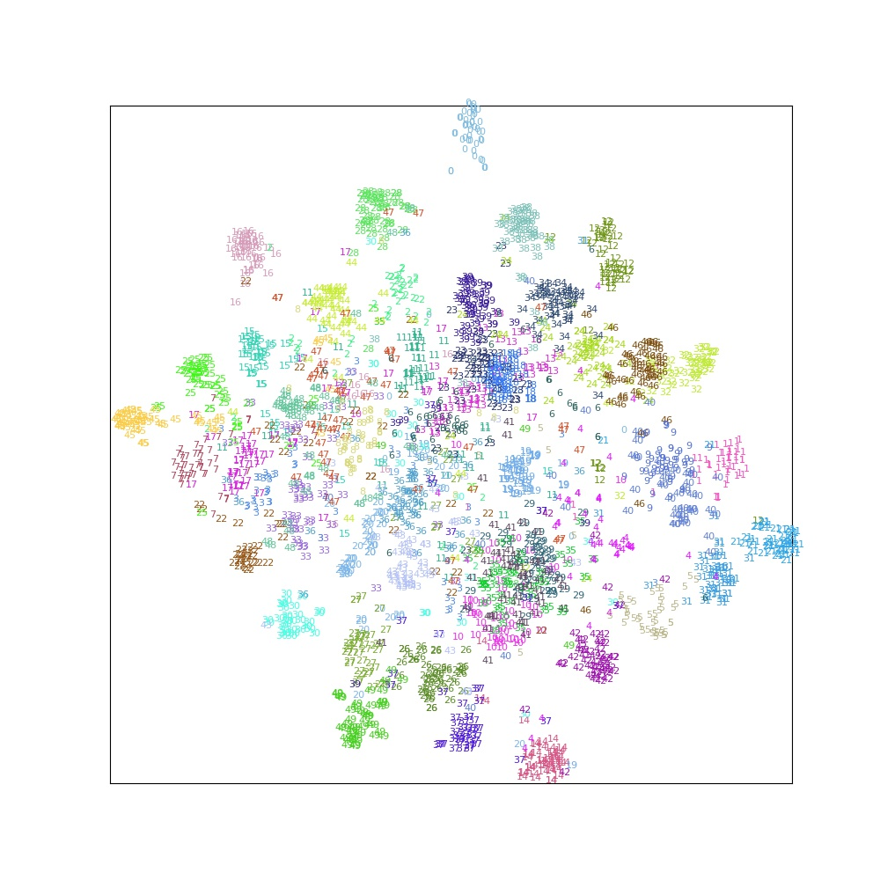

從t-SNE可以看出各個class的特性，可以注意到有些claas是自成一區，而有些則會與其他calss重疊。這可以簡單想成model對於各個class的辨識能力，若是自成一區，代表class對於有著鮮明的特徵，使得model能夠輕易地辨識出來；而若是與其他的重疊，代表重疊的class之間可能存在著某些相似的特徵，造成model混淆。

舉例來說，可以很明顯的注意到t-SNE圖最上方，class 0就自成一區，其對應到的圖片-腳踏車，在訓練中，並沒有與其相似的data，因此model能夠輕易地辨識腳踏車的特徵；而可以看到class 32與class 46幾乎都混在一起，兩者所對應到的皆為車輛相關的圖片，因此對於model來說就很容易辨識錯誤。(32與46甚至我用肉眼都沒辦法分辨)

# Problem 2

1. Print the network architecture of your VGG16-FCN32s model.

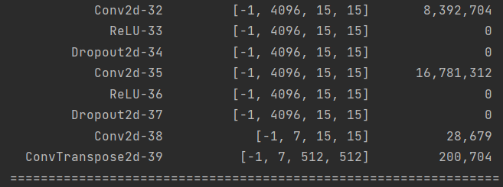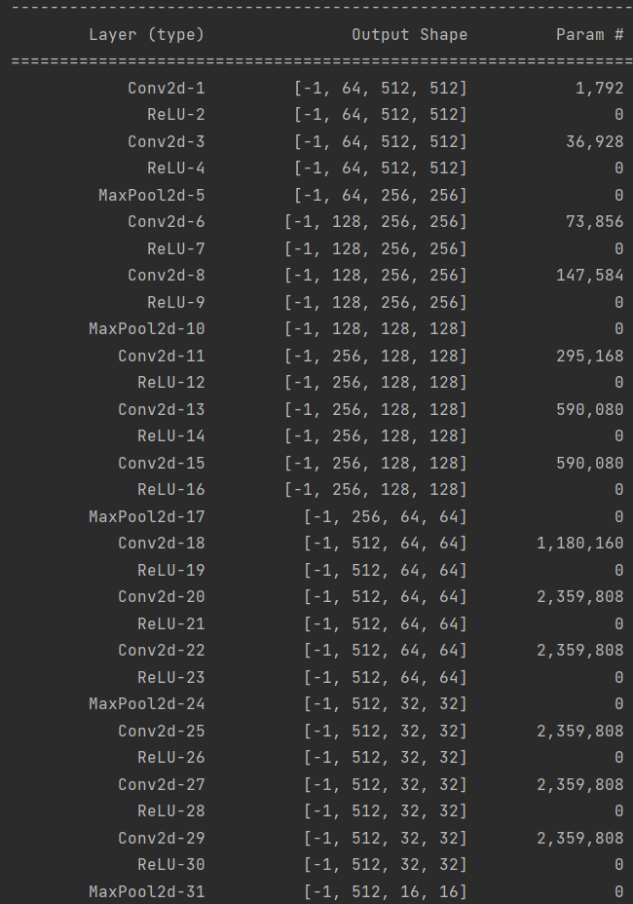

1. Implement an improved model which performs better than your baseline model. Print the network architecture of this model.

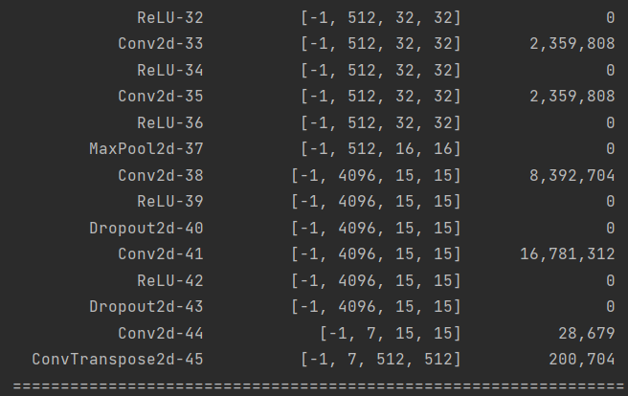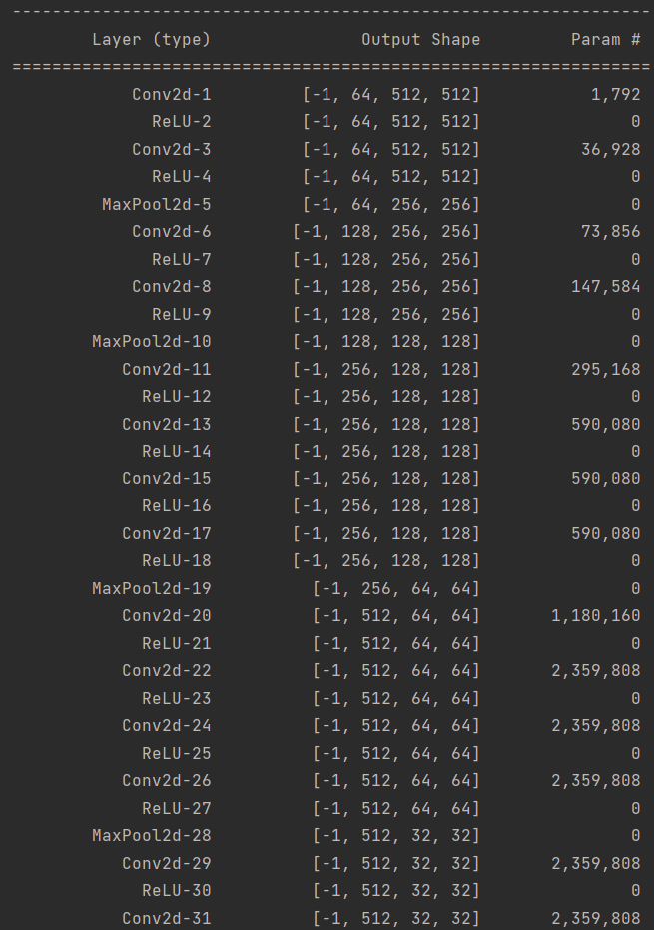

1. Report mIoU of the improved model on the validation set.

→ mIoU : 0.688

1. 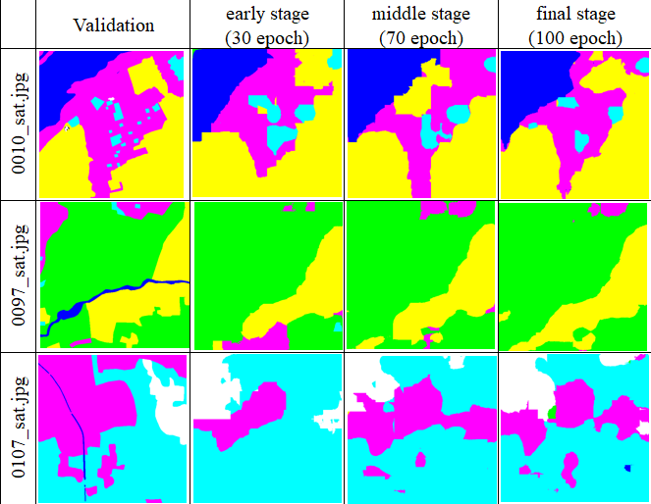Show the predicted segmentation mask of “0010_sat.jpg”, “0097_sat.jpg”, “0107_sat.jpg” during the early, middle, and the final stage during the training process of this improved model.

# Reference

1. Vgg16&FCN32

<https://blog.csdn.net/gbz3300255/article/details/105582572>

1. t-SNE

<https://scikit-learn.org/stable/modules/generated/sklearn.manifold.TSNE.html>

1. Print the network architecture of model.

<https://stackoverflow.com/questions/42480111/model-summary-in-pytorch>

1. How to use “register_forward_hook”.

<https://zhuanlan.zhihu.com/p/87853615>