Github link: https://github.com/XiangHerry/ReMo_Project.git

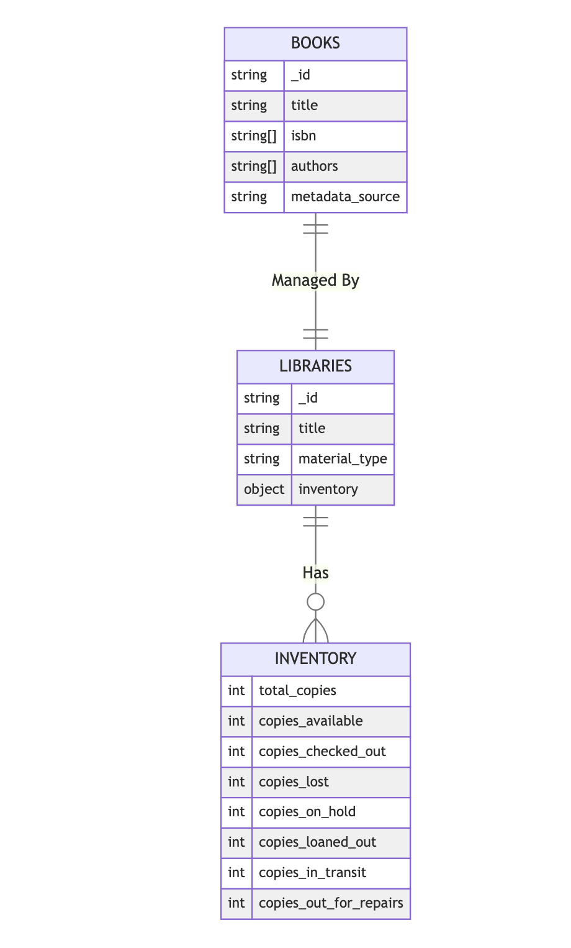

* **BOOKS**: Represents the catalog of books with details such as title, ISBNs, authors, and metadata source.
* **LIBRARIES**: Represents library entities with attributes like title, material type, and inventory.
* **INVENTORY**: Tracks the status of book copies in libraries, including total copies, available copies, and damaged/lost copies.

**Relationships**:

* **Managed By**: BOOKS are managed by LIBRARIES.
* **Has**: LIBRARIES maintain a detailed INVENTORY of books.

**Users and Their Roles in the ReMo System**

The ReMo (Reading Motivation) system is designed to create a supportive and engaging environment that fosters a love for reading by enabling the management of books and libraries. The system facilitates collaboration among students, educators, librarians, and administrators to enhance reading experiences and literacy initiatives.

**Students**

Students are at the center of the ReMo system. They use ReMo to:

* **Search for Books**: Students can browse through the library catalog to discover books that align with their interests, whether by title, genre, or subject.
* **Track Reading Progress**: By logging the books they have read, students can reflect on their reading journey and set goals for the future.
* **Access Library Resources**: ReMo empowers students to check the availability of books, ensuring they can borrow materials that support their academic and personal interests.

Through these features, ReMo inspires students to cultivate reading habits that contribute to their personal growth and academic success.

**Educators (Teachers)**

Teachers leverage the ReMo system to create a structured and encouraging reading environment for their students. They can:

* **Recommend Books**: By understanding students’ interests and reading progress, teachers can suggest books that align with students' goals.
* **Monitor Reading Activity**: Teachers can track which books students are engaging with and review logs for insights into reading habits.
* **Facilitate Library Usage**: Educators collaborate with librarians to ensure that students have access to recommended reading materials.

By tailoring reading experiences to individual needs, teachers foster a culture of enthusiasm for reading and help students achieve literacy milestones.

**Librarians**

Librarians serve as facilitators who connect students and teachers with the library’s resources. In ReMo, they can:

* **Manage the Library Catalog**: Librarians keep the system’s inventory accurate and up to date by maintaining the details of available books.
* **Assist in Book Discovery**: They help users explore books that meet specific needs, such as reading goals, subjects of interest, or academic requirements.
* **Curate Collections**: Librarians can highlight popular books, organize themed collections, and ensure that recommended resources are readily available.

Through their expertise, librarians make the library an essential part of the reading ecosystem, helping users fully utilize its resources.

**Administrators**

Administrators oversee the implementation and maintenance of ReMo, ensuring the system runs smoothly and supports the school’s literacy objectives. Their responsibilities include:

* **Managing Permissions**: Administrators control user roles and access to ensure data security and system integrity.
* **Analyzing Reading Data**: Aggregated data from ReMo helps administrators understand trends in book usage and library engagement, informing decisions about resource allocation.
* **Supporting Literacy Initiatives**: Administrators use insights from the system to develop and enhance programs that encourage reading across the school or district.

Their strategic oversight ensures that ReMo contributes to creating a reading culture that aligns with educational goals.

**In Summary**

The ReMo system brings together students, educators, librarians, and administrators to celebrate and promote reading. Here’s how each role contributes to the ecosystem:

* **Students**: Explore books, track reading progress, and set personal goals.
* **Educators**: Guide students in their reading journey, suggest books, and track engagement.
* **Librarians**: Maintain the catalog, assist in book discovery, and curate resources.
* **Administrators**: Manage permissions, analyze trends, and support literacy programs.

Together, these users form a cohesive community that makes reading a priority and transforms the library into a dynamic hub of learning and growth.