Meets Specifications

Hello,  
Congratulations, on meeting all of the specifications. keep this up!  
Good luck with with your Self Driving Car Nanodegree. 

**Required Files**

**The project submission includes all required files:**

* **Ipython notebook with code**
* **A writeup report (either pdf or markdown)**

**Lane Finding Pipeline**

**The output video is an annotated version of the input video.**

Good work! Your output videos are properly annotated. 

**In a rough sense, the left and right lane lines are accurately annotated throughout almost all of the video. Annotations can be segmented or solid lines**

Your pipeline is pretty good, with resulting lines centered on the target lane lines. The annotations were solid as well as the left and right lane lines were accurately annotated throughout the videos.

**Visually, the left and right lane lines are accurately annotated by solid lines throughout most of the video.**

You did good enough as the resulting lane lines are a single solid line and are are centered right on the actual lane lines throughout the videos.

[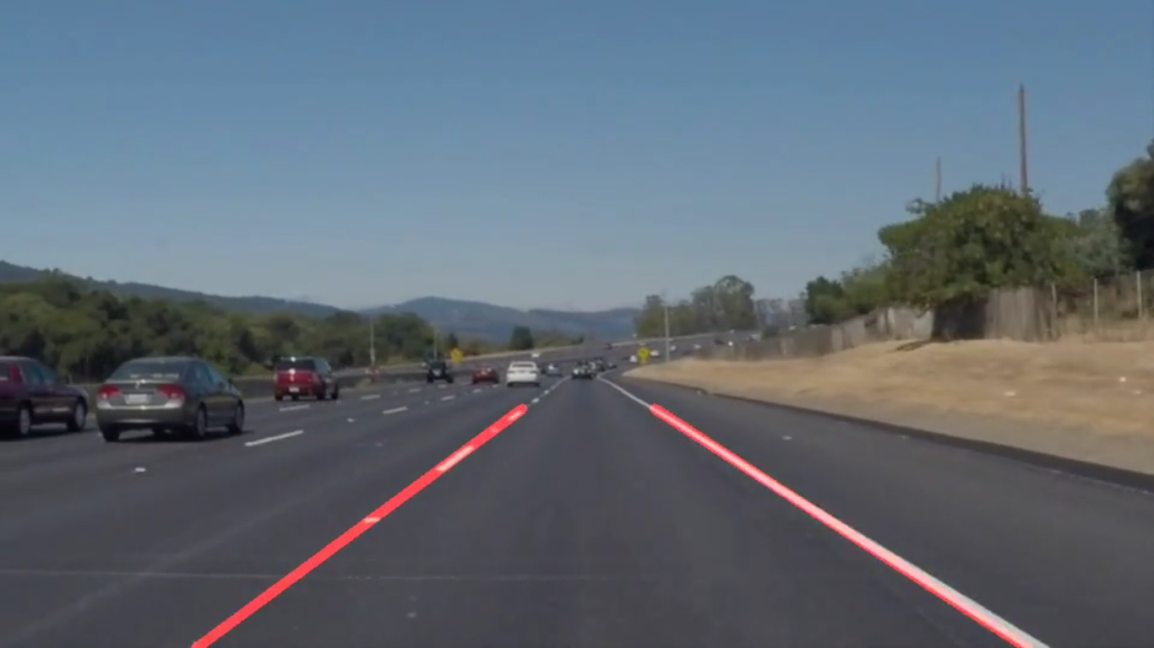](https://udacity-reviews-uploads.s3.us-west-2.amazonaws.com/_attachments/50281/1525629817/Screenshot__942_.png)

Furthermore, the following changes that might help you in certain conditions like curved lanes, shadows etc.

• Increasingmax_line_gap and min_line_len close to 150 will make your lines longer.  
• And increasing threshold will also help as this will get rid of the spurious lines.

**Reflection**

**Reflection describes the current pipeline, identifies its potential shortcomings and suggests possible improvements. There is no minimum length. Writing in English is preferred but you may use any language.**

Good work describing your current pipeline and figuring out some of its potential shortcomings and possible improvements.

Whereas more possible improvements are:

• Image from infrared camera.  
• Adding a outlier reduction approach like RANSAC on the hough lines.  
• Using curve fitting to plot the curve instead of straight lines

For further reference :

[RANSAC.pdf](https://udacity-reviews-uploads.s3.us-west-2.amazonaws.com/_attachments/50281/1525629938/RANSAC.pdf)  
[curve.pdf](https://udacity-reviews-uploads.s3.us-west-2.amazonaws.com/_attachments/50281/1525630267/curve.pdf)