What is Sustainable Fashion?
Sustainable fashion refers to clothing that is designed, produced, distributed, and used in ways that are environmentally and socially responsible. It aims to reduce the negative impact of the fashion industry by focusing on practices like:
- Using organic or recycled materials
- Reducing water and chemical usage
- Ensuring ethical labour practices
- Designing for durability and long-term use
- Minimising waste during production and packaging

Problem Statement
Young adults who are interested in sustainable fashion often struggle to find eco-friendly clothing options online. This leads to frustration, decision fatigue, and users abandoning their intention to shop sustainably.
Goal
To create an e-commerce website that makes it easy for users to discover and purchase
both regular and sustainable clothing.

Key Performance Indicators
KPI | Description | Purpose
Time Spent | Measure the average amount of time young adults spend searching for an available sustainable clothing. | To measure the efficiency of the current process of finding sustainable clothing.
Frequency of Use | Measure how often young adults visit the store. | To determine which store are most attractive.
Decision Criteria | Determine the factors that influence young adult’ choices when selecting a clothing. | To enable better design and price to meet young adult preferences.
Source of Information | Identify the sources young adults use to find sustainable clothing. | To optimise communication strategies and improve the visibility of available spaces

Research Objective
To understand how young adults search for sustainable clothing online and identify challenges they face when trying to make shopping decisions.
Quantitative Questions | Qualitative Questions
How easy or difficult is it to search for sustainable clothing? | Where do you search for sustainable clothing?
How much do you spend on clothing per month? | What kind of problem will you face when search for sustainable clothing?

Response 1 Screenshot
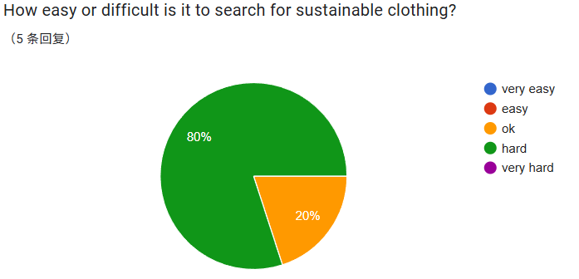
Key Insights
Most respondents (80%) feel that finding sustainable clothing is difficult.
This indicates that accessibility and availability are major issues, suggesting that sustainable clothing options may not be widely visible or easy to locate in online.

Only 20% of respondents feel it is moderately easy (“ok”).
Very few people find the process simple, meaning awareness or guidance on where to shop sustainably might be lacking.

No respondents chose “very easy” or “easy.”
This highlights a clear gap in the market—consumers are interested but are not being provided with easy pathways to buy sustainable fashion.

Response 2 Screenshot
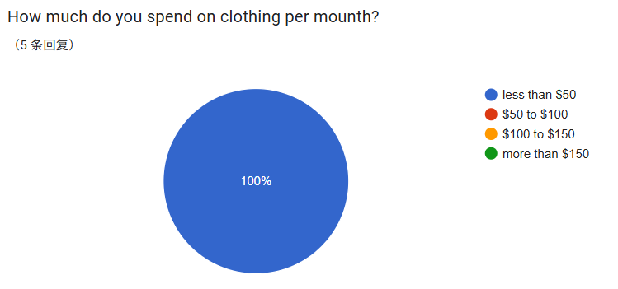
Key Insights
All respondents (100%) spend less than $50 per month on clothing.
This suggests that the surveyed group has a low monthly clothing budget, indicating cost sensitivity or minimal consumption habits.

No respondents reported spending above $50 monthly.
This implies that higher-priced sustainable clothing may be perceived as unaffordable, even if consumers are interested in sustainability.

User Data
Marcus: 21, an Engineering student who recently became more conscious about sustainable living. He is interested in supporting ethical brands but finds it hard to identify truly sustainable products online. He prefers convenient shopping experiences and often shops via websites and mobile apps.
Lily: 20, a Design student who actively promotes sustainability on social media. She enjoys thrifting and exploring eco-friendly fashion options. However, she finds it frustrating that most websites lack clear sustainability filters or product details, making her shopping experience time-consuming and unclear.

User Persona Details(Lily)
goals
- To quickly and easily filter products based on verifiable sustainability criteria
- To see standardized, clear sustainability badges or icons directly on product listings.
- To have a seamless and transparent shopping experience that doesn't require hours of research.
- To discover and support new, authentic sustainable brands through the platform itself.
Motivations
- To align her consumer choices with her values, reducing her personal environmental footprint.
- To inspire her peers and social media followers to make more conscious fashion decisions.
- To feel confident that the products she buys are ethically sourced and produced.
- To champion small businesses and brands that are genuinely committed to sustainability

Frustrations
- "It's so frustrating that most shopping websites have no clear sustainability filters. I have to dig through every product description."
- "I can't tell if a brand is truly eco-friendly or just greenwashing. The information is never straightforward."
- "Shopping for sustainable options is incredibly time-consuming. I just want a clear, trustworthy way to shop."
- "The lack of detailed information about materials and supply chains makes me doubt my purchases."

Interests
- Thrifting & Vintage Shopping: Loves the thrill of finding one-of-a-kind items.
- Eco-Friendly Fashion: Actively researches and supports brands with transparent, sustainable practices.
- Content Creation: Shares her sustainable fashion finds and tips with a growing online community.
- DIY & Upcycling: Enjoys customizing and repairing clothes to give them a new life.

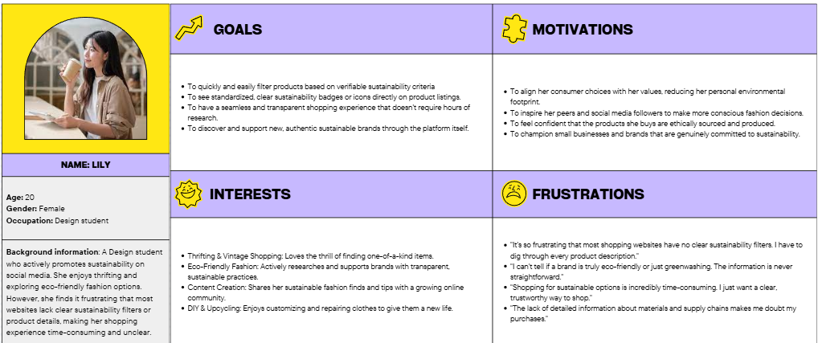

User Story 1
As an eco-conscious shopper, I want to filter search results by specific sustainability attributes, so that I can save my time.
User Story 2
As an eco-conscious shopper, I want to see a clear, standardized sustainability badge on the product, so that I know whether the product is sustainability.

Journey Map for Shopping on a Sustainable Fashion Website
User: Marcus, 21, Student
Lifestyle: Outgoing student who enjoys fashion and wants to shop more sustainably without giving up on convenience.
User Story: As a frequent online shopper, I want to easily find affordable, stylish, and truly sustainable clothing, so that I can look good while supporting ethical brands.
 | Browse Products | Filter Sustainable Items | View Product Info | Add to Cart | Checkout
Actions | Open the website and start to browse products | Use the filter to filter the item by the sustainability | Click into the product detail and take a look. | Click add to cart, select the number of items. | Click checkout, key in the address detail, payment type, then pay
Emotions and Pain Points | Looking forward to buying new clothes. | Feeling frustrated because can not quickly find clothes that is suitable. | Suspicion arises because the authenticity of the information cannot be verified. | Feeling happy as he like the product | Excited as the new clothes coming soon.
Emotion Curve | happy 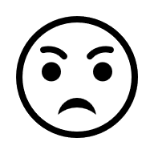 frustrated 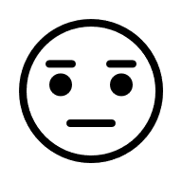 Neutral happy excited
Opportunities | Develop curated collections or shop sections that explicitly combine "Stylish & Sustainable" or "Affordable Eco-Fashion." Use styling visuals that appeal to his demographic. | Create a dedicated, multi-level "Sustainability" filter that goes beyond a simple tag. Include verifiable attributes like "Certified B Corp," "GOTS Organic," "Recycled Materials," "Carbon Neutral Shipping," and "Vegan." | Develop a clear, standardized system for displaying sustainability credentials directly on the product card and detail page. Use icons, badges, and a concise "Sustainability Facts" label (like a nutrition label). | Streamline the Post-Purchase Experience: Enhance order confirmations and tracking with positive impact metrics to reinforce the customer's good choice and sustain their excitement. | Ensure the interface is user-friendly with efficient navigation and search functionalities.

Goal
To design a homepage that helps users easily discover both regular and sustainable clothing, with clear labels and a smooth browsing experience.

Individual Sketch
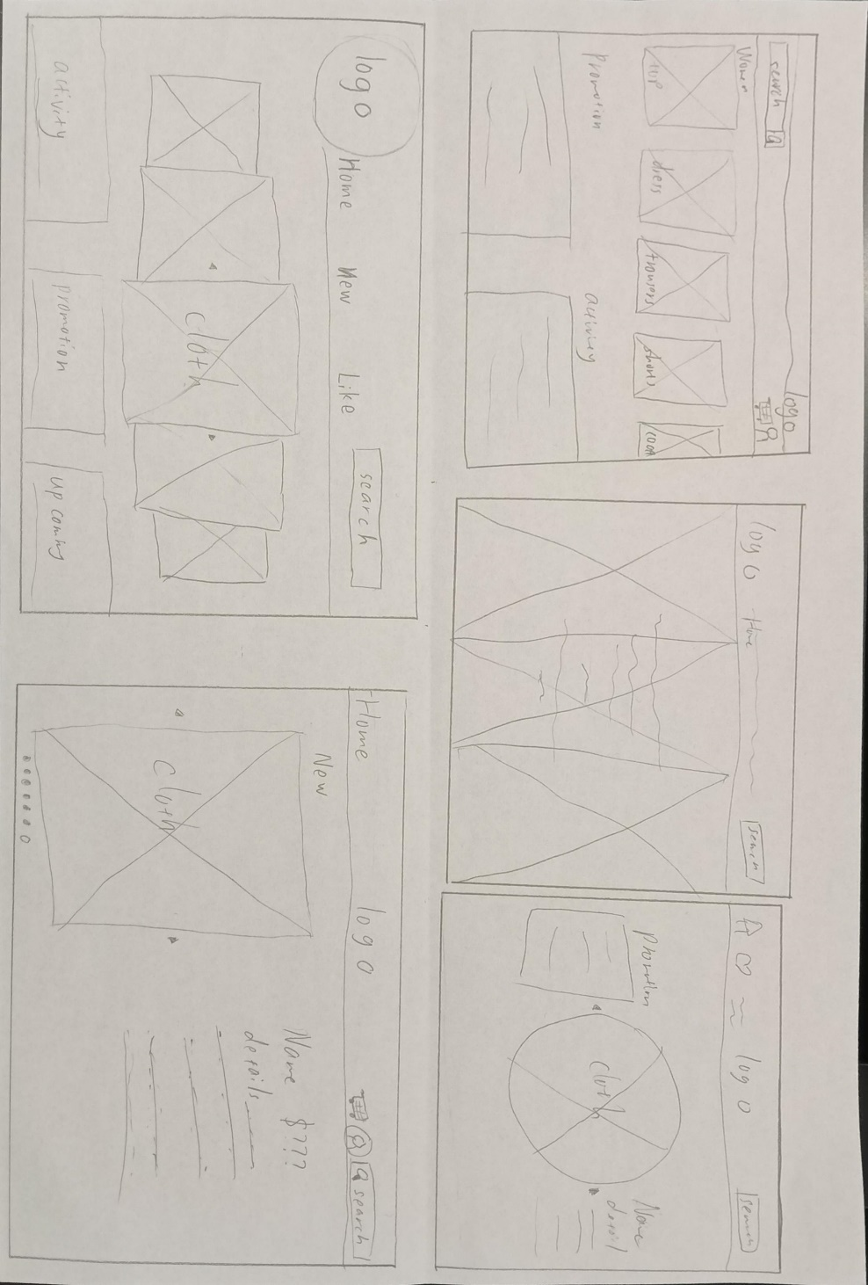

Description
- The logo of the website
- Search
- Activity
- Promotion
- The picture of the cloth
- Icon to about me page
- Icon to cart

User Story 1
As a student interested in eco-friendly fashion, I want to browse only sustainable products, so that I can make more environmentally conscious choices.
User Flow Diagram 1
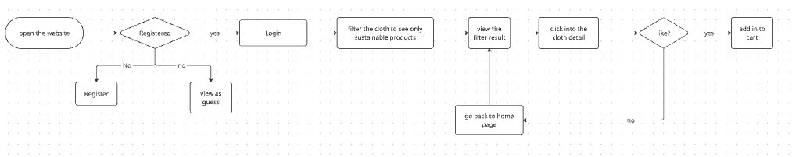

User Story 2
As an eco-conscious shopper, I want to see a clear, standardized sustainability badge on the product, so that I know whether the product is really sustainability.
User Flow Diagram 2
