Average Model for Buck-Boost Converter
Buck-Boost converter to be analyzed (Switch (S1) & Diode are IDEAL):
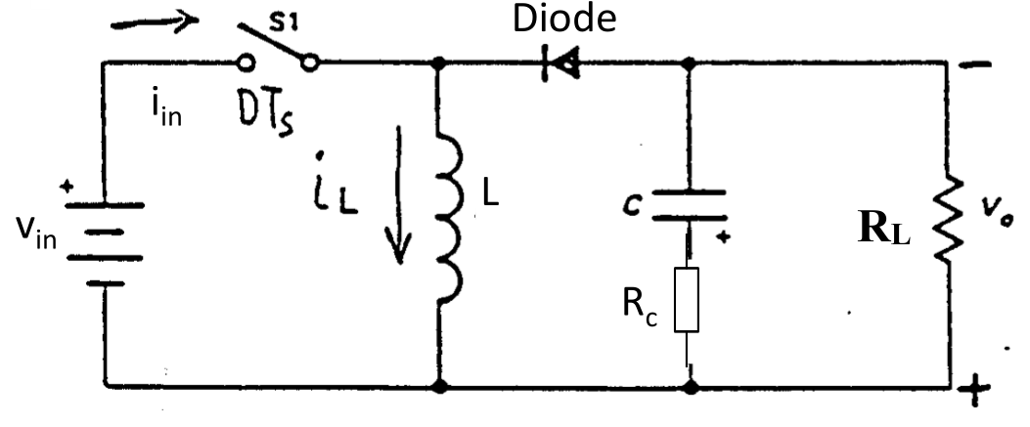
1) Derive the general expressions of Gvd(s)=vo(s)/d(s), audio susceptibility Gvin2vo(s)=vo(s)/vin(s), and Output Impedance Zo(s)= vo(s)/io(s) for the Buck-boost converter running at continuous current mode. Use the average model concept.
Steady state analysis:
During Toff time:
$$ν_{L}\left(t\right)=L\frac{di_{L}\left(t\right)}{dt}=-ν_{o}\left(t\right)$$
$$i_{C}(t)=C\frac{dν_{c}\left(t\right)}{dt}=i_{L}(t)-\frac{ν_{o}(t)}{R_{L}}$$
$$v_{o}\left(t\right)=ν_{c}\left(t\right)+i_{C}\left(t\right)⋅R_{c}$$

During Ton time:
$$ν_{L}(t)=L\frac{di_{L}\left(t\right)}{dt}=v_{in}$$
$$i_{C}\left(t\right)=C\frac{dν_{c}\left(t\right)}{dt}=-\frac{v_{o}\left(t\right)}{R_{L}}$$
$$v_{o}(t)=\frac{R_{L}}{R_{L}+R_{c}}ν_{c}(t)$$

According to voltage-sec balance on the inductor in the steady state:
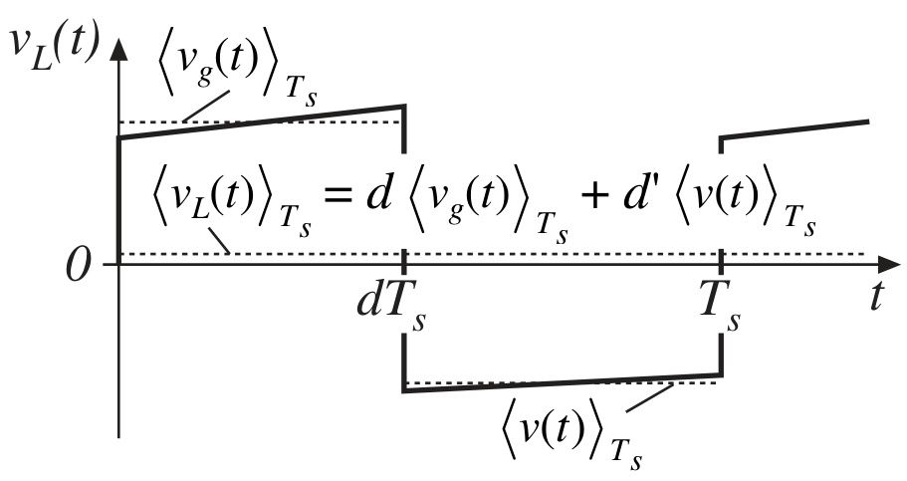
$\frac{1}{T_{s}}\int_{T_{s}}{v_{L}\left(t\right)dt} =v_{in} ⋅d+\left(-v_{o}\right)⋅d^{'}=0$, therefore, $\frac{V_{o}}{V_{in}}=D/D^{'}$
According to capacitor current balance on the inductor in the steady state:
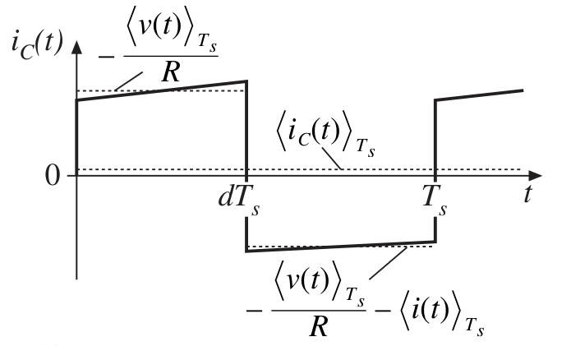
$$\frac{1}{T_{s}}\int_{T_{s}}{i_{C} \left(t\right)dt} =-\frac{v_{o}}{R_{L}} ⋅d+\left(i_{L}-\frac{ν_{o}}{R_{L}}\right)⋅d^{'}=0$$
Applying small signal perturbation to inductor equation:
$$L\frac{d\left(I_{L}+\hat{i}\left(t\right)\right)}{dt}=\left(D+\hat{d}\left(t\right)\right)\left(V_{in}+\hat{v_{in}}\left(t\right)\right)+\left(1-D-\hat{d}\left(t\right)\right)\left(-V_{o}-\hat{v_{o}}\left(t\right)\right)$$
$$L\left(\frac{dI_{L}}{dt}+\frac{d\hat{i}(t)}{dt}\right)=\left(DV_{in} -D^{'}V_{o}\right)+（D\hat{v_{in}}\left(t\right)-D^{'}\hat{v_{o}}\left(t\right)+(V_{in}+V_{o})\hat{d}\left(t\right)）+\left(\hat{v_{in}}\left(t\right)+\hat{v_{o}}\left(t\right)\right)\hat{d}\left(t\right)$$
The red terms are DC terms, which are automatically relinquished in small signal model, blue terms are 1st order linear ac terms, and green terms are negligent 2nd order ac terms. Then the equation can be derived as:
$$L\frac{d\hat{i}(t)}{dt}=D\hat{v_{in}}\left(t\right)-D^{'}\hat{v_{o}}\left(t\right)+(V_{in}+V_{o})\hat{d}\left(t\right)$$
Similarly, the capacitor equation perturbation leads to:
$$C\frac{d\left(V_{c}+\hat{ν_{c}}(t)\right)}{dt}=\left(D^{'}-\hat{d}(t)\right)\left(I_{L}+{\hat{i}}_{L}(t)\right)-\frac{\left(V_{o}+\hat{ν_{o}}(t)\right)}{R_{L}}$$
$$C\left(\frac{dV_{c}}{dt}+\frac{d\hat{ν_{c}}(t)}{dt}\right)=\left(D^{'}I_{L}-\frac{V_{o}}{R_{L}}\right)+\left(D^{'}{\hat{i}}_{L}\left(t\right)-\frac{\hat{ν_{o}}\left(t\right)}{R_{L}}-I_{L}\hat{d}(t)\right)+\hat{d}(t){\hat{i}}_{L}(t)$$
Neglect 2nd order term and remove the equal DC terms at both sides, the remaining terms are:
$$C\frac{d\hat{ν_{c}}(t)}{dt}=D^{'}{\hat{i}}_{L}\left(t\right)-\frac{\hat{ν_{o}}\left(t\right)}{R}-I_{L}\hat{d}(t)$$
Then we can construct small-signal converter equivalent circuit as:
input switch network Inductor equation capacitor equation

By combining all three equivalent circuits, and replace the dependent source with ideal dc transformers, the whole small signal circuit model can be derived as:
Small signal circuit model for buck-boost converter

Based on the derived circuit, using superimposition law, the Gvd(s)=vo(s)/d(s)

$$G_{vd}\left(s\right)=\frac{Vin\left(1 -\frac{DL_{e}}{R_{L}}s\right)\left(1+R_{c}Cs\right)}{{D'}^{2}\left(1+\left(R_{c}C+\frac{L_{e}}{R_{L}}\right)s+L_{e}C\left(\frac{{R_{c}+R}_{L}}{R_{L}}\right)s^{2}\right)}$$
$$G_{vd}\left(s\right)=G_{vd0}\frac{\left(1 -\frac{s}{ω_{Z}}\right)\left(1+\frac{s}{ω_{esr}}\right)}{\left(1+\frac{1}{Q}\frac{s}{ω_{0}}+\frac{s^{2}}{ω_{0}^{2}}\right)}$$
Where $G_{vd0}=\frac{V_{in}}{D^{'2}}$, $L_{e}=\frac{L}{D^{'2}}$, $ω_{Z}=\frac{R_{L}}{DL_{e}}$, $ω_{esr}=\frac{1}{R_{c}C}$, $ω_{0}=\frac{1}{\sqrt{L_{e}C\left(\frac{{R_{c}+R}_{L}}{R_{L}}\right)}}$, $Q=\frac{\sqrt{L_{e}C\left(\frac{{R_{c}+R}_{L}}{R_{L}}\right)}}{\left(R_{c}C+\frac{L_{e}}{R_{L}}\right)}$.

Audio susceptibility Gvin2vo(s)=vo(s)/vin(s)
$$G_{vv}=\frac{D\left(1+R_{c}Cs\right)}{D'\left(1+\left(R_{c}C+\frac{L_{e}}{R_{L}}\right)s+L_{e}C\left(\frac{{R_{c}+R}_{L}}{R_{L}}\right)s^{2}\right)}$$
$$G_{vv}\left(s\right)=G_{vv0}\frac{\left(1+\frac{s}{ω_{esr}}\right)}{\left(1+\frac{1}{Q}\frac{s}{ω_{0}}+\frac{s^{2}}{ω_{0}^{2}}\right)}$$
Where $G_{vv0}=\frac{D}{D'}$, $L_{e}=\frac{L}{D^{'2}}$, $ω_{esr}=\frac{1}{R_{c}C}$, $ω_{0}=\frac{1}{\sqrt{L_{e}C\left(\frac{{R_{c}+R}_{L}}{R_{L}}\right)}}$, $Q=\frac{\sqrt{L_{e}C\left(\frac{{R_{c}+R}_{L}}{R_{L}}\right)}}{\left(R_{c}C+\frac{L_{e}}{R_{L}}\right)}$.
Output Impedance Zo(s)= vo(s)/io(s)

$$Z_{o}=\frac{L_{e}s\left(1+R_{c}Cs\right)}{\left(1+\left(R_{c}C+\frac{L_{e}}{R_{L}}\right)s+L_{e}C\left(\frac{{R_{c}+R}_{L}}{R_{L}}\right)s^{2}\right)}$$
$$Z\left(s\right)=Z_{o0}\frac{\left(1+\frac{s}{ω_{esr}}\right)}{\left(1+\frac{1}{Q}\frac{s}{ω_{0}}+\frac{s^{2}}{ω_{0}^{2}}\right)}$$
Where $Z_{o0}=L_{e}s$, $L_{e}=\frac{L}{D^{'2}}$, $ω_{esr}=\frac{1}{R_{c}C}$, $ω_{0}=\frac{1}{\sqrt{L_{e}C\left(\frac{{R_{c}+R}_{L}}{R_{L}}\right)}}$, $Q=\frac{\sqrt{L_{e}C\left(\frac{{R_{c}+R}_{L}}{R_{L}}\right)}}{\left(R_{c}C+\frac{L_{e}}{R_{L}}\right)}$.
Short Summary:
Gvd(s) | Gvin2vo(s) | Zo(s)
$$\frac{v_{o}\left(s\right)}{d\left(s\right)}=\frac{Vin\left(1 -\frac{DL_{e}}{R_{L}}s\right)\left(1+\frac{s}{ω_{esr}}\right)}{{D'}^{2}\left(1+\frac{1}{Q}\frac{s}{ω_{0}}+\frac{s^{2}}{ω_{0}^{2}}\right)}$$ | $$\frac{v_{o}\left(s\right)}{v_{in}\left(s\right)}=\frac{D\left(1+\frac{s}{ω_{esr}}\right)}{D'\left(1+\frac{1}{Q}\frac{s}{ω_{0}}+\frac{s^{2}}{ω_{0}^{2}}\right)}$$ | $$\frac{v_{o}\left(s\right)}{i_{o}\left(s\right)}=\frac{L_{e}s\left(1+\frac{s}{ω_{esr}}\right)}{\left(1+\frac{1}{Q}\frac{s}{ω_{0}}+\frac{s^{2}}{ω_{0}^{2}}\right)}$$
Where $L_{e}=\frac{L}{D^{'2}}$, $ω_{Z}=\frac{R_{L}}{DL_{e}}$, $ω_{esr}=\frac{1}{R_{c}C}$, $ω_{0}=\frac{1}{\sqrt{L_{e}C\left(\frac{{R_{c}+R}_{L}}{R_{L}}\right)}}$, $Q=\frac{\sqrt{L_{e}C\left(\frac{{R_{c}+R}_{L}}{R_{L}}\right)}}{\left(R_{c}C+\frac{L_{e}}{R_{L}}\right)}$.

2) For the given circuit parameters: Vin=12 V, Vo=4V, L= 3 uH, C=300 uF, Rc = 3 mΩ, Fsw = 500 kHz, RL = 200 mΩ. Plot the derived transfer functions of Gvd(s), Gvin2vo(s), and Zo(s) from question 1 (10%) and verify Gvd(s), Gvin2vo(s), and Zo(s) with SIMPLIS simulation (10%).

The simulated and model bode plots are shown as below:
Bode plotes of $G_{vd}\left(s\right)=\frac{v_{o}\left(s\right)}{d\left(s\right)}$

Bode plotes of $G_{vv}\left(s\right)=\frac{v_{o}\left(s\right)}{v_{in}\left(s\right)}$
Bode plotes of $Z_{o}\left(s\right)=\frac{v_{o}\left(s\right)}{i_{o}\left(s\right)}$

3) Derive the general expression of Gvd(s)=vo(s)/d(s) of the Flyback converter operating at continuous current mode. You can transfer the original flyback circuit into equivalent buck-boost circuit first. Then you can derive the transfer function from the equivalent buck-boost circuit. The Flyback converter to be analyzed is given below:
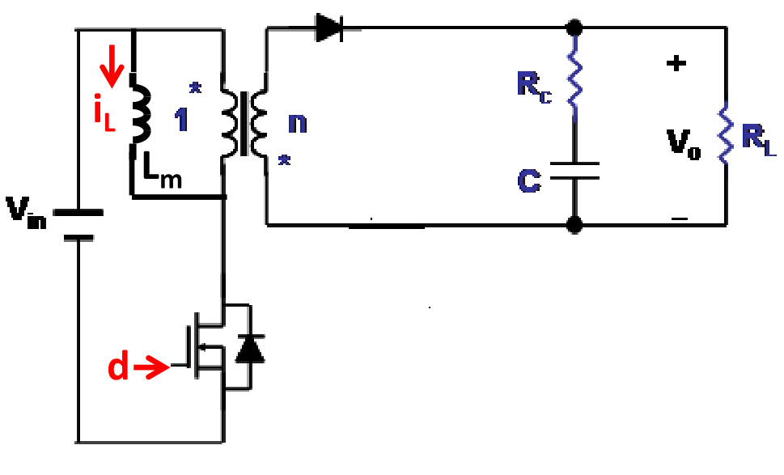
The difference between buck-boost transformer and flyback converter is the turns ratio on inductor, in buck-boost converter, it is a $1:1$ transformer, in its corresponding small signal model, the equivalent ideal DC transformer ratio should be $D^{'}:1$.
Buck-boost converter Flyback converter

Therefore, we can simply substitute the relating DC terms ($V_{o}, I_{L}, D^{'}:1$) in buck-boost small signal model to the $1/n$ times DC terms in flyback model ($\frac{V_{o}}{n},\frac{I_{L}}{n}, D^{'}:n$), inducing the small signal model as:
Small signal circuit model for flyback converter
The general expression of Gvd(s)=vo(s)/d(s) of flyback converter can be shown as,
$$\frac{V_{in}\left(n +(1-n)D - \frac{nDL_{e}}{R_{L}}s\right)\left(1+R_{c}Cs\right)}{{D'}^{2}\left(1+\left(R_{c}C+\frac{L_{e}}{R_{L}}\right)s+L_{e}C\left(\frac{{R_{c}+R}_{L}}{R_{L}}\right)s^{2}\right)}$$
$$G_{vd}\left(s\right)=G_{vd0}\frac{\left(1 -\frac{s}{ω_{Z}}\right)\left(1+\frac{s}{ω_{esr}}\right)}{\left(1+\frac{1}{Q}\frac{s}{ω_{0}}+\frac{s^{2}}{ω_{0}^{2}}\right)}$$
$G_{vd0}=\frac{V_{in}(n+D-nD)}{D^{'2}}$, $L_{e}=\frac{L}{D^{'2}}$, $ω_{Z}=\frac{R_{L}(n+D-nD)}{DL_{e}}$, $ω_{esr}=\frac{1}{R_{c}C}$, $ω_{0}=\frac{1}{\sqrt{L_{e}C\left(\frac{{R_{c}+R}_{L}}{R_{L}}\right)}}$, $Q=\frac{\sqrt{L_{e}C\left(\frac{{R_{c}+R}_{L}}{R_{L}}\right)}}{\left(R_{c}C+\frac{L_{e}}{R_{L}}\right)}$.

4) Discussion. You must discuss the following (discuss in detail):
(1) Qualitatively explain the conditions under which the expression Gvd(s) derived in Question 1 is valid? For the inductance, input voltage, output voltage and switching frequency given in Question 2, find the load resistance range over which expression for Gvd(s) in question 1 is valid.

The expression Gvd(s) from Q1 is derived based on CCM buck-boost converter. If the converter changes its operation mode to DCM, then the transfer function will be invalid.
For the condition in Q2, assuming the converter works approaching to CrCM, then:
$$DV_{in}=D^{'}V_{o}→D=0.25$$
$$I_{L}=\frac{I_{o}}{D^{'}}=\frac{V_{in}D}{R_{L}D^{'2}}→R_{L}=\frac{16}{3}Ω$$
If the output load is smaller than 16/3ohm, the expression of Gvd(s) is valid, otherwise invalid.

(2) Does the right half plane zero exist in all transfer functions that you have derived in Question 1 for Buck-boost converter? Explain the physical origins of right-half plane zero in boost and buck-boost converters? Explain the gain and phase characteristic of right half plane zero?

RHPZ only exist in Gvd(s) of CCM buck-boost converter.
RHPZ is basically an additional delay between the input (duty cycle change) and the output voltage response. In boost and buck-boost converter, the inductor will resonant with output cap only when the main switch is off, When the duty cycle increases, the switch stays on longer, reducing the time the inductor transfers energy to the load, which initially reduces the output voltage, resulting a delay in the system.
From Gain perspective, the RHPZ has no effect on low frequency, when frequency gets higher and approach RHPZ, the gain will increase in +20db/dec.
From Phase perspective, the RHPZ effect is opposite to that of a normal LHPZ, which give phase a -90degree phase lagging and destabilizing the phase margin.

(3) Why the double pole location is a function of duty cycle in the buck-boost converter?

The double pole is located at the resonant frequency of the LC filter. The frequency of this double pole will move with the operating duty cycle of the buck-boost converter, because it is determined by the equivalent inductance of the circuit, and this is a function of duty cycle.

(4) What is the effect of circuit parameters Vin, RL, Rc and Fsw on transfer function Gvd(s) for buck-boost in question 1?

According to the Gvd(s) transfer function, $V_{in}$ only affect DC gain of the converter, $R_{L}$ and $R_{c}$ together affect the location of double pole, and $R_{c}$ affects the esr LHPZ, Fsw is the operating frequency, will affect converter respond from the whole frequency spectrum, when the Fsw is determined, the specific Gain and phase will be determined, too.

(5) Explain how the Gvd(s)=vo(s)/d(s) of buck-boost and fly back converters differ? Does the turn ratio have any impact on right-half plane zero (RHPZ) of flyback converter, if so, explain how it impacts RHPZ?

In buck-boost converter, RHPZ frequency is located at $ω_{Z}=\frac{R_{L}}{DL_{e}}=\frac{R_{L}{\left(1-D\right)}^{2}}{DL}$, while in flyback converter, the RHPZ is $ω_{Z}=\frac{R_{L}(n+D-nD)}{DL_{e}}=\frac{R_{L}{(n+D-nD)\left(1-D\right)}^{2}}{DL}$, the turns ratio $n$scales the output voltage thus affect the location of RHPZ by altering the equivalent inductance, A higher turns ratio increases the frequency of the RHPZ, potentially improving stability and control performance but still introducing a phase lag that must be carefully managed in the control design.

(6) Explain the average modeling concept and its assumptions introduced in Chapter 1? Why does the small-signal model obtained using the average concept not agree with the simulation around switching frequency?

The Chapter 1 average concept includes three main factors: Averaging over one switching period; small signal perturbation; linear approximation.
They based on the assumptions that all injected perturbations are slow varying compared to the switching frequency; circuit works in steady state (constant duty cycle); and the high-order perturbations are neglected in the modeling.
When approaching the switching frequency, the switching frequency dynamics cannot be ignored and its related harmonics components will impact system; also the average model cannot capture the aliasing and sampled data effects, closing to the switching frequency.

