Three-terminal PWM switch model
1. Analysis of Buck-Boost converter (Diode and Switch are both ideal)
using three-terminal PWM switch model:
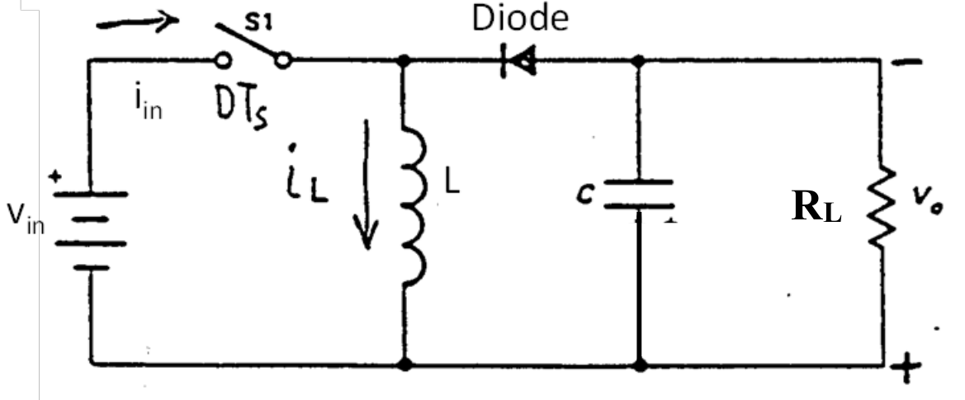
With circuit parameters as follows: Vin=12 V, Vo=4V, C= 300 uF, Fsw = 300 kHz, RL = 2 Ω.
1-A. Continuous Conduction Mode (CCM) Case [Ls = 10𝛍H] (25%)
i) Derive DC Model. (5%)
ii) Derive Small-signal equivalent circuit model. (5%)
iii) Derive transfer function of control to output Gvd(s)=vo(s)/d(s), and output impedance Zo(s)= vo(s)/io(s). (10%)
iv) Verify the model results of Gvd(s) and Zo(s) with SIMPLIS simulation. (5%)

i) For DC analysis, $\hat{d}$ is zero, $L$is a short and $C$ is an open. Then by a simple loop equation we get
$$-V_{in}+\frac{V_{CP}}{D}-V_{o}=0→V_{CP}=\left(V_{in}-V_{o}\right)D$$
According to steady state current equaitons:
$$I_{L}=-\frac{I_{o}}{1-D}$$
$$I_{o}=\frac{V_{o}}{R}$$
and writing another KVL loop to solve for $V_{CP}$, we get:
$$V_{CP}+V_{o}+V_{L}=0$$
While in average model the voltage across inductor $L$ in a switching period average is zero, then:
$$V_{CP}=-V_{o}$$
we solve them to get the steady-state voltage conversion relationship for the buck-boost power stage operating in CCM:
$$V_{o}=-V_{in}*\frac{D}{D^{'}}$$
ii) According to three-terminal PWM switch model, the equivalent circuit of buck-boost converter can be plotted as:
Where,
$$v_{AP}=v_{in}-v_{o}=V_{in}+\hat{v_{in}}-V_{o}-\hat{v_{o}}$$
$$v_{CP}=V_{CP}+\hat{v_{CP}}=\left(D+\hat{d}\right)\left(V_{AP}+\hat{v_{AP}}\right)=DV_{AP}+D\hat{v_{AP}}+V_{AP}\hat{d}+\hat{d}\hat{v_{AP}}$$
$$i_{C}=i_{L}=I_{L}+\hat{i_{L}}=-\frac{I_{o}}{1-D}+\hat{i_{L}}$$
$$i_{A}=I_{A}+\hat{i_{A}}=\left(D+\hat{d}\right)\left(I_{C}+\hat{i_{C}}\right)=DI_{C}+D\hat{i_{C}}+I_{C}\hat{d}+\hat{d}\hat{i_{C}}$$
iii) Derive transfer function:
For $G_{vd}(s)$ calculation, use superimposition law:
Accroding to KCL and KVL
$$\left\{\begin{aligned}I_{C}\hat{d}=i_{1}+i_{L}+i_{2} (KCL) \\ i_{1}=i_{L}*D (transformer) \\ v_{1}+\frac{V_{AP}}{D}\hat{d}=v_{2}+sLi_{2} (KVL1) \\ v_{1}=\frac{v_{2}}{D}(transformer) \\ v_{1}+\frac{V_{AP}}{D}\hat{d}=i_{2}*(\frac{1}{sC}||R_{L}) (KVL2)\end{aligned}\right.$$
Then we can derived the transfer function as:
$$G_{vd}\left(s\right)=\frac{V_{in}\left(1 -\frac{DL_{e}}{R_{L}}s\right)}{{D'}^{2}\left(1+\frac{L_{e}}{R_{L}}s+L_{e}Cs^{2}\right)}$$
$$G_{vd}\left(s\right)=G_{vd0}\frac{\left(1 -s/ω_{Z}\right)}{\left(1+\frac{1}{Q}\frac{s}{ω_{0}}+\frac{s^{2}}{ω_{0}^{2}}\right)}$$
Where $G_{vd0}=\frac{V_{in}}{D^{'2}}$, $L_{e}=\frac{L}{D^{'2}}$, $ω_{Z}=\frac{R_{L}}{DL_{e}}$, $ω_{0}=\frac{1}{\sqrt{L_{e}C}}$, $Q=\frac{1}{R_{L}}\sqrt{\frac{C}{L_{e}}}$.
For $Z_{o}(s)$ calculation, use superimposition law:
$$i_{L}=\frac{\left(1-D\right)v_{o}}{sL}$$
$$i_{o}=-Di_{L}+i_{L}+\frac{v_{o}}{\frac{1}{sC}||R_{L}}=\left(1-D\right)\frac{\left(1-D\right)v_{o}}{sL}+\frac{v_{o}}{\frac{1}{sC}||R_{L}}=\frac{v_{o}}{sL_{e}}+\frac{v_{o}}{\frac{1}{sC}||R_{L}}$$
Therefore, we can derived the output impedance as:
$$Z_{o}=\frac{v_{o}}{i_{L}}=\frac{L_{e}s}{\left(1+\frac{L_{e}}{R_{L}}s+L_{e}Cs^{2}\right)}$$
$$Z\left(s\right)=Z_{o}\frac{1}{\left(1+\frac{1}{Q}\frac{s}{ω_{0}}+\frac{s^{2}}{ω_{0}^{2}}\right)}$$
Where $Z_{o}=L_{e}s$, $L_{e}=\frac{L}{D^{'2}}$, $ω_{0}=\frac{1}{\sqrt{L_{e}C}}$, $Q=\frac{1}{R_{L}}\sqrt{\frac{C}{L_{e}}}$.
iv) Comparison of SIMPLIS simulation results with average model:
According to circuit parameters Vin=12 V, Vo=4V in CCM, the duty cycle should be 0.25.
Bode plotes of CCM buck-boost converter $G_{vd}\left(s\right)=\frac{v_{o}\left(s\right)}{d\left(s\right)}$
Bode plotes of CCM buck-boost converter $G_{vv}\left(s\right)=\frac{v_{o}\left(s\right)}{v_{in}\left(s\right)}$

1-B. Discontinuous Conduction Mode (DCM) Case [Ls = 0.5𝛍H] (35%)
i) Derive DC Model. (7.5%)
ii) Derive Small-signal equivalent circuit model. (7.5%)
iii) Derive transfer function of control to output Gvd(s)=vo(s)/d(s), and output impedance Zo(s)= vo(s)/io(s). (15%)
iv) Verify the model results of Gvd(s) and Zo(s) with SIMPLIS simulation. (5%)
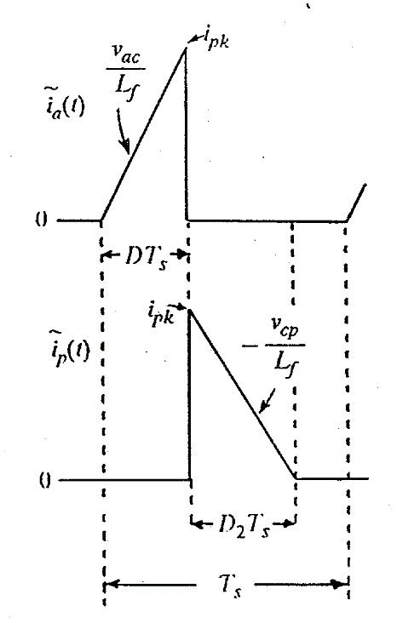
i) For Buck-boost converter DC Model:
$$I_{A}=\frac{I_{pk}}{2}D$$
$$I_{P}=\frac{I_{pk}}{2}D_{2}$$
$$V_{AC}=L\frac{I_{pk}}{DT_{s}}=V_{in}$$
$$V_{CP}=L\frac{I_{pk}}{D_{2}T_{s}}=-V_{o}$$
According to the instantaneous terminal currents shown, we have expressions for the average terminal currents and voltage as:
$$I_{A}=\frac{D}{D_{2}}I_{P}$$
$$V_{AC}=\frac{D_{2}}{D}V_{CP}$$
$$D_{2}=\frac{2L}{DT_{s}}\frac{I_{A}}{V_{CP}}=\frac{2L}{DT_{s}}\frac{I_{P}}{V_{AC}}$$
Therefore, With the above four equations, we have the DC equivalent circuit as: (the inductor is short circuit and capacitor is open circuit)
$$V_{CP}=μV_{AC}$$
$$I_{A}=μI_{P}$$
$$μ=\frac{D^{2}}{2LF_{s}}\frac{V_{CP}}{I_{A}}=\frac{D^{2}}{2LF_{s}}\frac{V_{o}}{I_{in}}$$
Therefore, the DC voltage gain of input and output is:
$$M=\frac{V_{o}}{V_{in}}=\frac{V_{CP}}{V_{AC}}=μ=\frac{D^{2}}{2LF_{s}}\frac{V_{CP}}{I_{A}}=\frac{D^{2}}{2LF_{s}}\frac{V_{CP}}{μI_{P}}=\frac{D^{2}R}{2LF_{s}}\frac{1}{μ}→M=μ=D\sqrt{\frac{R}{2LF_{s}}}$$

ii) For Small-signal equivalent circuit model, after applying perturbation and linearization, the equivalent circuit can be plotted as:
Where, $g_{i}=\frac{I_{A}}{V_{AC}}$, $k_{i}=\frac{2I_{A}}{D}$, $k_{o}=\frac{2I_{P}}{D}$, $g_{o}=\frac{I_{P}}{V_{CP}}$, $g_{f}=\frac{2I_{P}}{V_{AC}}$.
By substituting all the DC value into the components, we get the equivalent circuit as:
Where, $R_{e}=\frac{2LF_{s}}{D^{2}}$, $M=D\sqrt{\frac{R_{L}}{2LF_{s}}}$.

iii) For $G_{vd}(s)$ calculation, use superimposition law:
$$G_{vd}\left(s\right)=\frac{{\hat{ν}}_{0}}{\hat{d}}=G_{d0}\frac{(1-s/ω_{z2})}{(1+s/ω_{p1})(1+s/ω_{p2})}$$
Where $ω_{z2}=\frac{R_{L}}{M\left(1+M\right)L}$, $ω_{p1}=\frac{2}{R_{L}C}$, $ω_{p2}=2F_{s}{\left(\frac{\frac{1}{D}}{1+\frac{1}{M}}\right)}^{2}$, $G_{d0}=V_{in}\sqrt{\frac{R_{L}}{2LF_{s}}}=\frac{V_{o}}{D}$.
For $Z_{o}(s)$ calculation, use superimposition law:
$$Z_{o}(s)=Z_{0}\frac{(1-s/ω_{z2})}{(1+s/ω_{p1})(1+s/ω_{p2})}$$
Where $ω_{z2}=\frac{R_{L}}{M\left(1+M\right)L}$, $ω_{p1}=\frac{2}{R_{L}C}$, $ω_{p2}=2F_{s}{\left(\frac{\frac{1}{D}}{1+\frac{1}{M}}\right)}^{2}$, $Z_{0}=1$
According to circuit parameters Vin=12 V, Vo=4V, Fsw = 300 kHz, RL = 2 Ω, and L = 0.5uH in DCM, with equation from steady state $\frac{V_{o}}{V_{in}}=D\sqrt{\frac{R}{2LF_{s}}}$, we can derived the fixed duty cycle as 0.129. Then we can plot SIMPLIS simulation compared with modeled transfer function as:
Bode plotes of DCM buck-boost converter $G_{vd}\left(s\right)=\frac{v_{o}\left(s\right)}{d\left(s\right)}$
Bode plotes of DCM buck-boost converter $G_{vv}\left(s\right)=\frac{v_{o}\left(s\right)}{v_{in}\left(s\right)}$
1-C. Case Discussion (Your discussion should be rich enough.) (20%)
(i) What are the differences you observe between the control-to-output response and output impedance characteristics in CCM and DCM conditions? Will DCM reduce converter transfer function order? Does the system exhibit first order or second-order response in DCM?
Answer:
In CCM, the control-to-output response is second-order respond because the inductor energy is continuously flowing; the output impedance in CCM is typically lower.
In DCM, the control-to-output response typically exhibits a first-order response (To be specific the average model in both CCM and DCM is of the same 2nd order, the difference being only in the damping); the output impedance is generally higher and exhibits different frequency characteristics because the inductor does not continuously store energy.

DCM reduces the converter transfer function order. The key reason is that the inductor no longer contributes continuously to energy storage in the system, reducing the number of dynamic elements participating in the transfer function.

(ii) Does the magnitude plot of DCM control-to-output transfer function contain resonant peaks? If not, mathematically and physically explain the origins of additional damping using the transfer function and three-terminal model you derived in question 1B.
Answer:
In Discontinuous Conduction Mode (DCM), the magnitude plot of the control-to-output transfer function does not contain resonant peaks.

From math point of view, the two poles $ω_{p1}$ and $ω_{p2}$ are separate due to the DCM operation. The low frequency pole is controlled by capacitor; the high frequency pole is controlled by inductor (occurs in the range $f_{p2}$ > $f_{s}$). The damping comes from the equivalent small-signal resister $g_{o}$ and $g_{i}$ in the small-signal model. When $g_{o}$ and $g_{i}$ is big enough L is equally a part of current source, so no resonance exists in the system.

From physics point of view, in DCM, when the inductor current drops to zero, the inductor no longer stores energy. This introduces a "dead time" in the switching period where no energy is being transferred from the inductor to the load, the capacitor is separate from inductor and charge the load itself, broken the connection as well as the resonance between L C components.

(iii) Will DCM eliminate the right-half plane zero (RHPZ) in buck- boost converters? Explain the reasons for your stance.
Answer:
DCM cannot eliminate the RHPZ in buck-boost converter, but DCM operation could push this RHPZ to very high frequency. It can be easily seen that the RHPZ has the same dependence on M and the circuit parameters as the RHPZ in CCM. The relative position of $S_{z2}$ to $S_{p2}$ is given by:
$$S_{z2}=S_{p2}(1+1/M)>2F_{s}$$
where $S_{z2}$ occurs after $S_{p2}$. Hence, this RHPZ has no impact on converter’s controller design as it is out of the range of our desired design region (0.1~0.5$f_{s}$).

(iv) Analytically compare the relative locations of RHPZ in CCM and DCM conditions? which operation mode move RHPZ to higher frequency CCM or DCM?
Answer:
RHPZ exists in buck-boost-derived converters both in CCM and DCM. The power-stage inductance L determines the frequency at which it exists.
In DCM, it exists at a very high frequency beyond our highest frequency of interest such that its effect doesn't affect our feedback loop. This is because of the low-value inductance used in the power stage.
In CCM, because the inductance is heavy, it shows up at a frequency lower than our switching frequency and actually dwells within the vicinity of our desired crossover frequency

2. General Discussion. (20%) (Your discussion should be rich enough.) You must discuss the following:
(i) To derive the DCM three-terminal switch model, the ipk (peak current of inductor) is used. However, it is not used while deriving the CCM model. Does it mean the switching ripple is considered in small-signal model under DCM operation? State your opinion and explain the reason.
Answer:
No, there is no ripple information in the controller as only average value are taken as calculation value (See DC equivalent circuit derivation of DCM converter, or Slides Eq 5, Eq 6), the peak current is basically cancelled in the math procedure.

ii) For the small-signal model of PWM switching converters based on three-terminal PWM switch concept, will fsw (switching frequency) influence small-signal model? State your opinion and explain the reason. (Consider operation of CCM and DCM)
Answer:
The switching frequency $f_{s}$ can influence the small-signal model, but its impact is more evident in DCM than in CCM.
In CCM, the effect of $f_{s}$ on the small-signal model is usually minimal. The small-signal model reflects the low-frequency dynamics of the converter, which are primarily governed by the interaction of the inductor, capacitor, and load, rather than the high-frequency switching action. The switching frequency only becomes important if interested in high-frequency behavior, such as the effects of switching harmonics, but these are typically filtered out by the low-pass filter of L and C.

In DCM, the small-signal model is highly influenced by $f_{s}$. The switching period impacts the duty cycle and the amount of energy transferred in each cycle. From math point, the duty cycle is a function of the switching frequency and the converter's operating conditions; from physics view, energy transfer occurs in discrete "packets" because the inductor fully discharges and remains at zero for part of the cycle, which introduces more pronounced switching effects, so the switching frequency plays a larger role in determining how quickly energy is delivered to the load.

