Buck Converter _Voltage Mode Control
Synchronous rectifier (SR) buck converter is often used in the low voltage high current applications. It uses a synchronous rectifier (MOSFET) instead of the diode in the normal buck topology. The two MOSFETs’s gate signals are complementary. There is no DCM operation for the SR buck. The circuit diagram is shown below.
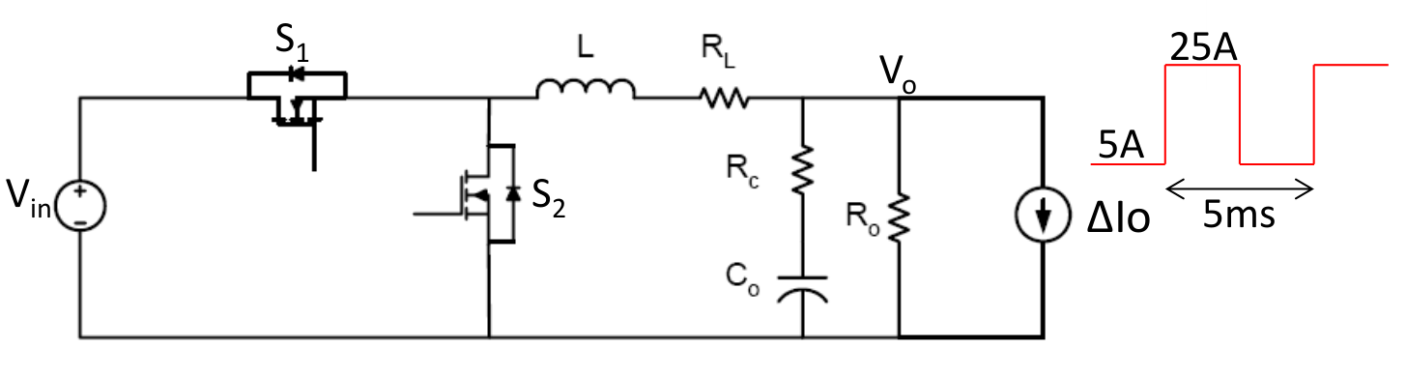
The parameters of the above SR buck converter are:
Vin=12V, Vo=2V, L=150nH, RL=2mΩ, Rc=1mΩ, Co=1mF, Ro=200mΩ, fs=1MHz; As shown in the graph, load transient current step ΔIo=20A with period Tload=5ms. Load transient is assumed to be an ideal square waveform (50% duty cycle) with 0 rising and falling time. In this exercise, we assume S1 and S2 are ideal switches and neglect the dead-time between S1 and S2.

1) Using three-terminal switch model, derive open-loop output impedance transfer function. Show the bode plot and verify with SIMPLIS simulation (Frequency range: 100Hz to 1MHz). Simulate the open-loop load transient response in SIMPLIS (Load transient current step ΔIo=20A, 5A to 25A with period Tload=5ms),

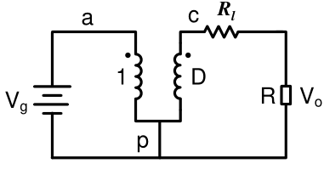
1) For DC analysis, $\hat{d}$ is zero, $L$is a short and $C$ is an open. Then by a simple loop equation we get
$$M=\frac{V_{o}}{V_{in}}=D\frac{R_{o}}{R_{o}+R_{l}}=D\frac{1}{1+\frac{R_{l}}{R}}≈D$$
We also need the operating point (Vap, IC) which is required in the small-signal model:
$$V_{AP}=V_{in}$$
$$I_{C}=\frac{V_{o}}{R_{o}}=\frac{DV_{in}}{R_{o}}$$
According to three-terminal PWM switch model, the control to output equivalent circuit of buck converter can be plotted as the following figure, which can be further simplified as the right one, then:
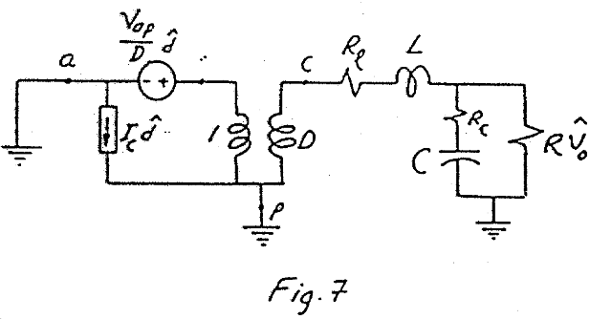
$$\hat{v_{o}}=V_{in}\hat{d}\frac{\left(R_{c}+\frac{1}{sC}\right)∥R_{o}}{R_{l}+sL+\left(R_{c}+\frac{1}{sC}\right)∥R_{o}} \\ =\frac{R_{o}*V_{in}\left(1+R_{c}Cs\right)}{\left(1+R_{o}Cs+R_{c}Cs\right)\left(R_{l}+ Ls +\frac{R_{o}\left(1+R_{c}Cs\right)}{1+R_{o}Cs+R_{c}Cs}\right)}$$
Then we can derive the transfer function as:
$$G_{vd}\left(s\right)=\frac{\hat{v_{o}}}{\hat{d}}=\frac{V_{in}\left(1+R_{c}Cs\right)}{\left(1+\frac{R_{l}}{R_{o}}+\left(\frac{R_{l}R_{c}}{R_{o}}C+R_{l}C+R_{c}C+\frac{L}{R_{o}}\right)s+LC\left(\frac{R_{o}+R_{c}}{R_{o}+R_{l}}\right)s^{2}\right)}$$
$$G_{vd}\left(s\right)=G_{vd0}\frac{\left(1+s/ω_{Z}\right)}{\left(1+\frac{1}{Q}\frac{s}{ω_{0}}+\frac{s^{2}}{ω_{0}^{2}}\right)}$$
Where $G_{vd0}=V_{in}$, $ω_{Z}=\frac{1}{R_{c}C}$, $ω_{0}=\frac{1}{\sqrt{LC\left(\frac{R_{o}+R_{c}}{R_{o}+R_{l}}\right)}}$, $Q=\frac{1}{ω_{0}}\frac{R_{o}R_{l}}{CR_{l}\left(R_{c}+R_{o}\right)+CR_{c} R_{o}+L}=\frac{1}{ω_{0}}\frac{1}{\frac{L}{R_{l}+R_{o}}+C(R_{c}+R_{l}∥R_{o})}$.
The double poles located at $f_{0}$=1.3×10^4 Hz, and the ESR zero located at $f_{z}$=1.59×10^5 Hz. Numerically, the system transfer function should be:
$$G_{vd}\left(s\right)=\frac{\hat{v_{o}}}{\hat{d}}=\frac{2.4×{10}^{-6} s+2.4}{3.015×{10}^{-11} s^{2}+7.52×{10}^{-7} s+0.202 }$$
For $Z_{o}(s)$ calculation, use superimposition law:
$$Z_{o}=R_{o}∥\left(R_{c}+\frac{1}{sC}\right)∥\left(R_{l}+sL\right)=$$
$$\frac{R_{o}\left(1+R_{c}Cs\right)\left(R_{l} + Ls\right)}{\left(1+R_{o}Cs+R_{c}Cs\right)\left(R_{l}+ Ls +\frac{R_{o}\left(1+R_{c}Cs\right)}{1+R_{o}Cs+R_{c}Cs}\right)}$$
$$=\frac{R_{o}R_{l}}{R_{l}+R_{o}}\frac{\left(1+R_{c}Cs\right)\left(1 +\frac{L}{R_{l}}s\right)}{\left(1+\frac{R_{l}}{R_{o}}+\left(\frac{R_{l}R_{c}}{R_{o}}C+R_{l}C+R_{c}C+\frac{L}{R_{o}}\right)s+LC\left(\frac{R_{o}+R_{c}}{R_{o}+R_{l}}\right)s^{2}\right)}$$
$$Z_{o}\left(s\right)=\frac{\hat{v_{o}}}{\hat{i_{o}}}=Z_{0}\frac{\left(1+s/ω_{Z1}\right)\left(1+s/ω_{Z2}\right)}{\left(1+\frac{1}{Q}\frac{s}{ω_{0}}+\frac{s^{2}}{ω_{0}^{2}}\right)}$$
Where $Z_{0}=\frac{R_{o}R_{l}}{R_{l}+R_{o}}$, $ω_{Z1}=\frac{1}{R_{c}C}$, $ω_{Z2}=\frac{R_{l}}{L}$, $ω_{0}=\frac{1}{\sqrt{LC\left(\frac{R_{o}+R_{c}}{R_{o}+R_{l}}\right)}}$, $Q=\frac{1}{ω_{0}}\frac{R_{o}R_{l}}{CR_{l}\left(R_{c}+R_{o}\right)+CR_{c} R_{o}+L}$.
Numerically, the system transfer function should be:
$$Z_{o}\left(s\right)=\frac{\hat{v_{o}}}{\hat{i_{o}}}=\frac{3×{10}^{-14} s^{2}+3.04×{10}^{-8} s+0.004}{3.015×{10}^{-11} s^{2}+7.52×{10}^{-7} s+0.202 }$$
Bode plotes of open loop Buck converter $G_{vd}\left(s\right)=\frac{v_{o}\left(s\right)}{d\left(s\right)}$
Bode plotes of open loop Buck converter $Z_{o}\left(s\right)$
(left) step up, (right) step down
SIMPLIS Transient response of open loop buck converter

2) Close the loop with voltage mode control: (50%)
a. Design the type III compensator to achieve 80kHz bandwidth (your bandwidth should be within ±5kHz window, i.e, 75kHz to 85kHz) with at least 60 degree phase margin and at least 10dB gain margin (it is OK if your gain margin is infinite, i.e, your phase never reaches -180 degree.). Show your critical design steps and show the values of your resistors and capacitors in your final compensator. Please use some practical values in the compensator design. For resistors, 10Ω to 1MΩ and for capacitors, 1pF to 100μF are fine. (20%).
Bode plotes of Open loop $G_{vd}\left(s\right)$ and Closed loop $T\left(s\right)$ of Buck converter
According to Gvd(s) open loop transfer function. The double poles located at $f_{0}$=1.3×10^4 Hz, and the ESR zero located at $f_{z}$=1.59×10^5 Hz. Then we can initiate the compensation using the controlSystemDesigner Function. This function enables users to freely assign the compensator poles and zeros and tuning the closed loop system.
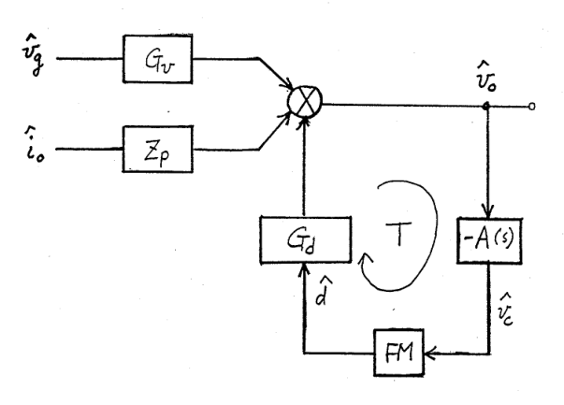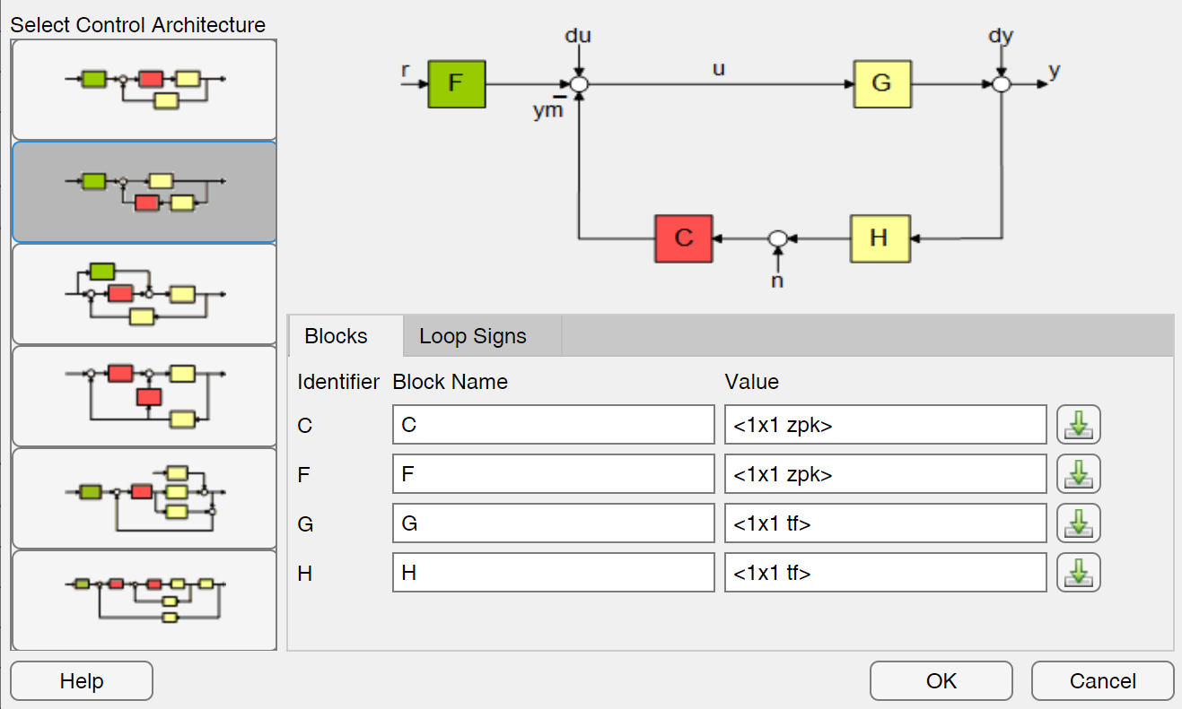
(left) Diagram cosed loop VCM buck converter, (right) controlSystemDesigner editable configuration

The loop of voltage mode buck converter has the same control architecture of controlSystemDesigner’s type 2 configuration, where the red C block is the compensator which is editable, located at the same place of FM*A(s).

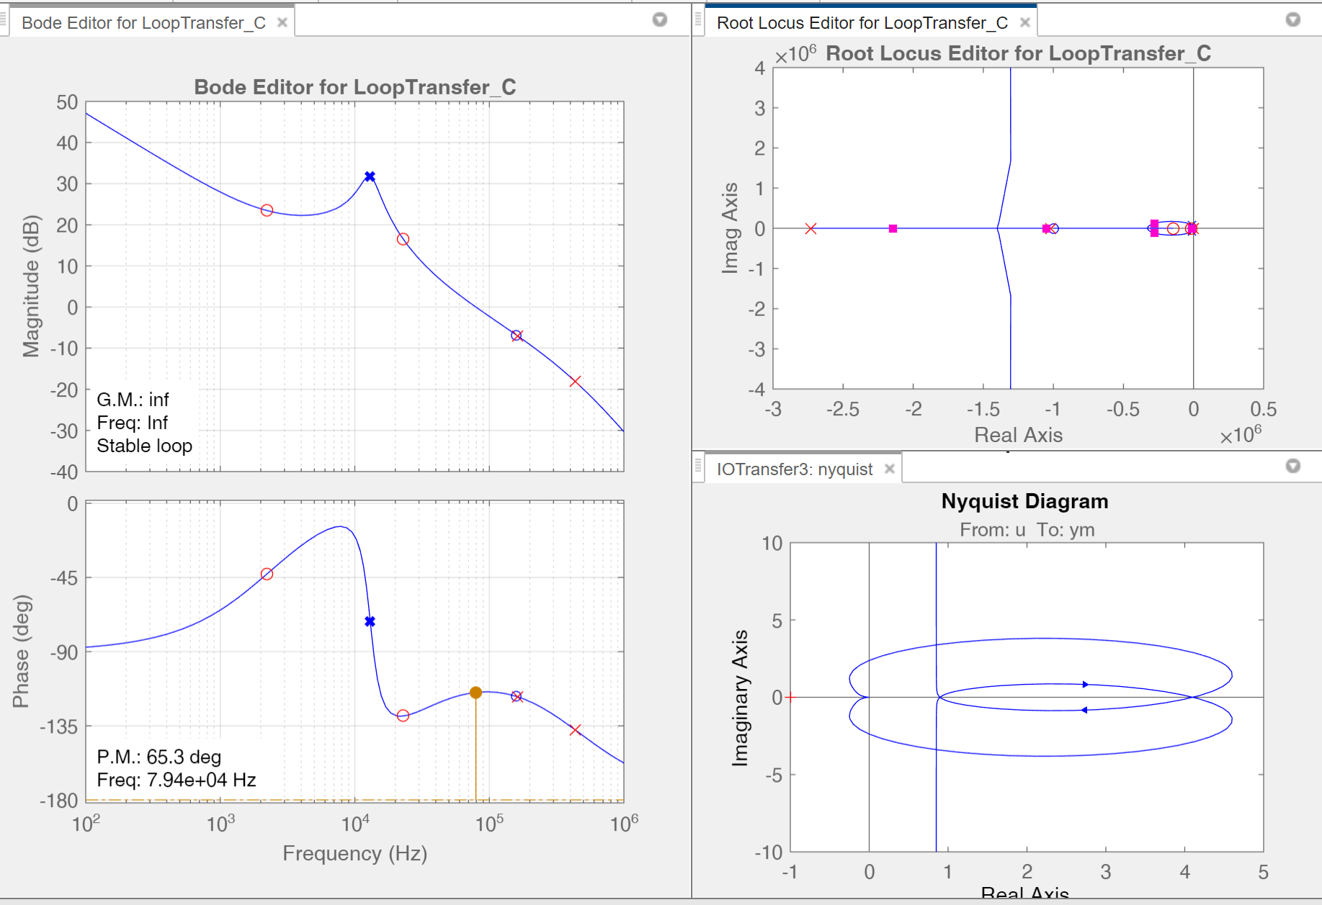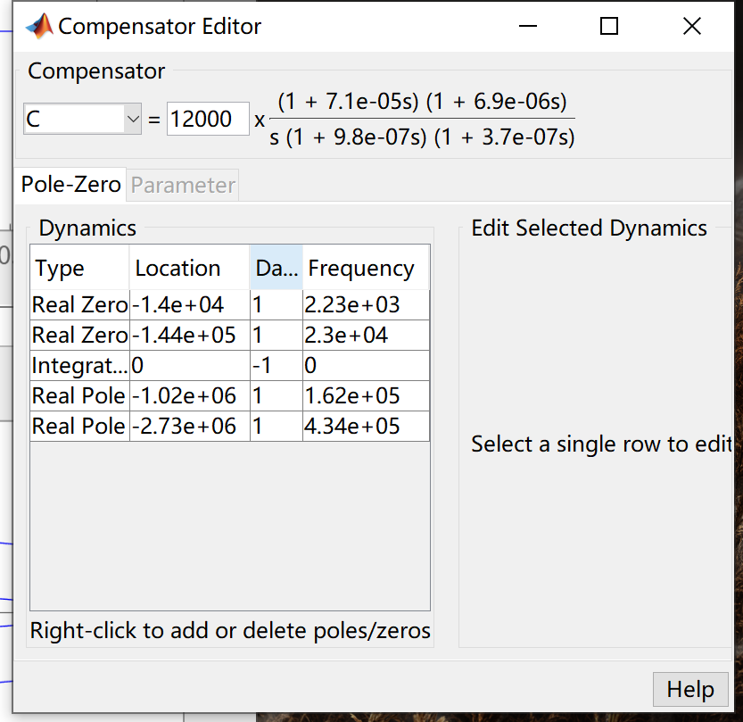
Chosed type III compensator with 2 real poles and 2 real zeros

As shown in the interface, we chose the proper combination of $ω_{i} , ω_{p1}, ω_{p2}, ω_{z1}, ω_{z2}$ to satisfied the closed system with a cut-off frequency of 80kHz and phase margin of above 60 degree. In this case, our chosen cut off frequency is 7.94kHz with phase margin of 65.3 degree. The exact $ω_{i} , ω_{p1}, ω_{p2}, ω_{z1}, ω_{z2}$ can be found in the next page.
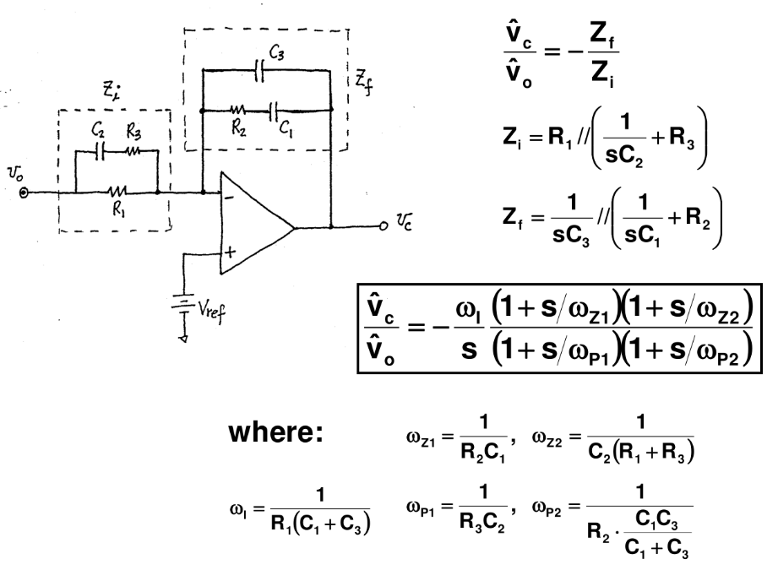
wi = 12000;
wz1 = 1.4e4;
wz2 = 1.44e5;
wp1 = 1.02e6;
wp2 = 2.73e6;

R1 = 100.00 k
R2 = 85.71 k
R3 = 14.12 k
C1 = 833.33 pF
C2 = 69.44 pF
C3 = 4.27 pF

Using the equations above, we can calculate the corresponding resister and capacitor value as above.

b. Show bode plot of your designed compensator transfer function and verify the transfer function with SIMPLIS simulation. Show bode plot of your designed loop gain transfer function and verify with SIMPLIS simulation (Mark the phase margin and gain margin). Show the bode plot of closed-loop output impedance and verify with SIMPLIS simulation. Please plot the model results and SIMPLIS on the same bode plot. (10%)
Bode plotes of Open loop $G_{vd}\left(s\right)$ and Closed loop $T\left(s\right)$ of Buck converter

Bode plotes of Closed loop $Z_{o}\left(s\right)$ of Buck converter

c. Simulate the same load step transient response in SIMPLIS as Question (1) and compare the results (overshoot, undershoot voltage and settling time) with open-loop case. Comment on the comparisons. (10%)
(left) step up, (right) step down
SIMPLIS Transient response of closed loop VCM buck converter with 80kHz cut-off frequency

Compared with open loop buck converter, the undershoot voltage decrease from 227.3mV to 43.73mV; the overshoot voltage decrease from 232.6mV to 28.58mV, about 100 times in amplitude. And the settling time are dramatically decreased from 334us level to 30us level. This result reveals the fact that proper closed loop can significantly improve the system dynamic and reduce the voltage shoots during the transient.

d. Change the first zero of your compensator design to 1/5 of the previous value while keeping the loop gain bandwidth still at 80kHz and at least 60 degree phase margin and at least 10dB gain margin. Please show bode plots of simulated loop gain both for this case and previous case in one graph. Compare the load transient performance with previous case. State your observations and explain the reason behind the observations. (10%)

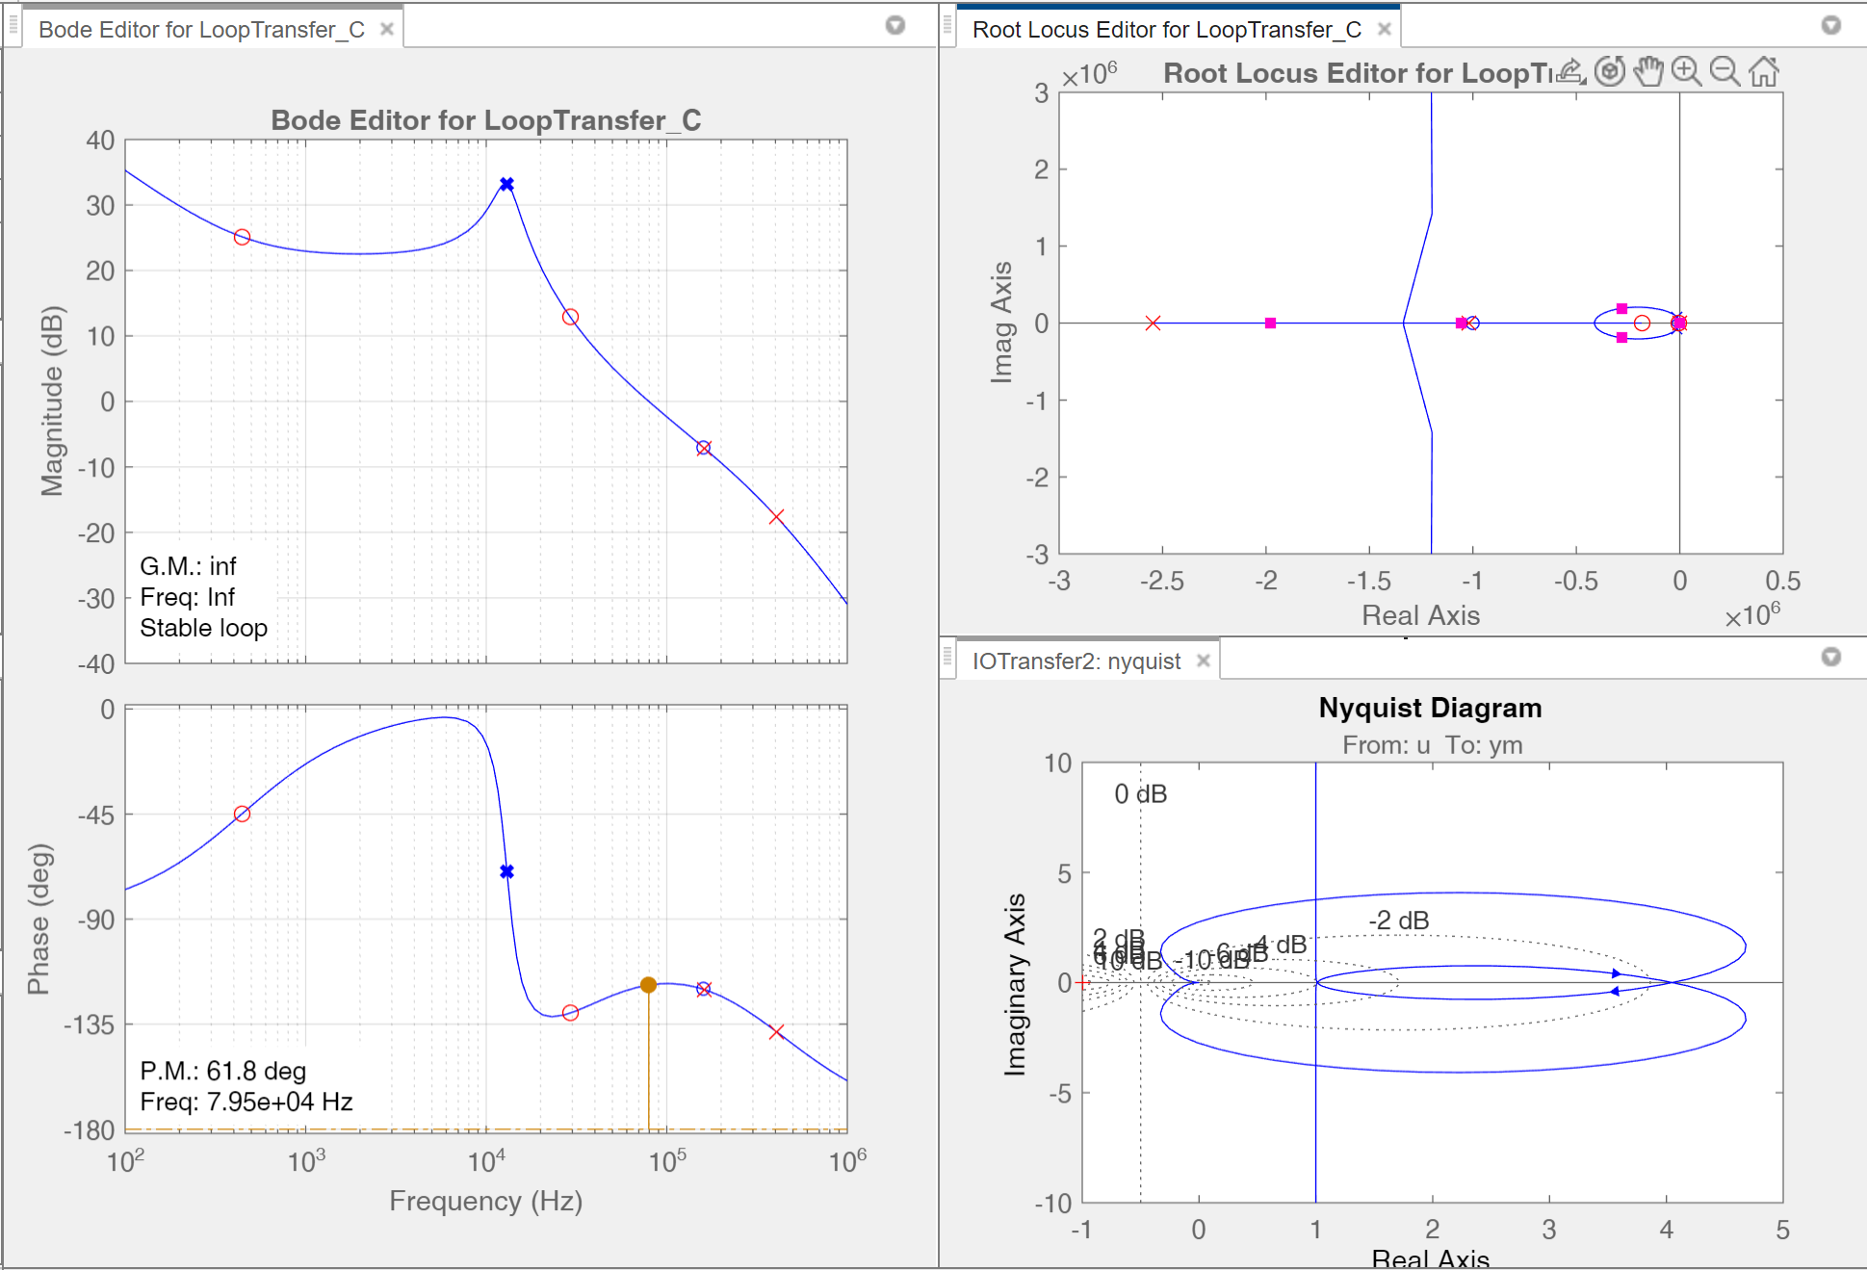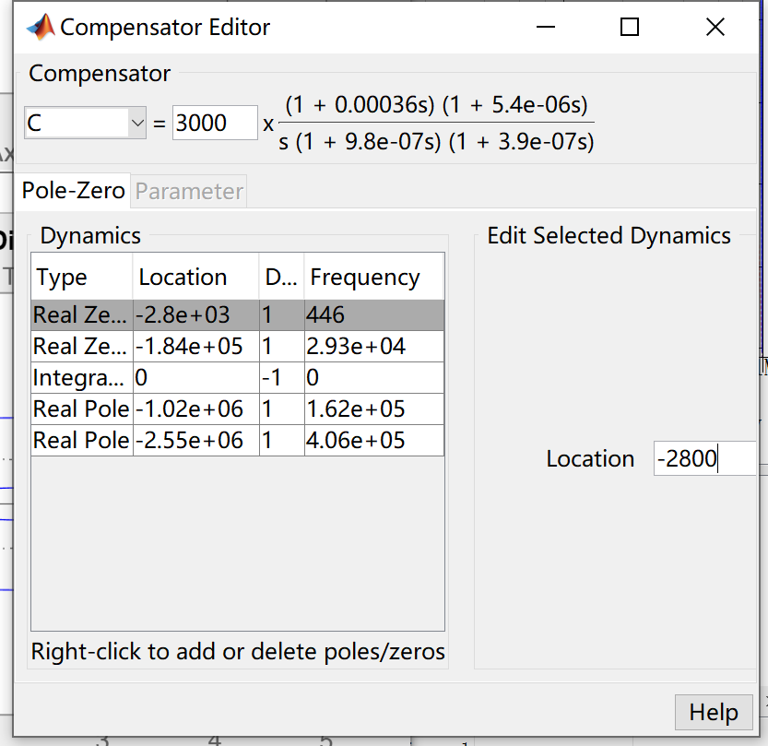
Chosed type III compensator with a 1/5$f_{z1}$ compared to the original case
(left) step up, (right) step down
Comparison Transient response of closed loop VCM buck converter with 80kHz cut-off frequency

Similarly, we can compensate the system with a 1/5 times first zero $f_{z1}$, but since we still keep the bandwidth at 80kHz, the integer of the closed loop should be decreased accordingly (otherwise the bandwidth will be increased dramatically). Even if we can split the two zeros to decrease the gain curve to a lower cut-off frequency, the first zero $f_{z1}$ is so dominated to the compensator that the influence of $f_{z2}$ is minimum.
(left) closed loop control to output transfer function $T(s)$, (right) closed loop output impedance $Z_{o}(s)$
Comparison plot of closed loop VCM buck converter with same $f_{c}$ and different $f_{z1}$

The transient response of two systems shows similar overshoots and downshoots voltage, but the settling time in reduced $f_{z1}$ compensator gets evidently large. The reason behind this phenomenon can be found through the closed loop output impedance where low frequency impedance gets higher in lower $f_{z1}$ compensator, increasing the low frequency step components amplitude, when this appears in load transient, longer settling time will be made.

3) Different loop gain bandwidth design: (35%)
a. Define the previous case fc=80kHz as case 1, now change loop gain bandwidth as the following two cases: Case 2: fc= 1kHz with at least 60 degree phase margin and at least 10dB gain margin; Case 3: fc=200kHz with at least 60 degree phase margin and at least 10dB gain margin. Describe what you change to increase and decrease the bandwidth. Show the bode plots of simulated loop gain for three cases in one graph (Mark the phase margin and gain margin for each case). You do not need to provide the detailed design steps for this part. (15%)

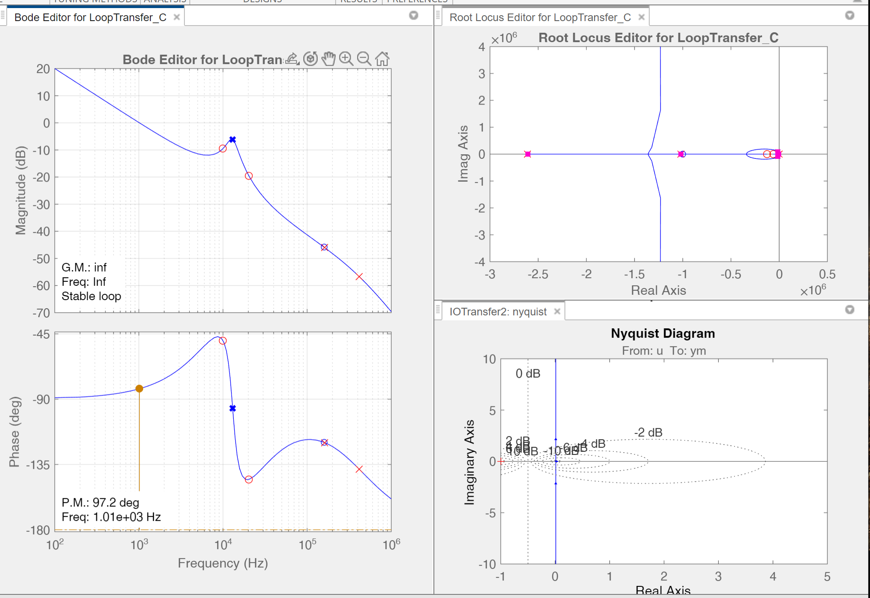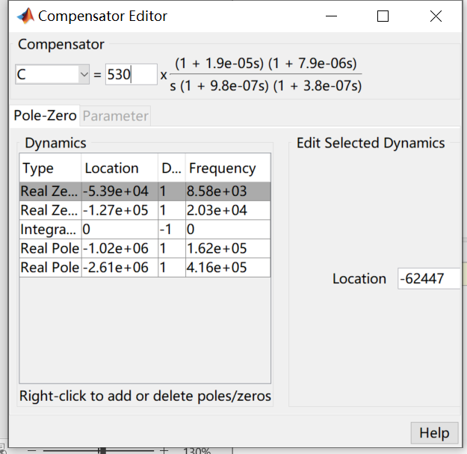
Chosed type III compensator with a 1kHz bandwidth compared to the original case
To obtain a 1kHz cut-off frequency system, the Integral gain $ω_{i}$ is significantly reduced, with a higher frequency $f_{z1}$ to further reducing the system gain, resulting $f_{z2}>f_{z1}≫f_{c}$. A early cross over is made.
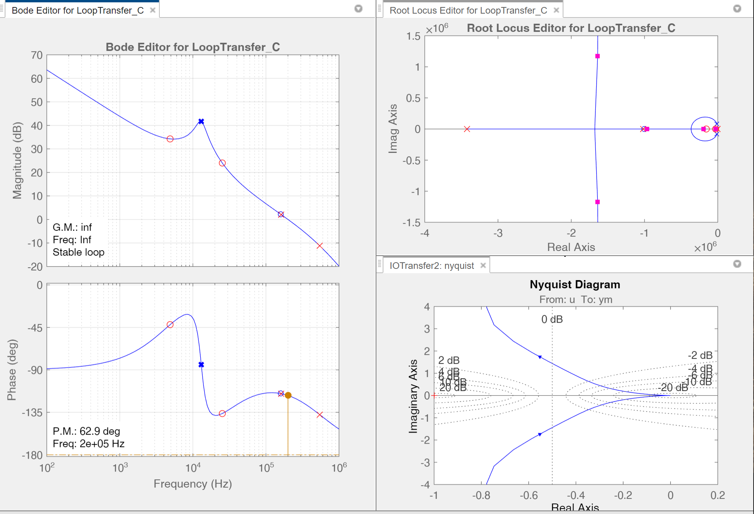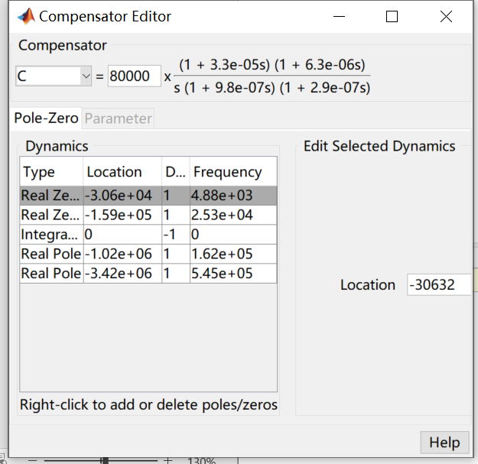
Chosed type III compensator with a 200kHz bandwidth compared to the original case
To obtain a 200kHz cut-off frequency system, the Integral gain $ω_{i}$ is increased to 80000, the most poles and zeros are unchanged or slightly drifted to be compatible to the requirement.

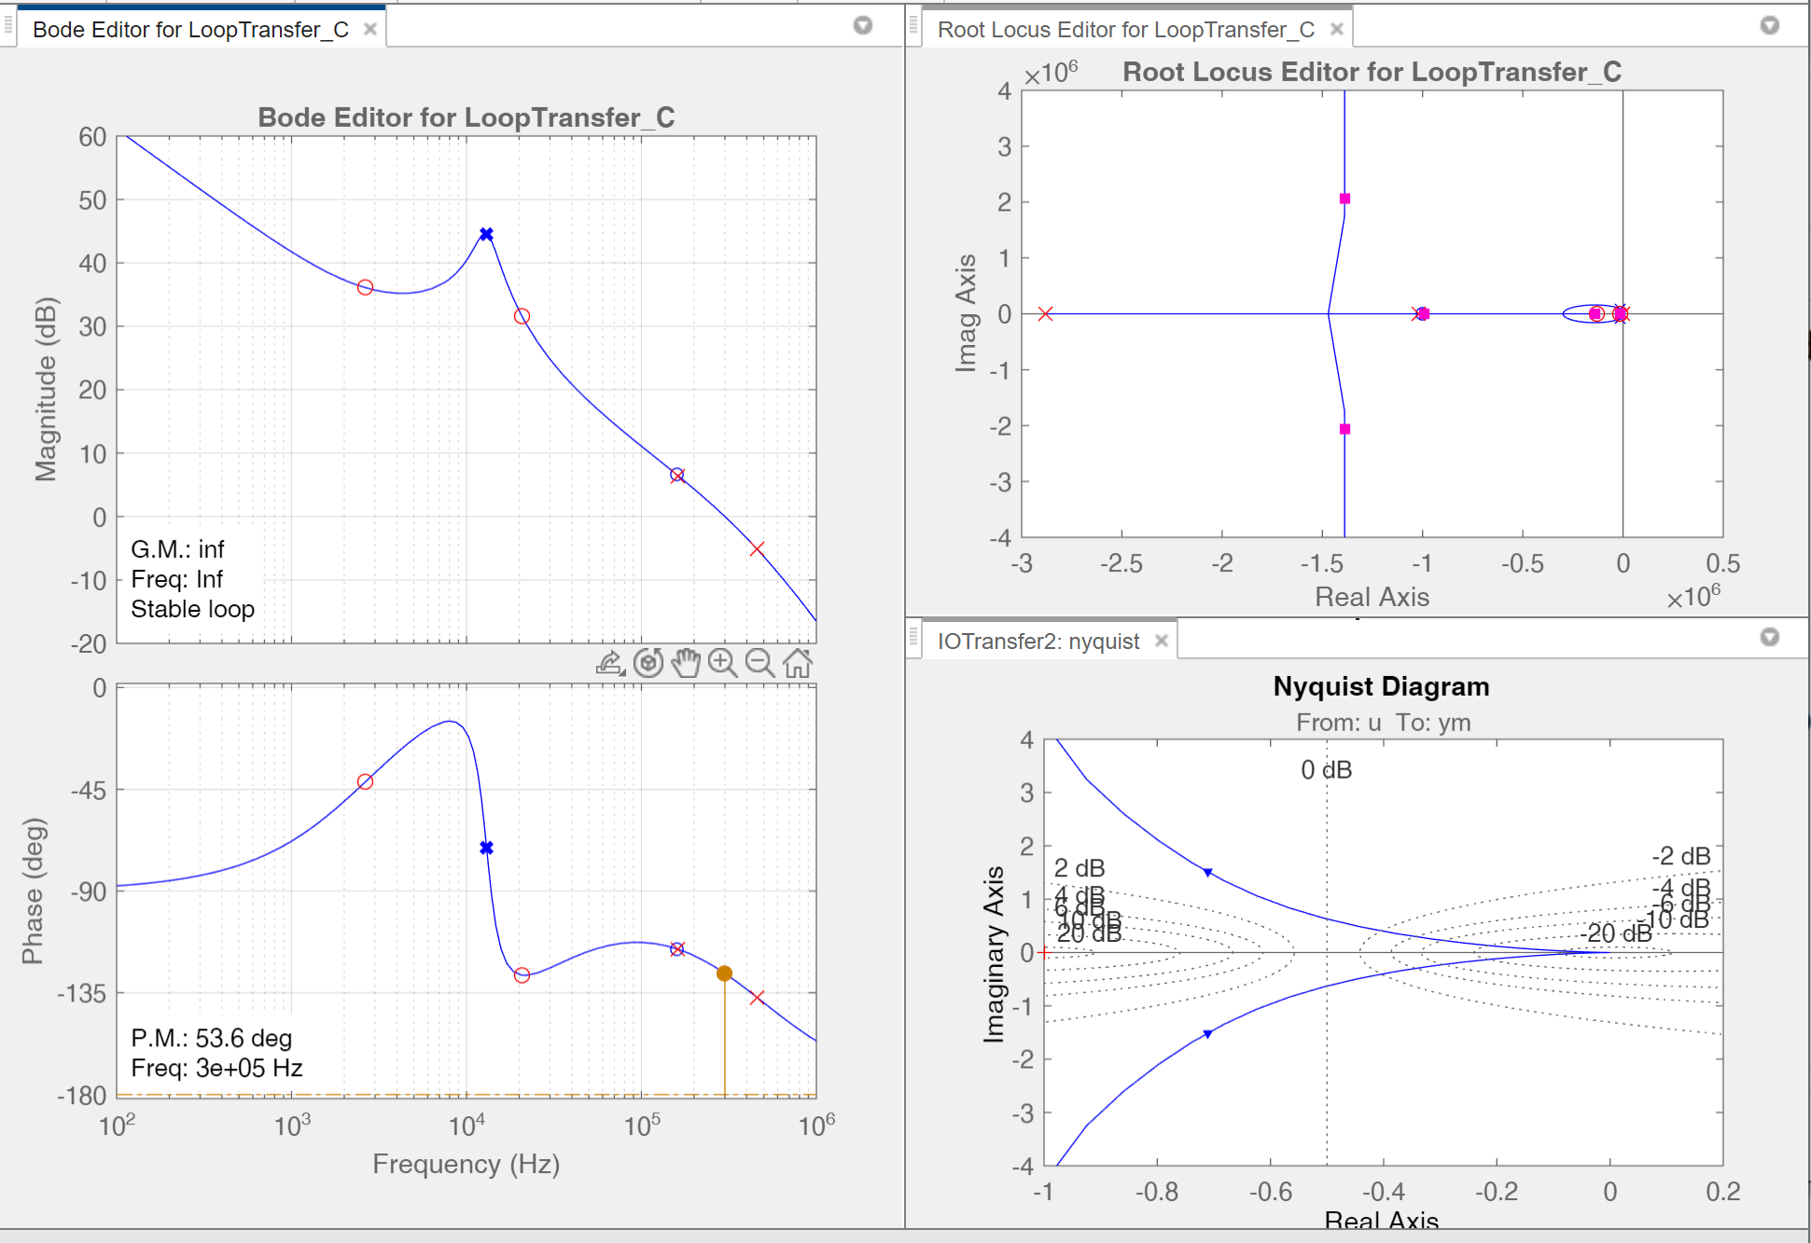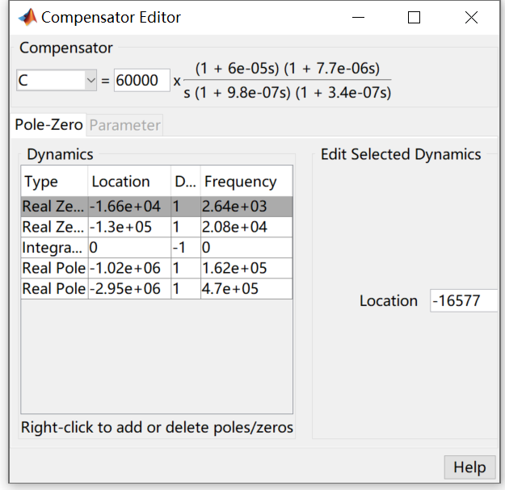
Chosed type III compensator with a 300kHz bandwidth compared to the original case

To obtain a 300kHz cut-off frequency system, the Integral gain $ω_{i}$ is increased to 660000, the two zeros are dragged to lower frequency to improve the cut-off frequency.

b. Show the closed-loop output impedances for these three cases in one graph and show the load step transient responses (overshoot, undershoot, and settling time) for these three cases in another graph. State your observations from these two graphs and explain the reason behind the observations. (10%)

(left) step up, (right) step down
Comparison plot of closed loop VCM buck converter with different cut-off frequency

(left) closed loop control to output transfer function $T(s)$, (right) closed loop output impedance $Z_{o}(s)$
Comparison plot of closed loop VCM buck converter with different cut-off frequency

It is clearly that higher bandwidth can reduce the settling time and attenuate the overshoots and downshoots, the diagram shows a trend that with bandwidth gets higher.
From the closed loop impedance, 1kHz closed loop shows a clear resonant point, which improves the impedance at this particular frequency, this matches the voltage shoots frequency; as the bandwidth push higher, the resonance disappear and the shoots gets lower accordingly.

c. Discussion: the overshoot and undershoot voltage are very important specs in many applications, does continuously pushing bandwidth to higher frequency keep reducing the overshoot and undershoot voltage? State your opinion and explain the reason. (10%)

Bandwidth Relative to Switching Frequency: Theoretically, keep pushing bandwidth can reduce the voltage shoots. However, in typical applications, control bandwidth doesn’t exceed the switching frequency because operating at higher bandwidths offers limited gains, there's little advantage in exceeding it.
Noise and Control Reliability: Higher bandwidth introduces increased noise sensitivity, which can compromise control reliability. When the control system operates at higher frequencies, it’s more susceptible to noise, which can lead to spurious signals and potential control failures.
Sensor Bandwidth and Cost Implications: Control bandwidth is ultimately limited by the bandwidth of the sensors used. Sensors with higher bandwidth are typically more expensive and add complexity to the design, which could make the system less cost-effective. Working within the bandwidth limitations of sensors helps maintain a balance between performance, cost, and complexity.

