**SUMMARY**

## USC ID/s:

Xiangjie Yuan: 4040019986

Haoyue Xu: 8869966520

Chenchao Lin: 8495662924

## Datapoints

|  |  |  |  |  |
| --- | --- | --- | --- | --- |
| M+N | Time in MS (Basic) | Time in MS (Efficient) | Memory in KB (Basic) | Memory in KB (Efficient) |
| 16 | 0.088 | 0.166 | 10360 | 10648 |
| 64 | 0.864 | 1.523 | 10332 | 10688 |
| 128 | 3.919 | 5.684 | 10484 | 10776 |
| 256 | 14.479 | 21.620 | 11184 | 10664 |
| 384 | 31.005 | 48.810 | 11852 | 10728 |
| 512 | 54.213 | 86.191 | 13008 | 10812 |
| 768 | 126.101 | 285.441 | 16424 | 10760 |
| 1024 | 222.848 | 355.337 | 21032 | 10744 |
| 1280 | 358.636 | 580.146 | 26964 | 10820 |
| 1536 | 553.691 | 827.774 | 34584 | 10840 |
| 2048 | 1022.417 | 1554.703 | 53092 | 10920 |
| 2560 | 1408.274 | 2407.146 | 76716 | 10996 |
| 3072 | 2192.303 | 3733.849 | 104820 | 11060 |
| 3584 | 2837.150 | 4529.528 | 141448 | 11036 |
| 3968 | 3982.372 | 5501.081 | 167628 | 11116 |

## Insights

### Graph1 – Memory vs Problem Size (M+N)

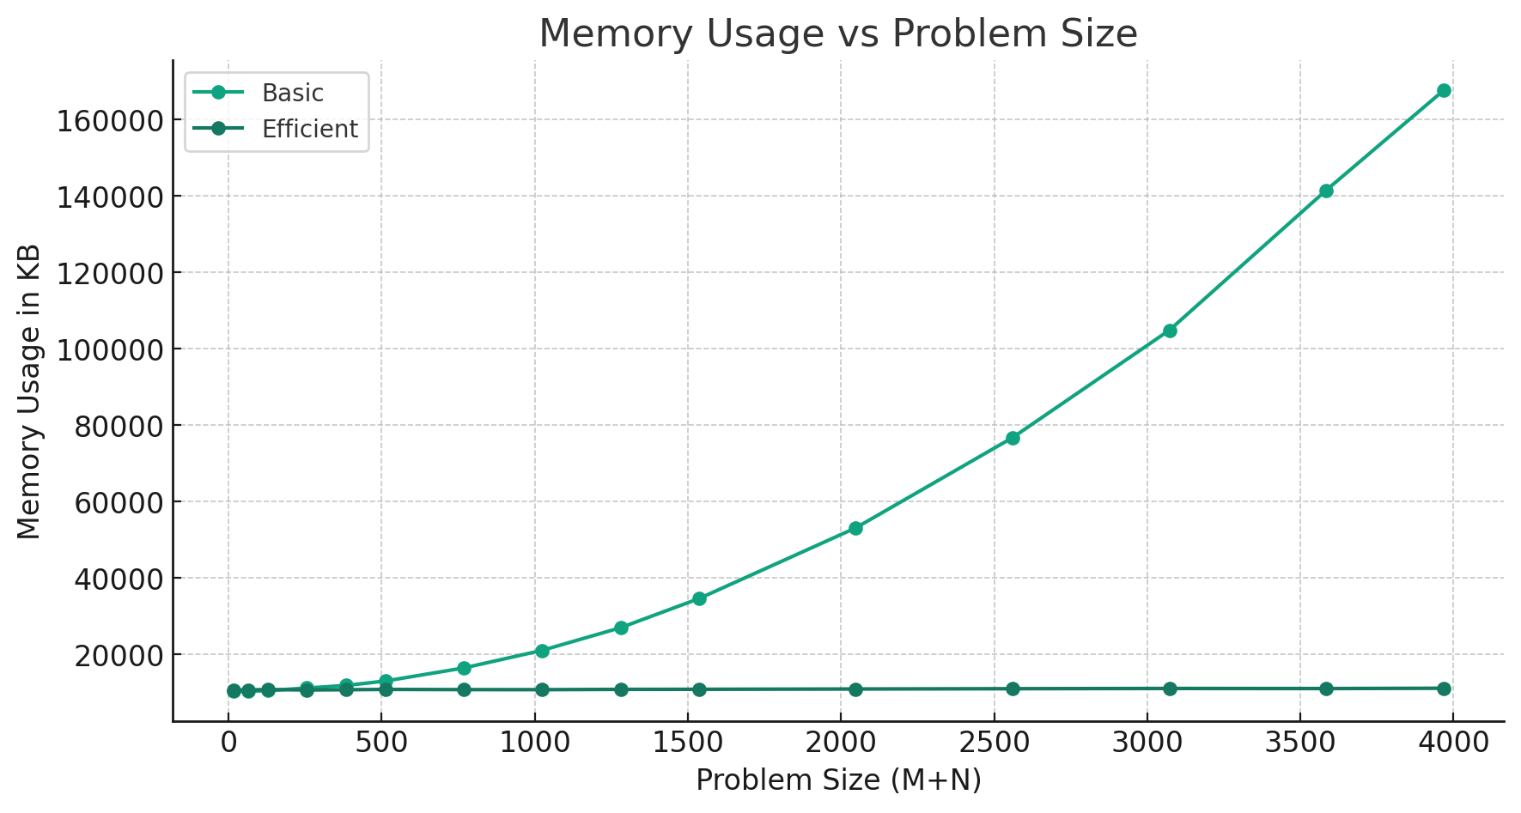

#### Nature of the Graph (Logarithmic/ Linear/ Polynomial/ Exponential)

Basic: Polynomial

Efficient: Linear

#### Explanation:

The Basic implementation shows a significant increase in memory usage as the problem size grows, indicating a higher space complexity. This is due to the use of a 2D memorization table in the Basic implementation, which stores the intermediate results for all subproblems.

The memory usage of the Basic implementation appears to grow quadratically with the problem size, suggesting an O((M+N)^2) space complexity. The size of the memorization table is directly proportional to the product of the lengths of the input strings.

In contrast, the Efficient implementation maintains a relatively constant memory usage across all problem sizes, indicating a more efficient memory utilization. The divide-and-conquer approach used in the Efficient implementation allows for a more space-efficient solution by recursively solving smaller subproblems and discarding intermediate results that are no longer needed.

The memory usage of the Efficient implementation is consistently lower than the Basic implementation, suggesting a better space complexity. The Efficient implementation achieves a space complexity of O(M+N) by storing only the necessary information for the current subproblem and the recursive calls.

### Graph2 – Time vs Problem Size (M+N)

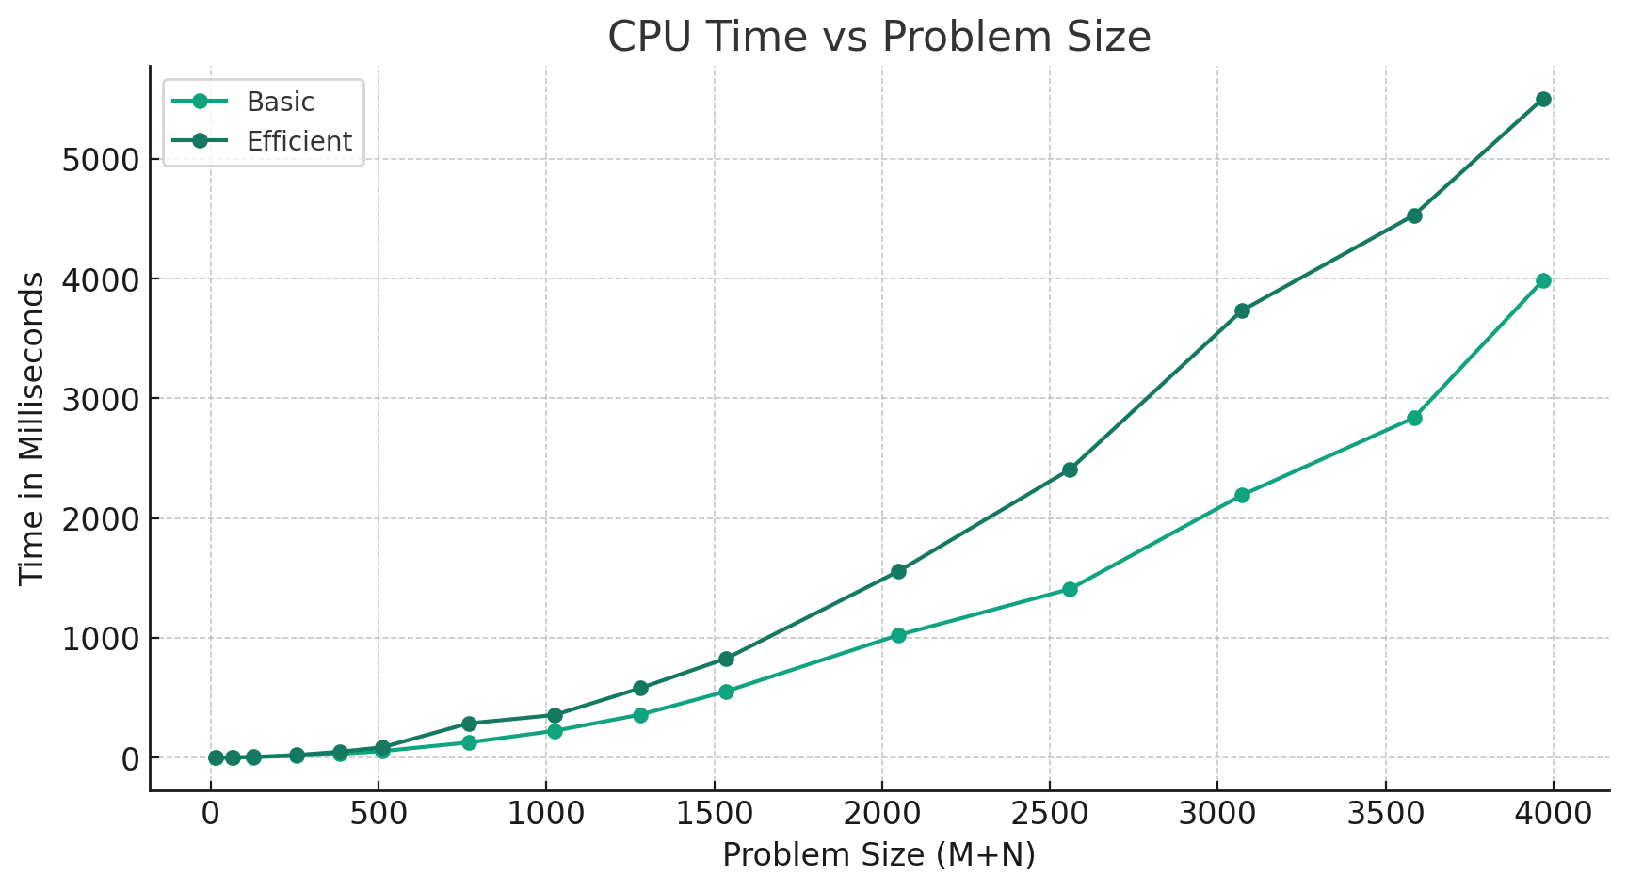

#### Nature of the Graph (Logarithmic/ Linear/ Polynomial/ Exponential)

Basic: Polynomial

Efficient: Polynomial

#### Explanation:

Both basic and efficient solution suggests a polynomial trend in CPU time as the problem size increases. This aligns with the expected behaviour of a dynamic programming solution to the sequence alignment problem, where the time complexity is generally O(mn) for two sequences of lengths m and n. The growth of CPU time is due to the fact that each cell in the dynamic programming matrix represents a subproblem whose solution depends on the solutions to other subproblems.

The Efficient implementation consistently takes more CPU time compared to the Basic implementation for all problem sizes. This is likely due to the additional overhead, the logarithmic factor, introduced by the divide-and-conquer approach used in the Efficient implementation. The recursive calls and the merging of subproblems contribute to the increased CPU time.

## Contribution

4040019986: Equal Contribution

8869966520: Equal Contribution

8495662924: Equal Contribution