1. Privacy concern of e-petition
2. <https://firstmonday.org/ojs/index.php/fm/article/view/6001/5910>

People were more likely to sign e-petitions anonymously if the e-petition initiator was anonymous. Because people are worried about what their names will do to their reputations if they become public.

1. http___www.aphref.aph.gov.au_house_committee_petitions_epetitioning_report_chapter4.pdf

* System use IP address to limit each people sign once
* three concerns have been raised on matters of privacy and security:

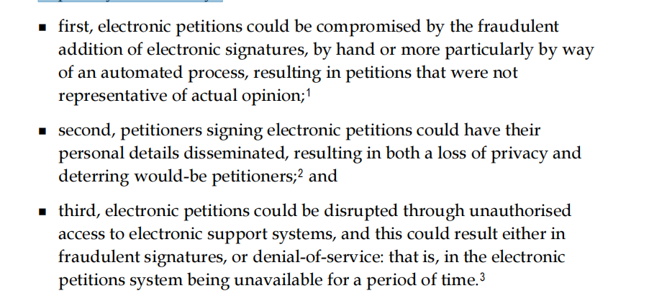

* Website uses strict rule to protect provacy

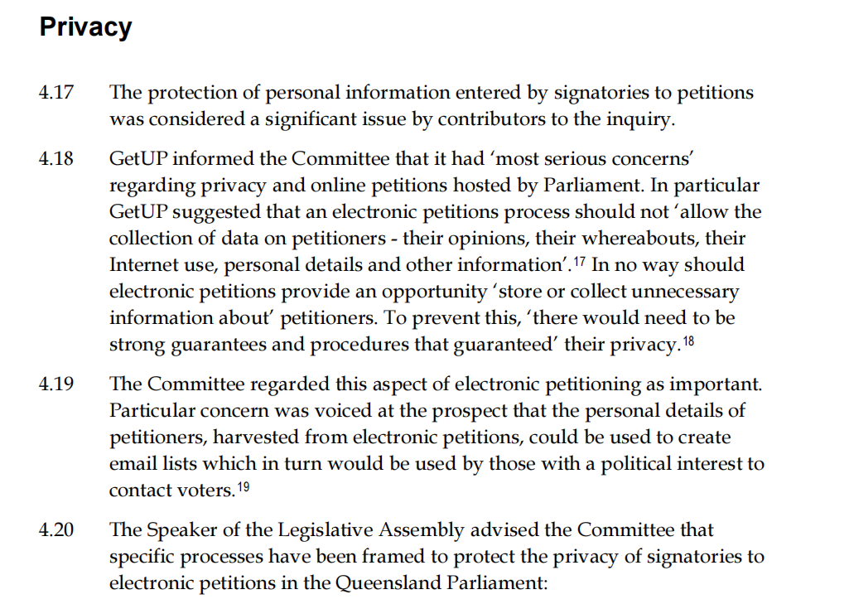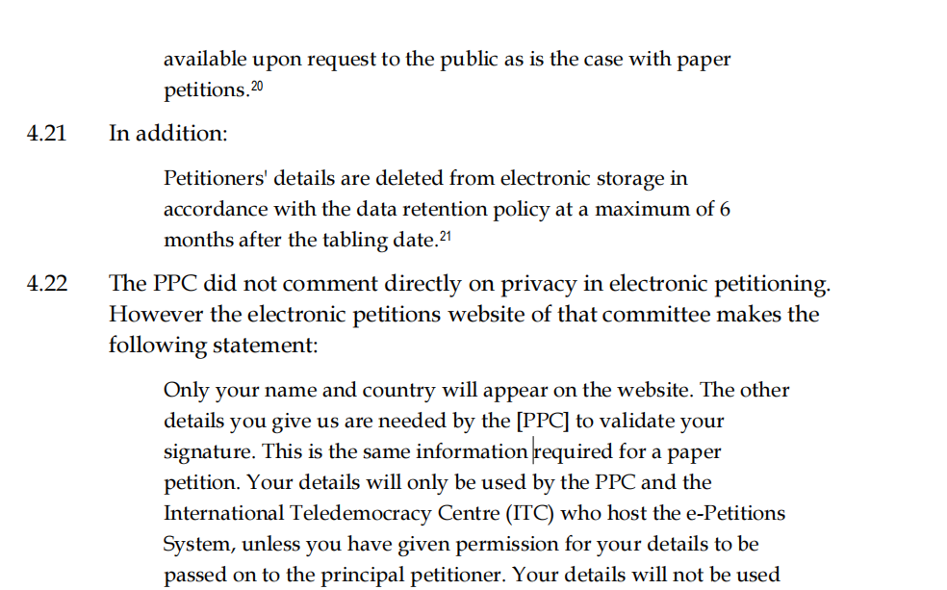

1. <https://petition.parliament.uk/privacy>

use people’s data to make sure:

* make sure that people only sign a petition once
* check that you’re eligible to sign a petition
* contact you about petitions you start
* if you consent, email you updates about what happens in Parliament petitions you’ve signed

We will retain your personal data from the date you start or sign a petition, until 6 months after that petition closes – a maximum of 12 months in total.

Using varying levels of encryption to save people’s data, and all personal data on Petitions is processed, stored and managed entirely in the European Economic Area (EEA)