**一．手动标点：**

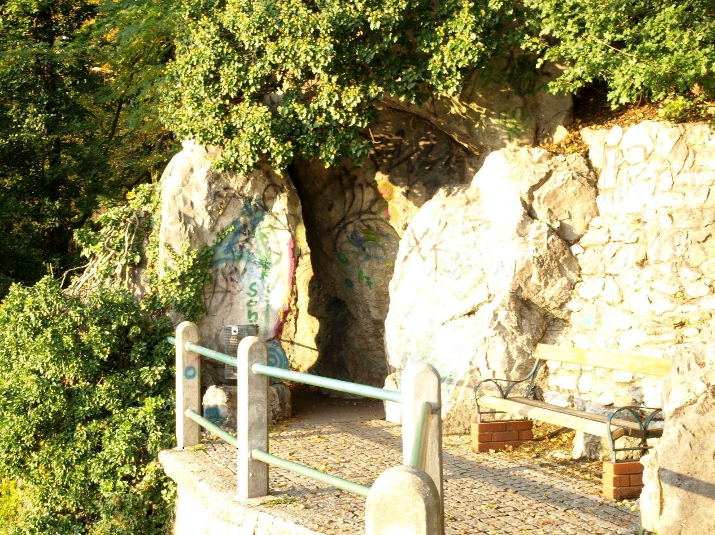



**二．输出两幅图中对应点的坐标：**

PiontsInA =

[1694, 1196],

[2290, 935],

[2294, 1210],

[2035, 2575],

[1164, 2847],

[1341, 257],

[ 858, 1672]

PointsInB =

[1252, 906],

[1762, 502 ],

[1836, 767 ],

[1936, 2151 ],

[1162, 2640 ],

[ 670, 88 ],

[ 566, 1581 ]

**三．计算转换矩阵：**

H= [ 9.65915157e-01 -2.55951363e-01 7.16453603e+02]

[ 2.55917310e-01 9.66176256e-01 -1.82364419e-01]

[ 1.62630326e-19 -1.35525272e-20 1.00000000e+00]

**四．输出转换之后的图像：**

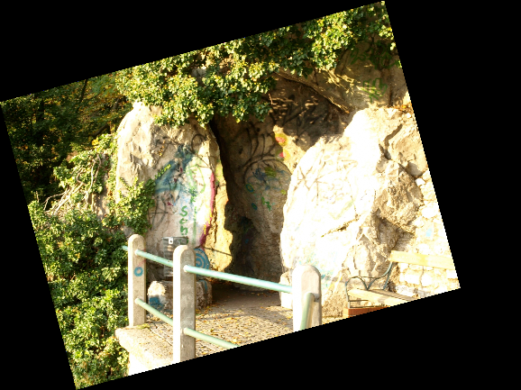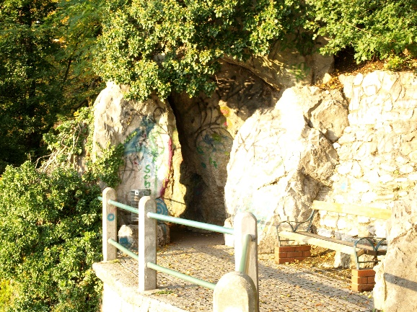

**五．代码示例：**

# -*- coding: utf-8 -*-

"""

Created on Sat Mar 2 10:37:19 2019

@author: Administrator

"""

from math import *

import numpy as np

import cv2 as cv

def calH(P,Q):

'''计算H

Args:

P:输入图像的点的坐标

Q:参考图像的点的坐标

'''

H=Q*P.I

return H

def bilinearityInterplotation(img,target,T):

'''双线性灰度内插

Args:

img :原始图片

target:目标图片

T :仿射矩阵

'''

(X,Y,Z) = img.shape

(x,y,Z) = target.shape

_T = T.I

for i in tqdm(range(x)):

for j in range(y):

xy = (_T*mat([i,j,1]).T).T

ii = xy[0,0]

jj = xy[0,1]

I = int(ii)

U = ii-I

J = int(jj)

V = jj-J

if 0<=I<X and 0<=J<Y:

weight = [(1-U)*(1-V),(1-U)*V,U*(1-V),U*V]

for k in range(Z):

try:

target[i,j,k] = weight[0]*img[I,J,k]+weight[1]*img[I,J+1,k]+weight[2]*img[I+1,J,k]+weight[3]*img[I+1,J+1,k]

except:

target[i,j,k] = 0

else:

target[i,j] = [0,0,0]

def imageMap(A,B,H,name):

'''图像配准

Args:

A:输入图像

B:参考图像

H:变换矩阵

name:配准后图像名字

'''

(x,y,z)=B.shape

target=np.empty([x,y,z],dtype=np.uint8)

bilinearityInterplotation(A,target,H)

cv.imshow("Map",target)

cv.waitKey(0)

cv.destroyAllWindows()

cv.imwrite("./map"+name+".bmp",target)

#人工选择7个点

Q=mat([[1694,1196,1],[2290,935,1],[2294,1210,1],[2035,2575,1],[1164,2847,1],[1341,257,1],[858,1672,1]]).T

P=mat([[1252,906,1],[1762,502,1],[1836,767,1],[1936,2151,1],[1162,2640,1],[670,88,1],[566,1581,1]]).T

H=calH(P,Q)

print(H)

A=cv.imread("./Image A.jpg")

B=cv.imread("./Image B.jpg")

imageMap(B,A,H,"B")

**六．心得体会：**

图像配准是利用人工选择的一系列点反向推导出从输入图像到参考图像的仿射变换矩阵，然后利用这个仿射变换矩阵实现输入图像到参考图像的配准过程，这其中还包括了灰度内插的算法。图像配准可以对齐两幅或多幅相同场景的图像，在数字图像处理中是一项十分重要的技术。