CS683
Xiangyu Hu
Project template
10/26/2023
CS683 Project Assignment 2
Poker-calculator
Xiangyu Hu
Githublink:https://github.com/CS683/project-xiangyu-hu
1,
In fact, I wanted to do this because I recently watched a movie about gambling, and then I heard that many friends around me like the game Poker but have not won any money. Most people just believe in the so-called fate or their own luck. But I think some things are still related to probability, but the human brain cannot get the results quickly. So I wanted to make this to show you the probability of winning with different cards.

2,
I only found one similar software, but it needs to provide everyone's hand information and then calculate everyone's probability of winning. I don't think it's useful because you can't possibly see other people's cards when you're out playing. So I hope to calculate different winning possibilities and odds without knowing other people's cards, and then use this result to make the bets.

3,
Title | Calculate the probability of winning after each card is turned over, and then give the losing hand type.  Simple custom settings, and the fastest way to calculate your hole cards and your opponent's probability of winning.  Hand Strength Analysis, giving the most appropriate advice.
Description | As a player I want to input the card as soon as possible and get the result faster, so that I can have more time to make decision.  As a player I want the result to be more accurate, so that at least I won't lose money.
Mockups
Acceptance tests
Test Results
Status

4,
Basic architecture
UI design and implementation：
After studying in lab3, we learned a lot about fragments, activities and navigation. This makes me more thoughtful when designing UI. I plan to have an edit fragment and show card list fragment just like in the lab. First there will be five community cards in the middle of the app, and then we will have two player cards ourselves. We think we use it ourselves, so we don’t know other people’s cards. Therefore, there will not be an option for other people's cards, only the number of players. Then we calculate what types of hands we will lose to. Like royal flush, straight flush and so on. Then the size of the card shape will be displayed on the other side. Let you know the probability that you can win. I have prepared these simple logical card sizes. The function of modifying this card will be added in iteration 2. Then complete the function of calculating these probabilities before iteration 3.

Other android features
Service, sensors, animations, etc
and need some Algorithms

- Project Structure：
Now：
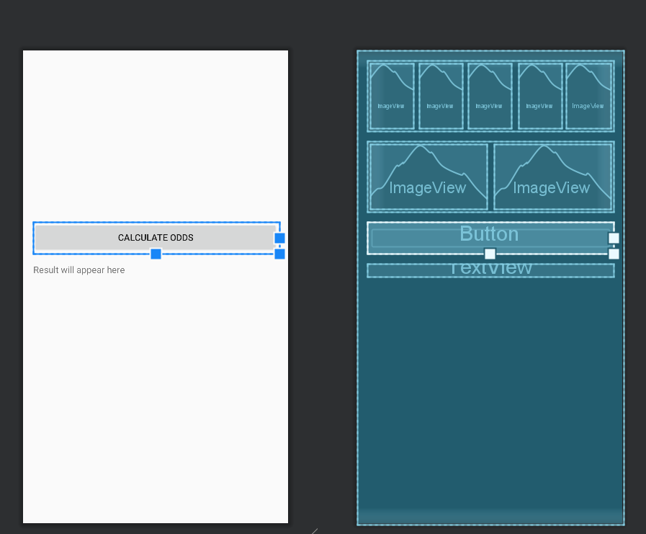

Future：
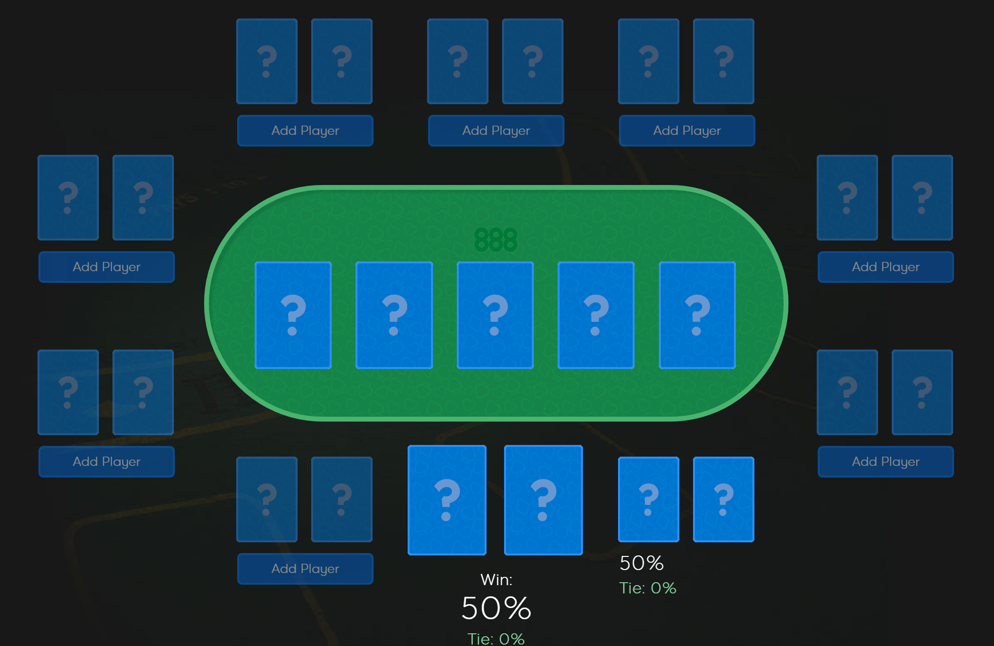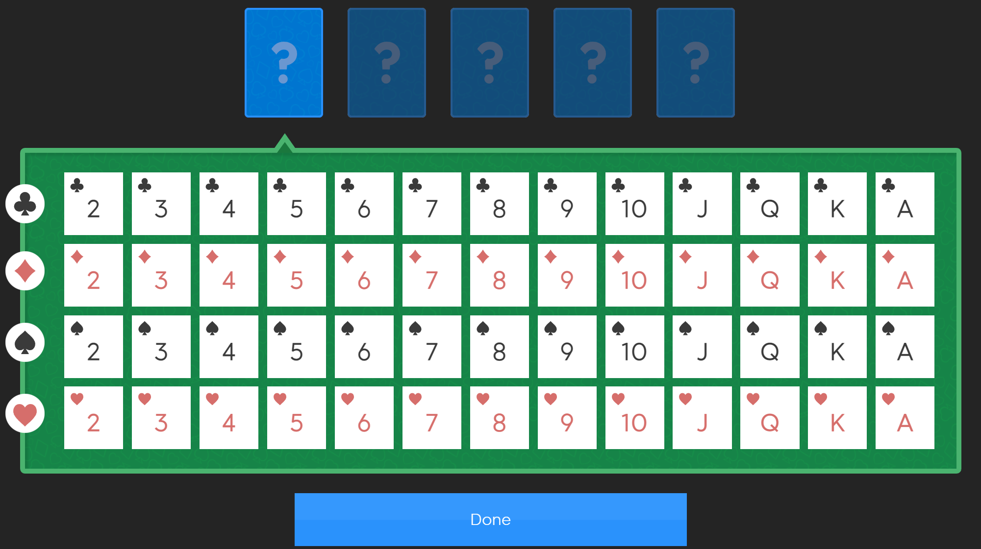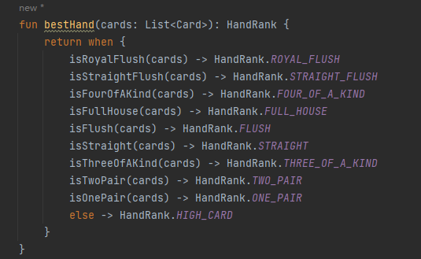
This is not what the project looks like now, but this is the direction I plan to work towards, that is, it should look like this in the end. Then I will set the size of each card type to determine winning or losing.,

- Timeline
I'll have a few options and buttons working in a week or so after November. But pictures of selected cards need to be found separately. This may require some third-party stuff.
iteration | Application Requirements (Eseential/Desirable/Optional) | Android Components and Features | member 1 contribution/tasks
1 | design UI | design UI | design UI
2
3

7,
Iteration 1: UI page
Iteration 2: basic function
Iteration 3: result more accurate.

