PharmaSUG China 2015 – Paper PT13

A Macro to Add Variables to SDTM Standard Domains

Xianhua(Allen) Zeng, PAREXEL International, Shanghai, China

ABSTRACT
In SDTM domains, all character variables are limited to a maximum of 200 characters due to FDA requiring datasets in SAS v5 transport format. Text more than 200 characters long should be stored as a record in the SUPP--dataset. But Comments (CO) and Trial Summary (TS) domains are allowed to add variables for the purpose of handling text exceeding 200 characters sections. To improve readability the text should be split between words not just broken the text into 200-character - i.e., when text is longer than 200 characters in CO domain, additional variables COVAL1-COVALn will be derived. The first 200 characters of the comment will be in COVAL, the next 200 in COVAL1, and additional text stored as needed to COVALn.
This paper presents the AddVar macro, which splits a long text variable into a set of smaller variables without truncating an intact word and automatically generate COVAL- COVALn in CO domain or TSVAL- TSVALn in TS domain.
AddVar checks that the user inputs are valid and that the specified split character does not already exist in the input variable. The newly created variables are added to the output data set.

INTRODUCTION
When creating SDTM datasets, the maximum length of a character variable is 200 characters. Text over 200 characters needs to be split into smaller strings without truncating an intact word not just be broken the original string into 200 character chunks. All long text strings in a SDTM conversion should be handled in this fashion, so it seemed appropriate to create a macro to handle the work.
This paper introduces a macro that can be called in the body of a SAS program to add variables for dataset that contains one or more lengthy variables. The macro should be called once for each variable to be split, and should be called in open code, outside of a DATA step.

MACRO PARAMETERS
Parameter | Description
IN_DATA | Name of input dataset. This is a REQUIRED parameter and there is no default
IN_VAR | Name of input variable. This is a REQUIRED parameter and there is no default
SPLITCHAR | Split character. Space, forward slash [/], backslash [\] cannot be used as a split character. This is a REQUIRED parameter and the default is ~
MAXLEN | Maximum length of a split part. This is a REQUIRED parameter and the default is 200
OUT_DATA | Name of output dataset. This is a REQUIRED parameter and there is no default
OUT_PRE | Prefix label for newly created variables. Parameter call should just use text. This is a REQUIRED parameter and there is no default.
Table 1. AddVar Parameters

METHODOLOGY
AddVar initially performs some checks on the user-supplied parameters –forward slash [/], backslash [\] cannot be used as a split character and the specified split character does not already exist in the input variable.
Following that, the macro checks to see if the length of the input variable is shorter than &MAXLEN – if it is, the macro redefines the length of the variable COVAL (200). If it isn’t, the macro uses the PRXCHANGE function to insert split character in the input variable according to the maximum length of a split part (&MAXLEN) and uses the COUNT function to determine how many variables will need to be created.
Syntax: PRXCHANGE(regular-expression-id|perl-regular-expression, times, source). Example:
VAR=prxchange('s/(.{1,200})([\s]|$)/\1~/', -1, cats(VAR));
Regular expression visualization:
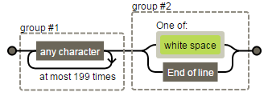
Figure 1. Regular Expression Visualization
AddVar looks at character &MAXLEN +1 – if it’s a space, the split character is inserting. Otherwise, the macro locates the position of the right most breaking character and inserts a split character. The process is repeated on the remaining characters in the string until the end of the input variable.
And finally AddVar extracts individual words from the input variable based on the delimiter (&SPLITCHAR), and each chunk is assigned to a new variable. Variables are named based on the user supplied prefix (&OUT_PRE) – according to the SDTM standard (first new variable is unnumbered, additional new variables are numbered sequentially).

MACRO SOURCE CODE
%macro AddVar(in_data=
, in_var=
, splitchar=~
, maxlen=200
, out_data=
, out_pre=
);

data _null_;
call symput("ERR", "ERR"||"OR:");
run;

/*Checks*/
%if "&splitchar" = "/" or "&splitchar" = "\" %then %do;
%put &err \ or / CAN NOT BE USED AS SPLIT CHARACTER. MACRO TERMINATING.;
%goto exit;
%end;

/*Check if a split character in the input variable*/
%let flag=0;

data _null_;
set &in_data;
if "&splitchar" not in ("", "/", "\") then do;
if prxmatch("/\&splitchar/", &in_var) then call symputx('flag', 1);
end;
run;

%if &flag=1 %then %do;
%put &err A SPLIT CHARACTER(&splitchar) WAS FOUND IN VARIABLE &in_var.. AddVar TERMINATING;
%goto exit;
%end;

/*Flag dataset*/
proc sql noprint;
select distinct max(length(&in_var)) into :lngth
from &in_data
;
quit;

%if &lngth > &maxlen %then %do;
/*Insert split character*/
data &in_data;
set &in_data;
length _&in_var._ $32767;
_&in_var._=prxchange("s/(.{1,&maxlen})([\s]|$)/\1&splitchar/", -1, cats(&in_var));
drop &in_var;
run;

/*Number of variables*/
proc sql noprint;
select cats(max(count(_&in_var._, "&splitchar"))-1) into :varn
from &in_data
;
quit;

data &out_data;
set &in_data;
array vlst{*} $200 &out_pre. &out_pre.1 - &out_pre.&varn;
do i=1 to %eval(&varn+1);
vlst(i)=scan(_&in_var._, i, "&splitchar");
end;
drop _&in_var._ i;
run;
%end;
%else %do;
data &out_data;
set &in_data(rename=&in_var=_&in_var._);
length &out_pre $200;
&out_pre=_&in_var._;
drop _&in_var._;
run;
%end;

/*if exit conditions exist, program will jump to this point*/
%exit:

%mend AddVar;

TEST EXAMPLE
/*To mute "WARNING: The quoted string currently being processed has become more than 262 characters long. You may have unbalanced quotation marks. "*/
options NOQUOTELENMAX;

/*Test data*/
data test;
length COVAL $500.;
COVAL="COMPARED TO PREVIOUS ECG, SIGNIFICANT CHANGES HAVE OCCURRED DUE TO CRITERIA FOR POSSIBLE ANTERIOR INFARCT GONE";
output;
COVAL="COMPARED TO BASELINE ECG, SIGNIFICANT CHANGES HAVE OCCURRED DUE TO NON-SPECIFIC INTRA-VENTRICULAR CONDUCTION DELAY IS SEEN COMPARED TO PREVIOUS ECG, SIGNIFICANT CHANGES HAVE OCCURRED DUE TO NON-SPECIFIC INTRA-VENTRICULAR CONDUCTION DELAY IS SEEN";
output;
COVAL="POSSIBLE WOLFF-PARKINSON-WHITE COMPARED TO BASELINE ECG, SIGNIFICANT CHANGES HAVE CCURRED DUE TO POSSIBLE WOLFF-PARKINSON-WHITE IS SEEN COMPARED TO PREVIOUS ECG, SIGNIFICANT CHANGES HAVE OCCURREDD DUE TO POSSIBLE WOLFF-PARKINSON-WHITE IS SEEN";
output;
COVAL="COMPARED TO BASELINE ECG, SIGNIFICANT CHANGES HAVE OCCURRED DUE TO AGE UNDETERMINED, SEPTAL MI IS SEEN COMPARED TO PREVIOUS ECG, SIGNIFICANT CHANGES HAVE OCCURRED DUE TO AGE UNDETERMINED, SEPTAL MI IS SEEN";
output;
COVAL="PROLONGED QT FULLY PACED BEAT, THE QT CHANGE AND QT PROLONGATION SHOULD BE ONSIDERED UNDER THESE CIRCUMSTANCES AND UNLIKELY TO BE DRUG EFFECT COMPARED TO BASELINE ECG, SIGNIFICANT CHANGES HAVE OCCURRED DUE TO QTCB CHANGED BY >60 MSEC FROM BASELINE COMPARED TO BASELINE ECG, SIGNIFICANT CHANGES HAVE OCCURRED DUE TO AV SEQUENTIAL OR DUAL CHAMBER ELECTRONIC PACEMAKER IS SEEN COMPARED TO PREVIOUS ECG, SIGNIFICANT CHANG HAVE OCCURRED DUE TO AV SEQUENTIAL OR DUAL CHAMBER ELECTRONIC PACEMAKER IS SEEN";
output;
run;

/*Invoke macro*/
%AddVar(in_data=test
, in_var=COVAL
, splitchar=~
, maxlen=200
, out_data=want
, out_pre=COVAL
)

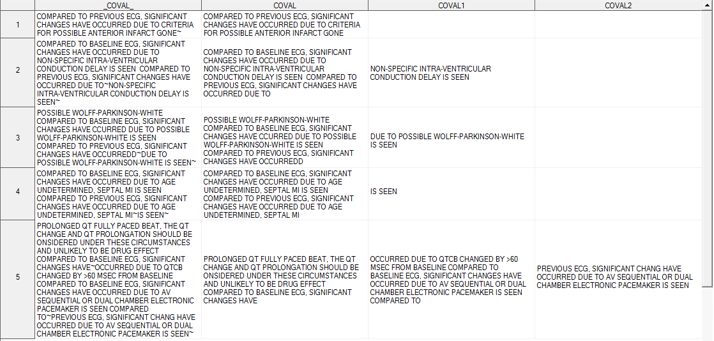
Figure 2. WANT Dataset Without Truncating Word (Keep variable _COVAL_ for demo purpose only)

CONCLUSION
The macro described in this paper is a very useful tool which can be used to derive COVAL-COVALn or TSVAL1 - TSVALn. In addition, the macro will perform automatically, regardless of length of input variable. So the users do not need to know how many variables will be added – the macro will determine that for them. While the macro was developed in response to specific needs found in SDTM conversions, it can be used for other cases where longer strings need to be broken apart. And the usage of PRXCHANGE function in this macro also can be used to align a column in TXT/LST/PDF output.

REFERENCE
CDISC Submission Data Standards Team. “SDTM Implementation Guide: Human Clinical Trials”. Available at http://www.cdisc.org/sdtm.
Richard Addy and Charity Quick. “BreakOnWord: A Macro for Partitioning Long Text Strings at Natural Breaks”. Proceedings of the PharmaSUG 2014 Conference. Available at http://www.pharmasug.org/proceedings/2014/CC/PharmaSUG-2014-CC20.pdf.
SAS Institute Inc. 2011. SAS® 9.2 Language Reference: Dictionary, Fourth Edition. Cary, NC: SAS Institute Inc. Available at http://support.sas.com/documentation/cdl/en/lrdict/64316/PDF/default/lrdict.pdf.
Jeff Avallone. “Regexper”. Available at http://www.regexper.com/.
Chunxia Lin. “Methods to Derive COVAL- COVALn in CO Domain”. Proceedings of the PharmaSUG 2013 Conference. Available at http://www.pharmasug.org/proceedings/2013/CC/PharmaSUG-2013-CC08.pdf.

ACKNOWLEDGMENTS
I would like to express my deep gratitude to my manager Shenglin Zhang for his support. I’d also like to thank my colleague Susie Yu for helpful discussion and proof reading.

CONTACT INFORMATION
Your comments and questions are valued and encouraged. Contact the author at:
Name: Xianhua Zeng
Enterprise: PAREXEL International
Address: 20F, Taiping Finance Tower, No. 488, Middle YinCheng Road, Pudong
City, State ZIP: Shanghai, 200120
Work Phone: +86 21-51118305
Fax: +86 21 61609196
E-mail: huazizeng@gmail.com
Web: http://www.parexel.com/

SAS and all other SAS Institute Inc. product or service names are registered trademarks or trademarks of SAS Institute Inc. in the USA and other countries. ® indicates USA registration.
Other brand and product names are trademarks of their respective companies.

