client A | Trial No. 123456
1 of 1
Figure 4.3.4
Box plots for Pulse Rates
(Treated Set)
Vital Signs Parameter: Pulse Rate (beats/min)
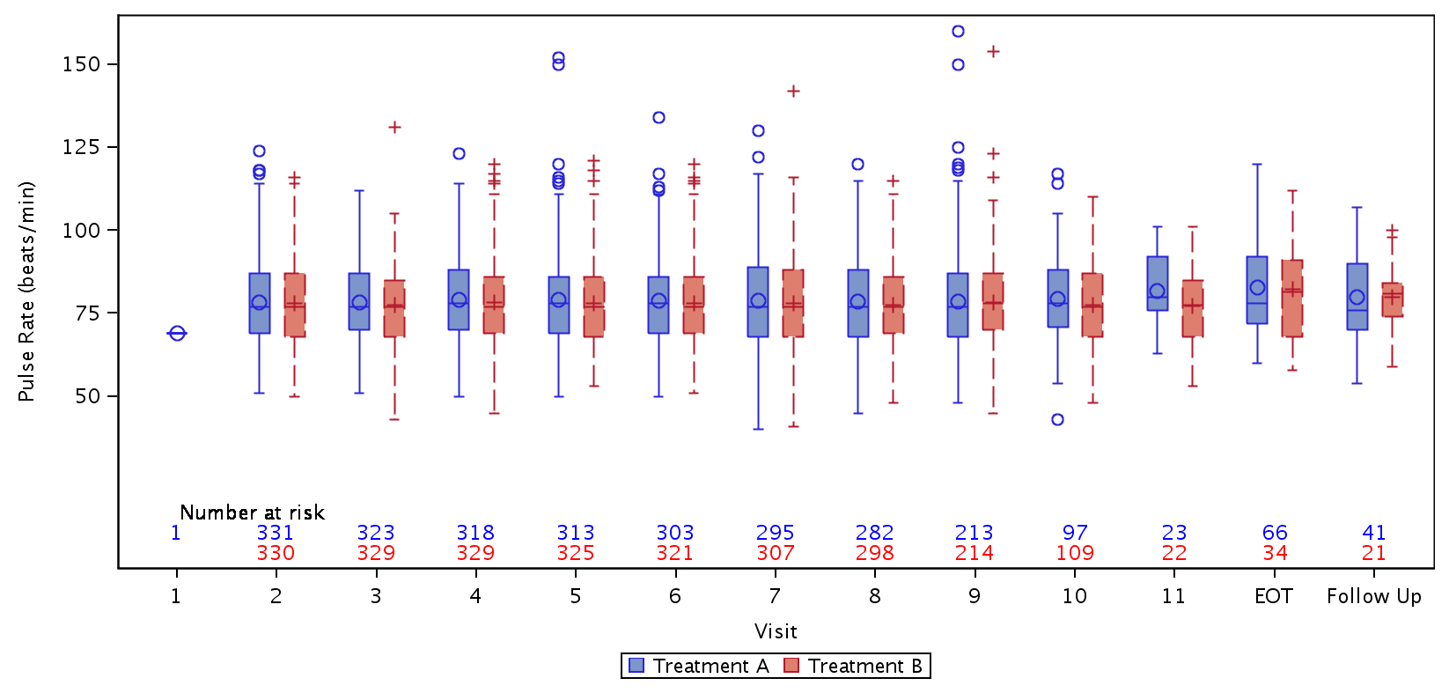
/unblinded/project123456/stats/dmc/prog/figures/boxplots.sas/06MAR19/02:44
Database Extract Date: 13Feb2019 | Final

