Table of Contents
Table 1.1:1 Disposition of Patients (Randomized Set) 2
Table 14.1.1.2 Subject Disposition - Part 1 (Drug Interaction) 4
Table 14.1.2.2 Baseline Characteristics 5
Figure 4.3:3.1.1 Systolic Blood Pressure by Visit - Treatment A (Treated Set) 9
Figure 4.3.4 Box plots for Pulse Rates (Treated Set) 12
Listing 7.001 Adverse Events – Overall Population 13

Table 1.1:1 Disposition of Patients (Randomized Set)
 | Treatment A  N=19  n (%) | Treatment B  N=18  n (%) | Total  N=37  n (%)
Screened |  |  | 188
Randomised | 14 | 12 | 48
Not treated | 2 | 0 | 1
Treated | 15 (87.1) | 13 (95.2) | 42 (86.3)
Not prematurely discontinued from trial medication | 15 (63.8) | 10 (63.8) | 34 (78.1)
Treatment ongoing | 15 (52.1) | 16 (64.3) | 23 (66.6)
Treatment completed | 2 (24.5) | 1 (14.4) | 4 (7.3)
Prematurely discontinued from trial medication | 3 (35.9) | 5 (15.9) | 9 (12.9)
Adverse event | 0 | 0 | 0
Protocol deviation | 0 | 0 | 0
Lost to follow-up | 0 | 0 | 0
Withdrawal by patient | 4 (19.8) | 3 (34.7) | 9 (10.9)
Other | 3 (1.6) | 0 | 2 (14.8)
Ongoing | 14 (74.5) | 10 (58.6) | 25 (80.4)
Completed planned observation time at 52 weeks | 2 (27.4) | 0 (7.8) | 5 (16.6)
Not completed planned observation time at 52 weeks | 3 (4.2) | 4 (13.5) | 6 (22.8)

 | Treatment A  N=19  n (%) | Treatment B  N=18  n (%) | Total  N=37  n (%)
Lost to follow-up | 5 (13.3) | 4 (13.1) | 5 (15.0)
Withdrawal by patient | 1 (9.5) | 4 (31.4) | 7 (18.0)
Death | 0 | 0 | 0
Other | 0 | 0 | 0

Client A  Trial No. 123456 | Page 4 of 15
Page 1 of 1
Table 14.1.1.2 Subject Disposition - Part 1 (Drug Interaction)

Table 14.1.1.2 Subject Disposition - Part 1 (Drug Interaction)
 | Drug A  500 mg  (N = 6) | Drug B 500 mg/  Drug C 500 mg  (N = 5) | Drug A 500 mg+  Drug B 500 mg/  Drug C 500 mg  (N = 5) | (N = 2)
Enrolled/Randomized Subjects | 7 | 5 | 7 | 3
Included in, n (%)
Safety Set | 4 (89%) | 5 (98%) | 7 (100%) | 4 (98%)
PK Concentration Set | 7 (93%) | 5 (90%) | 7 (91%) | 0
PK Parameter Set | 6 (98%) | 8 (89%) | 6 (88%) | 0
Completed Study, n (%) | 6 (69.6%) | 8 (92%) | 6 (91%) | 6 (97%)
Discontinued Study, n (%) | 5 (31.1%) | 0 | 0 | 0
Protocol Violation | 0 | 0 | 0 | 0
Serious or Intolerable Adverse Event(s) | 0 | 0 | 0 | 0
Clinically Significant Change in a Laboratory Parameter | 0 | 0 | 0 | 0
Sponsor/Investigator Discretion | 0 | 0 | 0 | 0
Voluntary Withdrawal of Consent | 0 | 0 | 0 | 0
Study Termination | 0 | 0 | 0 | 0
Non Compliance | 0 | 0 | 0 | 0
Lost to Follow Up | 3 (30.6%) | 0 | 0 | 0
Other | 0 | 0 | 0 | 0
N = Number of subjects in respective treatment in Safety Set, n = Number of subjects within each treatment.
Percentages are based on the number of subjects in Safety Set.
Source Data: Listing 16.2.1.1
Program: t_disp_ddi.sas | Executed: 27Feb2026 14:56

Table 14.1.2.2 Baseline Characteristics

Table 14.1.2.2 Baseline Characteristics
Parameter | Group A  (N = 221) | Group B  (N = 217) | Group C  (N = 82) | Group D  (N = 65) | Group E  (N = 70) | Total  (N = 438)
Curative Treatment,n(%)
Yes | 110 (58.9) | 85 (43.5) | 26 (54.3) | 35 (45.3) | 34 (71.0) | 241 (43.9)
No | 103 (43.5) | 131 (37.7) | 35 (47.3) | 38 (48.9) | 38 (39.3) | 219 (44.5)
ECOG Score,n (%)
0 | 30 (30.3) | 26 (15.1) | 10 (24.8) | 8 (5.0) | 6 (20.9) | 73 (18.0)
3 | 178 (87.5) | 188 (86.0) | 82 (93.7) | 38 (90.0) | 50 (91.6) | 397 (92.4)
ESCC Duration (months)
N (Missing) | 238 (2) | 258 (3) | 55 (17) | 60 (16) | 58 (9) | 352 (23)
(Mean (SD)) | 15.06 (16.285) | 17.83 (17.053) | 15.02 (13.105) | 25.13 (30.222) | 12.78 (11.469) | 13.51 (20.747)
Median | 13.63 | 12.69 | 9.25 | 11.24 | 13.03 | 13.67
Q1, Q3 | 6.50, 19.22 | 6.36, 21.51 | 6.69, 13.40 | 8.70, 21.97 | 7.65, 22.12 | 7.55, 17.15
Min, Max | 2.1, 126.6 | 2.0, 145.5 | 2.8, 88.1 | 2.4, 158.4 | 3.0, 58.0 | 2.0, 162.9
Time to 1st Recurrence/Metastasis (months)
N (Missing) | 208 (12) | 148 (2) | 95 (1) | 48 (14) | 68 (1) | 419 (8)
(Mean (SD)) | 2.84 (4.952) | 4.38 (9.980) | 4.25 (8.738) | 4.55 (9.665) | 2.80 (5.719) | 3.23 (6.773)
Median | 0.90 | 0.59 | 0.81 | 0.75 | 0.61 | 0.84
Q1, Q3 | 0.52, 1.94 | 0.40, 3.40 | 0.42, 2.81 | 0.45, 3.82 | 0.38, 5.05 | 0.53, 2.10
Min, Max | 0.2, 29.5 | 0.1, 64.4 | 0.3, 68.8 | 0.1, 51.9 | 0.2, 33.7 | 0.1, 61.6
Time to Most Recent Recurrence/Metastasis (months)
N (Missing) | 66 (133) | 71 (130) | 25 (75) | 26 (47) | 24 (51) | 108 (242)
(Mean (SD)) | 1.09 (0.987) | 1.06 (1.914) | 0.66 (0.527) | 1.38 (3.189) | 0.81 (1.292) | 0.82 (1.221)
Median | 0.61 | 0.74 | 0.62 | 0.56 | 0.80 | 0.62
Q1, Q3 | 0.51, 1.00 | 0.40, 1.02 | 0.43, 1.16 | 0.30, 1.08 | 0.41, 0.91 | 0.49, 0.91
Min, Max | 0.3, 7.3 | 0.2, 12.7 | 0.4, 3.1 | 0.2, 11.4 | 0.3, 6.2 | 0.2, 14.9
Initial Tumor Diagnosis,n(%)
ESCC | 243 (87.0) | 202 (96.9) | 100 (87.0) | 77 (83.6) | 81 (85.5) | 465 (83.5)
Other | 2 (4.2) | 1 (11.8) | 0 | 0 | 2 (4.9) | 6 (3.3)
Missing | 5 | 5 | 7 | 5 | 3 | 15
Initial Overall Tumor Stage,n(%)
Stage 0 | 0 | 0 | 0 | 0 | 0 | 0
Stage I | 6 (4.3) | 2 (1.5) | 3 (13.4) | 0 | 1 (0.1) | 11 (2.2)
Stage II | 13 (3.4) | 20 (13.1) | 5 (11.2) | 5 (2.1) | 9 (22.6) | 40 (0.8)
Stage III | 59 (26.0) | 36 (19.6) | 9 (11.3) | 24 (41.9) | 10 (33.4) | 82 (28.1)
Stage IV | 108 (31.1) | 129 (64.9) | 56 (48.1) | 27 (55.5) | 28 (58.5) | 146 (37.2)
Unknown | 8 (14.9) | 7 (14.6) | 5 (13.1) | 3 (2.9) | 7 (2.2) | 11 (16.1)
Other | 35 (9.6) | 31 (9.3) | 10 (6.3) | 9 (5.0) | 6 (7.0) | 50 (29.1)
Missing | 5 | 6 | 7 | 4 | 4 | 15
Overall Stage at Screening,n(%)
Stage III | 4 (15.4) | 0 (13.6) | 0 | 0 | 2 (2.9) | 4 (0.6)
Stage IIIA | 4 (6.7) | 0 | 0 | 0 | 0 | 5 (12.0)
Stage IIIB | 6 (10.5) | 7 (2.0) | 5 (3.3) | 0 (11.7) | 1 (9.3) | 10 (6.3)
Stage IV | 12 (21.1) | 8 (11.9) | 6 (14.8) | 7 (17.6) | 6 (6.4) | 30 (6.8)
Stage IVA | 10 (5.5) | 7 (3.7) | 8 (19.8) | 6 (13.5) | 2 (11.0) | 15 (7.7)
Stage IVB | 232 (66.9) | 165 (76.5) | 85 (87.3) | 60 (86.2) | 68 (88.2) | 386 (82.8)
Other | 0 | 0 | 0 | 0 | 0 | 0
Missing | 10 | 10 | 3 | 5 | 2 | 14
TNM Stage,n(%)
T Stage
Tx | 81 (37.0) | 65 (16.8) | 28 (20.0) | 18 (22.5) | 17 (18.0) | 98 (22.9)
T0 | 33 (16.6) | 23 (1.7) | 7 (20.8) | 6 (4.1) | 9 (9.1) | 42 (6.1)
Tis | 5 (10.7) | 0 | 0 | 0 | 0 | 0 (11.8)
T1 | 3 (2.9) | 9 (9.2) | 2 (10.4) | 0 (7.5) | 4 (11.9) | 10 (10.2)
T1a | 0 | 0 | 0 | 0 | 0 | 0
T1b | 0 | 5 (10.0) | 0 | 5 (14.7) | 4 (14.9) | 6 (7.0)
T2 | 10 (15.2) | 15 (9.2) | 4 (17.7) | 4 (16.2) | 6 (9.4) | 23 (5.6)
T3 | 55 (39.9) | 71 (30.5) | 30 (47.2) | 20 (29.2) | 25 (33.6) | 127 (41.6)
T4 | 17 (10.5) | 21 (13.9) | 9 (1.6) | 7 (9.4) | 11 (15.4) | 54 (0.5)
T4a | 6 (6.2) | 2 (15.5) | 2 (12.2) | 3 (8.9) | 5 (9.0) | 8 (14.7)
T4b | 4 (3.5) | 5 (8.0) | 4 (5.8) | 5 (13.2) | 0 | 8 (2.7)
Missing | 6 | 5 | 6 | 4 | 1 | 13
N Stage
Nx | 51 (23.6) | 36 (10.5) | 29 (18.4) | 16 (12.0) | 12 (13.5) | 81 (21.0)
N0 | 26 (19.7) | 20 (6.9) | 7 (5.6) | 5 (12.8) | 9 (13.5) | 42 (5.7)
N1 | 28 (25.6) | 48 (4.6) | 7 (27.0) | 11 (28.7) | 20 (13.9) | 62 (17.0)
N2 | 48 (28.6) | 55 (27.1) | 26 (39.7) | 13 (27.8) | 24 (33.7) | 104 (41.3)
N3 | 35 (23.7) | 36 (20.3) | 14 (11.7) | 12 (8.8) | 12 (6.7) | 109 (13.6)
Missing | 8 | 8 | 2 | 4 | 1 | 12
M Stage
M0 | 19 (9.7) | 8 (1.3) | 7 (6.4) | 5 (17.4) | 1 (7.8) | 29 (13.3)
M1 | 245 (86.5) | 159 (87.4) | 99 (89.3) | 58 (90.7) | 80 (95.3) | 399 (86.6)
Missing | 8 | 8 | 4 | 3 | 2 | 9
Histopathological Grade,n(%)
Gx | 112 (61.2) | 116 (63.7) | 50 (60.6) | 35 (47.4) | 43 (69.1) | 208 (52.6)
G1 | 13 (16.3) | 5 (4.8) | 5 (12.2) | 2 (9.2) | 5 (17.0) | 12 (4.6)
G2 | 45 (21.0) | 52 (10.6) | 16 (21.5) | 16 (19.9) | 8 (4.9) | 74 (17.0)
G3 | 34 (11.8) | 44 (13.6) | 17 (16.8) | 15 (36.4) | 15 (10.6) | 97 (16.2)
Missing | 13 | 12 | 5 | 1 | 7 | 23
Study Disease: Recurrence/Metastasis,n(%)
Yes | 62 (16.2) | 76 (41.1) | 25 (16.2) | 17 (38.0) | 17 (33.8) | 151 (30.5)
No | 120 (80.1) | 142 (61.4) | 51 (64.8) | 52 (68.7) | 42 (56.4) | 227 (71.5)
Missing | 8 | 5 | 7 | 3 | 1 | 7
Current Metastasis of Study Disease,n(%)
Yes | 221 (90.3) | 259 (88.0) | 57 (85.1) | 74 (85.4) | 51 (89.3) | 333 (92.3)
No. of Metastatic Sites
5 | 75 (36.2) | 111 (41.5) | 27 (20.5) | 28 (36.3) | 32 (43.2) | 233 (46.8)
5 | 72 (29.7) | 78 (27.1) | 40 (53.7) | 14 (25.2) | 18 (39.0) | 110 (45.6)
>=3 | 35 (22.8) | 52 (28.8) | 15 (15.4) | 20 (15.0) | 10 (18.7) | 109 (24.3)
No | 3 (0.5) | 2 (11.0) | 5 (13.9) | 0 | 0 | 2 (10.8)
Missing | 5 | 9 | 6 | 5 | 2 | 13
Metastatic Site,n(%)
Lymph Node | 148 (87.2) | 216 (77.4) | 66 (95.1) | 43 (72.9) | 64 (91.1) | 479 (88.2)
Liver | 56 (23.1) | 74 (35.7) | 26 (23.9) | 18 (32.3) | 22 (29.5) | 89 (39.1)
Lung | 55 (15.5) | 62 (16.2) | 24 (44.4) | 28 (44.6) | 22 (40.6) | 112 (27.9)
Other | 25 (13.2) | 42 (13.1) | 15 (11.1) | 10 (12.6) | 7 (22.9) | 72 (10.1)
Bone | 28 (8.6) | 17 (22.0) | 13 (12.2) | 5 (6.1) | 7 (20.3) | 51 (1.0)
Pleura | 9 (6.4) | 6 (2.1) | 4 (15.0) | 1 (11.9) | 6 (8.9) | 13 (3.6)
Mediastinum | 12 (12.1) | 7 (11.4) | 1 (3.5) | 5 (2.4) | 4 (8.5) | 22 (9.2)
Peritoneum | 5 (18.1) | 7 (13.8) | 0 | 7 (3.1) | 5 (0.2) | 15 (1.7)
Adrenal Gland | 11 (17.0) | 6 (16.4) | 5 (13.5) | 5 (18.3) | 2 (8.3) | 13 (7.5)
Ascites | 4 (15.6) | 0 | 0 | 0 | 0 | 2 (7.1)
Pleural Effusion | 2 (6.1) | 4 (7.9) | 1 (14.0) | 0 | 0 | 4 (12.1)
Brain | 0 | 0 | 0 | 0 | 0 | 0
Percentages are calculated using the number of subjects per group in mITT as denominator.
Data Source: Listing 16.2.4.2
Program: /PGM/t_base.sas; output: ./OUTPUT/t_14_1_2_2_base_mitt_i.rtf (2026-01-15T10:35).

Figure 4.3:3.1.1 Systolic Blood Pressure by Visit - Treatment A (Treated Set)
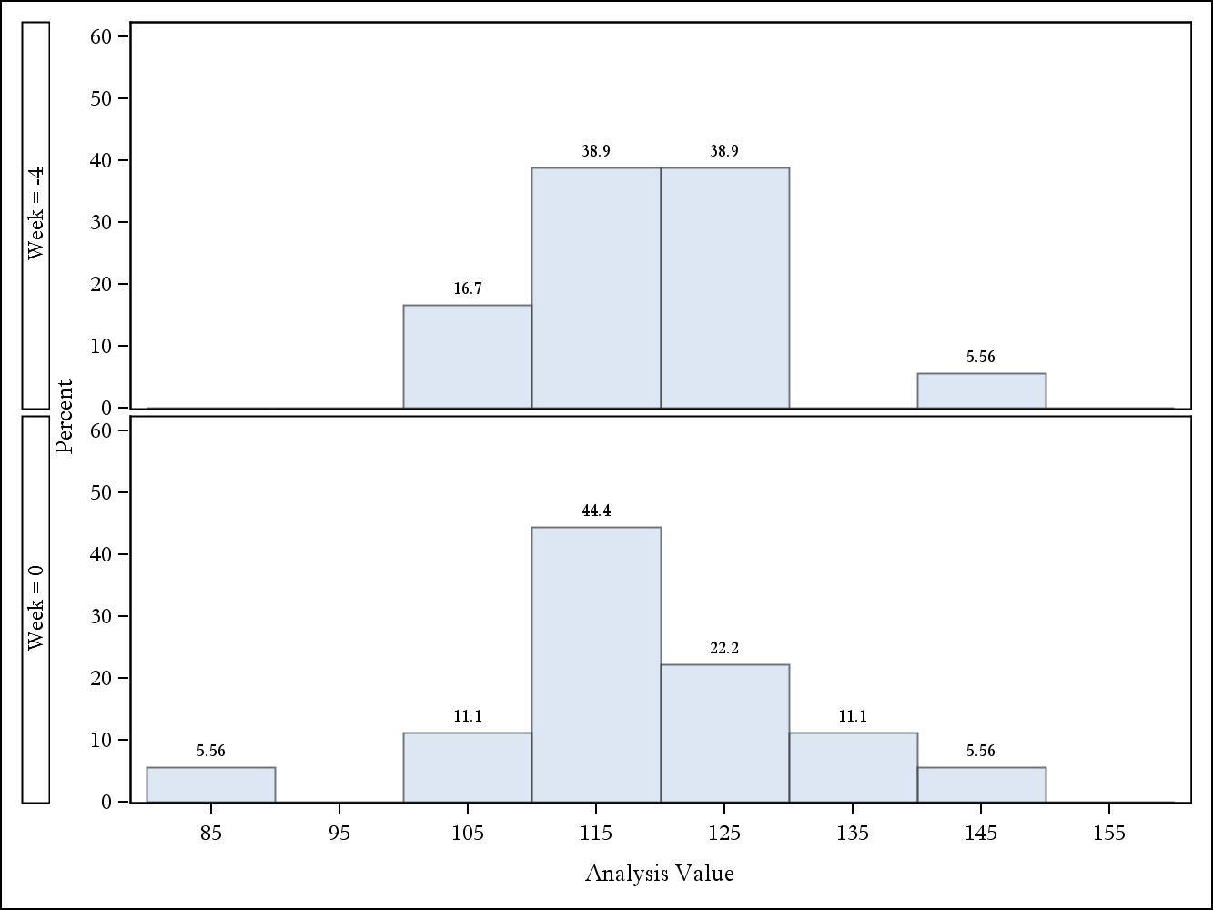

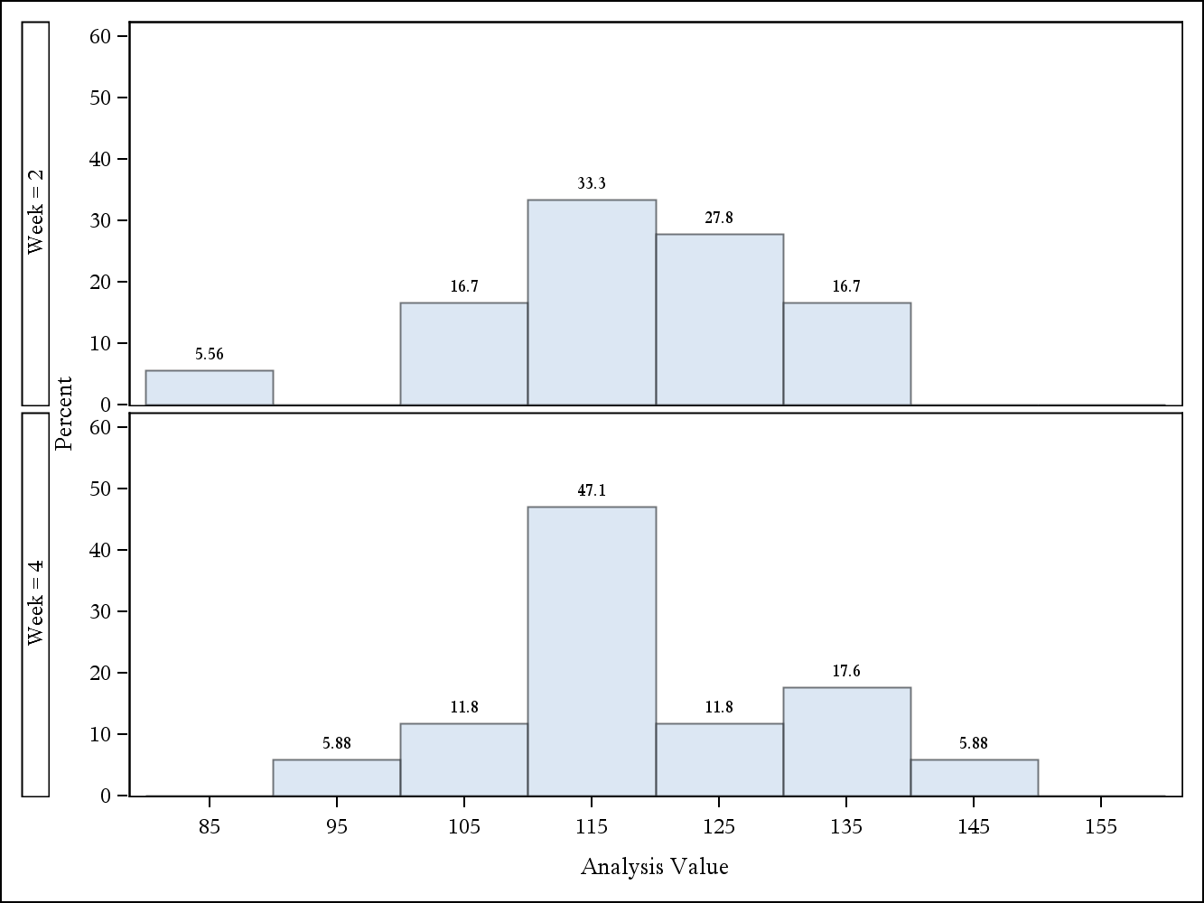

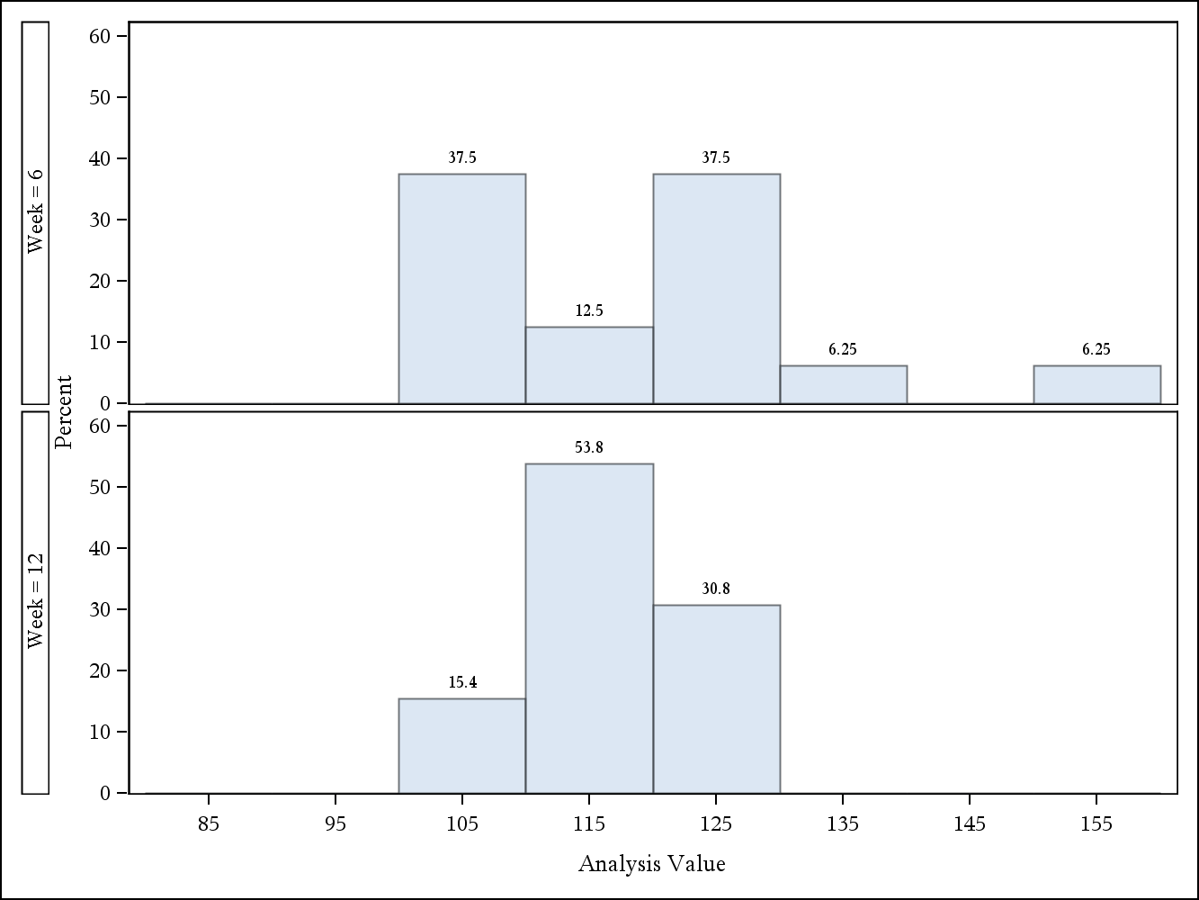

Figure 4.3.4 Box plots for Pulse Rates (Treated Set)

Client A |  | Trial No. 123456
Page 12 of 15
Page 1 of 1
Figure 4.3.4
Box plots for Pulse Rates
(Treated Set)
Vital Signs Parameter: Pulse Rate (beats/min)
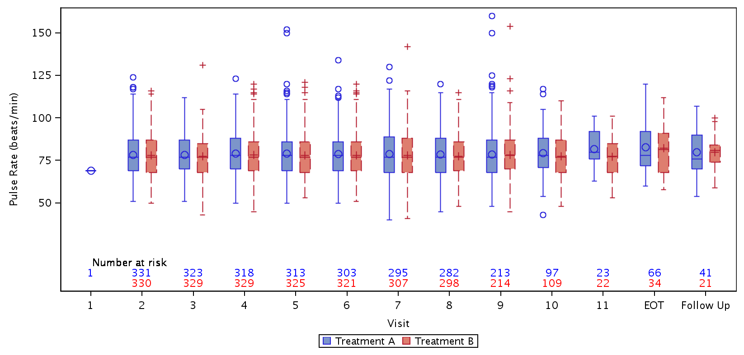
/unblinded/project123456/stats/dmc/prog/figures/boxplots.sas/06MAR26/02:44
Database Extract Date: 13Feb2026 |  | Final

Listing 7.001 Adverse Events – Overall Population
Patient ID | Age  (years) | SOC/  PT/  Reported Term | Start Date /  End Date | Outcome/  Intensity | Action Taken with  Treatment Due to AE/  Action(s) | Withdrawn from Study  Due to AE/  Reasonable Possibility  of AE caused by Treatment | SAE /  Detail of SAE | Result in  Death
03259 | 28 | General disorders and administration site conditions/  Therapeutic product effect decreased/  Drug effect decreased | 2026-04-19/  - | NOT RECOVERED/NOT RESOLVED/  NOT APPLICABLE | Action(s) taken with study treatment(s)/  DRUG WITHDRAWN | Yes/  Yes | No/  -
03219 | 36 | General disorders and administration site conditions/  Therapeutic product effect decreased/  Drug effect decreased | 2026-03-03/  - | NOT RECOVERED/NOT RESOLVED/  NOT APPLICABLE | Action(s) taken with study treatment(s)/  DRUG WITHDRAWN | Yes/  Yes | No/  -
02857 | 44 | General disorders and administration site conditions/  Therapeutic product effect decreased/  Poor therapeutic effect | 2026-04-28/  - | NOT RECOVERED/NOT RESOLVED/  NOT APPLICABLE | Action(s) taken with study treatment(s)/  DRUG WITHDRAWN | Yes/  Yes | No/  -
03687 | 46 | Blood and lymphatic system disorders/  Lymphadenopathy/  Lymphadenopathy | 2026-01/  - | UNKNOWN/  UNKNOWN | Action(s) taken with study treatment(s)/  DRUG WITHDRAWN | No/  Yes | Yes/  Results in disability/incapacity; Other | No
 |  | Neoplasms benign, malignant and unspecified (incl cysts and polyps)/  Metastases to bone/  mucinous carcinoma bone metastases | 2026-01/  - | NOT RECOVERED/NOT RESOLVED/  SEVERE | No (Dose not changed)/  - | Yes/  No | Yes/  Results in disability/incapacity; Other | No
02827 | 75 | General disorders and administration site conditions/  Therapeutic product effect decreased/  Drug effect decreased | 2026-03-19/  - | NOT RECOVERED/NOT RESOLVED/  NOT APPLICABLE | Action(s) taken with study treatment(s)/  DRUG WITHDRAWN | Yes/  Yes | No/  -
02945 | 54 | Neoplasms benign, malignant and unspecified (incl cysts and polyps)/  Hepatic cancer/  primary liver cancer | 2026-02-14/  2026-02-13 | NOT RECOVERED/NOT RESOLVED/  SEVERE | Action(s) taken with study treatment(s)/  DRUG WITHDRAWN | Yes/  No | Yes/  Results in death | Yes

