**Beam Design:**

Free body diagram:

Force analysis:

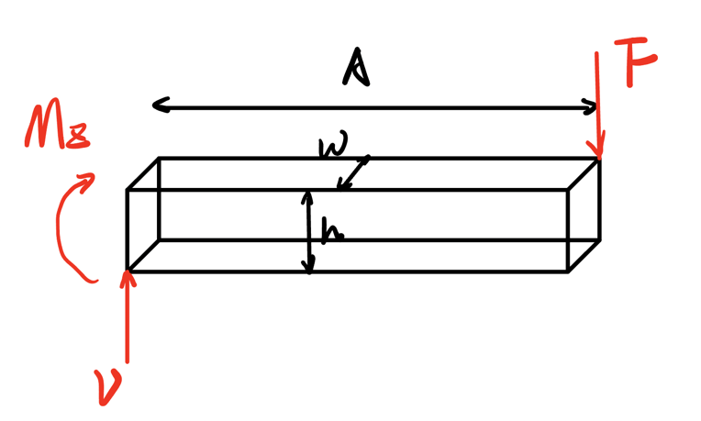

$$F_{mass}=F_{box}+F_{motor}+F_{shaft+gear+scissor}=185.423 \left[N\right]$$

To be more conservative, we magnify it by a factor $γ=1.5$.

$$F={γF}_{mass}=185.423*1.5=278.134 \left[N\right]$$

Force Diagram:

Point D is the critical point since the bending moment at this point is highest and there is a stress concentration of the guide rail.

The internal moment and the shear force at the critical point:

$$V = F$$

$$M_{z}=V*A=417.201 \left[Nm\right]$$

Let’s choose G10300 HR steel as the material from Shigley’s book Table A-20, the properties:



Assume the dimension of the beam:

Thickness: h = 0.25 m

Width: b = 0.25 m

Let’s check for the yielding:

Choose the safety factor as

$$n = 1.3$$

Bending stress:

Normal: $τ_{x}=-\frac{M_{z}y}{I_{z}}= -160.205 [MPa]$

Shear: $τ_{xz}=\frac{VQ}{Ib}=6.675 [MPa]$

Since it’s a ductile material, choose Distortion-energy criterion:

$$σ^{'}=(τ_{x}^{2}+3{τ_{xz}^{2})}^{\frac{1}{2}} = 160.344 [MPa]$$

$$σ^{'}≤\frac{S_{y}}{n_{d}}=\frac{260}{1.3}= 200 [MPa]$$

Thus, the beam will not yield.