**Shaft Design**

**Force Analysis:**

Free body diagram – as shown in the Figure4.1.1, Based on the FBD , the forces come from the scissors (in the x direction ) and gears (in the z direction ). The force on the gear comes from the motor driving the gear, and the reaction force is generated between the gears.

The top end of the shaft on the right side of the diagram (point A) is connected to the motor, and there is a bearing at point B that secures the shaft on the right side. On the left side of the diagram, there are bearings at points A and B securing the shaft. Perform a force analysis on these two shafts.

On xy-plane:

(in the left shaft the direction is along the positive x axis, in the right shaft the direction is along negative x axis)

On yz-plane

(in the left shaft the direction is along the negative z axis, in the right shaft the direction is along positive z axis)

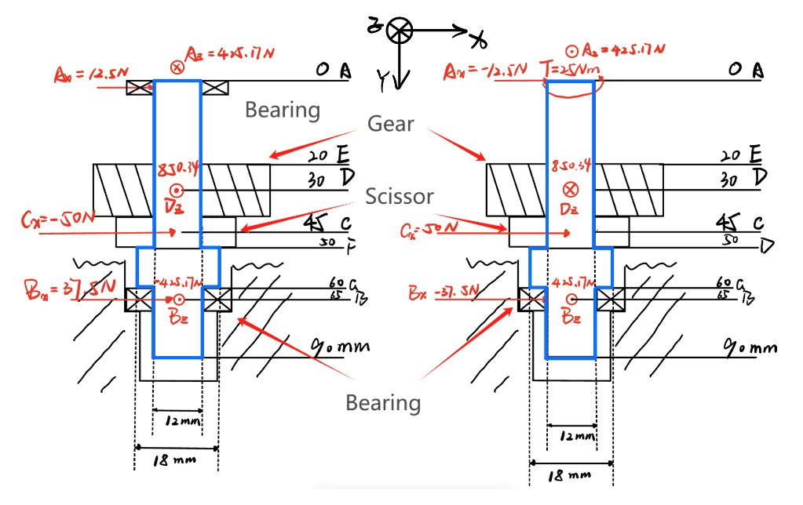

Figure4.1.1: Free body diagram of two shaft

After calculation of the shafts, we get the diagram of shear force and bending moment:

|  |  |
| --- | --- |
|  |  |
| Figure4.1.2: shear force in xy plane | Figure4.1.3: shear force in yz plane |
|  |  |
| Figure4.1.4 Bending moment in xy plane | Figure4.1.5 Bending moment in yz plane |
|  |  |
| Figure4.1.5 Torque diagram of right shaft | Figure4.1.6 Torque diagram of left shaft |

**Check the shaft:**

Choose the inexpensive steel, 1050CD steel, parameter is from Shigley’s book Table A-20:

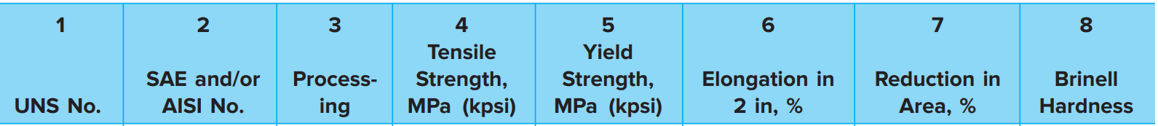



Start with point D, where the bending moment is high and there is the keyway

Forces at D:

Therefore,

Based on the inner radius of the gear (12 mm), let’s design the diameter d to be 12 mm.

Assume the radius at the bottom of the keyway will be the standard , thereby

Choose the stress concentration factors from Shigley’s book

From the Shigley’s book equation 6-32:

Then the modifying factors:

**Surface factor** from the Shigley’s book Table 6-2, from cold draw.

From equation 6-18:

**Size factor** from the Shigley’s book equation 6-19, due to the ,

**Load factor** from the Shigley’s book equation 6-25, and since there is not fluctuating axial loading, and the loading factor for torsion is already taken into account when using Mises Stress.

**Temperature Factor** the endurance limit is available or being estimated based on the ultimate strength at the operating temperature.

**Reliability Factor**

Estimating the Endurance Limit from equation 6-10,

Finally, the endurance limit: From equation 6-17:

Use von Mises stresses from equation 7-4 and equation 7-5:

Then calculate the safety, using the Goodman Criterion from equation 6-41

And the yielding safety factor:

**At point E**, there is a ring we will look up data for a specific retaining ring to obtain and more accurately.

With a quick online search of a retaining ring specification appropriate groove specifications for a retaining ring for a shaft diameter of 11.5mm are obtained as follows: width, a=1mm; depth, 0.25mm; and corner radius at the bottom of grove, r=0.13mm

Just to the up of point E.

Forces at E:

Therefore,

And

Choose the stress concentration factors from Shigley’s book

From the Shigley’s book equation 6-32:

Then the modifying factors:

**Surface factor** from the Shigley’s book Table 6-2, from cold draw.

From equation 6-18:

**Size factor** from the Shigley’s book equation 6-19, due to the ,

**Load factor** from the Shigley’s book equation 6-25, and since there is not fluctuating axial loading, and the loading factor for torsion is already taken into account when using Mises Stress.

**Temperature Factor** the endurance limit is available or being estimated based on the ultimate strength at the operating temperature.

**Reliability Factor**

Estimating the Endurance Limit from equation 6-10,

Finally, the endurance limit: From equation 6-17:

Use von Mises stresses from equation 7-4 and equation 7-5:

Then calculate the safety, using the Goodman Criterion from equation 6-41

And the yielding safety factor:

And then check for point C, here the bending moment is high and there is a stress concentration of the shoulder.

Forces at C:

Therefore,

Based on the inner radius of the gear (12 mm), let’s design the diameter d to be 12 mm.

Next, check for failure:

Choose diameter ratio for the shoulder: D/d = 1.5, thereby

Select standard value D = 18 mm.

Check if estimates were acceptable:

Choose fillet ratio for well-rounded shoulder, based on Shigley’s book [Table 7-1].

So the fillet radius is .

Choose the stress concentration factors from Shigley’s book

From the Shigley’s book equation 6-32:

Then the modifying factors:

**Surface factor** from the Shigley’s book Table 6-2, from cold draw.

From equation 6-18:

**Size factor** from the Shigley’s book equation 6-19, due to the ,

**Load factor** from the Shigley’s book equation 6-25, and since there is not fluctuating axial loading, and the loading factor for torsion is already taken into account when using Mises Stress.

**Temperature Factor** the endurance limit is available or being estimated based on the ultimate strength at the operating temperature.

**Reliability Factor**

Estimating the Endurance Limit from equation 6-10,

Finally, the endurance limit: From equation 6-17:

Use von Mises stresses from equation 7-4 and equation 7-5:

Then calculate the safety, using the Goodman Criterion from equation 6-41

And the yielding safety factor from equation 7-7:

Finally, let us check for deflection:

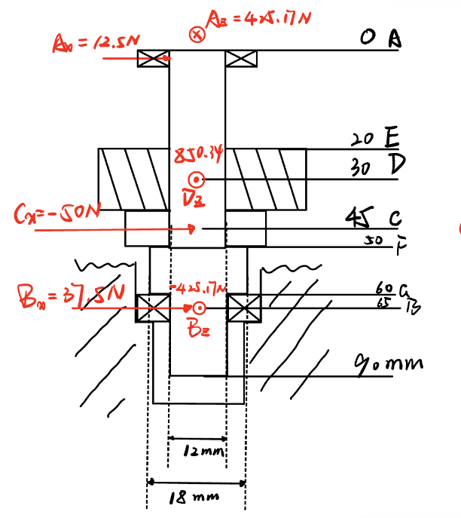

For simplification, let’s assume diameter from F to G is equal to OF, this is more conservative.

**In xy plane**, For boundary condition:

Integrate the moment functions:

And , and

So, there is four equations and four unknowns, use python to solve:

**In xz plane**, For boundary condition:

Therefore, use python to solve:

**Table4.1.1: Slope and Deflection Values at key Locations**

|  |  |  |  |
| --- | --- | --- | --- |
| Point of interest | XY Plane | XZ Plane | Total |
| Gear slope (D) | [rad] | [rad] | 0.00061131[rad] |
| Bearing slope (B) | [rad] | [rad] | 0.00152938[rad] |
| Gear deflection (D) | 0.00033[mm] | 0.000169[mm] | 0.00037[mm] |

The deflections and slopes at points of interest are obtained from the calculation, and combined with orthogonal vector addition, that is, . Results are shown in Table4.1.1 And according to the guidelines in Table 7-2 in Shigley’s book. It is satisfied for the requirement.